Notice of withdrawal to SDA provider
Residential Tenancies Act 1997, Part 12A
Specialist Disability Accommodation
Sections 498ZZB

Note:
Use this form if you are a specialist disability accommodation (SDA) resident who has given the SDA provider a notice of intention to vacate, but you wish to withdraw the notice.
The SDA provider must give details of this notice to the Director of Consumer Affairs Victoria within 14 days of receiving the notice. To notify us, visit consumer.vic.gov.au/SDAnotify.
Enter text in spaces provided only.
This document is available for download at consumer.vic.gov.au/forms.

How to use this form
- Complete all the questions
You must give the form to the same person you gave the notice that you want to withdraw.
- Sign at 10 and enter the date at 11
The same person who gave the notice that is being withdrawn must sign this form.

How to serve this notice
You can post the notice, deliver it personally to the provider between 8am and 6pm, or email it (with consent).
You can only give this notice by email if you already have the provider’s written consent to receive notices and other documents this way.
You and the provider may have consented to electronic service of notices and other documents in the SDA residency agreement.

Telephone Interpreter Service
If you have difficulty understanding English, contact the Translating and Interpreting Service (TIS) on 131 450 (for the cost of a local call) and ask to be put through to an Information Officer at Consumer Affairs Victoria on
1300 55 81 81.
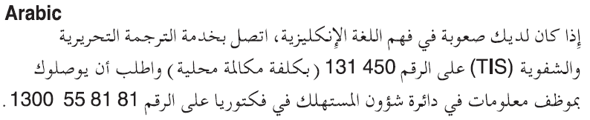
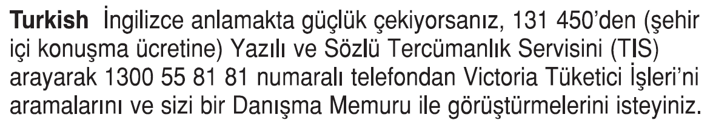
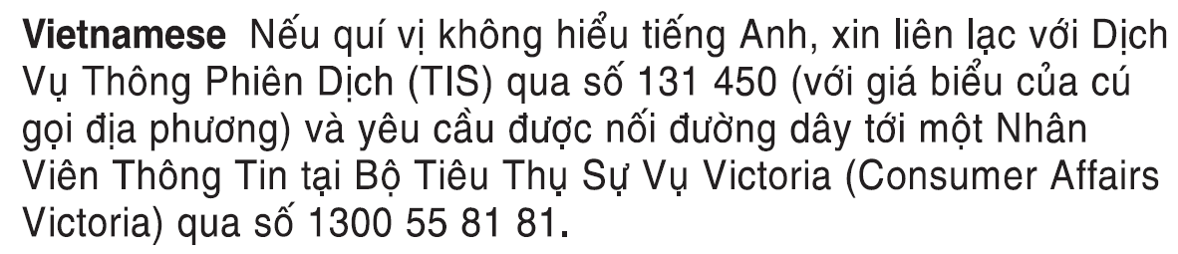
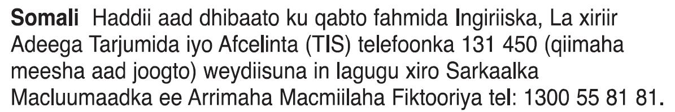
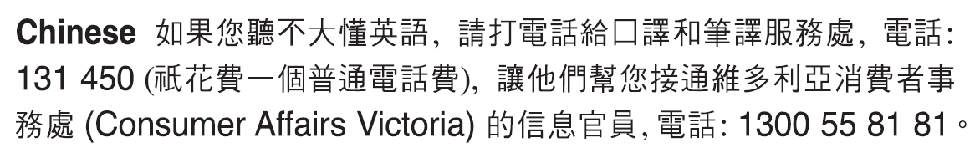
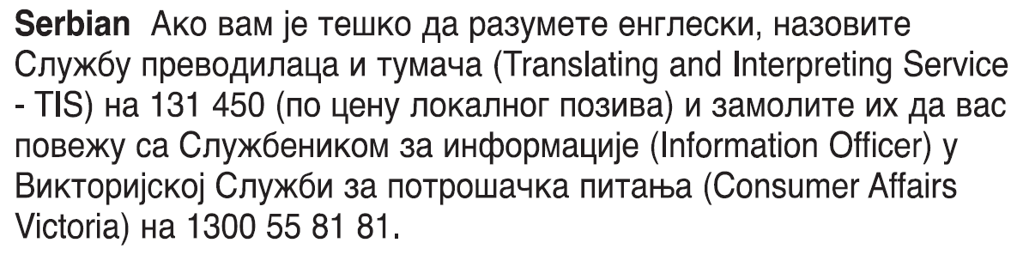
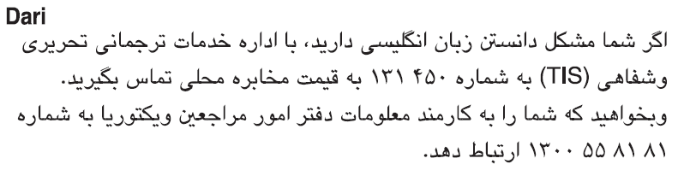
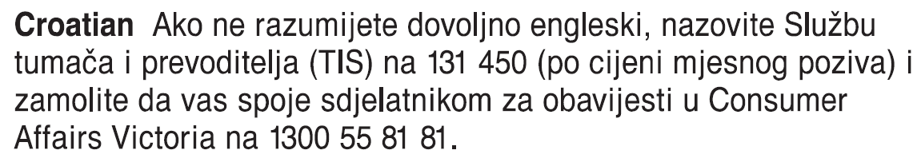
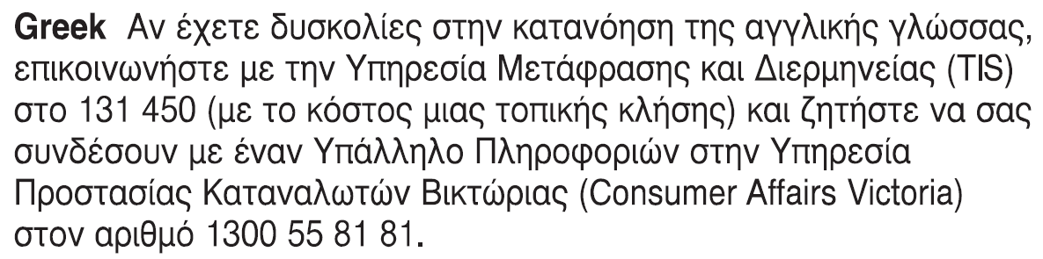
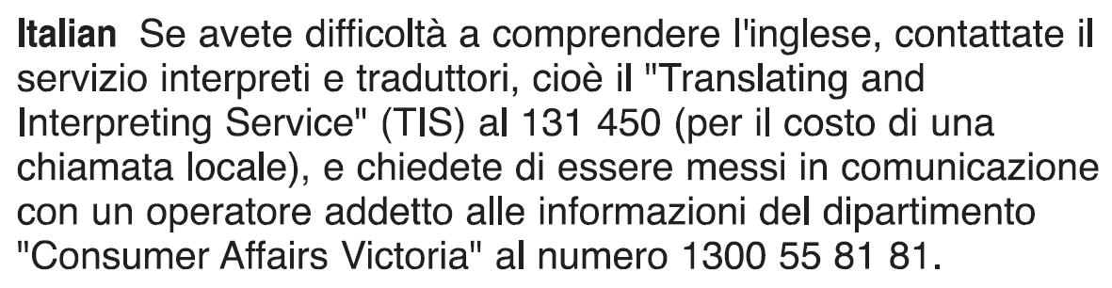 Information about renting is available in other languages at consumer.vic.gov.au/languages.

Notice of withdrawal to SDA provider SDA resident’s copy
Residential Tenancies Act 1997 s498ZZB

SDA provider details
- This notice is given to:
(SDA provider’s name)
- SDA provider’s address:
(write address)

SDA resident details
- SDA resident name:
- This notice is given on behalf of the resident by the SDA resident’s guardian or administrator:
(if applicable, write name below)
- Regarding the SDA enrolled dwelling at:
(write address)
- Address for serving documents:
(insert address resident would like documents to be sent to)
- Contact telephone numbers:
(can be the resident’s, or their guardian’s or administrator’s)
Business hours:
After hours:

Withdrawal of notice
- On:
(dd/mm/yyyy)
/ /
I gave you a Notice of intention to vacate
- I am withdrawing the Notice of intention to vacate.
- Signature of SDA resident:
(or guardian or administrator if applicable)
- Date:
(dd/mm/yyyy)
/ /
The SDA provider must give details of this notice to the Director of Consumer Affairs Victoria within 14 days of receiving the notice.
To notify us, visit consumer.vic.gov.au/SDAnotify.

Notice of withdrawal to SDA provider SDA resident support person’s copy
Residential Tenancies Act 1997 s498ZZB

SDA provider details
- This notice is given to:
(SDA provider’s name)
- SDA provider’s address:
(write address)

SDA resident details
- SDA resident name:
- This notice is given on behalf of the resident by the SDA resident’s guardian or administrator:
(if applicable, write name below)
- Regarding the SDA enrolled dwelling at:
(write address)
- Address for serving documents:
(insert address resident would like documents to be sent to)
- Contact telephone numbers:
(can be the resident’s, or their guardian’s or administrator’s)
Business hours:
After hours:

Withdrawal of notice
- On:
(dd/mm/yyyy)
/ /
I gave you a Notice of intention to vacate
- I am withdrawing the Notice of intention to vacate.
- Signature of SDA resident:
(or guardian or administrator if applicable)
- Date:
(dd/mm/yyyy)
/ /
The SDA provider must give details of this notice to the Director of Consumer Affairs Victoria within 14 days of receiving the notice.
To notify us, visit consumer.vic.gov.au/SDAnotify.

Notice of withdrawal to SDA provider SDA provider’s copy
Residential Tenancies Act 1997 s498ZZB

SDA provider details
- This notice is given to:
(SDA provider’s name)
- SDA provider’s address:
(write address)

SDA resident details
- SDA resident name:
- This notice is given on behalf of the resident by the SDA resident’s guardian or administrator:
(if applicable, write name below)
- Regarding the SDA enrolled dwelling at:
(write address)
- Address for serving documents:
(insert address resident would like documents to be sent to)
- Contact telephone numbers:
(can be the resident’s, or their guardian’s or administrator’s)
Business hours:
After hours:

Withdrawal of notice
- On:
(dd/mm/yyyy)
/ /
I gave you a Notice of intention to vacate
- I am withdrawing the Notice of intention to vacate.
- Signature of SDA resident:
(or guardian or administrator if applicable):
- Date:
(dd/mm/yyyy)
/ /
The SDA provider must give details of this notice to the Director of Consumer Affairs Victoria within 14 days of receiving the notice.
To notify us, visit consumer.vic.gov.au/SDAnotify.

