Notice of temporary relocation
Residential Tenancies Act 1997 (the Act), Part 12A
Specialist Disability Accommodation (SDA) Section 498ZV

Who can use this form?
A specialist disability accommodation provider (SDA provider) can use this form to give notice of temporary relocation to an SDA resident living in an SDA enrolled dwelling.

Notice of temporary relocation can be issued:
- when the SDA resident:
- endangers the safety of other SDA residents or staff at the SDA enrolled dwelling
- is causing serious disruption to the proper use and enjoyment of the SDA enrolled dwelling by other SDA residents
- is a danger to themselves
- can no longer be appropriately supported in the SDA enrolled dwelling
- has caused serious damage or destroyed any part of the SDA enrolled dwelling
- has used the SDA enrolled dwelling for an illegal purpose
- for the SDA resident’s safety or wellbeing
- when specialist disability accommodation will no longer be provided at the SDA enrolled dwelling
- when the SDA enrolled dwelling is no longer suitable to provide specialist disability accommodation
- when the SDA provider intends to repair the SDA enrolled dwelling immediately after the notice has effect, and:
- has all necessary permits and consents to carry out the work, and
- the work cannot be carried out unless the SDA resident vacates the area or room that they exclusively occupy in the SDA enrolled dwelling.
Note: Enter text in spaces provided only. This form will be invalid if you remove or change any questions or other text.

How to use this form
- Identify your reason
Read the reasons for giving a notice of temporary relocation on pages 3 to 4 and identify the correct reason for your circumstances.
The number beside each reason is the relevant section of the Act.
- Consult the Act
You should consult Part 12A of the Act to make sure that you are entitled to give a notice of temporary relocation.
- Complete the notice
You must complete all boxes on the notice.
- Sign at 8 and write your name at 9
- Write your reason in 10
In box 10, write the relevant section number and the exact words in the table on pages 3 to 4.
- When the form is complete
Give a copy of the form to the SDA resident. For more information, see ‘How to serve this notice’.
Keep copies of the notice for your records.

How to serve this notice
You can serve this notice to the resident by hand between 8am and 6pm, or by post, or by email (with consent).
You can only send this notice by email if you already have the resident/s’ written consent to receive notices and other documents this way. The resident/s may have consented to electronic service of notices and other documents in the SDA residency agreement.
You must also explain the notice of temporary relocation using terms and methods that the resident/s can understand. You can do this verbally or in writing.
If it helps the resident, you should also give a copy of the notice to their guardian, administrator, family member, carer, advocate or chosen person.

After you have served this notice
Within 24 hours of giving a notice of temporary relocation to an SDA resident, you must notify the following organisations – you can be fined if you fail to do this.
When you give a notice to an SDA resident who is an SDA recipient, you must also notify the:
- Chief Executive Officer of the National Disability Insurance Agency
- Office of the Public Advocate
- Consumer Affairs Victoria – to notify us, visit consumer.vic.gov.au/SDAnotify.
When you give a notice to an SDA resident who is receiving continuity of supports under the Commonwealth Continuity of Support Programme, you must also notify the:
- Office of the Public Advocate
- Consumer Affairs Victoria – to notify us, visit consumer.vic.gov.au/SDAnotify.
If you need help with this notice, visit the Specialist disability accommodation section – Consumer Affairs Victoria website (consumer.vic.gov.au/sda) or call Consumer Affairs Victoria on 1300 40 43 19.

Telephone Interpreter Service
If you have difficulty understanding English, contact the Translating and Interpreting Service (TIS) on 131 450 (for the cost of a local call) and ask to be put through to an information officer at Consumer Affairs Victoria on 1300 55 81 81 (9am to 5pm Monday to Friday, except public holidays).
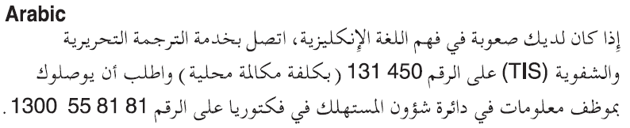
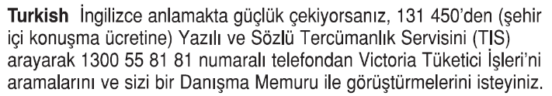
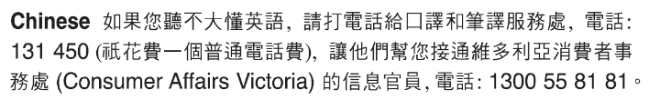
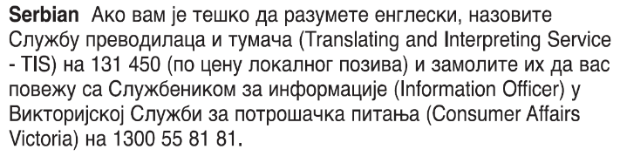
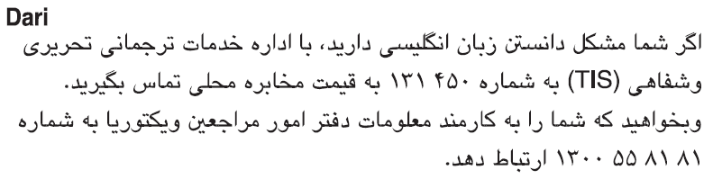
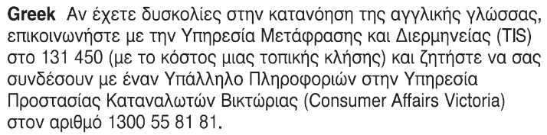
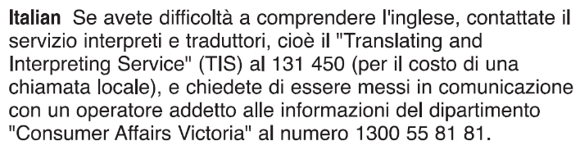 Information about renting is available in other languages at consumer.vic.gov.au/languages.

Reasons for giving notice of temporary relocation

Period of relocation
On the notice, you must include both the date that the notice takes effect and the date the notice ends. The end date cannot be more than 90 days after the date that the notice takes effect.
Note: a notice of temporary relocation given for section 498ZV(1)(i) cannot specify an end date that is longer than the time required to carry out the work.
Section of the Act | Reason for giving notice | Additional requirements (if any)
498ZV(1)(a) | The SDA resident endangers the safety of other SDA residents or staff at the SDA enrolled dwelling. | If an SDA provider gives a notice of temporary relocation under section 498ZV(1)(a) they must take reasonable steps to notify the SDA resident’s Supported Independent Living provider before the notice expires, to provide an opportunity for the SDA resident’s support plan to be reviewed.
498ZV(1)(b) | The SDA resident is causing serious disruption to the proper use and enjoyment of the SDA enrolled dwelling by other SDA residents. | If an SDA provider gives a notice of temporary relocation under section 498ZV(1)(b) they must take reasonable steps to notify the SDA resident’s Supported Independent Living provider before the notice expires, to provide an opportunity for the SDA resident’s support plan to be reviewed.
498ZV(1)(c) | The SDA resident is a danger to themselves. | If an SDA provider gives a notice of temporary relocation under section 498ZV(1)(c) they must take reasonable steps to notify the SDA resident’s Supported Independent Living provider before the notice expires, to provide an opportunity for the SDA resident’s support plan to be reviewed.
498ZV(1)(ca) | The SDA resident can no longer be appropriately supported in the SDA enrolled dwelling. | None
498ZV(1)(d) | It is for the SDA resident’s safety or wellbeing. | If an SDA provider gives a notice of temporary relocation under section 498ZV(1)(d) they must take reasonable steps to notify the SDA resident’s Supported Independent Living provider before the notice expires, to provide an opportunity for the SDA resident’s support plan to be reviewed.
498ZV(1)(e) | The SDA resident has caused serious damage or destroyed any part of the SDA enrolled dwelling. | Important: an SDA provider must not give a notice of temporary relocation under section 498ZV(1)(e) if any of the following have significantly contributed to the serious damage or destruction:  - Fair wear and tear  - Accidental damage  - Reasonable use of the SDA enrolled dwelling  - Reasonable use of any aids, equipment, fixtures and fittings used in the dwelling  - The act of omission of a person other than the SDA resident  - Any behaviour arising from the SDA resident’s disability, including circumstances aggravating to the SDA resident’s disability or emotional wellbeing  - A failure by a person to implement or comply with the SDA resident’s support plan  - The unauthorised use of a restrictive practice within the meaning of the Disability Act 2006  - Where the SDA resident has been subjected to abuse or neglect.  If an SDA provider gives a notice of temporary relocation under section 498ZV(1)(e) they must take reasonable steps to notify the SDA resident’s Supported Independent Living provider before the notice expires, to provide an opportunity for the SDA resident’s support plan to be reviewed.
498ZV(1)(f) | The SDA resident has used the SDA enrolled dwelling for an illegal purpose. | If an SDA provider gives a notice of temporary relocation under section 498ZV(1)(f) they must take reasonable steps to notify the SDA resident’s Supported Independent Living provider before the notice expires, to provide an opportunity for the SDA resident’s support plan to be reviewed.
498ZV(1)(g) | Specialist disability accommodation will no longer be provided at the SDA enrolled dwelling. | None
498ZV(1)(h) | The SDA enrolled dwelling is no longer suitable for the provision of specialist disability accommodation. | None
498ZV(1)(i) | The SDA provider intends to repair the SDA enrolled dwelling immediately after the notice of temporary relocation has effect and has obtained all necessary permits and consents to carry out the work and the work cannot be properly carried out unless the SDA resident vacates the area or room of the SDA enrolled dwelling exclusively occupied by the SDA resident. | Important  Where:  - the proposed repairs will affect the SDA resident’s area or room but will not affect all areas or rooms in the dwelling; and  - an area or room equivalent to the SDA resident’s area or room at an equivalent rent is available in the dwelling.  A notice of temporary relocation must not be given unless the SDA provider has first offered an equivalent area or room to the SDA resident and the resident has refused to occupy that area or room.

Notice of temporary relocation SDA resident’s copy

SDA resident details
- This notice is given to:
(insert resident’s name)
- A copy of this notice is also given to:
(if applicable, insert name and address of resident’s family member, carer, advocate, guardian, administrator or other chosen person)
- Regarding the SDA enrolled dwelling at:
(write address)

SDA provider details
- SDA provider’s name:
(cannot be an agent’s name)
- Address for serving documents:
(can be an agent’s address)
- Contact telephone numbers:
(of SDA provider or agent)
Business hours:
After hours:

Service details
- This notice is given:
(mark one method only and if posted note the delivery speed)
By hand:
By registered post:
By ordinary post:
By email:
Insert email address:
(if applicable)
On:  (dd/mm/yyyy) | / /
- Signature of SDA provider, their authorised officer or agent:
- Name of SDA provider, their authorised officer or agent signing this notice:

Reason for notice
- Write the section number and reason, using the words provided on pages 3 to 4 ‘Reason for giving notice’:

Outline of circumstances giving rise to this notice
- Please provide details of the circumstances that support the issuing of this notice:

When this notice takes effect
- This notice takes effect on this date:
(dd/mm/yyyy)
/ /
Resident please note: from the date entered into the box above, you cannot remain in your SDA enrolled dwelling but must move to the alternative premises identified in box 13.

Alternative premises during period of relocation
- During the period of this notice, the SDA resident will be relocated to:
(insert property number, street name, suburb and postcode of the alternative accommodation)

End of relocation period
- This notice of temporary relocation ends on this date:
(dd/mm/yyyy)
/ /
Resident please note: from the date entered into the box above you are entitled to return to your SDA enrolled dwelling
If you need help with this notice, call Consumer Affairs Victoria on 1300 40 43 19 or visit consumer.vic.gov.au/sda.

Notice of temporary relocation SDA resident support person’s copy

SDA resident details
- This notice is given to:
(insert resident’s name)
- A copy of this notice is also given to:
(if applicable, insert name and address of resident’s family member, carer, advocate, guardian, administrator or other chosen person)
- Regarding the SDA enrolled dwelling at:
(write address)

SDA provider details
- SDA provider’s name:
(cannot be an agent’s name)
- Address for serving documents:
(can be an agent’s address)
- Contact telephone numbers:
(of SDA provider or agent)
Business hours:
After hours:

Service details
- This notice is given:
(mark one method only and if posted note the delivery speed)
By hand:
By registered post:
By ordinary post:
By email:
Insert email address:
(if applicable)
On:  (dd/mm/yyyy) | / /
- Signature of SDA provider, their authorised officer or agent:
- Name of SDA provider, their authorised officer or agent signing this notice:

Reason for notice
- Write the section number and reason, using the words provided on pages 3 to 4 ‘Reason for giving notice’:

Outline of circumstances giving rise to this notice
- Please provide details of the circumstances that support the issuing of this notice:

When this notice takes effect
- This notice takes effect on this date:
(dd/mm/yyyy)
/ /
Resident please note: from the date entered into the box above, you cannot remain in your SDA enrolled dwelling but must move to the alternative premises identified in box 13.

Alternative premises during period of relocation
- During the period of this notice, the SDA resident will be relocated to:
(insert property number, street name, suburb and postcode of the alternative accommodation)

End of relocation period
- This notice of temporary relocation ends on this date:
(dd/mm/yyyy)
/ /
Resident please note: from the date entered into the box above you are entitled to return to your SDA enrolled dwelling.
If you need help with this notice, call Consumer Affairs Victoria on 1300 40 43 19 or visit consumer.vic.gov.au/sda.

Notice of temporary relocation SDA provider’s copy

SDA resident details
- This notice is given to:
(insert resident’s name)
- A copy of this notice is also given to:
(if applicable, insert name and address of resident’s family member, carer, advocate, guardian, administrator or other chosen person)
- Regarding the SDA enrolled dwelling at:
(write address)

SDA provider details
- SDA provider’s name:
(cannot be an agent’s name)
- Address for serving documents:
(can be an agent’s address)
- Contact telephone numbers:
(of SDA provider or agent)
Business hours:
After hours:

Service details
- This notice is given:
(mark one method only and if posted note the delivery speed)
By hand:
By registered post:
By ordinary post:
By email:
Insert email address:
(if applicable)
On:  (dd/mm/yyyy) | / /
- Signature of SDA provider, their authorised officer or agent:
- Name of SDA provider, their authorised officer or agent signing this notice:

Reason for notice
- Write the section number and reason, using the words provided on pages 3 to 4 ‘Reason for giving notice’:

Outline of circumstances giving rise to this notice
- Please provide details of the circumstances that support the issuing of this notice:

When this notice takes effect
- This notice takes effect on this date:
(dd/mm/yyyy)
/ /
Resident please note: from the date entered into the box above, you cannot remain in your SDA enrolled dwelling but must move to the alternative premises identified in box 13.

Alternative premises during period of relocation
- During the period of this notice, the SDA resident will be relocated to:
(insert property number, street name, suburb and postcode of the alternative accommodation)

End of relocation period
- This notice of temporary relocation ends on this date:
(dd/mm/yyyy)
/ /
Resident please note: from the date entered into the box above you are entitled to return to your SDA enrolled dwelling
If you need help with this notice, call Consumer Affairs Victoria on 1300 40 43 19 or visit consumer.vic.gov.au/sda.

