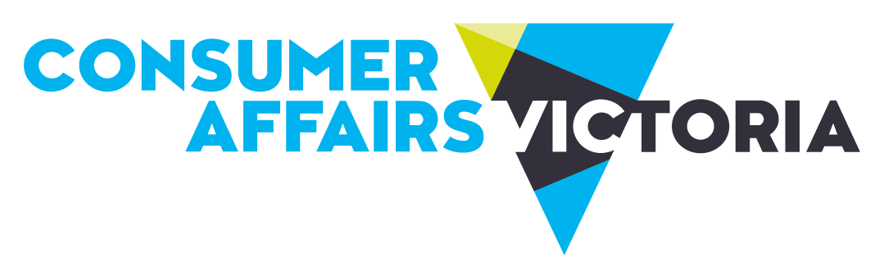
Consumer Affairs Victoria

Information about shopping and services

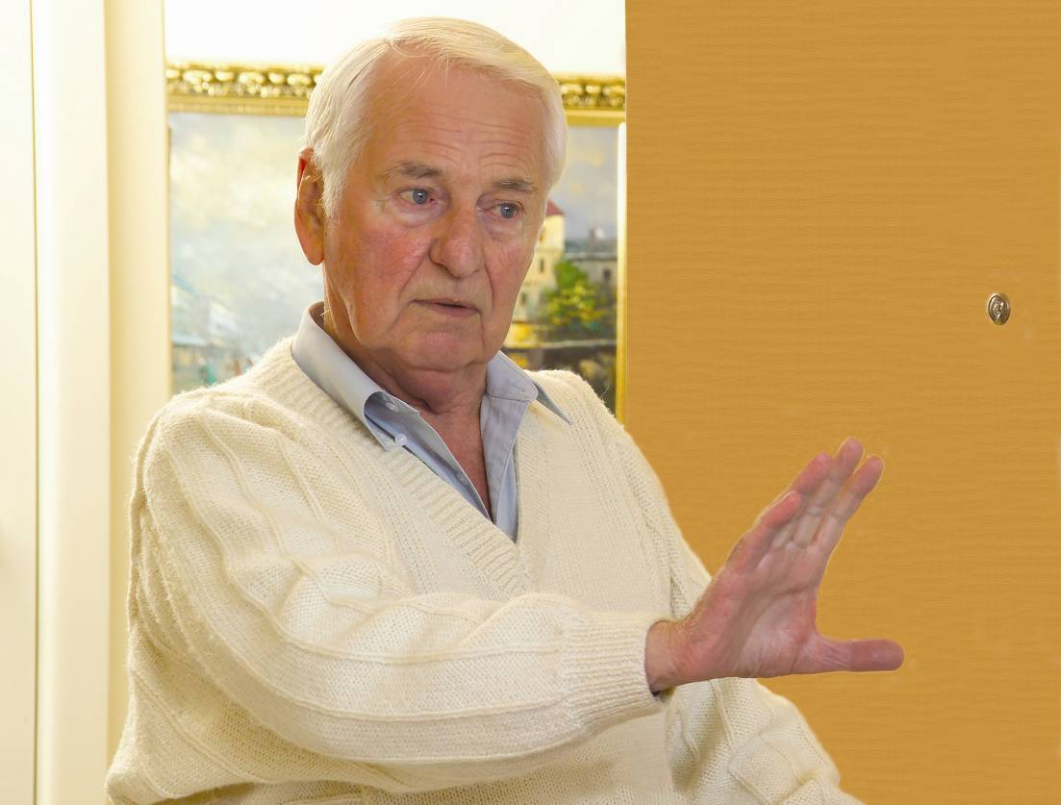
Door to door sales

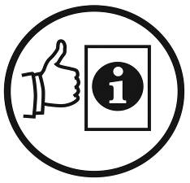
Easy English fact sheet
For more information about this fact sheet, see page 8.

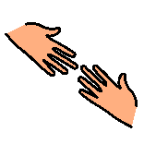
You might need help to read this information.
A friend, family member or support person can help you.


What are door to door sales?

A person comes to your house or work.
The person tries to sell you a product.
This person is called a sales person.

A product is something you
- buy, for example, gas, electricity, a holiday or pay TV
- pay someone to do for you. For example, paint your house.

What are the laws?
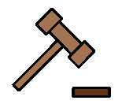
There are laws when you buy a product that costs more than $100.
The laws protect you when buy a product from a door to door sales person.

Buyers and sales people must follow the law.

The sales person must
- Tell you why they are at your house
- Show you a card with their name on it and where they work. For example, a gas company or electricity company
- Say that you can ask them to leave
- Leave when you ask them to

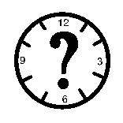
When can sales people visit your house or work?

Monday to Friday between 9 am to 6 pm

Saturdays between 9 am to 5 pm.
You do not have to let sales people into your house or work.

Sales people can not visit you on Sundays or public holidays, for example, Anzac Day or Christmas Day.


You can say “no, goodbye” and close the door at any time. The sales person must leave if you tell them to go away.

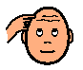
Remember you do not have to buy anything or sign anything.

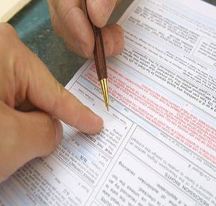
If you want to buy a product, the sales person will give you a sales contract. This might be called a Sales Agreement.

A sales contract might be 1 page or lots of pages.
You can ask a support person to help you read it and understand it.
- It must be easy to read. It must say
- All the rules about buying the product
- How much the product costs
- Extra money you might have to pay. Extra money is called a fee or a charge
- The sales person’s name and work address
- What will happen if you change your mind about buying the product.

What should you do with the sales contract?

- Read the contract carefully
- Make sure you understand the contract
- Ask for more time to read it, if you need to
- Ask the sales person to come back later, if you need more time
- Sign the contract only when you feel happy with the contract.
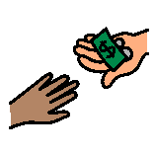
Paying for products

- Do not pay any money straight away
- Wait to get the product and then pay
- You have 1 to 10 days to make sure you are happy before you pay. This is called a cooling off period
- Ask for your money back if you are not happy with the product.
A cooling off period is when you have 10 days to change your mind.


More fact sheets and information

Consumer Affairs Victoria
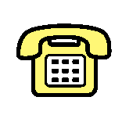  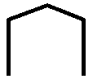   | Address 113 Exhibition Street  Melbourne Victoria 3000
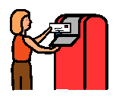 | Phone 1300 55 81 81
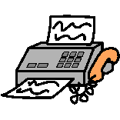 | Mail GPO Box 123  Melbourne Victoria 3001
 | Fax (03) 8684 6295
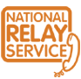   | Interpreter 131 450
 | National Relay Service 133 677
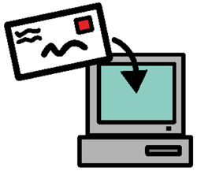 | Email consumer@justice.vic.gov.au
 | Website http://www.consumer.vic.gov.au
This information is written in Easy English. You might need more information about the law.
- You can ask Consumer Affairs Victoria for more information.

Version 3. Updated January 2011.

Easy English fact sheet produced by Scope, July 2008.

Look at the Easy English Writing Style Guide for information about the format and writing style of this document.
You can find more information at http://www.scopevic.org.au or
phone (03) 9843 2000.

The Picture Communication Symbols ©1981-2008 by Mayer-Johnson LLC. All Rights Reserved Worldwide. Used with permission.

COMPIC is used with permission. You can find more information about COMPIC at http://www.scopevic.org.au.

