Notice of revocation
Residential Tenancies Act 1997, Part 12A
Specialist Disability Accommodation
Sections 498DA

Note:
Use this form if you are a specialist disability accommodation (SDA) provider registered under the NDIS and:
- your registration under the NDIS has been revoked, or
- the dwelling is no longer an SDA enrolled dwelling.
This form may be used where accommodation is provided under an SDA residency agreement or a residential tenancy agreement.
You must give this notice to the SDA resident (the resident) within five days of your registration being revoked or the dwelling ceasing to be an enrolled dwelling.
Enter text in spaces provided only.
You can download this document at consumer.vic.gov.au/forms.

How to use this form
- Complete all the questions
Select the correct option at 9.
- Sign at 11 and enter the date at 13.

How to serve this notice
You can post the notice, deliver it personally to the resident between 8am and 6pm, or email it (with consent).
You must give a copy of the notice to the resident’s guardian or administrator, if any.
You must also explain the notice in a language, mode of communication and terms the resident is likely to understand. If it will help the resident, you must explain it verbally and in writing.
If it will help the resident, you must also give a copy of the notice to the resident’s family member, carer, advocate or other chosen person.
If the resident has not chosen a support person, you can choose a person who is not your employee or representative to assist the resident.
You can only give this notice by email if you already have the resident’s written consent to receive notices and other documents this way.
You and the resident may have consented to electronic service of notices and other documents in the SDA residency or residential tenancy agreement.

Telephone Interpreter Service
If you have difficulty understanding English, contact the Translating and Interpreting Service (TIS) on 131 450 (for the cost of a local call) and ask to be put through to an Information Officer at Consumer Affairs Victoria on
1300 55 81 81.
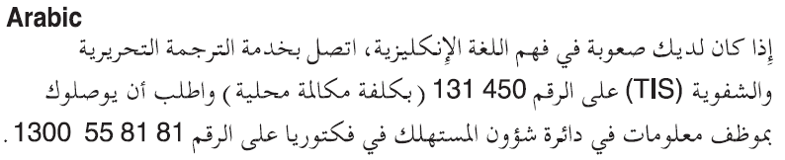
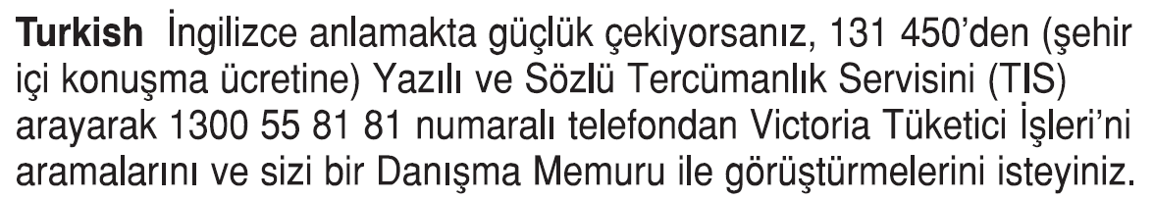
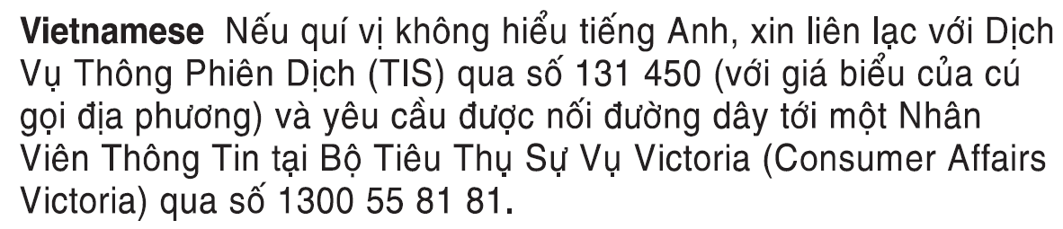
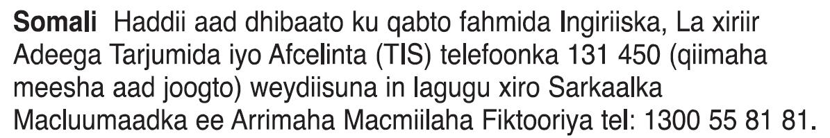
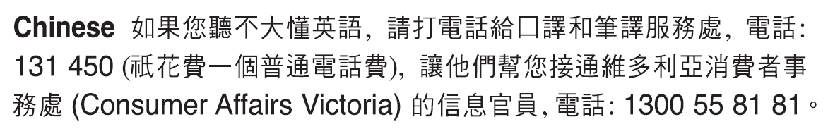
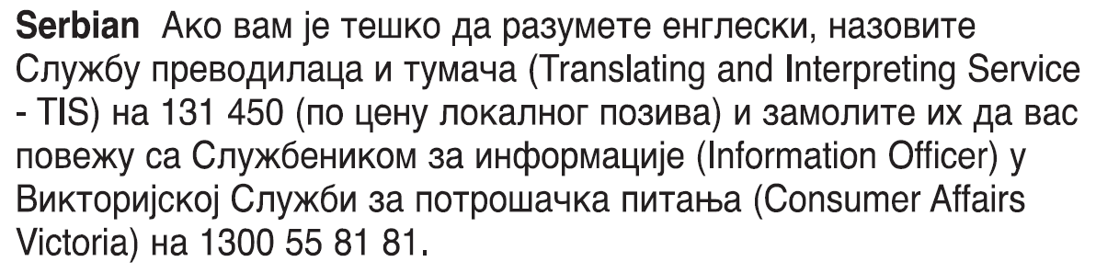
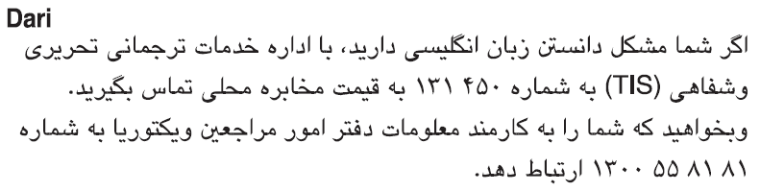
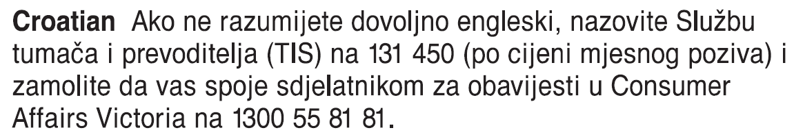
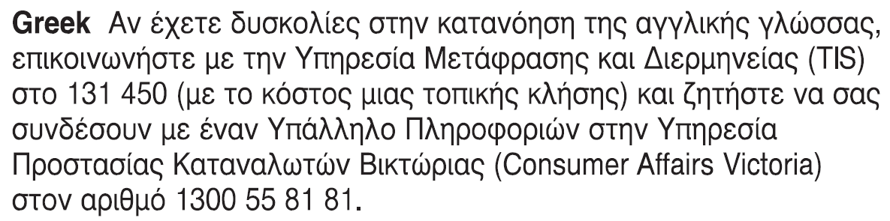
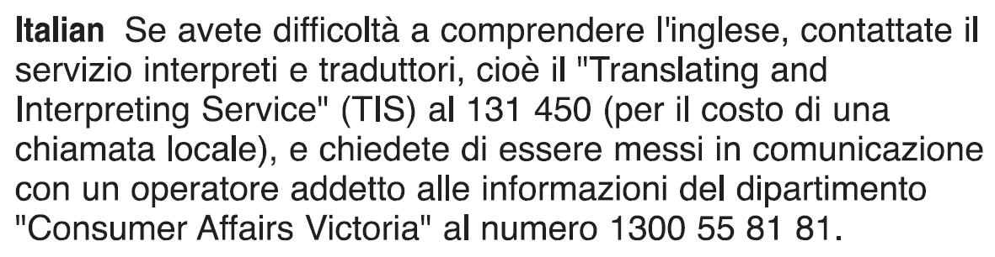 Information about renting is available in other languages at consumer.vic.gov.au/languages.

Notice of revocation SDA resident’s copy
Residential Tenancies Act 1997 s498DA

SDA resident details
- This notice is given to:
(resident/s name)
- A copy of this notice is also given to:
(if applicable, insert name and address of resident’s family member, carer, advocate, guardian, administrator or other chosen person)
- Regarding the SDA dwelling at:
(write address)
- Resident’s address:

SDA provider/mortgagee/owner details
- I am giving you this notice as:
(mark one only)
The SDA provider:
The mortgagee:
The owner:
- SDA provider/mortgagee/owner name:
(cannot be agent’s name)
- SDA provider/mortgagee/owner address for serving documents:
(can be an agent’s address)
- Contact telephone numbers for SDA provider/mortgagee/owner:
(can be agent’s telephone number)
Business hours:
After hours:

Revocation of registration or enrolment
- □ The SDA provider’s registration under the NDIS was revoked on:
(dd/mm/yyyy)
/ /
Or
□ The dwelling is no longer an SDA enrolled dwelling as of:
(dd/mm/yyyy)
/ /
- The SDA residency agreement will terminate on:
(dd/mm/yyyy)
/ /
This date must be 90 days from the date provided at 9.
- Signature of SDA provider, their authorised officer or agent:
- Name of SDA provider, their authorised officer or agent signing this notice:
- Date:
(dd/mm/yyyy)
/ /

Notice of revocation SDA resident support person’s copy
Residential Tenancies Act 1997 s498DA

SDA resident details
- This notice is given to:
(resident/s name)
- A copy of this notice is also given to:
(if applicable, insert name and address of resident’s family member, carer, advocate, guardian, administrator or other chosen person)
- Regarding the SDA dwelling at:
(write address)
- Resident’s address:

SDA provider/mortgagee/owner details
- I am giving you this notice as:
(mark one only)
The SDA provider:
The mortgagee:
The owner:
- SDA provider/mortgagee/owner name:
(cannot be agent’s name)
- SDA provider/mortgagee/owner address for serving documents:
(can be an agent’s address)
- Contact telephone numbers for SDA provider/mortgagee/owner:
(can be agent’s telephone number)
Business hours:
After hours:

Revocation of registration or enrolment
- □ The SDA provider’s registration under the NDIS was revoked on:
(dd/mm/yyyy)
/ /
Or
□ The dwelling is no longer an SDA enrolled dwelling as of:
(dd/mm/yyyy)
/ /
- The SDA residency agreement will terminate on:
(dd/mm/yyyy)
/ /
This date must be 90 days from the date provided at 9.
- Signature of SDA provider, their authorised officer or agent:
- Name of SDA provider, their authorised officer or agent signing this notice:
- Date:
(dd/mm/yyyy)
/ /

Notice of revocation SDA provider’s copy
Residential Tenancies Act 1997 s498DA

SDA resident details
- This notice is given to:
(resident/s name)
- A copy of this notice is also given to:
(if applicable, insert name and address of resident’s family member, carer, advocate, guardian, administrator or other chosen person)
- Regarding the SDA dwelling at:
(write address)
- Resident’s address:

SDA provider/mortgagee/owner details
- I am giving you this notice as:
(mark one only)
The SDA provider:
The mortgagee:
The owner:
- SDA provider/mortgagee/owner name:
(cannot be agent’s name)
- SDA provider/mortgagee/owner address for serving documents:
(can be an agent’s address)
- Contact telephone numbers for SDA provider/mortgagee/owner:
(can be agent’s telephone number)
Business hours:
After hours:

Revocation of registration or enrolment
- □ The SDA provider’s registration under the NDIS was revoked on:
(dd/mm/yyyy)
/ /
Or
□ The dwelling is no longer an SDA enrolled dwelling as of:
(dd/mm/yyyy)
/ /
- The SDA residency agreement will terminate on:
(dd/mm/yyyy)
/ /
This date must be 90 days from the date provided at 9.
- Signature of SDA provider, their authorised officer or agent:
- Name of SDA provider, their authorised officer or agent signing this notice:
- Date:
(dd/mm/yyyy)
/ /

