Written receipt for rent - SDA enrolled dwelling
Residential Tenancies Act 1997
s498ZE
SDA providers may use this form to provide a written receipt for rent paid.

How to use this form
- Complete each section.
- Sign the receipt.

How to provide this receipt
If payment is made in person, you must provide the receipt immediately.
If payment is not made in person and a receipt is requested at the time of payment, you must provide the receipt within five business days of receiving the payment.
If you send this receipt by post, you must take into account the extra days it takes for the notice to be delivered.
Australia Post has three different speeds for ordinary mail delivery – express, priority and regular mail, which may take up to six days. Priority and regular delivery speeds also apply for registered post.
You may wish to keep evidence of the mail delivery method you relied on to send this notice. For more information about Australia Post’s mail delivery options and times, visit the Australia Post website (auspost.com.au).
You can only send this receipt by email if you already have the SDA resident’s written consent to receive notices and other documents this way.
The SDA resident may have given consent in the SDA residency agreement or separately in writing. A consent form is available from the Forms and publications section – Consumer Affairs Victoria website (consumer.vic.gov.au/forms).
If you send this receipt by email, the provisions of the Electronic Transactions (Victoria) Act 2000 apply. For legal purposes, the time when a notice is received is when it can be retrieved from the email address the recipient nominated.

Telephone Interpreter Service
If you have difficulty understanding English, contact the Translating and Interpreting Service (TIS) on 131 450 (for the cost of a local call) and ask to be put through to an Information Officer at Consumer Affairs Victoria on
1300 55 81 81.
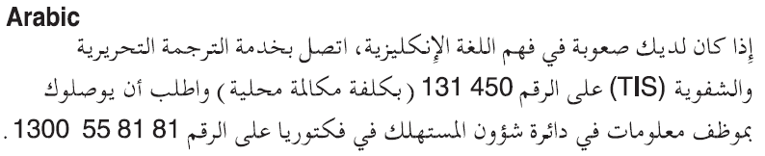
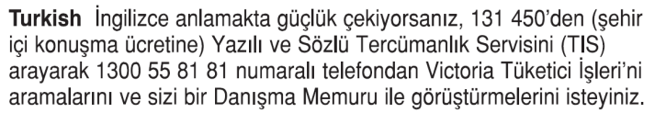
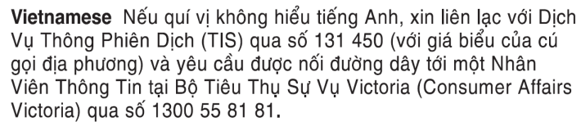
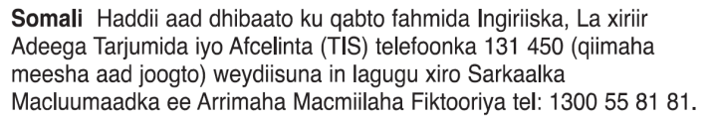
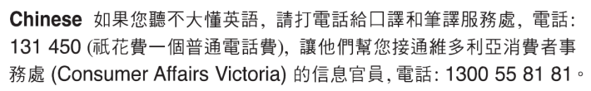
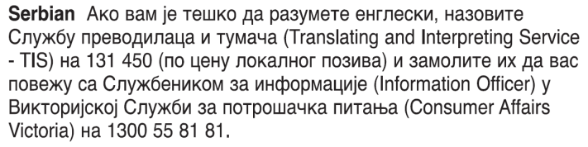
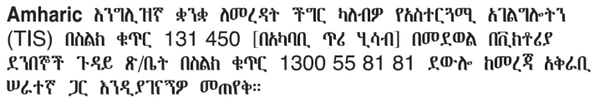
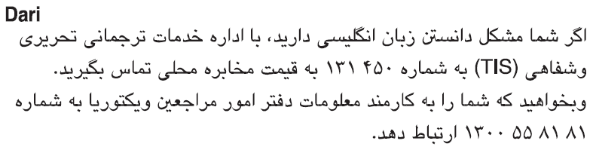
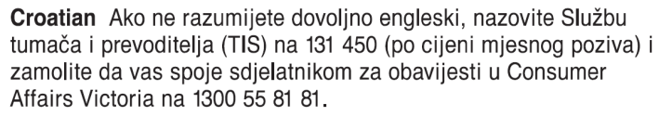
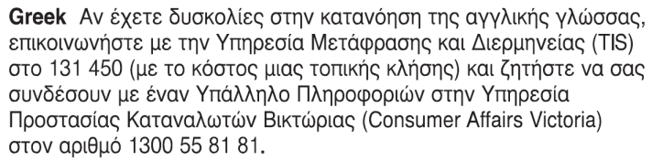
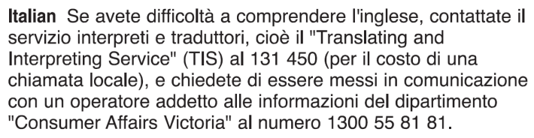
Information about renting is available in many languages at consumer.vic.gov.au/languages.

Written receipt for rent - SDA enrolled dwelling

Date rent received: / /
(dd/mm/yyyy)
SDA resident:
(Name)
SDA enrolled dwelling:
(Address)
Rent payment for:  (dd/mm/yyyy) | / / to / /
Amount paid:
$
Paid by:
(Name of SDA resident or another person)
Payment method: | Centrepay  Cash  Cheque  Electronic funds transfer  Direct debit
SDA provider or agent:
(Name)
Signature:
(SDA provider or agent’s signature)

