Information privacy complaint

This form is to assist you in making a complaint about the handling of personal information under the Privacy and Data Protection Act 2014 by Consumer Affairs Victoria.
For the protection of everyone’s privacy we can accept only complaints made by the person involved – or an authorised representative. Therefore, if you want to complain on behalf of another person please provide a proof of your authority to do so.
To assist our staff, it is important that all the required information is legible. If more space is needed, please attach additional pages. Use of this form, however, is optional.

How to lodge this complaint
If you cannot resolve the problem, please complete all pages of the complaint form and lodge it with CAV.
Scan and email the form and supporting documentation to consumer@justice.vic.gov.au or post to:
Privacy Coordinator
Consumer Affairs Victoria GPO Box 123
Melbourne VIC 3001

What happens next?
Consumer Affairs Victoria will contact you regarding this complaint.

Privacy
Consumer Affairs Victoria collects and handles your personal information consistent with the requirements of the Privacy & Data Protection Act 2014. Where you do not provide the information required by this form, we may refuse or be unable to process this transaction. We may need to disclose your personal information to other State and Commonwealth Agencies, a review body or a court. For more information, view the Privacy statement page on the Consumer Affairs Victoria website (consumer.vic.gov.au/privacy).

Telephone Interpreter Service
If you have difficulty understanding English, contact the Translating and Interpreting Service (TIS) on 131 450 (for the cost of a local call) and ask to be put through to an Information Officer at Consumer Affairs Victoria on 1300 55 81 81.
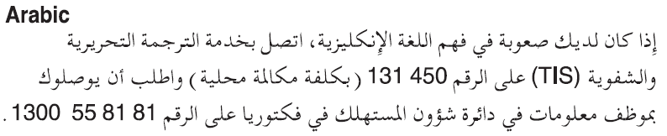
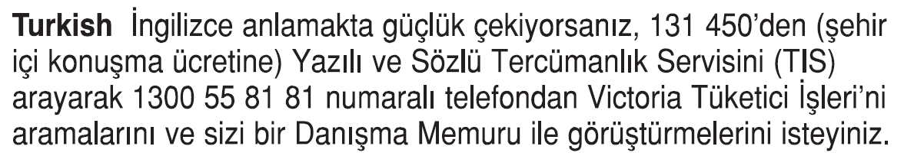
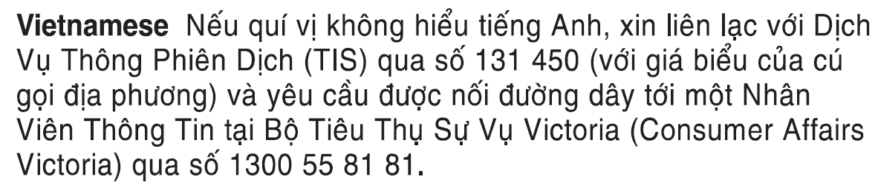
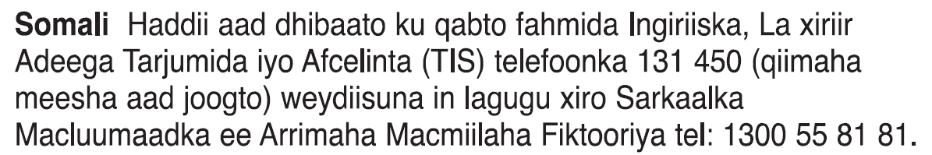
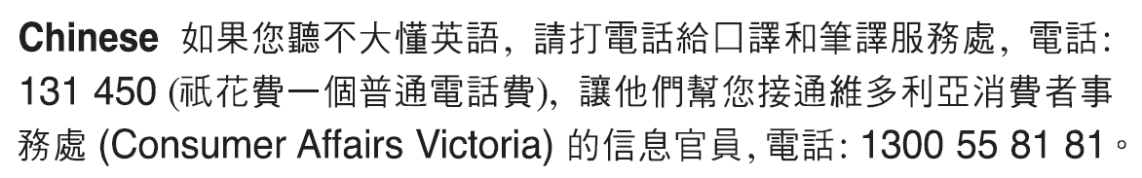
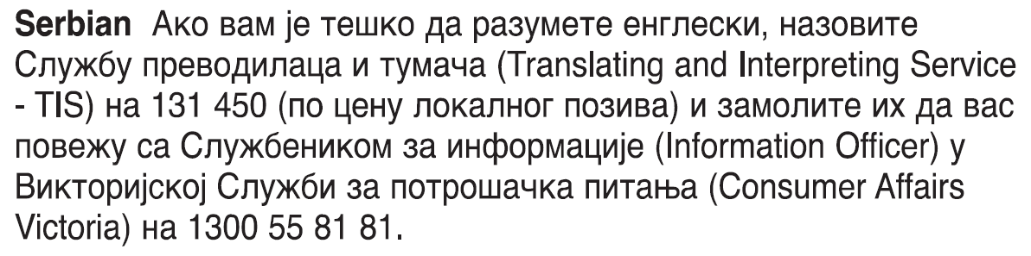

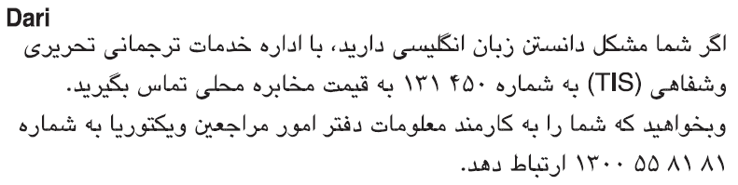
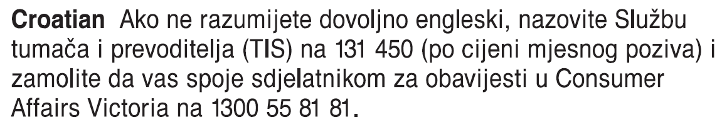
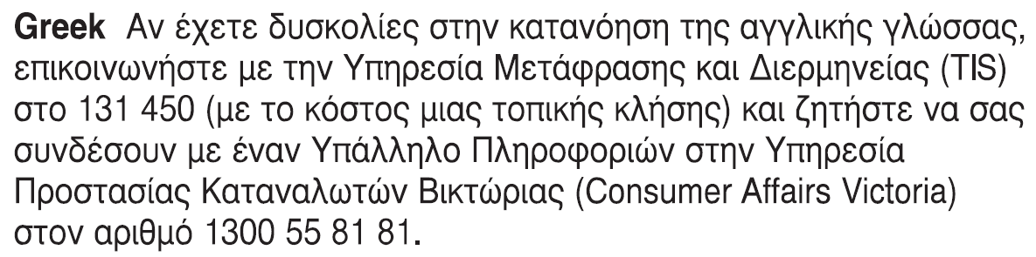
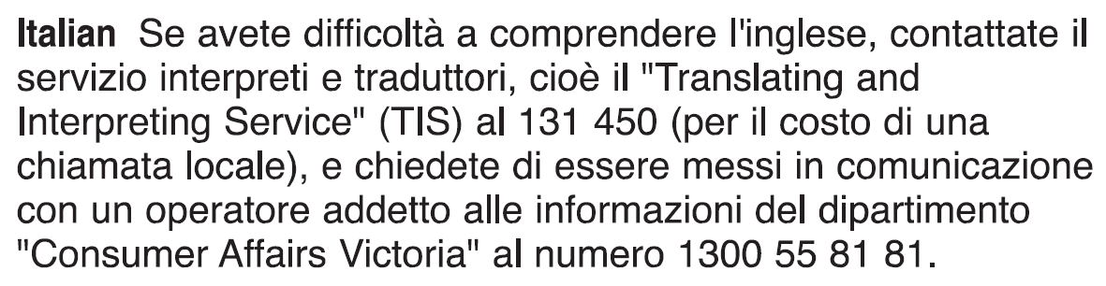

- Your details
Title
Family name
Given names
Street address
Suburb
Postcode
Daytime telephone number
Email address
Are you making a complaint on behalf of someone else?
Yes |  |  | No – go to question 2
Name of person
Your relationship to that person
Please attach written proof of your authorisation to make a complaint on behalf of this person.
- Do you require an interpreter?
Yes |  |  |  |  | No
If yes, specify language
- What/who are you complaining about?
I am complaining about the handling of my personal information by Consumer Affairs Victoria. The person I believe to be responsible is
I do not know/am not sure who is responsible
What involvement have you had with Consumer Affairs Victoria?
If there are more agencies/individuals you are complaining about, please provide the details on a separate page.
- Your complaint
How do you believe that your privacy has been breached?
Please describe briefly how, in your view, your privacy has been breached. What happened, where did it happen, when did it happen, and who did it? Please give us as many details as you can recall.
When did you find out about the breach?
What impact has the breach had on you?
- Documents
Please give us copies (not the originals) of any documents that may help us to investigate your complaint (for example, any correspondence or records of conversations you have had with the area involved). Please submit these with the form.
- Signature
I declare that the above information is true and correct to the best of my knowledge. I agree that the information I have given in this form may be used or disclosed by Consumer Affairs Victoria to process this complaint.
Signature
Date | / /

