Application to Director
Residential Tenancies Act 1997 (the Act)
SDA residents may use this form to apply to the Director of Consumer Affairs Victoria to investigate:
- the need for non-urgent repairs
- a rent increase proposed by the SDA provider.

How to use this form
- Identify the reason you are applying in part 1. If your application is about a rent increase, you must apply to the Director within 30 days of receiving the notice of rent increase.
- Complete parts 2 to 5.
- If you provide other documents, attach them to the notice and circle ‘Yes’ in box 6.
- Sign at part 7.
- Send a completed copy of the form to the Director.

How to lodge this application
You can:
- Email this form and attachments to: renting@justice.vic.gov.au
- Post this form and attachments to:
Consumer Affairs Victoria GPO Box 123
Melbourne VIC 3001
Remember to attach a copy of all documents you have given to the SDA provider or the SDA provider has given to you.
If you send this notice by post, you must take into account the extra days it takes for the notice to be delivered. Australia Post has three different speeds for ordinary mail delivery – express, priority and regular mail, which may take up to six days. Priority and regular delivery speeds also apply for registered post.
You may wish to keep evidence of the mail delivery method you relied on to send this notice. For more information about Australia Post’s mail delivery options and times, visit the Australia Post website (auspost.com.au).
If you send this notice by email, the provisions of the Electronic Transactions (Victoria) Act 2000 apply. For legal purposes, the time when a notice is received is when it can be retrieved from the email address the recipient nominated.
To help calculate the total minimum days to allow, depending on the notice period required and the method of delivery, visit the Giving notices – Residential Tenancies List page on the Victorian Civil and Administrative Tribunal website (vcat.vic.gov.au/resources/giving-notices-residential-tenancies-list).

Where to get help
If you need help with this notice, visit the Specialist disability accommodation section – Consumer Affairs Victoria website (consumer.vic.gov.au/sda) or call Consumer Affairs Victoria on 1300 40 43 19.

Telephone Interpreter Service
If you have difficulty understanding English, contact the Translating and Interpreting Service (TIS) on 131 450 (for the cost of a local call) and ask to be put through to an Information Officer at Consumer Affairs Victoria on 1300 55 81 81.
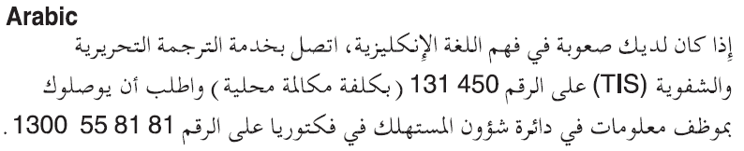
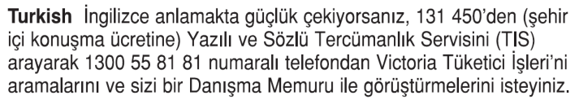
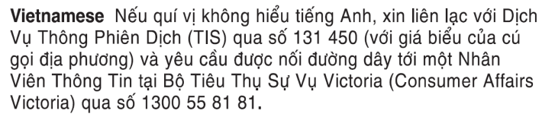
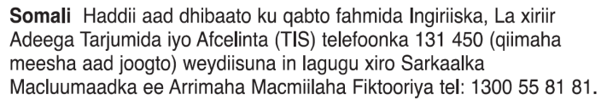
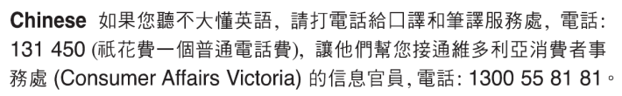
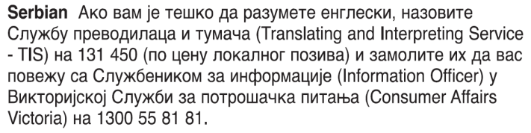
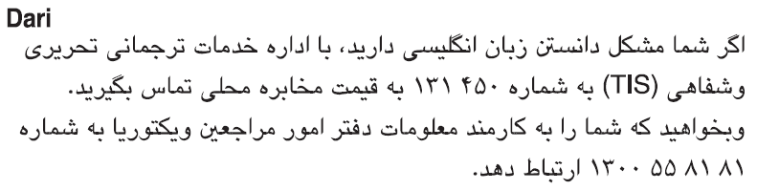
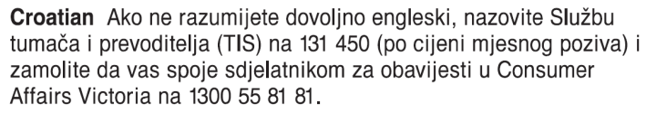
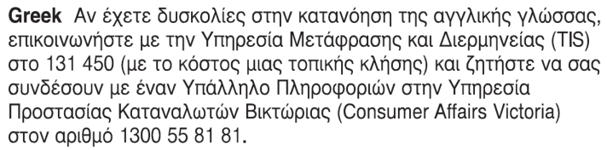
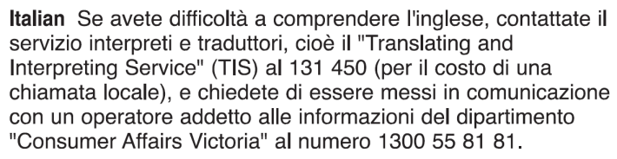
Information about renting is available in other languages at consumer.vic.gov.au/languages.

Application to director

1. What is this application for?
(select the reason and include further details in the box below)

Need for non-urgent repairs (s498R)
I have given the SDA provider written notice advising them that non-urgent repairs are required. The SDA provider has not carried out the repairs within 14 days of being given the notice.
Repair | Date requested  (dd/mm/yyyy) | Details
 | / /
 | / /
 | / /

Excessive rent increase (s498ZG)
I have received a notice of a rent increase and I consider the proposed amount to be excessive.
Current rent amount | Proposed rent amount | Date notice of rent increase given
$ | $ | / /  (dd/mm/yyyy)

2. SDA resident details
Resident’s name:
Regarding the SDA enrolled dwelling at:
(write address)
Address for serving documents:
(if the same as the SDA enrolled dwelling, write ‘as above’)
Resident’s contact telephone numbers
Business hours
After hours

3. SDA provider details
Name:
SDA provider’s address:

4. Service details
This notice is given:
(Mark one method only and if posted, add the delivery speed)
By hand:
By registered post:
By ordinary post:
By email:
Insert email address:
(if applicable)
On:  (dd/mm/yyyy) | / /

5. Application
I am applying to you to investigate the following:
(write the reason you selected in question 1 and include further details in the box below)

6. Reasons
Have you attached documents as evidence? Yes / No

7. Resident’s signature

