SDA Resident request for new agreement under Schedule 4
Residential Tenancies Act 1997, Part 12A, Schedule 4, Part 3, Division 3, Clause 10
_____________________________________________________________________________________________________
Part A -- Information for SDA Resident

Who can use this form
Use this form if you are an SDA resident and your SDA residency agreement has been validated under Part 2 of Schedule 4, to notify your SDA provider that you would like to enter into or establish a new agreement.

Only use this form if Schedule 4 applies to your SDA residency agreement

How to use this form

Before you complete this form, you must choose whether you would like to enter into or establish a new:
- SDA residency agreement; or
- Residential rental agreement

Make sure you understand the difference between the two types of agreements and your rights and responsibilities under each. Read Main differences between the types of agreements - Consumer Affairs Victoria

Once you have chosen the type of agreement, make sure you:
- complete all parts of the form.
- sign the form.
- give the completed form to your SDA provider. You can keep a copy for yourself.

How to serve this form
Deliver the notice in Part B to you SDA provider
You can give this form to your SDA provider at any time, as long as you have not terminated your agreement.
It can be delivered by hand or mail, or by email if you have the provider’s written consent to receive documents in that way.
Telephone Interpreter Service
If you have difficulty understanding English, contact the Translating and Interpreting Service (TIS) on 131 450 (for the cost of a local call) and ask to be put through to an Information Officer at Consumer Affairs Victoria on
1300 40 43 19.

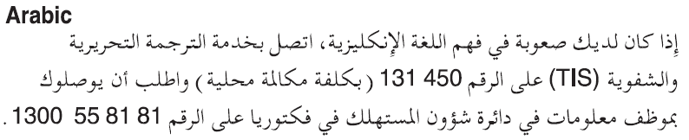
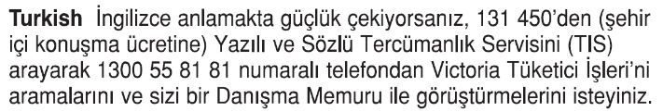
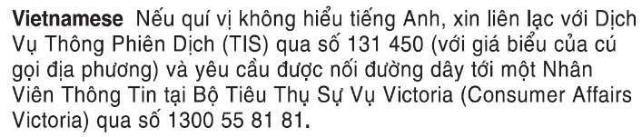
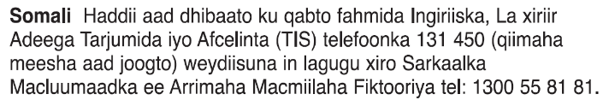
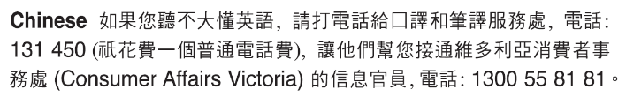
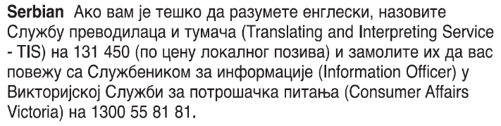

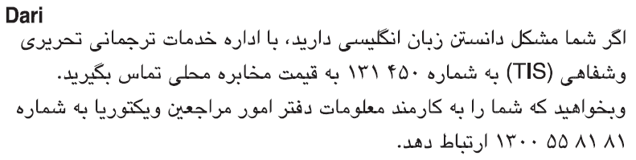
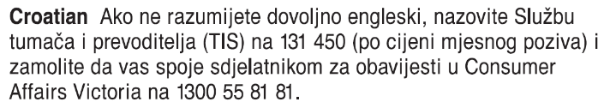
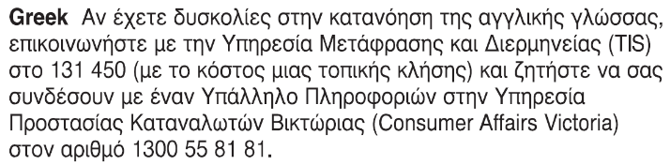
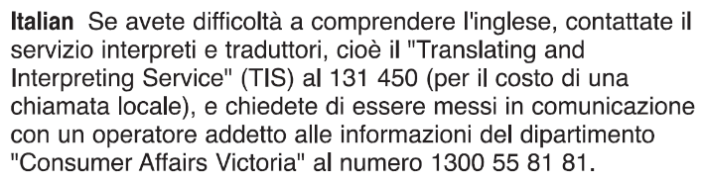
Information about renting is available in other languages at consumer.vic.gov.au/languages.
Part B – Notice SDA Provider’s copy

SDA Resident request for new agreement under Schedule 4
Residential Tenancies Act 1997, Part 12A, Schedule 4, Part 3, Division 3, Clause 10
_____________________________________________________________________________________________________

SDA provider details
This request is given to:

- SDA provider’s name:

- SDA provider’s address: (can be an agent’s address)
Postcode

SDA resident details
This request is given by:

- SDA resident’s name:

- If the request is given on behalf of the resident by the resident’s guardian or administrator:
(Name of guardian or administrator)

- Residing at the SDA dwelling at: (write address)
Postcode

- SDA resident’s contact details (email and/or telephone number):

Selected new agreement
- Resident’s choice
(select the applicable option)
I make this request to enter into or establish a new (select one of the following):
☐ SDA residency agreement
☐ Residential rental agreement

Service details
- This request is given:
(mark one method)
By hand:
(insert the name of receiver)
By registered post:
By ordinary post:
By email:
(insert email address)
On:  (dd/mm/yyyy) | / /

- Signature of SDA resident:
(or guardian or administrator if applicable)

