Transfer of residency right (caravan)
Residential Tenancies Act 1997 Section 195

Warning: Enter text in spaces provided only. This form will be invalid if you remove or change any questions or other text.

Important information
- The transfer of a caravan residency right can only occur if the purchaser will reside in the caravan.
- Consent to this transfer will be deemed to be given if the caravan park owner/agent does not consent or refuses to consent within 7 days of being given this form. If posted, the notice is taken to have been given on the third business day after posting.
- The caravan park owner/agent must not unreasonably withhold consent to this transfer. The resident has the right to apply to the Victorian Civil & Administrative Tribunal to challenge an unreasonable refusal.
- The caravan park owner/agent must not charge a fee for consenting to this transfer.

Telephone Interpreter Service
If you have difficulty understanding English, contact the Translating and Interpreting Service (TIS) on 131 450 (for the cost of a local call) and ask to be put through to an Information Officer at Consumer Affairs Victoria on 1300 55 81 81.

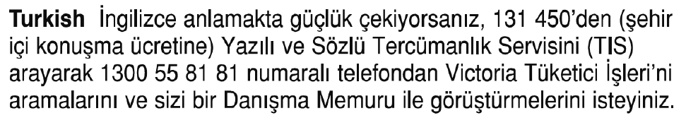
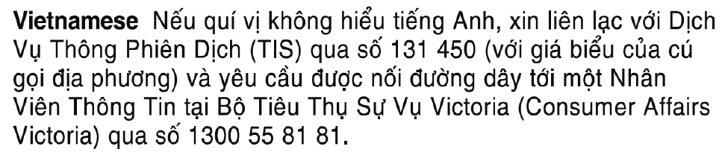

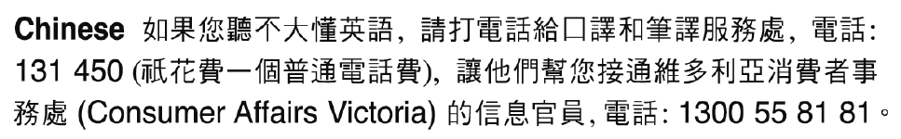
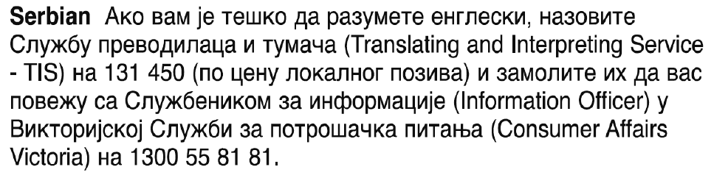

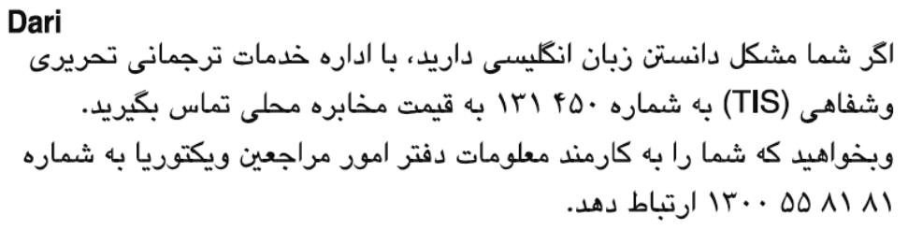

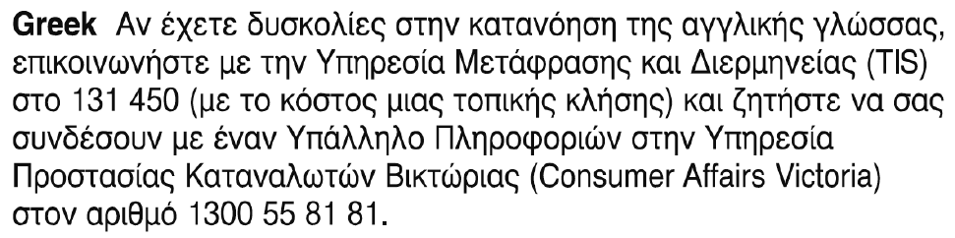
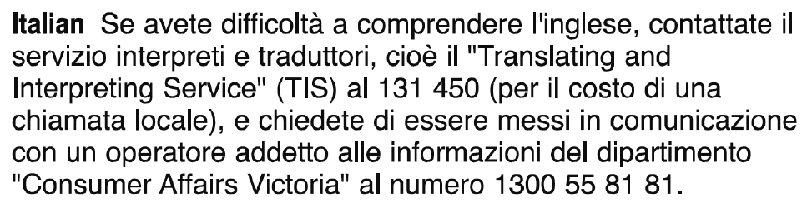

Transfer of residency right (caravan) Seller’s copy

From

To be completed by current resident (seller)
Full name of current resident (seller):

Name of caravan park:
Address of caravan park:
Postcode:
Site number:
I have arranged for the sale of my caravan which is located on the above site and request the caravan park owner/agent to consent to the transfer of my residency right to the purchaser.
Signature of current resident (seller):
Date: | / /

To be completed by future resident (purchaser)
Full name of future resident (purchaser):
Full names of other people who will reside in this caravan:
I declare that I will reside in the above caravan.
Signature of future resident (purchaser):
Date: | / /

To

To be completed by caravan park owner/agent
The caravan park owner/agent is requested to consent to the transfer of residency right as outlined in this form.
Tick applicable box
I consent to the transfer of residency right:

I do not consent to the transfer of residency right:
Reason:
Signature of caravan park owner/agent:
Printed name:
Date:
/ /

Completed form instructions
Original – To be retained by current resident (seller)
Duplicate – To be retained by future resident (purchaser)
Triplicate – To be retained by caravan park owner/agent

Transfer of residency right (caravan) Purchaser’s copy

From

To be completed by current resident (seller)
Full name of current resident (seller):

Name of caravan park:
Address of caravan park:
Postcode:
Site number:
I have arranged for the sale of my caravan which is located on the above site and request the caravan park owner/agent to consent to the transfer of my residency right to the purchaser.
Signature of current resident (seller):
Date: | / /

To be completed by future resident (purchaser)
Full name of future resident (purchaser):
Full names of other people who will reside in this caravan:
I declare that I will reside in the above caravan.
Signature of future resident (purchaser):
Date: | / /

To

To be completed by caravan park owner/agent
The caravan park owner/agent is requested to consent to the transfer of residency right as outlined in this form.
Tick applicable box
I consent to the transfer of residency right:

I do not consent to the transfer of residency right:
Reason:
Signature of caravan park owner/agent:
Printed name:
Date:
/ /

Completed form instructions
Original – To be retained by current resident (seller)
Duplicate – To be retained by future resident (purchaser)
Triplicate – To be retained by caravan park owner/agent

Transfer of residency right (caravan) Owner/agent’s copy

From

To be completed by current resident (seller)
Full name of current resident (seller):

Name of caravan park:
Address of caravan park:
Postcode:
Site number:
I have arranged for the sale of my caravan which is located on the above site and request the caravan park owner/agent to consent to the transfer of my residency right to the purchaser.
Signature of current resident (seller):
Date: | / /

To be completed by future resident (purchaser)
Full name of future resident (purchaser):
Full names of other people who will reside in this caravan:
I declare that I will reside in the above caravan.
Signature of future resident (purchaser):
Date: | / /

To

To be completed by caravan park owner/agent
The caravan park owner/agent is requested to consent to the transfer of residency right as outlined in this form.
Tick applicable box
I consent to the transfer of residency right:

I do not consent to the transfer of residency right:
Reason:
Signature of caravan park owner/agent:
Printed name:
Date:
/ /

Completed form instructions
Original – To be retained by current resident (seller)
Duplicate – To be retained by future resident (purchaser)
Triplicate – To be retained by caravan park owner/agent

