

Consumer Affairs Victoria

Report on Operations 2014-15

Making markets fair

Dear Minister
In accordance with the Australian Consumer Law and Fair Trading Act 2012, the Credit (Administration) Act 1984 and the Veterans Act 2005, I have pleasure in submitting the Consumer Affairs Victoria Report on Operations for the year ended 30 June 2015, for you to present to the Houses of Parliament.
Yours sincerely
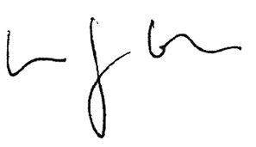
Simon Cohen
Director
Consumer Affairs Victoria

The Hon. Jane Garrett MP
Minister for Consumer Affairs, Gaming and Liquor Regulation

Director’s Foreword

I am pleased to present the Consumer Affairs Victoria (CAV) Report on Operations 2014-15, demonstrating another year of achievement in ensuring a fair and competitive marketplace in Victoria.
The report provides information about the advice and services we have provided to hundreds of thousands of Victorian consumers, businesses, tenants and landlords. We also report on the significant compliance and enforcement actions taken to promote business conformance with consumer protection laws. In addition, we record the registration and licensing transactions that enable the effective operations of businesses and associations. In all, we have provided close to one million discrete services to the Victorian community.
The Report on Operations reflects our focus in providing digital services. Almost three million visits to our website, and thousands of downloads of our apps demonstrate the demand for effective online regulation services. These complement our increasing use of social media to inform consumers, businesses, tenants and landlords of their rights and responsibilities. We continue to maintain a digital first approach to all our communications.
And at the pointy end, we have focused on using the full range of regulatory tools, including undertakings and court actions, to address serious wrong conduct by businesses and significant breaches of consumer protection laws.
In addition to these activities, we have taken a lead in ensuring an effective consumer protection framework, through activities such as our Better Business Initiative and by leading a national credit card chargebacks project.
In June 2015, Consumer Affairs Minister Jane Garrett launched Fairer, Safer Housing, an initiative which centres on a review of the Residential Tenancies Act 1997, the primary consumer protection law for Victorians living in rental housing. We are extremely pleased to lead this review, and the response to our initial consultation paper, Laying the Groundwork, has demonstrated the strong interest of the Victorian community in this important work.
The Report on Operations provides data to the community about our services. The Report is complemented by our first Year in Review, available on the CAV website. The Year in Review has more detailed information about individual cases and activities in a digital format, to provide Victorians a full and accessible picture of CAV and our role. The Year in Review can be viewed at the Annual report page on the Consumer Affairs Victoria website <www.consumer.vic.gov.au/annualreport>.
March 2015 marked the departure of CAV’s longest-serving Director, Dr Claire Noone. Claire’s expertise in regulation and unwavering passion for supporting a fair marketplace in Victoria has left an indelible mark on our organisation. The achievements detailed in the Report on Operations and in our Year in Review are a testament to Claire’s commitment and success. It is also important that I acknowledge the great leadership of Phil D’Adamo and Elizabeth Lanyon, who acted in the Director role following Claire’s departure until I commenced on 31 August 2015.
The Report on Operations also reflects the commitment and passion of our staff across Victoria in ensuring businesses, consumers, tenants and landlords know about and play by the rules.
Our team has provided an outstanding service to the community in the past year.
Simon Cohen
Director
Consumer Affairs Victoria

Contents
Director’s Foreword 3
About us 6
Our vision 6
Our goals 6
Our functions 6
Our regulatory approach 6
1 Our performance 7
Performance against Budget Paper Number 3 (BP3 targets) 7
2 Businesses are compliant with consumer laws 10
Registers administered by Consumer Affairs Victoria 11
Parties signed to enforceable undertakings 13
Court and tribunal matters 13
Ongoing court matters as at 30 June 2015 14
3 Victorians exercise their consumer rights 16
4 A fair and safe rental market for Victorians 17
5 A modern and effective consumer law framework 18
Acts and regulations passed 18
Legislation administered by Consumer Affairs Victoria as at 30 June 2015 19
6 A sustainable and innovative regulator 21
Reducing red tape 21
Trust funds managed by Consumer Affairs Victoria 21
Grants approved 22
Financial information 2014-15 23
Consumer Affairs Victoria 25
Ordered to be published
Victorian Government Printer
October 2015
PP No 84, Session 2014-15

About us

Our vision
A fair and competitive marketplace in Victoria

Our goals
- Businesses are compliant with consumer laws
- Victorians exercise their consumer rights
- A fair and safe rental market for Victorians
- A modern and effective consumer law framework
- A sustainable and innovative regulator

Our functions
Consumer Affairs Victoria is the state’s consumer affairs regulator. Our role is to:
- review and advise the Victorian Government on the consumer protection framework
- provide information and advice to consumers, tenants, businesses and landlords on their rights, responsibilities and changes to relevant laws
- register and license businesses and occupations
- enforce and ensure compliance with consumer laws.
We provide administrative support to several statutory offices and bodies including the Business Licensing Authority, the Estate Agents Council, the Motor Car Traders Claims Committee and the Residential Tenancies Bond Authority, as well as supporting Consumer Affairs ministerial advisory roles.

Our regulatory approach
When businesses comply, consumers are protected. This knowledge guides the way we regulate. We use an integrated compliance approach to ensure businesses comply with consumer laws, and to promote a thriving Victorian economy.
Integrated compliance is about using all our tools effectively. We:
- provide compliance information to businesses so that they understand their obligations and the consequences of not meeting them
- work with industry partners to achieve compliance. This means working with our colleagues in other jurisdictions, as well as organisations who are working towards similar outcomes. By doing so, we can improve the way we provide information to businesses and better target groups with specialised information needs
- provide information to consumers and tenants to help them assert their rights in a dispute, thus holding businesses to account for compliance.
We use compliance tools to monitor businesses, stop misconduct and prevent future breaches. We take a risk-based approach to compliance monitoring, targeting those that pose the highest risk to Victorians.
For the most serious matters or systemic non-compliance, we take enforcement action to put a stop to, and deter, unlawful conduct.

1 Our performance
This report contains important statistical and factual information about our activity as required under the Australian Consumer Law and Fair Trading Act 2012, the Credit (Administration) Act 1984 and the Veterans Act 2005. For a more comprehensive account of our performance against our goals, see the Year in Review at the Annual report page on the Consumer Affairs Victoria website <www.consumer.vic.gov.au/annualreport>.

Performance against Budget Paper Number 3 (BP3 targets)
This section reports on our performance against BP3 targets specified for Consumer Affairs Victoria in the 2014-15 Victorian Budget. For budget purposes, outputs are defined as those goods and services provided to government by departments, agencies, statutory bodies and through funding provided to others, such as community agencies. The table below reports actual performance against targets for each output measure.
Corresponding data for the two previous financial years is also included.
 | Unit of measure | 2012-13 Actual | 2013-14 Actual | 2014-15 Target | 2014-15 Actual
Quantity
Information and advice provided through telephone service (1) | number | 409,936 | 390,349 | 375,000 | 352,369
Information and advice provided through other services including written correspondence, face-to-face and dispute assistance (2) | number | 84,659 | 133,729 | 140,000 | 129,430
Inspections, compliance monitoring and enforcement activitiess (3) | number | 9,749 | 10,588 | 12,000 | 11,344
Transactions undertaken: registration and licensing transactions | number | 61,378 | 67,520 | 69,500 | 70,679
Transactions undertaken: Residential Tenancies Bond Authority (RTBA) | number | 406,535 | 419,135 | 448,000 | 432,569
Quality
Customer satisfaction with services provided (4) | per cent | 94.0 | 93.2 | 90.0 | 95.6
Timeliness
Services provided within agreed timeframes | per cent | 90.1 | 86.2 | 90.0 | 90.5
Cost
Total output cost (5) | $ million | 90.4 | 80.8 | 123.4 | 119.1
Commentary on performance
- The actual is below the target due to an increased focus on directing contacts to the CAV website rather than the telephone service.
- The actual is below the target due to a reduction in the number of conciliations as consumers increasingly resolve their own disputes by using information available on the CAV website.
- The actual is below the target due to a lower than anticipated increase in market monitoring activity. This was offset by increases in inspections conducted and infringement notices issued.
- The actual is above the target and is reflective of the high satisfaction levels of people served by CAV through the Information and Dispute Services Centre (IDSC) and Regulatory Transactions Centre (RTC) according to a customer satisfaction survey.
- The Total output cost is higher in 2014-15 largely due to the inclusion of payments for the Victorian Civil and Administrative Tribunal in relation to the Residential Tenancies List, Domestic Building List, and the Owners Corporations List from Consumer Affairs Victoria managed trust funds ($16.5 million). These costs were included as part of the Courts budget output prior to the establishment of Court Services Victoria. In addition, there was a $19 million increase in 2014-15 of grant payments from the Victorian Property Fund to support affordable housing.

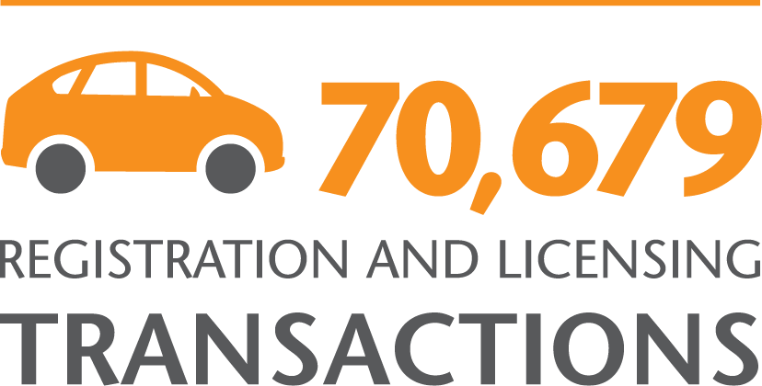

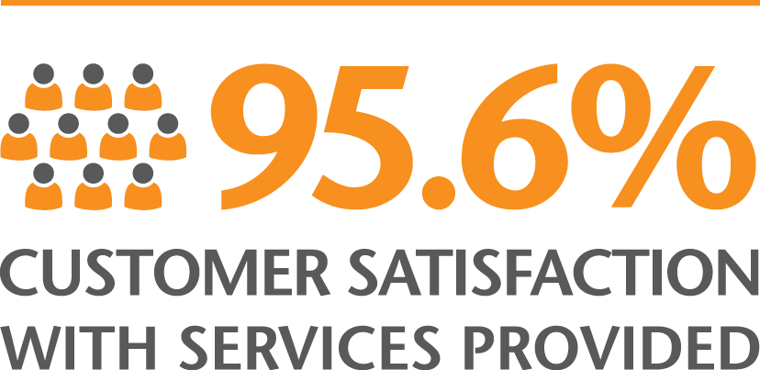



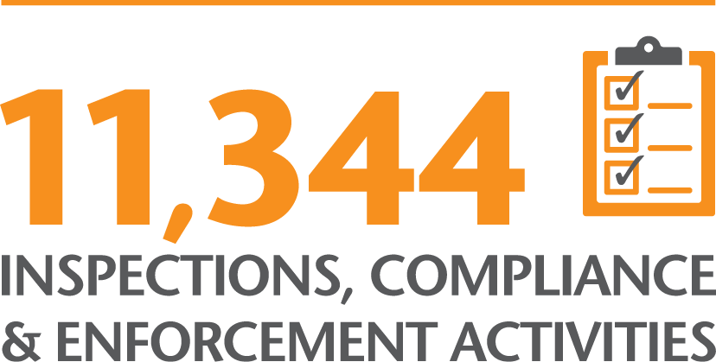

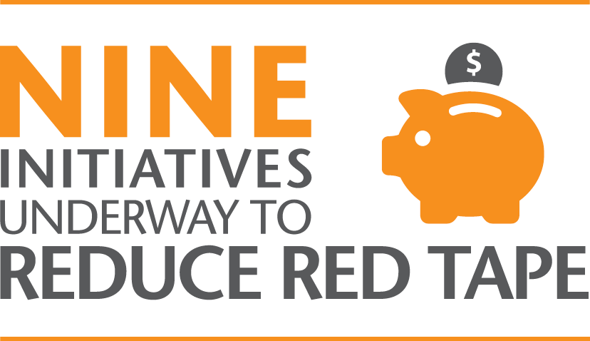

2 Businesses are compliant with consumer laws
The key to achieving a fair and competitive marketplace is ensuring that businesses comply with consumer laws.
We focus on achieving high levels of business compliance by working with industry and partner organisations, and with consumers so that they effectively assert their consumer rights. We continue to support businesses by providing them with tools that help them to meet their obligations.
Our risk-based approach to compliance means that we act quickly against those causing most harm, protecting consumers earlier, more efficiently and more effectively.
The data provided in the table below varies between years based on our regulatory risk priorities, government policy, the nature of our compliance programs, and the cyclical nature of our integrated compliance approach.
 | 2012-13 | 2013-14 | 2014-15
Compliance
Compliance assistance site visits | 4,434 | 4,671 | 4,433
Inspections | 2,702 | 2,713 | 3,470
Investigations (1) | 573 | 610 | 161
Market monitoring activity | N/A | 895 | 802
Businesses engaged through the Better Business Initiative | N/A | 51 | 80
Enforcement
Prosecutions finalised | 33 | 24 | 21
Civil actions finalised | 61 | 64 | 66
Parties signed to enforceable undertakings | 30 | 15 | 17
Registrations and licensing
Annual returns, updates or cancellations processed for incorporated associations, fundraisers and co-operatives | 33,679 | 39,014 | 36,243
Total registration and licensing transactions | 61,378 | 67,520 | 70,679
- Investigations are lower in 2014-15 due to revised investigations procedures aimed at capturing evidence and information (for example, use of statutory notices).

Registers administered by Consumer Affairs Victoria
 | 2012-13 | 2013-14 | 2014-15
Estate agents
New applications lodged | 1,079 | 1,219 | 1,216
Total on register | 10,565 | 11,171 | 11,679
Motor car traders
New applications lodged | 173 | 177 | 149
Total on register | 2,243 | 2,188 | 2,127
Incorporated associations
New applications lodged | 1,599 | 1,695 | 1,980
Total on register | 38,751 | 39,883 | 39,665
Co-operatives
New applications lodged | 5 | 10 | 25
Total on register | 655 | 630 | 602
Fundraisers
New registrants | 507 | 771 | 657
Renewals | 491 | 168 | 281
Total on register | 1,961 | 2,191 | 2,265
Second-hand dealers and pawnbrokers
New applications lodged | 345 | 436 | 350
Total on register | 4,526 | 4,385 | 4,120
Patriotic funds
New applications lodged | 2 | 5 |  | 6
Total on register | 604 | 602 |  | 600
Limited partnerships
New applications lodged | 63 | 29 |  | 16
Total on register | 256 | 271 |  | 286
Conveyancers
New applications lodged | 80 | 80 |  | 92
Total on register | 730 | 712 |  | 768
Owners corporation managers
New applications lodged | 78 | 88 |  | 74
Total on register | 570 | 602 |  | 621
Retirement villages
New applications lodged | 6 | 6 |  | 12
Total on register | 409 | 415 |  | 426
Funeral service providers
New applications lodged | 24 | 12 |  | 10
Total on register | 407 | 415 |  | 424
Sex work service providers (licensees)
New applications lodged | 13 | 21 |  | 10
Total on register | 139 | 130 |  | 133
Sex work brothel managers
New applications lodged | 187 | 195 |  | 178
Total on register | 746 | 756 |  | 710
Sex work providers (exempt)
New applications lodged | 232 | 327 |  | 326
Total on register | 600 | 609 |  | 651

Parties signed to enforceable undertakings

Australian Consumer Law (Victoria)
Freeway Fitness Pty Ltd
Kristian Nathan Woods
Real Wealth Australia Pty Ltd
Helen Connie Collier-Kogtevs
Get off Drugs Naturally Foundation Inc
Dr Nerida James
H2Coco Pty Ltd
David Freeman
Solarex Australia Pty Ltd
Ali Syed
Mohammed Syed
Standby Savers Pty Ltd
Marcus Munro Hickey
Accrue Property Pty Ltd
James Allan Monaghan

Estate Agents Act 1980
Taylors Real Estate Agents Pty Ltd
Enzo Bufano

Court and tribunal matters

Prosecutions finalised

Australian Consumer Law (Victoria)
Yuting Wang
Keat Enterprises Pty Ltd
Yuting Wang (appeal against sentence)

Domestic Building Contracts Act 1995
Anthony Jakupi
Jakupi Excavations Pty Ltd

Motor Car Traders Act 1986
Emrah Sen
Mustapha Ali Ali
Shefket Idrizi
Cars National Pty Ltd
Melbourne Autohaus Pty Ltd
Alexsandar Jovanovski
Eray Sahin
Maurizio Duchini
Khaled El Mohamed

Estate Agents Act 1980
Kian Meng (Dennis) Ong
Colin Rounds
Suzanne Zvizdalo
Boris Real Estate Pty Ltd
Konstantinos Balasis (appeal against sentence)

Residential Tenancies Act 1997
City Hostels Pty Ltd
Mandy Le

Civil proceedings (including disciplinary inquiry)

Estate Agents Act 1980
Afif Shaba
Christine Parsons
Quoc Hung Ly
G L Lee Real Estate Pty Ltd
Baycrown Management Pty Ltd
Terry Pak Kwai Choe
Matthew White
Frank Flanagan
Sunnymac Pty Ltd
Craig Alan McIntosh
Anthony Vito Brancatella
Benjamin David Chislett
Benny Bull Pty Ltd
Creative Property Australia Pty Ltd
L J Investment Group Pty Ltd

Australian Consumer Law (Victoria)
CK Import & Wholesale Pty Ltd
William Yang
D W International Trading Pty Ltd
Bo Hui Dong
Andrew Withall
Burlesque Interiors Pty Ltd
Olivia Eckford
Alpha Flight Services Pty Ltd
Qantas Airways Limited
1 House Group Pty Ltd
Nicole Papadopoulos
Mark Smith
Agrison Pty Ltd
Volkan Yokus

Conveyancers Act 2006
Bluebell Conveyancing Australia Pty Ltd
Elaine Daher
Han Yan
Jing Xu
Cornell Conveyancing Pty Ltd
Low Co$t Pty Ltd
Ashley Clarke
Pamela Redford
Michael Joseph Goujan
Virginia Sivasamy

Motor Car Traders Act 1986
Yuze Cao
AusCarClub Pty Ltd

Fundraising Act 1998
Co.As.It Italian Assistance Association (order to disburse appeal proceeds)

Administrative review – on behalf of the Business Licensing Authority (BLA)

Estate Agents Act 1980
Danielle Anderson

Motor Car Traders Act 1986
Siong Ha Yu

Administrative review – on behalf of the Motor Car Traders Claims Committee (MCTCC)

Motor Car Traders Act 1986
David Crowe
Luke Higney
Kristina Barac

Administrative review – Victorian Property Fund (VPF) on behalf of Secretary to the Department of Justice & Regulation

Estate Agents Act 1980
Mr Asoka De Silva
Ms Rozanne De Silva

Ongoing court matters
as at 30 June 2015

Criminal prosecution

Domestic Building Contracts Act 1995
Daniel Wayne Auld

Motor Car Traders Act 1986
Saleh Ibrahim
Melbourne Prestige Cars Pty Ltd

Estate Agents Act 1980
Anthony Vito Brancatella

Civil proceedings
(including disciplinary inquiry)

Estate Agents Act 1980
Benjamin David Chislett
Benny Bull Pty Ltd
Creative Property Australia Pty Ltd
Scott Hoare
Aaron James McDonald
Michael Knight
Century 21 Australia Pty Ltd
George Fakhri
Clynton Mark Roberts
Frank Valentic
Advantage Property Consulting Pty Ltd

Australian Consumer Law (Victoria)
Tom Bull
BigAussie Deals Pty Ltd
Steven Petkovski
Belle Gibson Pty Ltd (enforcement of statutory notice)
Nightingale Electrics Pty Ltd
George Anderson
Marlo Woods (Australia) Pty Ltd
Domain Register Pty Ltd
The Good Guys Discount Warehouse (Australia) Pty Ltd
Parke Muirs Pty Ltd
Alpha Flight Services Pty Ltd (appeal)
Qantas Airways Limited (appeal)

Conveyancers Act 2006
Bluebell Conveyancing Australia Pty Ltd
Anthony Lee
Mandeep Johal

Motor Car Traders Act 1986
Yuze Cao
AusCarClub Pty Ltd

Sex Work Act 1994
Xian Yang Meng
Jian Qing Xu
Lynette Farrar
Zhao Pan
Josef Rutten
Joe Paul Molinari
Lin Gao

Fire Services Levy Monitor (Director of Consumer Affairs is the legal successor)
Mecon Insurance Pty Ltd
Mechanical and Construction Insurance Pty Ltd

Administrative review
– on behalf of the BLA

Estate Agents Act 1980
Gregory Flessas
Scott Darragh
Daniel Taylor
Zole Elali

Motor Car Traders Act 1986
Beniamin Bratoiu
Antonio Lekkas

Administrative review – on behalf of Secretary to the Department of Justice & Regulation and Director of Consumer Affairs Victoria

Estate Agents Act 1980
Julie Truong

Fundraising Act 1998
AFG Group Pty Ltd

3 Victorians exercise their consumer rights
We empower Victorians to exercise their consumer rights by providing them with information and support. We continue to work with partner organisations to improve the information we provide, and to target groups who have specialised information needs.
The details provided below relate to the information and advice we provide to all Victorians, including consumers, tenants and businesses.
 | 2012-13 | 2013-14 | 2014-15
Information and advice
Calls answered | 409,936 | 390,349 | 352,369
Advice provided to resolve disputes
Disputes finalised (1) | 15,676 | 13,358 | 8,975
Digital
Website visits | 1,654,784 | 2,372,794 | 2,942,816
Letters, email and online contacts (2) | 31,042 | 58,041 | 59,432
Twitter followers | 3,300 | 4,984 | 6,832
Facebook page likes | 6,354 | 17,418 | 23,628
YouTube video views | 199,487 | 500,105 | 411,456
Community information
Information sessions | 1,225 | 897 | 931
Face-to-face or intensive assistance
CAV’s funded community services
Victorians assisted under the Consumer Advice and Assistance Program | 263 | 375 | 446
Clients assisted with financial counselling | N/A | 29,515 | 34,453
MoneyHelp website visits | 222,485 | 402,191 | 878,029
- The decreasing trend in disputes finalised demonstrates our shift from resolving disputes to providing information and advice so that consumers can resolve their own disputes. This is part of our broader objective of empowering consumers to assert their consumer rights.
- The increase in letters, email and online contacts in 2013-14 is partly attributable to a change in counting rules in 2013-14 to include enquiries which were not previously captured.

4 A fair and safe rental market for Victorians
As the Victorian regulator of residential tenancies, we work to achieve fair and safe rental housing in Victoria.
Our priority is to ensure that the residential tenancy framework reflects the needs of the modern rental marketplace, to deliver best results for all in the accommodation sector.
This includes increased collaboration with partners so that we can continue to improve our understanding of the needs of a modern market, and make positive changes across the sector.
 | 2012-13 | 2013-14 | 2014-15
Information and advice
Calls answered – residential tenancies | 93,127 | 90,952 | 73,791
Calls answered – Residential Tenancies Bond Authority (RTBA) | 95,120 | 97,309 | 99,325
RentRight app downloads | N/A | 10,368 | 16,591
Transactions
Bonds lodged | 216,400 | 221,623 | 228,955
Bond repayments | 190,100 | 197,500 | 203,614
Bonds transferred | 61,600 | 60,398 | 73,639
Bonds held | 518,098 | 542,209 | 567,550
Value held | $747.2 million | $806 million | $874 million
Total transactions – RTBA | 406,535 | 419,135 | 432,569
Face-to-face or intensive assistance
CAV’s funded community services
Tenants assisted under the Tenancy Advice and Assistance Program | 5,003 | 6,178 | 6,267
Assessments
Repair reports | 1,177 | 1,106 | 936
Goods left behind | 4,193 | 4,130 | 3,885
Rental reports | 1,223 | 1,052 | 1,115

5 A modern and effective consumer law framework
To be an effective regulator, our consumer law framework must continue to evolve with the changing market. We lead and participate in policy and legislative reviews, and work in partnership with other regulators and organisations, to ensure our consumer law framework supports a fair and competitive marketplace.

Acts and regulations passed
In 2014-15, we advised on legislative changes to improve consumer protection and remake regulations due to expire, or that no longer met the needs of Victorian businesses and consumers. These changes are detailed in the table below.

Acts passed
Name | Date of royal assent
Consumer Affairs Legislation Amendment Act 2014 | 12 August 2014
Veterans and Other Acts Amendment Act 2015 | 21 April 2015

Regulations commenced
Name | Date commenced
Sex Work (Fees) Regulations 2014 | 1 July 2014
Estate Agents (Contracts) Amendment Regulations 2014 | 1 October 2014
Owners Corporations Amendment Regulations 2014 | 1 October 2014
Residential Tenancies Amendment (Prescribed Rating for Replacement Water Appliances) Regulations 2014 | 1 October 2014
Sale of Land (Infringements) Regulations 2014 | 1 October 2014
Sale of Land (Public Auctions) Regulations 2014 | 1 October 2014
Estate Agents (General, Accounts and Audit) Amendment (Penalty and Infringements) Regulations 2014 | 7 October 2014
Motor Car Traders Amendment (Red Tape Reduction) Regulations 2014 | 3 November 2014
Credit Regulations 2014 | 15 December 2014
Credit (Administration) Regulations 2014 | 15 December 2014
Associations Incorporation Reform Amendment (Privacy) Regulations 2015 | 15 June 2015
Estate Agents (Exemption) Amendment Regulations 2015 | 16 June 2015

Regulations revoked
Name | Date revoked
Sex Work (Fees) Regulations 2004 | 1 July 2014
Sale of Land Regulations 2005 | 1 October 2014

Legislation administered by Consumer Affairs Victoria as at 30 June 2015
Associations Incorporation Reform Act 2012
Australian Consumer Law and Fair Trading Act 2012
Business Licencing Authority Act 1998
Business Names (Commonwealth Powers) Act 2011
Chattel Securities Act 1987
Company Titles (Home Units) Act 2013
Consumer Credit (Victoria) Act 1995
Conveyancers Act 2006
Co-operatives National Law Application Act 2013
Credit Act 1984
Credit (Administration) Act 1984
Credit (Commonwealth Powers) Act 2010
Domestic Building Contracts Act 1995 – except Part 5 (administered by the Attorney General)
Estate Agents Act 1980
Fundraising Act 1998
Funerals Act 2006
Goods Act 1958
Motor Car Traders Act 1986
Owners Corporations Act 2006
Partnership Act 1958
Residential Tenancies Act 1997:
- Sections 23A-25, 27, 32-33, 45-48, 74-77, 82, 90, 91, 91A 102, 102A, 103, 104(1), 104(4), 104(5), 104(6), 105(2), 105(2A), 105(3), 124, 128, 130-134, 141-142B, 142D-212, 213AA-215, 230, 232-234, 241, 277, 289A, 291-327, 329-333, 335-339, 341, 343-366, 373-376, 385, 388, 388A, 390, 390A, 395-398, 399A-439M, 480, 486-499, 501-504, 505A-510C and 511.
- Section 66(1) jointly administered with Minister for Housing, Disability and Ageing)
- The RTA is otherwise administered by the Attorney General, Minister for Housing, Disability and Ageing and the Minister for Planning.
Retirement Villages Act 1986
Sale of Land Act 1962
Second-Hand Dealers and Pawnbrokers Act 1989
Sex Work Act 1994
Subdivision Act 1988:
- Part 5
- Section 43 (insofar as it relates to part 5)
- The Act is otherwise administered by the Minister for Planning.
Travel Agents Repeal Act 2014
Veterans Act 2005:
- Part 4 (the Act is otherwise administered by the Minister for Veterans)
Warehouseman’s Liens Act 1958

6 A sustainable and innovative regulator
Efficient and effective internal operations are critical to our ability to be a modern and effective regulator. We continue working on new ways to foster better capability, better technology and better collaboration with our partner agencies.

Reducing red tape
In 2014, the former Minister for Consumer Affairs issued a reducing red tape Statement of Expectations (SOE) to CAV, seeking reduced business costs through red tape reduction targets for some key compliance processes and licensing and registration activities.
The red tape reduction program and implementation of the SOE is continuing under the Andrews Government.
The Statement encouraged us to continue our risk-based approach to regulation and to identify key areas of governance and operational performance where there were opportunities to reduce the cost of regulation for business, while maintaining a high level of consumer protection.
The projects identified as part of the Statement fall under four broad objectives:
- increased accountability and transparency
- improved timeliness
- clearer and more consistent regulation
- better compliance assistance and advice.
Our work to reduce red tape and meet the SOE is well underway and will be implemented by June 2016. An outline of each initiative is available on our website.

Trust funds managed by Consumer Affairs Victoria
Consumer Affairs Victoria manages eight funds established by Acts of Parliament. The funds, and their expenditure purpose, are as follows:

Trust funds
- Domestic Builders Fund (administration of the Domestic Building Contracts Act 1995, costs relating to the Domestic Building List of VCAT)
- Motor Car Traders Guarantee Fund (administration of the Motor Car Traders Act 1986, guarantee claims)
- Residential Bonds Investment Income Account (administration of the Residential Tenancies Bond Authority)
- Residential Bonds Account (bonds held on trust, repayment of bonds)
- Residential Tenancies Fund (administration of the Residential Tenancies Act 1997, costs relating to the Residential Tenancies List of VCAT)
- Sex Work Regulation Fund (administration of the Sex Work Act 1994)
- Victorian Consumer Law Fund (administration of the Australian Consumer Law and Fair Trading Act 2012 Part 7, Division 2, s.102A to E, orders for payment to non-party consumers, special purpose grants)
- Victorian Property Fund (Administration of the Estate Agents Act 1980 and other real estate related legislation as permitted by s.75 of the Act, grants relating to real estate as permitted by s.76(3) of the Act, operation of the Estate Agents Council, guarantee claims, costs relating to the Owners Corporation List of VCAT).

Grants approved

Victorian Property Fund
The Estate Agents Act 1980 allows the Minister for Consumer Affairs to make grants from the Victorian Property Fund for the purposes specified in section 76(3) of the Act. The Minister makes her decision on grants after consultation with the Estate Agents Council, Consumer Affairs Victoria and any industry associations, government departments and other bodies she thinks appropriate.
In 2014-15, the Consumer Affairs Ministers approved the grants outlined in the table below:
Grant recipient | Description of funded program | Value*
Real Estate Institute of Victoria | Professional Development 2014-17 | $620,726
Director of Housing | Urgent Maintenance and Upgrades to Public Housing | $15,000,000
Australian Livestock and Property Agents Association | Professional Development and Education 2014-17 | $183,945
Housing Choices Australia | Veterans’ Accommodation 2014-15 | $1,350,000
Common Equity Housing | Acquisition of Affordable Housing at Harmony Village Dandenong | $2,700,000
Victorian Women’s Housing Association | Coburg Affordable Housing for Low Income Women | $1,618,000
Community Housing (Vic) | Manningham Affordable Housing | $550,000
Total |  | $22,022,671
* Value is reported exclusive of GST, representing the net cost to the Fund.
Payment of the above grants may extend over more than one year. Expenditure shown in the Financial Information section reflects part payment on these grants plus payments made in 2014-15 on grants approved in previous years.

Financial information 2014-15
 | Victorian Consumer Law Fund | Domestic Builders Fund | Motor Car Traders’ Guarantee Fund | Residential Bonds Investment Income Account | Residential Tenancies Fund | Sex Work Regulation Fund | Victorian Property Fund | Trust Funds total  2014-15 | Consumer Affairs Victoria appropriations & other  2014-15 | Consumer Affairs Victoria total output 2014-15
Consumer Affairs Victoria revenue
Revenue recognition, estate agent and conveyancer trust accounts |  |  |  |  |  |  | 30,947,107 | 30,947,107 |  | 30,947,107
Revenue recognition, residential tenancy bonds |  |  |  | 21,345,097 |  |  |  | 21,345,097 |  | 21,345,097
Appropriations : Consumer Affairs Victoria |  |  |  |  |  |  |  |  | 27,396,041 | 27,396,041
Appropriations: Fire Services Levy Monitor (1) |  |  |  |  |  |  |  |  | 2,277,000 | 2,277,000
Fees income |  | 569,166 | 3,426,872 |  | 2,957,051 | 809,583 | 5,177,807 | 12,940,479 | 2,270,796 | 15,211,275
Interest income | 27,091 | 398,464 | 22,128 | 437,104 | 892,365 | 9,598 | 17,807,165 | 19,593,915 |  | 19,593,915
Transferred from the Building Commission Victoria (2) |  | 10,516,157 |  |  |  |  |  | 10,516,157 |  | 10,516,157
Grants received and other revenue | 16,062 | 90,782 | 15,361 | 1,312 | 273 | 790 | 26,597 | 151,177 | 44,688 | 195,865
Recoveries related to claims previously paid |  |  | 203,242 |  |  |  |  | 203,242 |  | 203,242
Penalty income |  |  | 47,594 |  |  | 29,383 | 2,400 | 79,377 |  | 79,377
Transfers |  |  | 600,000 | (10,000,000) | 20,000,000 | 700,000 | (10,000,000) | 1,300,000 |  | 1,300,000
Total Consumer Affairs Victoria revenue | 43,153 | 11,574,569 | 4,315,197 | 11,783,513 | 23,849,689 | 1,549,354 | 43,961,076 | 97,076,551 | 31,988,525 | 129,065,076
Consumer Affairs Victoria expenditure
Audit services |  |  |  | 12,850 |  |  |  | 12,850 |  | 12,850
Claims on consumer guarantee funds |  |  | 381,343 |  |  |  | 1,388,337 | 1,769,680 |  | 1,769,680
Consumer Utilities Advocacy Centre |  |  |  |  |  |  |  |  | 580,000 | 580,000
Contractors, consultants and professional services |  | 52,064 | 78,540 | 367,967 | 348,201 | 41,564 | 1,143,119 | 2,031,455 | 2,211,261 | 4,242,716
Departmental governance and support costs |  |  |  |  |  |  |  |  | 6,029,047 | 6,029,047
Fire Service Levy Monitor |  |  |  |  |  |  |  |  | 1,501,312 | 1,501,312
Employee related costs |  | 2,786,977 | 2,430,899 | 1,514,293 | 8,158,403 | 1,078,490 | 9,621,471 | 25,590,533 | 9,898,640 | 35,489,173
Grants paid |  | 3,258,545 |  |  | 14,462,088 | 14,500 | 23,648,466 | 41,383,599 | 698,811 | 42,082,410
Information technology |  | 9,148 | 77,126 | 53,469 | 426,344 | 41,542 | 313,361 | 920,990 | 899,648 | 1,820,638
Occupancy costs |  | 314,027 | 126,416 | 116,474 | 393,489 | 40,068 | 444,964 | 1,435,438 | 3,165,212 | 4,600,650
Other operating costs |  | 737,923 | 437,291 | 764,309 | 2,281,688 | 190,047 | 1,874,524 | 6,285,782 | 1,477,670 | 7,763,452
Outsourced contracted costs |  |  |  | 6,006,750 |  |  |  | 6,006,750 | 7,158,056 | 13,164,806
Total Consumer Affairs Victoria expenditure | - | 7,158,684 | 3,531,615 | 8,836,112 | 26,070,213 | 1,406,211 | 38,434,242 | 85,437,077 | 33,619,657 | 119,056,734 (3)
Trust funds
Trust funds, opening equity 1 July 2014 | 1,091,585 | 14,813,750 | 979,286 | 4,571,928 | 39,311,340 | 478,734 | 409,064,259 | 470,310,882
Current year operating surplus /(deficit) | 43,153 | 4,415,885 | 783,582 | 2,947,401 | (2,220,524) | 143,143 | 5,526,834 | 11,639,474
Capital contribution |  | 376,660 |  |  | 1,689,779 |  | 481,084 | 2,547,523
Trust funds, closing equity 30 June 2015 | 1,134,738 | 19,606,295 | 1,762,868 | 7,519,329 | 38,780,595 | 621,877 | 415,072,177 | 484,497,879
- Fire Services Levy Monitor is included in the CAV Output
- Domestic building dispute levy and registration fees
- CAV total output for 2014-15 was $119,056,734 (the CAV 2013-14 Output was $80,827,330). The Total Output is higher in 2014-15 largely due to the inclusion of payments for VCAT in relation to the Residential Tenancies List, Domestic Building List, and the Owners Corporations List from CAV managed trust funds ($16.5 million). These costs were included as part of the Courts budget output prior to the establishment of Court Services Victoria. In addition, there was a $19 million increase in 2014-15 of grant payments from the Victorian Property Fund to support affordable housing.

Consumer Affairs Victoria
Consumer Affairs Victoria website <consumer.vic.gov.au
Facebook page of Consumer Affairs Victoria <facebook.com/ConsumerAffairsVictoria>
Twitter page of Consumer Affairs Victoria < twitter.com/consumervic>
YouTube page of Consumer Affairs Victoria <youtube.com/consumervic>
Consumer Affairs Victoria acknowledges Aboriginal and Torres Strait Islander people as the Traditional Custodians of the land. The department also acknowledges and pays respect to their Elders, past and present.
Authorised and published by the Victorian Government, 1 Treasury Place, Melbourne
Printed by On Demand, Port Melbourne
October 2015
© State of Victoria
ISBN: 978 1 921079 64 1
This report is protected by copyright. Apart from any use permitted under the Copyright Act 1968, and those explicitly granted below, all other rights are reserved.
Accessibility
If you would like to receive this publication in an accessible format please visit the Consumer Affairs Victoria website <consumer.vic.gov.au> or call 1300 55 81 81.
Unless indicated otherwise, this work is made available under the terms of the Creative Commons Attribution 3.0 Australia licence.
To view a copy of this licence, visit the Creative Commons Australia website <http://creativecommons.org/licenses/by/3.0/au>.
It is a condition of this Creative Commons Attribution 3.0 Licence that you must give credit to the original author, who is the State of Victoria.

