Statement of Expectations Evaluation Report

Consumer Affairs Victoria

Table of contents
1. Introduction and background 3
1.1 Evaluation purpose 3
1.2 Statement of Expectations 3
1.3 Consumer Affairs Victoria 4
1.4 Evaluation methodology 5
2. Process evaluation 7
2.1 SOE development process 7
3. Outcomes evaluation 9
3.1 Timeliness 9
3.2 Risk-based strategies 13
3.3 Compliance-related assistance and advice 15
3.4 Assessment of regulator performance against SOE targets 19
4. Lessons Learned 21
4.1 Interpretation of the SOE Framework and Guidelines 21
4.2 Flexiblity of Framework 21
4.3 Resourcing and Planning 22
Appendix 1 Process evaluation methodology 23
Appendix 2 Outcome evaluation methodology 25
Appendix 3 SOE letter and response 32
5. Document information 39

Introduction and background
A Statement of Expectations (SOE) is an agreement on performance improvements and targets between the minister and the regulator.
The Victorian Government’s Statement of Expectations Framework for Regulators (the SOE Framework), requires departments to evaluate the SOEs of their portfolio regulators.
The Guidelines for Evaluations of Statements of Expectations for Regulators (the SOE Guidelines) also require that these evaluation reports be published, along with a link to the relevant SOE and the regulator’s response to its SOE, on both the regulator’s website and Department of Justice and Community Safety’s (DJCS) website.
In April 2018, the Strategic Planning Unit (SPU) was commissioned by the Regulation Division of DJCS to undertake an evaluation of the 1 June 2017 to 30 June 2019 SOE for Consumer Affairs Victoria (CAV). SPU is a DJCS internal consulting group, working across the department delivering evaluation services, including process and outcomes evaluations; cost effectiveness analysis; and the development of evaluation frameworks and plans.

Evaluation purpose
Consistent with the SOE Framework, the purpose of this evaluation is to assist CAV to identify opportunities, and develop plans, to:
- improve regulator performance
- improve regulator outcomes
- reduce costs on regulated parties.

Statement of Expectations
The SOE Framework seeks to improve regulator performance by promoting greater efficiency and effectiveness in the administration and enforcement of regulation to deliver better economic and social outcomes for Victoria. The SOE Framework includes elements of good regulatory practice, which are summarised in Table 1 below:
Table 1: Elements of Good Regulatory Practice – SOE Guidelines
 |  | Mandatory Elements
Performance |  | Timeliness
 |  | Risk-based strategies
 |  | Compliance-related assistance and advice
 |  | Recommended Elements
 |  | Incentive-based regulation
 |  | Suggested Elements
 |  | Clear and consistent regulatory activities
Governance |  | Role Clarity
 |  | Cooperation amongst regulators
 |  | Stakeholder consultation and engagement
 |  | Accountability and transparency
The SOE Framework requires the preparation of the SOE letter, the regulator response and the evaluation report.
In developing the SOE letter, government departments consult with regulators to identify key elements of good regulatory practice, and develop:
- a self-assessment against the elements of good regulatory practice being undertaken in order to establish a baseline of current performance
- a Good Regulatory Practice Plan, focusing on elements identified in the self-assessment as having the greatest opportunity for improvement.
The regulator then prepares SOE targets for their minister’s consideration using the SOE Framework and Guidelines.
Based on consultation with the regulator, the minister identifies key areas of governance and operational performance where there are opportunities for the regulator to make improvements that would reduce cost impacts on business. The minister sends an SOE letter to each regulator, asking it to respond with activities it will undertake to achieve specified performance improvements and targets.
The regulator develops its response, consulting with business and the broader community (as appropriate) outlining how it will achieve the required improvements and targets. The response details the actions that will be taken to meet the ministerial expectations and performance targets, and is published on the regulator’s website, with progress reports provided regularly through corporate planning and annual financial reporting cycles.

Consumer Affairs Victoria
CAV is a business unit of DJCS, within the Victorian government, and is Victoria’s consumer affairs regulator, with the following key functions:
- review and advise the state government on consumer legislation and industry codes
- advise and educate consumers, tenants, businesses and landlords on their rights, responsibilities and changes to the law
- register and license businesses and occupations
- conciliate disputes between consumers and traders, and tenants and landlords
- enforce and ensure compliance with consumer laws.
In Victoria, CAV shares responsibility with ASIC for administering the Australian Consumer Law, which is a single, uniform national law covering consumer protection and fair trading. In Victoria, the Australian Consumer Law provisions are in the Australian Consumer Law and Fair Trading Act 2012 (ACLFTA).

CAV Statement of Expectations
On 28 June 2017, the Minister for Consumer Affairs, Gaming and Liquor Regulation (the minister) wrote to CAV, setting out her expectations and requesting the activities that CAV would undertake to achieve performance improvements and targets. CAV responded to the minister’s letter and published its response on the CAV website:
Timeliness
Improvement strategies | CAV Response
Make it easier for licensees and registrants to submit required data on-line, check on their application status and remain compliant with their obligations | More efficient digital services  - Replace legacy systems with enterprise wide application  - Extend MyCAV for licensing and registration transactions
Expand use of the Residential Tenancies Bond Authority’s Electronic Transactions by property managers to make it easier to submit forms | New on-line service to replace five paper based processes for landlords and estate agents  - Reduced paper based processes  - Education program under development  - New on-line system developed and launched  - Current attitudes to e-transactions analysed and assessed
Reduce red tape and duplicated reporting requirements for a range of not-for-profit incorporated associations and registered fundraisers | “Report once-use often” approach to annual reporting requirements  - Education program implemented for charities and not-for-profit organisations  - Collaborative national approach  - Memorandum of understanding between Australian Charities and Not-for-profits Commission and CAV

Risk-based strategies
Improvement strategies | CAV Response
Improve CAV compliance operations to concentrate on areas of greatest risk to the achievement of regulatory outcomes | Establish Compliance Operating Model  - Strengthened risk management framework

Compliance-related assistance and advice
Improvement strategies | CAV Response
Increase awareness and understanding amongst estate agents of their obligations under the legislation concerning underquoting | Focused business education program  - Develop and deliver education program to real estate agents  - Develop and deliver underquoting communications campaign to general public
Make on-line advice on regulatory requirements accessible to all regulated parties including businesses, advocates, landlords, tenants and consumers | Responsive website  - Equality of access to information for all regulated Parties  - Information accessible across all platforms
The SOE applies for the period 1 June 2017 to 30 June 2019.
The full SOE letter and CAV’s response are in Appendix 3.

Evaluation methodology
The evaluation of the CAV SOE collected quantitative and qualitative data to understand the extent to which CAV has achieved the minister’s expectations.
The evaluation plan includes a program logic model that articulates the rationale for the SOE, and informs the evaluation parameters. The program logic model identifies:
- Background: the minister’s expectations as to CAV’s continued contribution to the government’s Regulation Reform Program and on broader improvements for CAV’s performance; and the initiatives CAV has agreed to implement in response to the minister’s expectations
- Activities: the key deliverables that CAV will produce
- Outcomes: the efficiencies and improvements made by CAV in the administration and enforcement of regulation.
The program logic model was developed in conjunction with key CAV project team members responsible for delivering the projects in the regulator response and approved by the Deputy Secretary, Regulation, DJCS, as part of the evaluation plan.
Interviews were held with DJCS and CAV key staff, and the evaluation team analysed a wide range of documents including project plans, reports, risk registers, policies and procedures. Relevant websites and databases were also utilised as data sources, and where appropriate, the evaluation team attended internal briefings and presentations on SOE initiatives.
The evaluation was conducted between 1 July 2018 and 31 November 2018, in accordance with the SOE Framework, and this report provides the observations, findings and recommendations of the evaluation.

Process evaluation
This section addresses the process evaluation questions set out at Appendix 1.

SOE development process

How appropriate was the process for developing the SOE letter?
The Corporate Planning, Reporting and Governance team considered the SOE Framework elements, and identified existing projects that would fit against these elements.
Table 2: SOE Process Timeline
Date | Process
January 2017 | CAV Corporate Plan approved by the Executive Management Team
May 2017 | Department of Treasury and Finance published the SOE Framework on its website.
May 2017 | Memo to Executive Management Team meeting providing list of potential measures or initiatives for the SOE letter
June 2017 | Initiatives approved by Executive Management Team
June 2017 | Minister for Consumer Affairs, Gaming and Liquor Regulation briefed on 2017-2019 SOE initiatives
June 2017 | SOE letter received from the Minister for Consumer Affairs, Gaming and Liquor Regulation
June 2017 | CAV response to the Minister for Consumer Affairs, Gaming and Liquor Regulation
July 2017 | SOE and CAV response published on the CAV website
A selection of potential initiatives to be recommended to the minister for inclusion in the SOE letter was presented to the CAV Executive for discussion and approval, and this presentation included a brief overview of each project. This discussion paper provided enough information to also form the basis of CAV’s SOE response, which was developed as part of CAV’s normal corporate planning process.
CAV is a mature regulator with a well-established corporate planning process that takes into account government priorities and continuous improvement processes. The corporate planning process provided an efficient and suitable means of developing performance targets for the SOE. Given the strong alignment of the CAV strategic planning process with the SOE Framework requirements, CAV did not need to adopt the good regulatory practice self-assessment in the SOE Framework, and elected to develop the SOE targets and response from the activities undertaken as part of its corporate planning.

Was the evidence base appropriate to develop the SOE letter?
There are strong synergies between CAV’s planning processes and the targets and projects selected for the SOE process, due to the alignment of CAV’s strategic planning and the SOE process. The initiatives in the SOE response were already CAV regulatory priorities or were aligned with government priorities.
As part of the evaluation process, CAV General Managers and other CAV staff who were involved in the SOE process completed a short survey on the SOE development process (CAV Survey). 75 per cent of respondents to the CAV Survey said it was easy to get the information required for the SOE, utilising the information gathered for the CAV Strategic Plan to develop the SOE response. The remainder of the respondents to the survey used other sources of information, where additional data or analysis was required to develop estimates of improvement.

Was sufficient time allocated to complete each part of the process?
CAV has a well-developed business planning process, which informed the SOE development. Some internal activities were required to develop the SOE performance measures and responses, for example, a review of corporate planning activities and consultation with general managers. The SOE development was efficient because it was done in conjunction with CAV’s regular planning activities.
Although external stakeholders were not directly involved in the development of the SOE, CAV considered external perspectives through a range of representative bodies with which CAV consults, including consumer bodies, businesses, renter advocates, not-for-profit sector representatives, other regulators, and government, at local, state and national levels.
As CAV has already completed a number of SOE’s the processes were well developed, however the SOE Framework allowed for SOEs to be issued in two tranches leading to some initial uncertainty around whether a new SOE was required or whether there would be an extension to the existing SOE.

Were all parties satisfied with the SOE development process?
CAV did not identify any challenges in the development of the SOE, given CAV’s view that reducing red tape is a “business as usual activity”. CAV’s direction for 2017-18 and beyond was already established through annual corporate planning processes and, as noted above, the planning process had informed the SOE development.
CAV noted that it may find it difficult to align initiatives to the current mandatory elements (timeliness, risk-based strategies and compliance assistance) in future SOEs. CAV suggested that for future SOEs the elements in the SOE Framework could be rotated to refresh the mandatory, recommended and suggested elements.
CAV noted the importance of embedding the SOE Framework requirements into ongoing annual corporate planning thereby ensuring the maximum unity between the minister’s published SOE targets and CAV’s activities (response). CAV recognised that the SOE process should not be an administrative burden added on to existing work, but should rather be aligned to strategic intent.
CAV Survey respondents felt there could be improvements in the integration of the SOE process and the CAV strategic planning process, to ensure the SOE outcomes were clearly defined and strongly aligned with the strategic plan, and to enhance the understanding of the SOE and its role and purpose. There is an opportunity for CAV to see how achieving regulator best practice can be more closely integrated to strategic planning.

Outcomes evaluation
The CAV SOE provides three mandatory elements from the SOE Framework as the focus for the SOE period:
- Timeliness
- Risk-based strategies
- Compliance-related assistance and advice.
This section addresses the outcome evaluation questions set out at Appendix 2.

Timeliness

Easier on-line data submission and application status checking
Table 3 sets out the minister’s first improvement statement under the timeliness element, along with CAV’s response and progress towards completion of the improvement.
Table 3: Regulator response to SOE letter – Digital first services
SOE Improvement Statement | Regulator Response and actions from the 2017-19 SOE | Progress
Make it easier for licensees and registrants to submit required data on-line, check on their application status and remain compliant with their obligations | CAV will reduce the time required by operators of licensing and registration schemes to interact with us via more efficient digital services. This will involve replacing legacy systems that support existing licensing and registration schemes with one enterprise-wide application that will enhance our web-based service delivery upon which regulated individuals and groups transact and communicate with us. This platform will enable CAV to deliver services to its stakeholders in ways that are “digital first” – convenient, available when it suits them, taking advantage of technology to reduce the effort involved in fulfilling their regulatory obligations.  This multi-phase project will further the work done for incorporated associations and extend CAV’s integrated digital self-service portal, myCAV, for licensing and registration transactions. It will provide Victorians with the opportunity to access, share, submit and update information in a way that does not depend upon intervention by individual CAV staff. | Ongoing
CAV has commenced a program of works to transform its Information Communication Technology (ICT) systems and business processes. This program will see CAV replace current legacy ICT and paper-based systems with a single enterprise wide, on-line application making it easier for registrants to submit required data on-line and meet their legal obligations.

myCAV On-line Portal
In April 2015, the myCAV on-line portal was launched to enable on-line registration and management of approximately 30,000 incorporated associations. Between May and July 2018, there were over 10,000 logins to the portal.
CAV worked with representative industry groups and members of the general public to improve the usability and design of myCAV. CAV also engaged an external accessibility expert to review the entire myCAV site and recommend changes to improve the overall accessibility of the system to all members of the public.

Licensing and registration transactions on myCAV
CAV has extended myCAV to other regulatory contexts. The first of these was the Estate Agent and Rooming House Licensing Scheme (EARL), which commenced in April 2017 (rooming house operators) and November 2017 (estate agents). CAV anticipates that this change will save 20 minutes per licence application.
The CAV ICT strategy involves the retirement of all remaining legacy systems, and the EARL solution was designed with flexibility, so it could be scaled to other licensing and registration schemes. This functionality will be leveraged for further licensing schemes such as motor car traders, and second hand dealers and pawn brokers.
As at 30 July 2018, over 70 per cent of estate agents, rooming house operators and retirement village operators were registered on myCAV and that almost all of these transactions were processed completely on-line. CAV estimates that, as at November 2018, there was almost universal use of myCAV by estate agents.

Notifications on myCAV
As well as improving licensing and registration, myCAV provides electronic notifications to licensees and registrants to ensure they comply with their obligations. These automated notifications replace the previous manual process where licensees and registrants would need to call CAV to get updates. myCAV also allows licensees and registrants to check progress to date in their application. Where a phone number has been provided, the system also generates an SMS reminder. Reminders are time based, providing a timeframe for when action is required, such as renewal due in three days.

Further improvements to myCAV
Improvements continue to be made to myCAV to enhance its utility. The end date of the myCAV roll-out is planned for 30 June 2021.

Residential Tenancies Bond Authority’s electronic transactions
Table 4 sets out the minister’s second improvement statement under the timeliness element, along with CAV’s response and progress towards completion of the improvement.
Table 4: Regulator response to SOE letter – RTBA electronic transactions
SOE Improvement Statement | Regulator Response and actions from the 2017-19 SOE | Progress
Expand use of the Residential Tenancies Bond Authority’s Electronic Transactions by property managers to make it easier to submit forms | The new on-line service that replaces five paper-based processes will be provided free of cost to the users of these services, whether it be a private landlord or licensed estate agent. Managers of rented properties will be able to register with the Residential Tenancies Bond Authority (RTBA) and have a seamless experience, including the ability to undertake electronic transactions.  The project will include an assessment of the current attitudes to electronic transactions and use the information gained to design and implement a comprehensive promotion and education program aimed to better meet the needs of clients and improve their on-line engagement. | Five paper-based processes replaced by on-line services  Assessment of attitudes to electronic transactions complete  Education ongoing
The Residential Tenancies Bond Authority (RTBA) is established by the Residential Tenancies Act 1997 to hold all Victorian residential tenancy bonds, including those applying to long-term caravan and rooming house residents. The RTBA is a statutory authority of the Government of Victoria, administered within DJCS.

RTBA On-line
CAV is in the process of transitioning all RTBA transactions from paper to the digital environment, improving timeliness of rental bond transactions and reducing the cost of regulation. The key advantage of this is simplified tenant transfers including faster return of bonds and receipts, the elimination of postal delays, and removal of the need to chase paper forms and tenants’ signatures.
During 2016-17, the RTBA continued to enhance its transactional website, RTBA Online, to make it easier to submit forms electronically. A new module was added to RTBA Online to allow agents and landlords to register with the RTBA as a property manager. New registrants are automatically authorised to undertake electronic transactions and can move seamlessly to lodging a bond, with the bond payment collected by electronic funds transfer (EFT). This on-line process replaced the following five paper-based forms:
- Property Manager Registration - new registrations and update of registered information
- Property Manager Bank details (for EFT of bond repayments) - new and updated details
- Application for Electronic Transactions - this is now automatic for all new registrations done on-line
- Update of Electronic Fax Facility details (new applications for this facility are being discouraged as CAV wants people to move to electronic transactions, so the application itself was not moved on-line)
- Update of Property Manager Delivery instructions for three outputs - bond receipts, transaction rejection notices, and management advices.
The RTBA 2017-18 Annual Report shows that in 2017-18, on-line access to forms and reports generated by RTBA Online saved the Authority 2.35 million sheets of paper (4,699 reams) in pre-printed forms and circulation of reports.
Use of RTBA Online has continued to increase as demonstrated in Table 5 below.
Table 5: RTBA Online Activity
RTBA On-line Activity | 2015-16 | 2016-17 | 2071-18
Unique visitors | 189,072 | 200,271 | 263,383
Enquiries by registered users | 696,989 | 716,055 | 834,462
Enquiries by landlords | 24,621 | 25,276 | 26,535
Lodgement forms created | 188,440 | 227,728 | 251,230
Claim forms created | 208,052 | 226,312 | 263,098
Tenant transfer forms created | 29,535 | 33,447 | 39,187
Agent/landlord transfer forms created | 18,886 | 24,846 | 28,207
Number of registered users | 5,416 | 4,261 | 6,526
Since RTBA went on-line CAV are now receiving registrations from private landlords who were previously not registered with CAV.
CAV operates the RTBA call centre which provides information and advice on bond matters. The most frequent enquiries relate to the status of a bond repayment claim. In 2017-18, the RTBA responded to 71,378 calls and 32,522 emails, compared to 77,847 calls and 27,450 emails in 2016-17. Anecdotally, this decrease in telephone calls is credited to the improved on-line processes, with tenants and property managers now better aware they can get in the information they require on-line.
At 30 June 2018, the RTBA held 644,229 bonds, valued at $1.128 million. This represents an increase of 3.5 per cent in the number of bonds since 30 June 2017, and an increase of 8.4 per cent in value.
Most bond repayments are made by direct credit to a bank account (91 per cent). Six per cent of repayments are issued by cheque, and a further 3 per cent are retained due to incorrect information such as bank account details or address.

Attitudes to electronic transactions
CAV assessed the attitudes of property managers to electronic transactions through interviews between CAV and high volume property managers. The key factor for property managers with large rent rolls and many staff using electronic transactions was concerns over security and financial controls. In order to mitigate the risk of potential fraud, estate agents sought more control over what their staff can do in the on-line environment. CAV recognised that there needed to be capability for property managers to determine which staff would have access to various functions such as bond lodgements, repayments, and reporting – known as segregation of roles. CAV is still working with stakeholders on the development of a framework around segregation of roles.

Education
CAV has recognised the churn of real estate agents (where they leave the industry altogether, move between entities, or move within their existing organisation to a different role) requires CAV to provide ongoing education.
CAV is conducting an education campaign aimed at increasing electronic usage. The campaign identifies benefits for agents in moving to an on-line system, and is directed to all who interact with the systems including agents and landlords. CAV is also working with stakeholders such as the Real Estate Institute of Victoria to ensure information for the industry is readily available.

Not-for-profit incorporated associations and registered fundraisers
Table 6 sets out the minister’s third improvement statement under the timeliness element, along with CAV’s response and progress towards completion of the improvement.
Table 6: Regulator response to SOE letter – Reduce red tape and reporting requirements
SOE Improvement Statement | Regulator Response and actions from the 2017-19 SOE | Progress
Reduce red tape and duplicated reporting requirements for a range of not-for-profit incorporated associations and registered fundraisers | CAV will identify opportunities to reduce regulatory burden and reporting obligations of incorporated associations and fundraisers that are registered as charities with the Australian Charities and Not-for-profits Commission (ACNC) and implement actions to reduce red tape. Around 2,000 fundraisers and 3,000 incorporated associations that are registered both with CAV and the ACNC will benefit from the introduction of a ‘report once-use often’ approach to annual regulatory reporting requirements. | Complete for incorporated associations who are registered charities

Incorporated Associations
There are more than 38,000 incorporated associations in Victoria, approximately 5,000 of which are registered as charities with the Australian Charities and Not-for-profits Commission (ACNC). Until recently, Victorian incorporated associations were required under law to lodge an annual statement each year with CAV.
As a result of amendments to consumer legislation (Consumer Acts Amendment Act 2017) and a Memorandum of Understanding (MOU) with the ACNC, the following benefits have accrued to incorporated associations:
- The MOU eliminated the need for registered charity incorporated associations to be registered with both the ACNC and CAV. In 2018-19, this led to a saving of $454,000 to incorporated associations.
- Increased data sharing between CAV and the ACNC has reduced dual reporting by approximately 5,000 incorporated associations that are also registered charities.
CAV undertook a wide-ranging communications campaign to advise incorporated associations of the change.

Fundraisers
CAV anticipates that these changes could also benefit the 1,280 Victorian fundraisers currently registered with ACNC as charities. A review of reporting requirements for registered fundraisers is under consideration.

Risk-based strategies

CAV compliance operations
Table 7 sets out the minister’s improvement statement under the risk-based strategies element, along with CAV’s response and progress towards completion of the improvement.
Table 7: Regulator response to the SOE letter – improve CAV compliance operations
SOE Improvement Statement | Regulator Response and actions from the 2017-19 SOE | Progress
Improve CAV compliance operations to concentrate on areas of greatest risk to the achievement of regulatory outcomes | CAV will establish a Compliance Operating Model to ensure that risk is at the centre of compliance decision making. This will involve strengthening the risk assessment process and enhancing compliance intelligence to inform inspection targeting. | Framework implemented August 2017, and operating model ongoing
The CAV Compliance Risk Framework (CAVCOM), implemented in August 2017, is a comprehensive risk management tool, and is the cornerstone of CAV’s Compliance Operating Model.
The Compliance Risk Register is the central repository of all compliance risks that CAV manages. It provides transparency by recording each risk, compliance risk ratings and responses, and centralises risk information into one place. The accompanying Risk Manual guides the way CAV staff work, detailing processes for the management of compliance risk in the organisation. It sets out processes for the identification of risks, analysis and rating of risks, treatment and rating of risks, and review of risks and responses.
CAV has established a Compliance Operating Group (COG), which consists of senior CAV decision makers. It reviews and updates compliance risks, considers new compliance risks and decides on risk responses. This group is supported by the Compliance Coordination Unit (CCU), and the Information and Analysis Branch, who maintain the Intelligence and Compliance Risk manuals.
Centralising compliance risk management has, where possible enabled CAV to identify risks at an early stage rather than as a reaction to media coverage or a complaint. Treatments and controls are focused on preventing the risk becoming an issue. Rather than working case by case, CAV manages risk at a system level and is able to be proactive, for example inspecting registered or licensed businesses that have been deemed at most risk of non-compliance, rather than responding to individual complaints.
CAVCOM has led to a cultural shift in the way that CAV approaches risk. COG, with the assistance of the CCU, has worked with internal stakeholders to help them move to and understand the centralised risk management model, both through presentations to branches, e-learns and the provision of specialist risk training. A key example is CAV’s Enquiries Officers in the Information and Dispute Services Centre, who have moved to an understanding that the call centre role is not simply recording and managing complaints, but is a key source of intelligence gathering for risk management. The evaluation team was advised that the Enquiries Officers now understand why the data is important and how its management will help them do their role.
The intelligence industry reports produced by the Information and Analysis Branch assist COG and the various compliance risk working groups to better understand issues and risks, and to develop processes and responses to enable CAV to be more proactive and responsive to risks.
Prior to the implementation of CAVCOM, risks were being treated differently across the branches of CAV and were developed and reviewed on an annual basis. Under the new framework, compliance risk, controls and treatments are being continually reviewed and revised as intelligence updates and outcomes are assessed in a centralised forum. CAV now collectively reviews risks and develops mitigating strategies with measurable outcomes. COG has reviewed existing risk plans under the new model, and the 35 legacy risks presented to COG have been reduced to 17 current risks reflective of CAV regulatory priorities.
CAV staff advised that this new approach has allowed them to ‘work collectively and use better intelligence management to evaluate risk, and with better evidence we are able to get a more realistic risk rating’. CAV staff members also noted the new approach is bringing them better learnings, noting that previously ‘we worked case-by-case instead of as a whole, and so didn’t learn from each case’.
The implementation of CAVCOM has also provided clarity to CAV about focusing on risks within its jurisdiction. Where another agency is the primary regulator CAV does not consider that to be a compliance risk but rather works with that regulator to assist them to manage the risk. In the past, CAV managed risks where the majority of the risk lay outside its business.
CAV is working more constructively with its external stakeholders, including other regulators and government departments, through information sharing agreements, and intelligence gathering and sharing. Information Sharing Agreements have been signed with the:
- Domestic Building Dispute Resolution Victoria
- Victorian Building Authority
- Victorian Commission for Gambling and Liquor Regulation.

Compliance-related assistance and advice

Underquoting
Table 8 sets out the minister’s first improvement statement under the compliance-related assistance and advice element, along with CAV’s response and progress towards completion of the improvement.
Table 8: Regulator response to the SOE letter - Underquoting
SOE Improvement Statement | Regulator Response and actions from the 2017-19 SOE | Progress
- Increase awareness and understanding amongst estate agents of their obligations under the legislation concerning underquoting | - CAV will roll out a program to inform the real estate industry about the legislative changes and educate estate agents through multiple communication tools about their obligations under the new law with the aim to reduce industry non-compliance. This will be done through a focused business education program, which will support CAV’s State Inspection Program and ensure estate agents are reached through a number of different channels. CAV will also produce an underquoting communications campaign targeting potential buyers to increase their awareness of estate agent obligations and their rights under the new legislation. | - Complete
Estate agents (agents) provide a range of services regarding the sale of residential property including acting on behalf of sellers and buyers. Under the Estate Agents Act 1980, Victorian agents and agents’ representatives must be licensed.
The relevant consumer protection laws (the Australian Consumer Law and the Estate Agents Act) prohibit agents from making false or misleading statements about property prices, such as underquoting (marketing a property for sale at a lower than estimated selling price, or seller’s asking price). The Estate Agents Act requires estate agents to prepare Statements of Information, which provide price details for comparable properties to that which is being sold.
Analysis by CAV during December 2017 and January 2018 shows that 100 per cent of agents included an Indicative Selling Price in their documentation, and 100 per cent of these were within the permissible 10 per cent range. However, of the 100 Statements of Information they examined, 21 per cent were non-compliant as they did not list three comparable properties.

Underquoting campaign – estate agents
In the months leading up to the introduction of amendments to the Estate Agents Act (which commenced on 1 May 2017), CAV ran a campaign on underquoting as follows:
- Digital communication
  - 1000 web page views of the underquoting content on the CAV website over three months
  - over 10,000 eNewsletters sent to real estate agents with 56.4 per cent open rate
  - Facebook and Twitter posts
  - 2,158 views of a video describing the changes.
- Regional community education presentations
  - 69 presentations, two webinars, one law week presentation with a total attendance of over 2,000
  - participant feedback showed an increase in knowledge on underquoting from 2.7 out of 4 to 3.2 out of 4.
- Using Real Estate Institute of Victoria (REIV) engagement channels to distribute messages
  - 40 REIV presentations and one webinar with a total attendance of 3,500
  - articles by CAV in the Estate Agent publication
  - Facebook and Twitter posts.
- Direct communication activities
  - five radio spots, five TV stories and ten news articles
  - estimated reach of over one million via media generated stories (as identified by DJCS Strategic Communication Branch)
  - direct mail to all estate agents in Victoria.
The minister officially launched the Underquoting Laws Campaign at an open-for-inspection property on 22 April 2017, alongside the Chief Executive Offricer of REIV.
While the primary audience was agents, the information provided on the CAV website and through social media also informed consumers.
Real estate advertising portals such as domain.com and realestate.com were also adjusted to incorporate the Statement of Information in property listings, as were industry software providers such as Rex and iDashboard.

Underquoting campaign – consumers
In October 2017 CAV launched a campaign to educate home buyers on price advertising and navigating the property market. The campaign aimed to inform prospective homebuyers about their rights under the amended Estate Agents Act.
The campaign complemented the education campaign previously delivered to agents and drew on research conducted by CAV in August 2017. The main call to action of the campaign was for buyers to check the Statement of Information to help them to work out the likely selling price for a property for sale.
The campaign ran from 1 October to 20 December 2017, and 1 to 28 February 2018, and included:
- Information for culturally and linguistically diverse (CALD) stakeholders, including Chinese (traditional), Arabic, Burmese, Vietnamese, Karen and Hindi
  - 83 CALD stakeholders including local councils received information via the Victorian Multicultural Commission
  - CALD information sent to estate agents.
- Radio advertising which reached an audience of approximately 450,000 by the end of the campaign period.
- Use of social media platforms
  - articles on realestate.com.au (reach of 888,000 users and 31,000 views of articles)
  - on-line video - videos were created in conjunction with realestate.com.au and were promoted via their extensive network
  - in-stream video across desktop and mobile websites (134,107 video completions)
  - Facebook (reach of 156,000 users)
  - Twitter (reach of 546,393 users)
  - paid Facebook posts including an animated video to build awareness of new underquoting laws to users within their news feed
  - Google Pay Per Click advertising which aimed to reach users searching general real estate terms and users who were aware of the issue but want to know more (35,000 impressions).

Accessible on-line advice
Table 9 sets out the minister’s second improvement statement under the compliance-related assistance and advice element, along with CAV’s response and progress towards completion of the improvement.
Table 9: Regulator response to the SOE letter – Accessible advice on-line
SOE Improvement Statement | Regulator Response and actions from the 2017-19 SOE | Progress
Make on-line advice on regulatory requirements accessible to all regulated parties including businesses, advocates, landlords, tenants and consumers | CAV’s digital first approach will continue through the work on designing a responsive website as a way to engage and enable Victorian businesses and consumers to access easy to understand information on a range of devices and platforms. This will promote a seamless experience on desktop, tablets and mobile.  In addition to the written content, the use of video, icons and other visual tools will assist consumers to understand their rights and responsibilities, and businesses to understand what they have to do to comply with the law.  The website will provide assistance in languages other than English, and options for those with low literacy, learning disabilities and visual impairment. | Complete – continual improvement business as usual
CAV’s digital first approach includes designing a responsive website as a way to enable Victorian businesses and consumers to access easy to understand information on a range of devices and platforms. In addition to the written content, the use of video, icons and other visual tools will be included to assist consumers to understand their rights and responsibilities, and businesses to understand what they have to do to comply with the law.

Enhanced CAV website
CAV launched an improved website in June 2017 that is responsive to mobile device users, has improved functionality and streamlined menus. Enhancements include more advanced search features to help direct users to the correct content more quickly.
The website provides improved assistance in languages other than English, and options for easy English. The ReadSpeaker tool, a text-to-speech tool which reads information on the page, has been incorporated into the website, as well as a notification area to communicate urgent matters such as public warnings, product safety concerns, court outcomes or legislation changes.
From 1 July 2017 to 31 January 2018, some of the key pages where the ReadSpeaker tool was used include:
- Your renting rights – Hindi
- Releasing or claiming the bond – landlords and owners
- Resolve your problem or complaint
- Used car vehicle status check.
Page views of pages in other languages increased from 32,092 (1 July 2016-30 June 2017) to 55,414 (1 July 2017-30 June 2018). During this timeframe, newsletter subscribers increased from 17,668 to 19,540.

Ongoing improvements
CAV is currently working on the ‘Contact us’ page on its website. User feedback indicated that the complexity of the contact forms, and the number of different forms available to choose from, was creating confusion and frustration in users. The contact forms will be redesigned, consolidated, and will ask a series of questions which will assist in targeting complaints. Work is also being undertaken on decision tree functionality that will provide tailored content for users by asking a series of questions related to a particular subject matter, such as giving notice to vacate.

Assessment of regulator performance against SOE targets
A number of improvements and targets established in the SOE letter are not due for completion until 30 June 2019, so a full post-implementation evaluation of these initiatives has not been possible. The projects are progressing on track and SOE reporting requirements have been met, through the Residential Tenancies Bond Authority’s Annual Report and the CAV Annual Report.
The evaluation finds that, at the time of this report, the CAV initiatives are either complete or are on schedule for delivery within the timeframes of the SOE, and when complete will meet the characteristics of best practice under each regulatory element. The details of each initiative are set out in section 3.3.

Timeliness element
- The myCAV system is fulfilling the characteristics of best practice as set out in the SOE Framework.
- CAV continues to improve the RTBA’s electronic systems to make it easier to submit forms. The uptake in usage demonstrates electronic usage is preferred.
- Changes to consumer legislation and an MOU with the ACNC led to significant savings and efficiency benefits for incorporated associations. CAV is considering changes for fundraisers registered with ACNC.

Risk-based strategies element
The CAV Compliance Operating Model has been established and CAV continues to focus on intelligence gathering and sharing, and ensuring that risk is central to its decision making. CAV describes itself as an “intelligence-led, risk-based and outcome-focussed” regulator. The CAV Compliance Operating Model enables CAV to be more responsive by managing risks in a new way, and using risk based information to inform operational processes and investigation targets.

Compliance-related assistance and advice element
Underquoting
The education program on underquoting was comprehensive and widely distributed, both to agents and the community.
The agents campaign was completed prior to the commencement of the SOE, but CAV continues to monitor agents’ understanding of their obligations under the legislation concerning underquoting, including whether they are listing comparable properties in the Statement of Information.
CAV continues to educate agents and explore additional means of targeting consumers, such as media launches, the use of both organic and paid digital tactics and the use of targeted social media. CAV will also build on its collaboration with REIV to reach additional stakeholders.
Accessible on-line advice
The new CAV website has meant that content is easier to find and search functions have improved. The website is more accessible for users of mobile devices.
CAV has an extensive web analytics framework to track changes in usage and performance, and user and accessibility testing occurred extensively throughout its design and development. As well as external stakeholders, CAV also held training sessions internally with team leaders across the business, who tested the website and made suggestions for improvements. CAV continues to conduct user testing (and accessibility testing as required) to improve standards.
CAV has completed the initiatives set out in its response to the minister, and continues to make improvements to its website to enable easier and faster access to information.

Lessons Learned

Interpretation of the SOE Framework and Guidelines
CAV was concerned that potential future priority projects may not align with the mandatory performance targets, and that it might have difficulty in fulfilling these elements in the next SOE cycle. CAV suggested that the SOE Guidelines could include a refresh of the elements, potentially alternating the existing mandatory, recommended and suggested elements.
There appears to be a disconnect between how the mandatory element requirements of the SOE Framework are interpreted compared to the function of these elements as described by the Framework. As set out in the mandatory elements of the SOE Framework, best regulatory practice includes continuous improvement to the timeliness requirements of regulation, having risk-based regulatory outcomes and ensuring assistance and advice is effective and reduces the risk of non-compliance.
Regulators may have key reform projects that have a focus on the suggested elements of good regulatory practice in the SOE Framework, such as improving cooperation amongst regulators, or improving performance reporting. These projects, however, may have limited opportunity to improve in the areas set out in the mandatory elements, for example timeliness. As a result, regulators may select projects which, while not high on their regulatory reform agenda or in their strategic plan, demonstrate alignment with the mandatory areas for future SOEs. Over sequential SOEs, this methodology for selecting SOE project/targets may have diminishing capacity to deliver the most appropriate alignment of targets to the SOE Framework intention, or provide the most valuable regulator improvements. Where this occurs, undertaking/repeating the regulator self-assessment to prepare a Good Regulatory Practice Plan, as outlined in the SOE Framework, can guide regulators in ranking and prioritising areas where there is the greatest opportunity for improvement.
DTF should provide guidance as to how regulators should proceed where they have projects that do not fit into the mandatory elements but deliver improved regulatory processes, especially where those projects deliver on government priorities.
CAV also expressed concern around one of the key evaluation questions in the SOE Guidelines - “What difference did the SOE make towards achieving greater efficiency and effectiveness in the administration and enforcement of regulation”.
CAV, as a major regulator, is continually reviewing and improving regulatory practice and considers improving the administration and enforcement of regulation to be business as usual. In interviews, senior CAV managers noted that CAV would still be engaged in making regulatory improvements regardless of the SOE, and the SOE itself does not influence identification of initiatives or shaping/improving outcomes; it is not the function or effect of the SOE to affect greater efficiency and effectiveness.
CAV noted that some of the language and content in the SOE Framework and Guidelines could be improved. As part of this evaluation exercise, DTF should take the opportunity to review these documents to improve clarity.

Flexiblity of Framework
CAV felt the SOE Framework should be designed to allow flexibility for regulators, whose regulatory responsibilities, powers, size and focus are all different. CAV’s regulatory responsibilities under Australian Consumer Law relate to enforcement of national regulation where policy is established by agreement between the Commonwealth and States. CAV’s other occupational licensing schemes are more direct and involve different powers and responsibilities for CAV, including variations on regulatory policy and enforcement responsibilities as well as involving co-regulators such as local government or Victoria Police. CAV has the viewpoint that, given the wide-ranging regulatory responsibilities of CAV, a “one size fits all” view of regulatory best practice is unsuitable in many cases
Due to the differences in size and purpose of regulators, DTF should consider whether it may be necessary to tailor the SOE process to take account of these differences.

Resourcing and Planning
CAV has integrated the SOE process into its strategic planning processes, resulting in the smooth development of the SOE without creating an exceptional additional workload. CAV’s approach is that the SOE process should not be an administrative burden added on to existing work, but rather be aligned to strategic intention.
If changes are being made to the SOE Framework and SOE Guidelines, DTF needs to ensure regulators and departments are advised as early as possible to allow enough time for regulators to work through the necessary steps, including internal strategic planning processes.
The SOE Framework states “Evaluation of regulator’s performance by departments … ensures that post-implementation evaluation is meaningful and can be used to further improve the design and development of the next SOE”. The majority of projects reviewed for this evaluation were not due for completion until after the evaluation report was due.
CAV noted it needs to ensure evaluation processes are developed as part of the project planning process. This would improve the development of the SOE letter, SOE response and the end of project evaluation and subsequent reporting.

- Process evaluation methodology
The SOE Guidelines provided a suggested data collection table for the SOE process evaluation. The key evaluation questions in this table were:
- How appropriate was the process for developing the SOE letter?
- Did the regulator deliver the improvements and targets established in the SOE letter and regulator response on time and on budget.
These over-arching questions guided the process questions and measures set out below.

Lesson learned questions
Key Question | Sub-Question
“Demographic” information | What team are you with?
 | What was your involvement in the development of the SOE?
How appropriate was the process for developing the SOE letter? | What level of clarity did you have regarding the steps and timing for developing the SOE?
 | Did you adopt the process recommended in the SOE Framework?
 | If not, why not, and what process did you use?
Was the evidence base appropriate to develop the SOE letter? | What level of clarity did you have regarding the content that should be included in the SOE?
 | How was an appropriate evidence base on which to develop the SOE letter identified?
Was sufficient time allocated to complete each part of the process? | How easy was it to get the information to create the required response to the SOE?
 | How many days did it take your team to prepare the SOE?
 | Do you think this was the right level of effort for your team to spend on developing the SOE?
 | Was sufficient time allocated to complete the SOE?
 | How many internal staff from your team were involved in the development of the SOE?
 | What, if any, external stakeholders (apart from the department) were involved in the development of your part of the SOE?
 | If external stakeholders were involved, how many people in total from these organisations provided input directly on your part of the SOE?
Were all parties satisfied with the SOE development process? | What were the biggest challenges for your team in developing the SOE?
 | What level of engagement did your Executive have with the development of your part of the SOE?
 | How was the Department of Justice & Regulation involved in the development of the SOE?
 | What were the biggest challenges for your organisation as a whole in developing the SOE?
 | Did the SOE process change your perception about how important your regulatory role is?
 | What were the key learnings you took from the process?
 | How do you think the SOE development process could be improved?

Evaluation Element | Measure(s)
Developing the SOE letter | - Identified appropriate baseline of current performance against each of the elements of good regulatory practice  - Time invested in development of SOE  - Identification of best practice
Delivery of improvements and targets in the SOE letter | - Appropriateness of SOE targets

Data sources and evidence
Evidence Reviewed
CAV Corporate Plan | EMG meeting papers detailing projects for inclusion in the SOE process
30 June 2018 Statement of Expectations Progress Report | Ministerial briefings
20 April 2017 Status Report on 2016-17 SOE projects | RTBA annual reports 2016-17; 2017-18
CAV branch plans | Campaign outcomes evaluation: Underquoting law changes for estate agents 2017
Underquoting Consumer Campaign Evaluation | CAV 2017-18 Annual Report
Survey
CAV General Managers
Interviews
Director Consumer Affairs | Senior regulatory analysis team members
CAV General Managers

- Outcome evaluation methodology
The SOE Guidelines provided a suggested data collection table for the SOE outcome evaluation. The key evaluation questions in this table were:
- What difference did the SOE make towards achieving greater efficiency and effectiveness in the administration and enforcement of regulation?
- To what extent did the regulator improve the elements of good regulatory practice as set out in the governance and performance matrix as outlined in the SOE Guidelines?
In the SOE Framework, three elements of good regulatory practice were identified as mandatory for all regulators. These over-arching questions guided the outcomes questions and measures set out below across these elements.
Timeliness
SOE Framework minimum standards and characteristics of best practice - Timeliness
Minimum standards | Characteristics of best practice
- Processes/systems are in place to make it as easy as possible for businesses to complete forms.  - Regulator provides clarity about the timing and scope of regulatory processes.  - Timetables for completing forms take into account all requests for information that a regulated party is dealing with, including requests from other regulators.  - Processes/systems are in place to make it easy for businesses to submit required data and to check on the status of any applications. | - Regulator strives for improved e-capability.

Evaluation questions - Submit data on-line and check application status
SOE improvement statement | Regulator response | Key Questions | Suggested Measures
Make it easier for licensees and registrants to submit required data on-line, check on their application status and remain compliant with their obligations | More efficient digital services  - Replace legacy systems with enterprise wide application  - Extend myCAV for licensing and registration transactions | - What proportion of eligible licensees use the portal?  - Can applicants check the progress of their application on-line (milestone reporting)?  - What is the volume of traffic on the website?  - What internal cost savings have been made?  - What new mechanisms are in place to provide advice and information (such as guidelines)?  - Where is this information available?  - How has CAV improved its responsiveness in time/processes?  - What is the average time saved per applicant?  - What barriers were there to implementation? | - Per cent of eligible licensees using myCAV  - Total number of enquiries  - On-line status checks per applicant  - Average time saved per applicant

Data sources and evidence - Submit data on-line and check application status
Evidence Reviewed
Project board minutes | Benefits plan and business cases
Communications plan and collateral – EARL | Post implementation review - EARL
Red tape savings documentation | Statement of Expectations Progress Report April 2018
Review of myCAV system | Review of back end GEM system
Interviews
CAV Project Team

Evaluation questions - RTBA electronic transactions
SOE improvement statement | Regulator response | Key Questions | Suggested Measures
Expand use of the Residential Tenancies Bond Authority’s Electronic Transactions by property managers to make it easier to submit forms | New on-line service to replace five paper-based processes for landlords and estate agents  Reduced paper-based processes  Education program under development  New on-line system developed and launched  Current attitudes to e-transactions analysed and assessed | - How many electronic transactions are being processed in comparison to paper based?  - Has the number of phone call queries reduced?  - How much have paper-based processes reduced?  - What proportion of forms are non-compliant?  - Can applicants check the progress of their application on-line (milestone reporting)?  - What is the volume of traffic on the website?  - What will the education program consist of, and how will it be disseminated?  - What does the analysis of e-transactions show and how will this be incorporated into future plans?  - What information has come from the summaries of engagement with property managers and how is this being used? | - Number of electronic transactions vs paper-based forms  - Number of phone call queries  - Per cent non-compliant forms

Data sources and evidence - RTBA electronic transactions
Evidence Reviewed
RTBA annual reports 2016-17; 2017-18 | Education and communications plans
Review of on-line system | Project management documentation
Progress Report | Statement of Expectations Progress Report April 2018
Interviews
CAV Project Team

Evaluation questions and suggested measures - Not-for-profit incorporated associations and registered fundraisers
SOE improvement statement | Regulator response | Key Questions
Reduce red tape and duplicated reporting requirements for a range of not-for-profit incorporated associations and registered fundraisers | “Report once-use often” approach to annual reporting requirements  Education program implemented for charities and not-for-profit organisations  Collaborative national approach  MOU between Australian Charities and Not-for profits Commission and CAV | - Change in red tape savings  - Number of views on on-line education programs  - Number of views of newsletter  - MOU signed

Data sources and evidence - Not-for-profit incorporated associations and registered fundraisers
Evidence Reviewed
Memorandum of Understanding – Supply of ACNC data | Red tape savings documentation
Examples from education campaign | Statement of Expectations Progress Report April 2018
CAV Website
Interviews
CAV Project Team

Risk-based strategies – CAV compliance operations
SOE Framework minimum standards and characteristics of best practice – Risk-based strategies
Minimum standards | Characteristics of best practice
- Regulator has collected relevant data to inform a risk-based approach to regulation, and to evaluate outcomes.  - Regulator has an established approach to risk assessment.  - Requests for data from regulated parties are proportionate to risk.  - Risk-based approaches to compliance and enforcement are considered and adopted where appropriate (for example, regulator tailors sanctions so that they are proportionate and meaningful). | - Risk assessment is consistently applied across all activities.  - Knowledge of risk informs inspection targeting.  - Risk assessment processes and methodologies are transparent.  - Resources are concentrated in areas of greatest risk to the achievement of outcomes.

Evaluation questions and suggested measures
SOE improvement statement | Regulator response | Key Questions | Suggested Measures
Improve CAV compliance operations to concentrate on areas of greatest risk to the achievement of regulatory outcomes | Establish Compliance Operating Model  Strengthened risk management framework | - How is risk assessment used in the identification of targets?  - How many risk plans have been completed?  - How is the risk management framework utilised?  - What have been the changes in risk management procedures as a result of the new framework?  - How has the number of issues being referred to the Compliance Operating Group changed? | - Number and quality of issues referred to Compliance Operating Group  - Changes in model to incorporate improved risk management  - Changes in risk management procedures

Data sources and evidence
Evidence Reviewed
CAV Wiki on risk and information management | Compliance risk framework
Statement of Expectations Progress Reports: June 2018 and April 2018 | COG Workplan 2017-18
CAV Risk Manual | Examples of risk validations
CAV Regulatory Approach and Compliance Policy
Interviews
CAV Project Team
Compliance-related assistance and advice
SOE Framework minimum standards and characteristics of best practice – Compliance-related assistance and advice
Minimum standards | Characteristics of best practice
- Regulator provides assistance and advice in order to secure compliance.  - Advice is: easily available (for example, accessible in appropriate formats); accurate; easy to understand (i.e. written in plain English); comprehensive (e.g. include illustrative examples); timely (e.g. provided in time for individuals and businesses to adjust to changes in regulation); and, regularly reviewed and updated in light of feedback.  - Administration and enforcement is accompanied by ongoing advice.  - Regulator judges the effectiveness of its assistance and advice by monitoring regulated parties’ awareness and understanding of the services.  - Regulator provides clarity about the status and objectives of advice (i.e. whether it is statutory or non-statutory). | - Assistance and advice services cover the full range of regulated activities and are tailored where appropriate to different groupings of regulated parties.

Evaluation questions and suggested measures - Underquoting
SOE improvement statement | Regulator response | Key Questions | Suggested Measures
Increase awareness and understanding among estate agents of their obligations under the legislation concerning underquoting | Focused business education program  Develop and deliver education program to real estate agents  Develop and deliver underquoting communications campaign to general public | - How many downloads of the Statement of Information or views of the video?  - What level of compliance has there been with the Statement of Information requirements (either through inspections or on-line)?  - Were external stakeholders involved in the development of the communications plan?  - What was the reach of the communications plan?  - How was success of the plan measured?  - Has there been a reduction in underquoting?  - How has understanding of obligations around underquoting increased? | - Number of real estate agents educated  - Number of educational programs delivered  - “Statement of Information” downloads  - Views of video  - Interviews with CAV – perceptions of level of awareness  - Number of public announcements  - Per cent of agents compliant with “Statement of Information” requirements

Data sources and evidence - Underquoting
Evidence reviewed:
State Inspection Program Compliance Report – Financial year ending 30 June 2017 | Real Estate newsletters
Estate Agents Compliance Report – State Inspection Program 2016-17 | Communications campaign collateral
Underquoting Consumer Campaign Evaluation | Mandatory Property Price Advertising – Regulatory Change Measurement
Campaign outcomes evaluation: Underquoting law changes for estate agents 2017 | Statement of Expectations Progress Report April 2018
https://www.realestate.com.au/news/new-laws-to-discourage-underquoting-real-estate-come-into-play-from-today/ | Snapshot “Estate Agents – SOI Review”
Interviews:
CAV Project team

Evaluation questions and suggested measures
SOE improvement statement | Regulator response | Key Questions | Suggested Measures
Make on-line advice on regulatory requirements accessible to all regulated parties including businesses, advocates, landlords, tenants and consumers | Responsive website  Equality of access to information for all regulated parties  Information accessible across all platforms | - How many views of ‘accessibility’ pages on the website?  - How many views have been on mobile devices?  - How many uses of ‘ReadSpeaker’ tool are there?  - Does the website comply with Disability Commissioner Guidelines?  - How long are search times within site? | - Views of relevant website pages  - Views of “English as a second language” pages  - Search times within site  - Mobile views  - Use of ‘ReadSpeaker’ tool  - Number of public announcements  - Compliance with VicGov Digital Guidelines/Disability Commissioner guidelines

Data sources and evidence - accessible advice on-line
Evidence reviewed:
Website analytics | CAV website
Internal CAV Feedback Report Jan-Mar 2018 | Statement of Expectations Progress Report April 2018
CAV 2017-18 Annual Report
February 2018 CAV Website User Survey analytics | Recommendations from Website User Survey
Interviews:
CAV Project team

- SOE letter and response

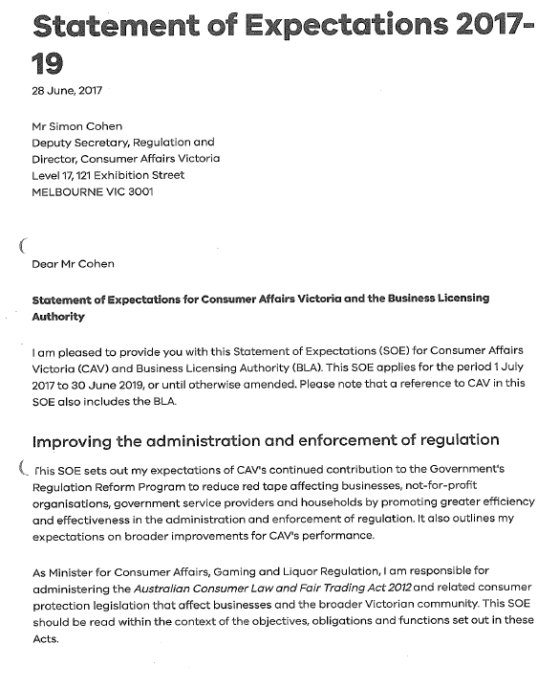

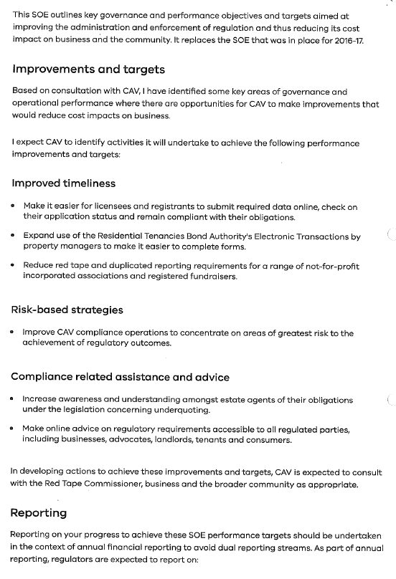

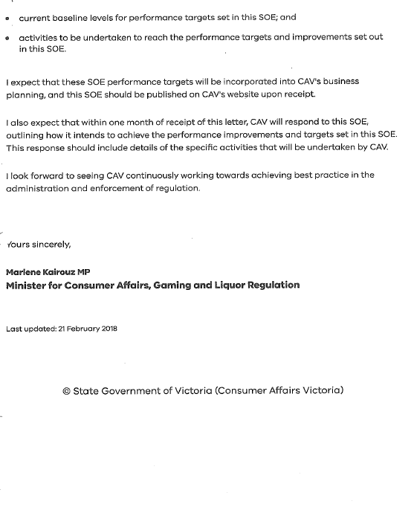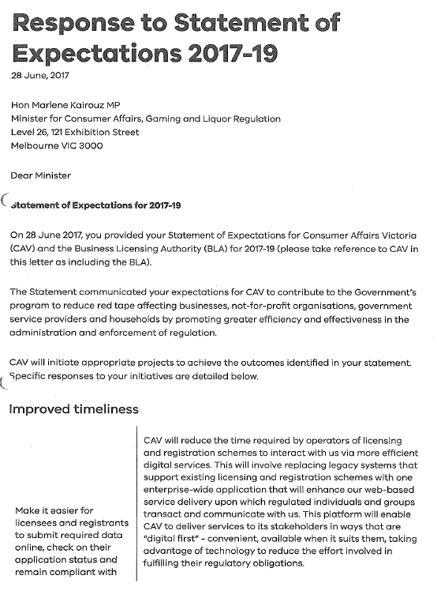

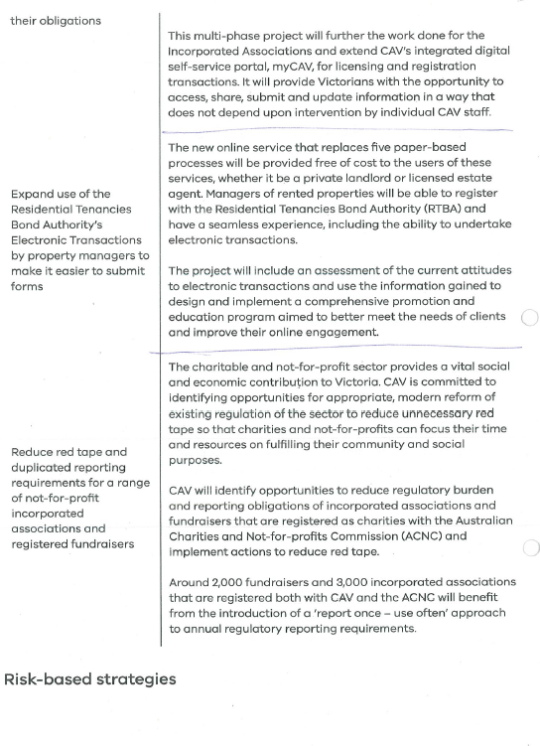

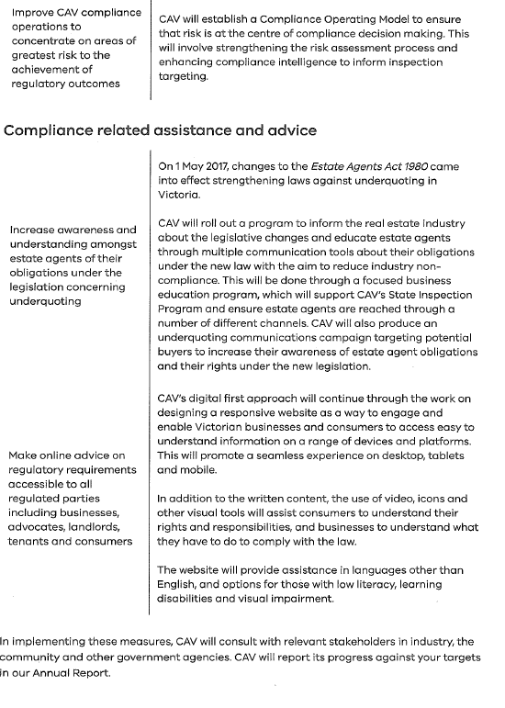

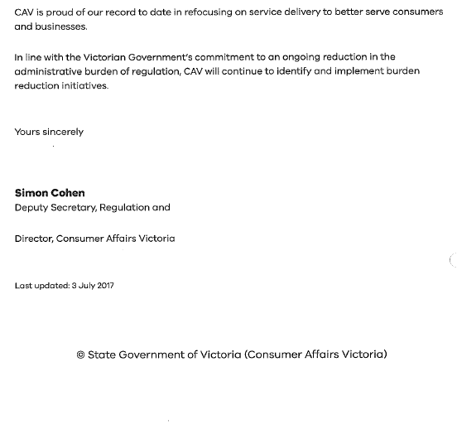

Document information
Document details
Criteria | Details
TRIM ID: | CD/18/704334
Document title: | CAV Statement of Expectations Evaluation Report
Document owner: | Strategic Planning Unit
Document approval
This document requires the following approval:
Name | Title | Organisation
Neil Twist | Director, Strategic Planning | DJCS
Simon Cohen | Deputy Secretary, Regulation | DJCS
Audience
The audience for this document is Consumer Affairs Victoria to provide the findings of the SOE evaluation.
Reference material
Attached references | TRIM ID/Location
CAV SOE and response | CD/18/274595
Acronyms
Acronyms | Description
ACNC | Australian Charities and Not-for-profits Commission
AIRA | Associations Incorporation Reform Act 2012
CALD | Culturally and linguistically diverse
CAV | Consumer Affairs Victoria
CCU | Compliance Coordination Unit
COG | Compliance Operating Group
DJCS | Department of Justice and Community Safety
EARL | Estate Agent and Rooming House Licensing Scheme
EFT | Electronic Funds Transfer
I&A | Information and Analysis Branch
ICT | Information Communication Technology
IDSC | Information and Dispute Services Centre
MOU | Memorandum of Understanding
REIV | Real Estate Institute of Victoria
RTBA | Residential Tenancies Bond Authority
SOE | Statement of Expectations
SPU | Strategic Planning Unit

