

Residential Tenancies Bond Authority

Annual Report
2012-13



Published by the Department of Justice, September 2013
Printed by Kwik Kopy, William Street, Melbourne
© Copyright State of Victoria 2013
This publication is copyright. No part may be reproduced by any process except in accordance with the provisions of the Copyright Act 1968 (Cth).
Enquiries to:
Residential Tenancies Bond Authority
GPO Box 123
MELBOURNE VIC 3001
AUSTRALIA
Telephone 1300 137 164
Facsimile +61 3 8684 6299
e-mail rtba@justice.vic.gov.au
Internet www.rtba.vic.gov.au
Department of Justice

Residential Tenancies Bond Authority | GPO Box 123  Melbourne VIC 3001  Telephone 1300 137 164  Facsimile 03 8684 6299  Email rtba@justice.vic.gov.au

Hon Heidi Victoria MP
Minister for Consumer Affairs
Level 6, 5 Kavanagh Street
SOUTHBANK VIC 3004

Dear Minister,
Annual Report 2012-13

I am pleased to present to you the Annual Report of the Residential Tenancies Bond Authority for the financial year ending 30 June 2013.
This report has been prepared in accordance with the requirements of the Financial Management Act 1994, for you to present to the Parliament of Victoria.

Yours sincerely,
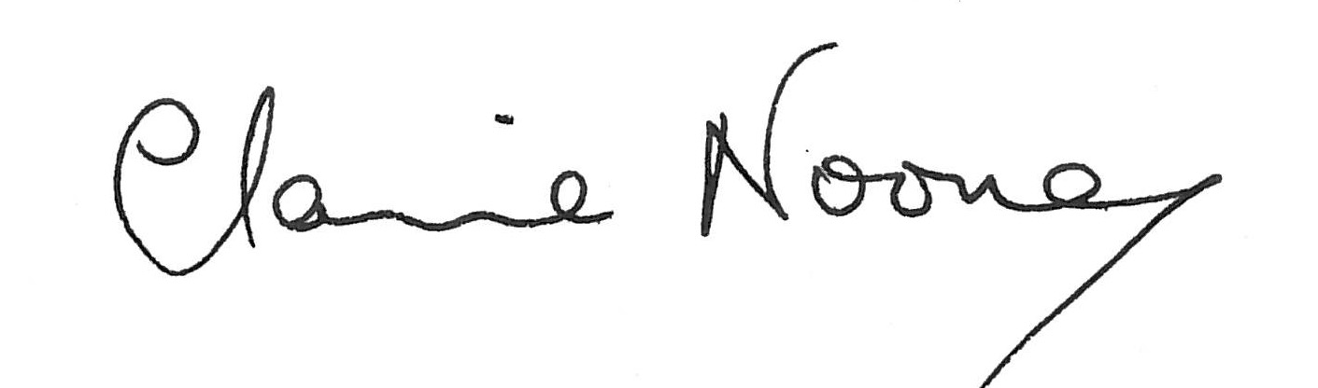

Dr Claire Noone
Constituting Member
Residential Tenancies Bond Authority
Residential Tenancies Bond Authority
Annual Report for the financial year 1 July 2012 to 30 June 2013

Contents

Charter and purpose 5
Year in review 6
Operations and service levels 7
Bond lodgements 7
Bond repayment claims 7
Transfers 7
Enquiries 7
SMS notifications 8
Receipts and periodic statements 8
RTBA Online 8
RTBA Online Activity 9
Service enhancements 10
Other activities 10
Compliance 10
Education 10
Website 11
Outsourced services 11
Freedom of Information 11
Privacy 12
Application of merit and equity principles 12
Disclosure of major contracts 12
Compliance with the Building Act 1993 12
Compliance with the Protected Disclosure Act 2012 (formerly, the Whistleblowers Protection Act 2001) 12
Financial report and accompanying statements 13
Statement by the Accountable offer and Chief Finance and Accounting Officer 14
Victorian Auditor – General’s Report 15
Comprehensive Operating Statement 17
Balance Sheet 18
Statement of Changes in Equity 19
Cash Flow Statement 20
Notes to the Financial Statements 21

Charter and purpose
The Residential Tenancies Bond Authority (RTBA) is a statutory authority of the Government of Victoria, administered within the Department of Justice.
The RTBA is established by the Residential Tenancies Act 1997 (the Act) to hold all Victorian residential tenancy bonds, including those applying to long-term caravan and rooming house residents.
Section 429 of the Act establishes the RTBA as a body corporate constituted by the Director of Consumer Affairs Victoria (CAV). The RTBA has no other members and employs no staff.
The functions of the RTBA, as set out in section 431 of the Act, as follows:
(a) to collect and disburse bond money paid to the Authority under this Act;
(b) to establish and administer –
(i) a Residential Bonds Account; and
(ii) a Residential Bonds Investment Income Account;
- to invest money held in those Accounts in accordance with this Act;
(ca) to collect the information contained in bond lodgement forms given to the Authority and other information kept by the Authority in relation to bonds held by the Authority;
(cb) to disclose the information (other than persons' names) referred to in paragraph (ca), whether it was collected before, on or after the commencement of section 16 of the Residential Tenancies (Amendment) Act 2003, to the Director of Housing for the purpose of the use of that information by the Director of Housing in research, compiling statistics and public education;
(d) to carry out any other function conferred on it by this Act.
Under section 432 of the Act, the RTBA has power to do anything necessary or convenient in connection with carrying out its functions.
The RTBA can only repay bonds as agreed by the landlord and tenant, or as directed by the Victorian Civil and Administrative Tribunal (VCAT) or a court.
The RTBA is managed and supported by staff from the Department of Justice and CAV. Processing of bond transactions and maintenance of the RTBA Register is outsourced to an external provider of registry services. The cost of these inputs is met by the RTBA.

Year in review
At 30 June 2013, the RTBA held 518,098 bonds, valued at $747 million. This represents an increase of 5.3 per cent in the number of bonds since 30 June 2012, and of 9.4 per cent in value.
Bond money received by the RTBA is invested in the Residential Bonds Account.
Pursuant to Section 436 of the Act, interest earned on the bonds is paid to the Residential Bonds Investment Income Account, where it is applied to the costs of administering the RTBA and to making contributions to the Residential Tenancies Fund. Transfers to the Residential Tenancies Fund during 2012-13 totalled $16.1 million - $6.9 million less than the previous year, due to reduced earnings as a result of lower interest rates.
The monthly lodgement and repayment of bonds over the past two years is shown in the following chart:

Operations and service levels
The RTBA’s operations and service levels are as follows:
- 99 per cent of all bond forms received by 12 noon are processed on the same day as receipt;
- forms that cannot be processed are returned on the following business day; and
- bond repayments are made by a direct credit issued on the evening of the day the repayment is approved, or by a cheque mailed the next business day.

Key bond processes and achievements for the year are:

Bond lodgements
The RTBA registered about 216,400 bond lodgements in 2012-13 (an average of 4,161 a week) compared with 204,600 in 2011-12 (an average of 3,935 a week).

Bond repayment claims
The RTBA repaid about 190,100 bonds (an average of 3,656 a week) compared with 175,800 in 2011-12 (an average of 3,381 a week). 86 per cent of repayments were made by direct credit, and were therefore in the payee’s bank account on the following business day.
92 percent of bond claims were made by agreement between tenant and the landlord/agent, with 8 per cent by direction of VCAT or a court.
77 per cent of bond repayment claims were received through the RTBA’s Fax Facility available to approved users. The process of claims received by fax and funds transferred by direct credit allows bond repayments to be repaid within 24 hours of the tenant and managing agent agreeing to the distribution of the bond.

Transfers
Under the Act, the RTBA must be notified of changes in tenants or landlord/agent. In the year ending 30 June 2013, there were 61,600 transfers (an average of 1,185 a week) compared to 61,000 in 2011-12 (an average of 1,173 a week).
53 per cent of bond transfers were received by fax.

Enquiries
The RTBA call centre provides information and advice on bond matters. The most frequent enquiries relate to the status of a bond repayment claim.
In 2012-13, the RTBA responded to 99,157 calls and 14,570 emails, compared to 99,795 phone calls and 10,857 emails in 2011-12.
The call centre’s phone number (1300 137 164) is a local call service which ensures no RTBA client is disadvantaged because of their geographic location or financial circumstances. During 2012-13, the RTBA answered 83 per cent of the calls received within the target time of two minutes.

SMS notifications
The RTBA continued to use SMS notifications during 2012-13, to advise of issues with the processing of forms or to remind landlords advertising properties of the need to lodge bonds.
SMS sent
SMS type | 2011-2012 | 2012-13
Agent/landlord transfer rejection | 39 | 46
Bond claim – rejection | 10,130 | 9,674
Retained repayment – creation | 18 | 7
Replacement repayment - rejection | 525 | 1,024
Tenant transfer – rejection | 1,609 | 1,752
Electronic transactions alerts | 2,048 | 6,225
Landlord reminders | 602 | 3,668
Total | 14,971 | 22,396

Receipts and periodic statements
When a bond is lodged with the RTBA, a receipt is sent to the tenant and to the landlord/agent. Property managers registered with the RTBA are also provided with access to a weekly statement of all bond lodgements, repayments and transfers registered against their name, through RTBA Online.

RTBA Online
RTBA Online provides online access to the RTBA Register. It delivers a number of benefits, including:
- access at any time to bond information, including the status of a bond, and the lodgement, transfer, and claim history;
- the ability to “self serve”, allowing users to see all available information first-hand. This includes the print-out of proof that a bond is lodged with the RTBA, as is required for a bond related application to VCAT;
- speedier bond transactions, by allowing users to view and confirm the most up-to-date information held by the RTBA, avoiding return of bond forms due to avoidable errors;
- generating forms for submitting lodgements, repayment claims, and transfers; and
- the ability to search for a lost bond repayment held by the RTBA. Where a bond is closed but a repayment cannot be made due to a lack of details, the RTBA holds the money as a retained repayment, which can be redeemed by the person to which it is owed.
RTBA Online operates in two modes:
Tenants and landlords: provides for access to the details for a single bond through a log-in based on a combination of the bond number and tenant’s name.
Registered users: Property managers registered with the RTBA as managing a portfolio of bonds have access to all of their bonds via a password-protected log-in, and access to a wider range of functions, including:
- undertaking bond transactions electronically;
- searching across all bonds registered to the agent in a number of different ways;
- more bond related information than in the tenant/landlord module;
- images of forms processed by the RTBA since 2004;
- images of transaction rejection notices issued by the RTBA since November 2009;
- weekly agent statements, including access to back copies;
- an agent bond list showing all bonds registered to the agent; and
- various pro forma RTBA documents in regular use by agents.
Both modes of RTBA Online comply with the Privacy Principles of the Information Privacy Act 2000 and the confidentiality requirements of the Act.
Without having to log into a bond, users can also:
- generate bond lodgement forms;
- search retained repayments for lost bond repayments; and
- access general RTBA information, including frequently asked questions.
Use of RTBA Online has continued to increase.

RTBA Online Activity
Online activity | 2008-09 | 2009-10 | 2010-11 | 2011-12 | 2012-13
Number of registered users | 1,771 | 2,346 | 2,850 | 3,497 | 4,147
Enquiries by registered users | 110,891 | 143,734 | 174,871 | 224,381 | 284,020
Enquiries by landlords | 26,529 | 20,412 | 19,528 | 19,393 | 20,900
Enquiries by tenants | 26,218 | 60,851 | 58,972 | 66,741 | 82,664
Lodgements forms created | 18,874 | 31,041 | 47,362 | 69,770 | 93,599
Claims forms created | 37,170 | 57,963 | 75,403 | 97,773 | 127,329
Tenant transfers forms created | 3,227 | 6,655 | 9,353 | 12,632 | 16,461
Agent/landlord transfers forms created | 1,547 | 3,039 | 5,269 | 5,630 | 9,013
Document images viewed | 9,732 | 6,375 | 4,357 | 2,871 | 3,985
Weekly agent statements accessed | 3,651 | 8,573 | 5,853 | 5,296 | 4,664
Agent bond lists accessed | 800 | 6,841 | 6,209 | 6,661 | 7,232
Visitor sessions | N/A | N/A | N/A | 359,276 | 479,545
Unique visitors | N/A | N/A | N/A | 95,986 | 132,323
Total activity | 240,410 | 346,059 | 407,681 | 967,007 | 1,262,385

In 2012-13, forms and reports generated by RTBA Online saved 1.3 million sheets of paper (2,612 reams) in pre-printed forms and circulation of reports compared to 1.0 million sheets (2,070 reams) in 2011-12.

Service enhancements

The RTBA remains committed to improving service levels based upon a continuous improvement program.

During 2012-13, the RTBA:
- extended the length of SMS messages to provide additional information;
- introduced standard addressing to meet the requirements of Australia Post’s Delivery Point Identifier (DPID) system.
- undertook a system upgrade to improve overall system performance of RTBA Online.
- introduced improvements to RTBA Online, including:
  - ensuring its compatability with Firefox, Chrome and Safari browsers
  - automated expiry of registered users online accounts;
  - improved instructions on bond transaction screens;
  - strengthened security to the tenant, landlord, and registered user entry points, to reduce the risk of unauthorised access;
  - modified agent bond lists to indicate if the bond was created electronically or from a paper form; and
  - researching what people like and dislike about RTBA Online, as a first step in redesigning the website.
- extended its contract with the outsourced services provider. The extension included:
  - a hardware and software refresh;
  - new key performance measures or system performance; and
  - the introduction of intelligent character recognition by 2016.
- repaid the Director of Housing (DoH) over $940,000. This payment followed the recent amendment to the Residential Tenancies Act 1997, allowing the RTBA to repay bonds to the DoH where a subsequent bond had been lodged, regardless of when the DoH loan was made.

Other activities
Other activities of the RTBA include:

Compliance
Enforcement of the bond lodging requirements of the Act is pursued by identification of non-complying landlords and agents, issuing of advice and warnings and, if necessary, referrals to Consumer Affairs Victoria for investigation and enforcement.

Education
The RTBA educates agents, landlords, and tenants, to help ensure they understand the RTBA and its procedures, and their rights and obligations. During 2012-13, education activities included seminar presentations to agents and an agent update about the introduction of standard addressing to meet the requirements of Australia Post’s Delivery Point Identifier (DPID) system, and other issues.

Website
The RTBA website (www.rtba.vic.gov.au ) provides an overview of the RTBA, information on bond requirements and processes, access to a knowledge base with answers to the most frequently asked questions, and access to RTBA Online.

Outsourced services
Since it was established in 1998, the RTBA has outsourced its registry services, including the receipt, registration, transfer and repayment of bonds.

iGATE Global Solutions Limited is the present provider, under a contract running to 30 June 2018. The contract was extended during 2012-13 for five years, from the previous end date of 30 June 2013.
During the year ended 30 June 2013, iGATE maintained the RTBA’s target performance levels, including processing 99 per cent of transactions on the day of receipt.

Freedom of Information
The RTBA maintains documents and electronic records relating to the transactions of receipt, registration, transfer, and repayment of residential bonds. These documents are principally the forms completed by interested parties in undertaking a transaction, and any supporting attachments. An electronic register with a summary of the transactions is also maintained.
Decisions made by the RTBA relate to scrutiny of the forms and supporting documentation, to ensure that sufficient evidence is provided to support the transaction requested. The RTBA has no role in resolving disputes between parties to a tenancy; this role is undertaken by VCAT or a court.
The Register, transaction forms and supporting documents are confidential, pursuant to section 499 of the Residential Tenancies Act 1997. They are not subject to Freedom of Information requests.
The Freedom of Information Act 1982 allows the public a right of access to documents held by the RTBA. For the 12 months ending 30 June 2013, the RTBA received no requests.
Making a request
Access to documents may be obtained by written request to:
Freedom of Information Officer
Residential Tenancies Bond Authority
17/121 Exhibition Street
Melbourne VIC 3000
Requests can also be lodged online at www.foi.vic.gov.au.
In summary, the requirements for making a request are that:
- it should be in writing;
- it should identify as clearly as possible which document is being requested; and
- it should be accompanied by the appropriate application fee (the fee may be waived in certain circumstances).
Access charges may also apply once documents have been processed and a decision on access is made; for example, photocopying and search and retrieval charges.
Further information regarding Freedom of Information can be found at www.foi.vic.gov.au.

Privacy
In terms of the collection, use and disclosure of personal information obtained in the operation of its functions, the RTBA is bound by the Information Privacy Act 2000. The RTBA will only disclose the information it holds where required or allowed by law.

Application of merit and equity principles
Staff from the Department of Justice and CAV who undertake RTBA functions are covered by the Department’s performance management system, which encourages and supports staff development and rewards merit, and by the Victorian Public Service Code of Conduct.

Disclosure of major contracts
In accordance with the requirements of government policy and accompanying guidelines, the RTBA has disclosed all contracts greater than $10 million in value which it entered into during the 2012-13 financial year. Details of contracts, disclosed in the Victorian Government contracts publishing system, can be viewed at www.contracts.vic.gov.au.
Contractual details have not been disclosed for contracts for which disclosure is exempted under the Freedom of Information Act 1982 and/or government guidelines.
The details of the variation of the contract with iGATE Global Solutions Limited was disclosed on 28 June 2013.

Compliance with the Building Act 1993
The RTBA does not own or control any government buildings and as such, is excempt from notifying its compliance with the building and maintenance provisions of the Building Act 1993.

Compliance with the Protected Disclosure Act 2012 (formerly, the Whistleblowers Protection Act 2001)
The Protected Disclosure Act 2012 encourages and assists people in making disclosures of improper conduct by public officers and public bodies. It protects people who make disclosures in accordance with the Act, establishes a system for disclosed matters to be investigated, and for rectifying action to be taken.
Staff from the Department of Justice and CAV undertaking RTBA functions are covered by the Department’s policy in relation to making disclosures and the protection offered to them.

Financial report and accompanying statements

Statement by the Accountable offer and Chief Finance and Accounting Officer

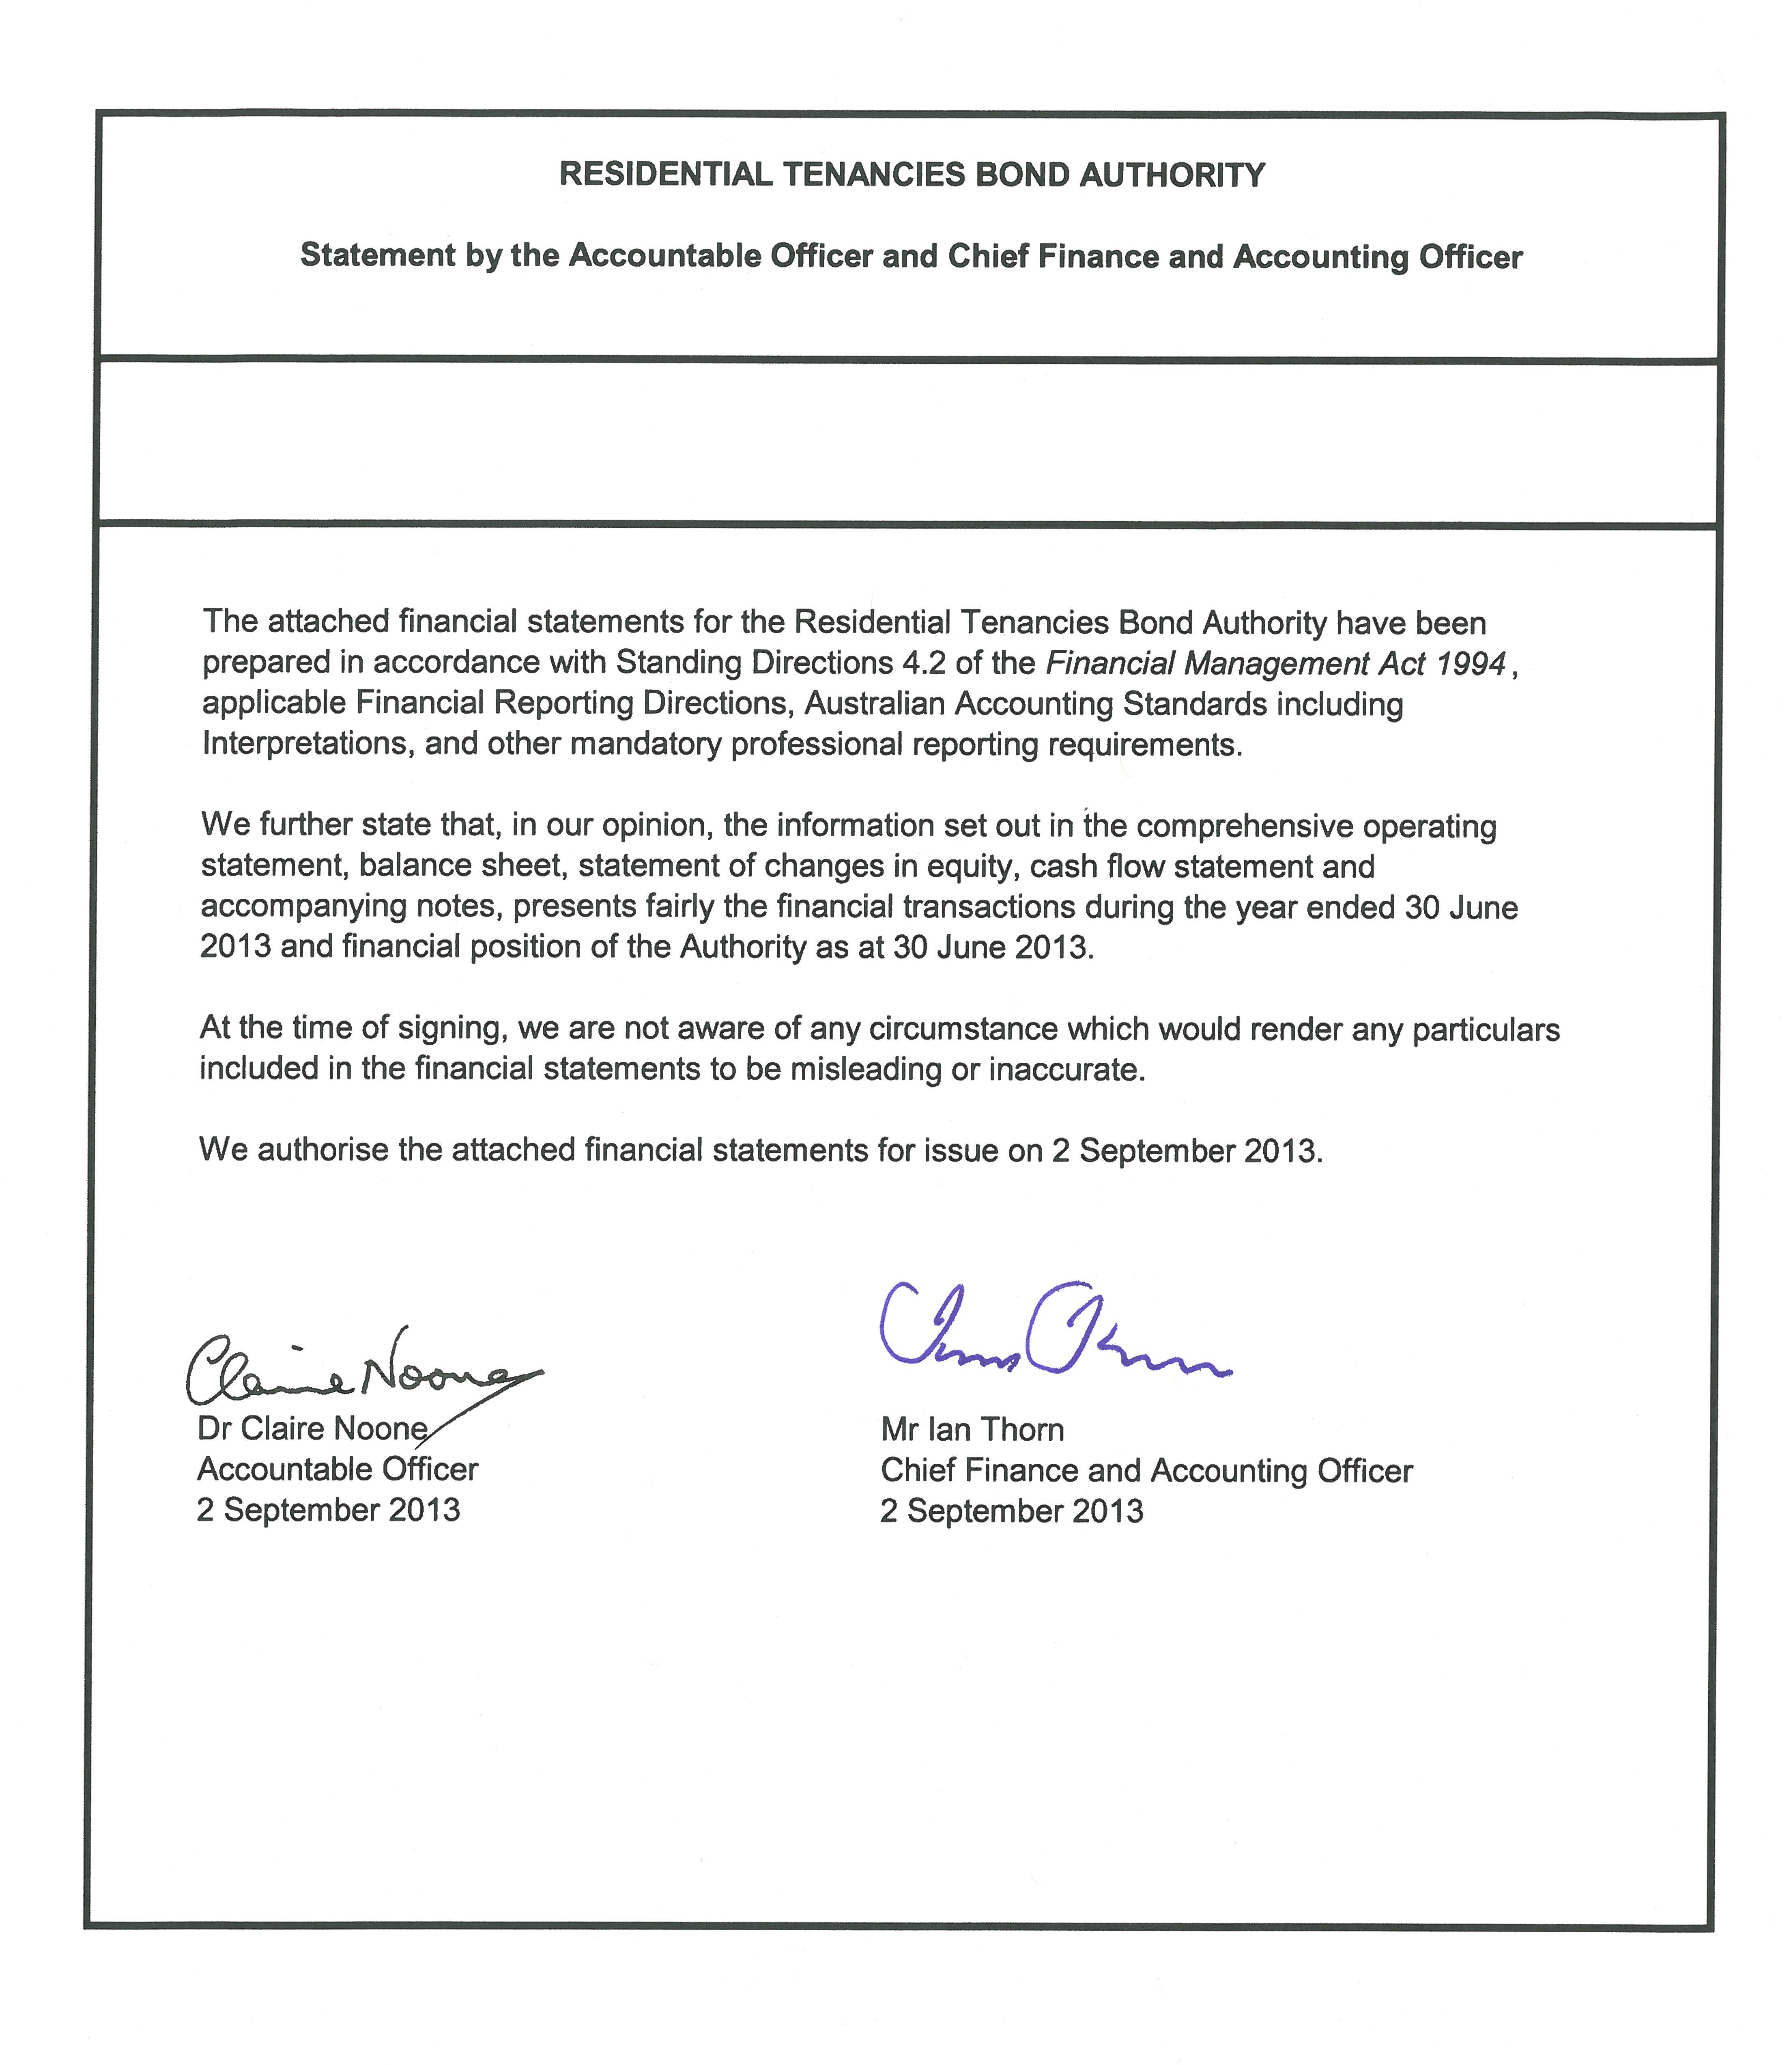

Victorian Auditor – General’s Report
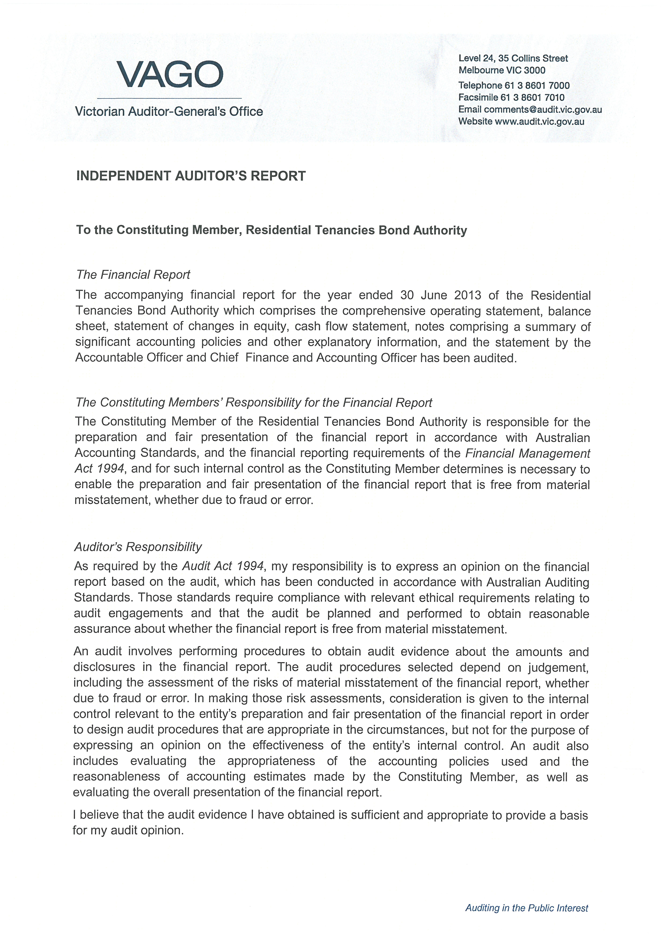
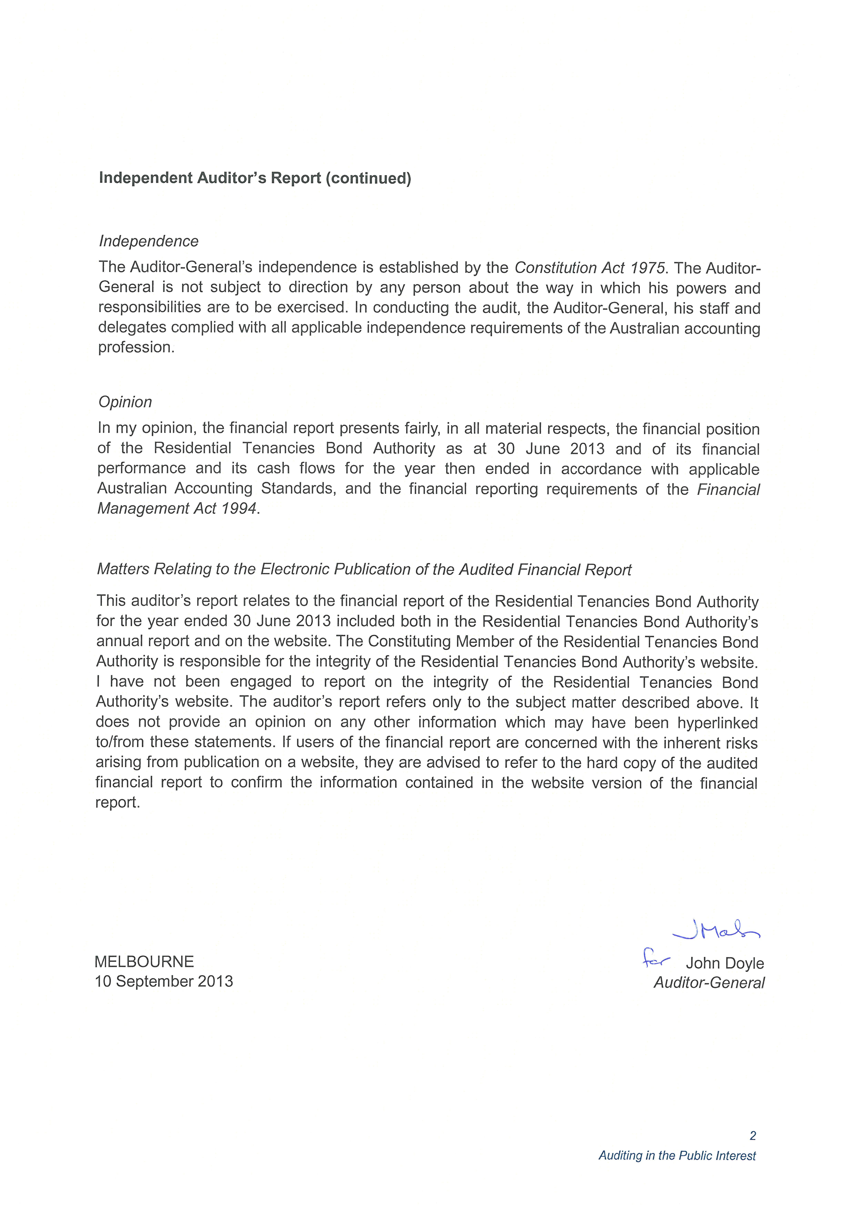
Comprehensive Operating Statement

Balance Sheet

Statement of Changes in Equity

Cash Flow Statement

Notes to the Financial Statements

