

Residential Tenancies Bond Authority

Annual Report
2013-14



Authorised and published by the Victorian Government,
1 Treasury Place, Melbourne
October 2014
Printed by ACM Printing Pty Ltd, Melbourne
ISSN 2203-8426 (Print) ISSN 2203-8434 (pdf)


Unless indicated otherwise, content in this publication is provided under a Creative Commons Attribution 3.0 Australia Licence. To view a copy of this licence, visit creativecommons.org/licenses/by/3.0/au
It is a condition of the Creative Commons Attribution 3.0 Licence that you must give credit to the original author who is the State of Victoria.
If you would like to receive this publication in an accessible format, such as large print or audio, or additional copies, please contact:
Residential Tenancies Bond Authority
GPO Box 123
MELBOURNE VIC 3001
AUSTRALIA
Telephone 1300 137 164
Facsimile +61 3 8684 6299
e-mail rtba@justice.vic.gov.au
Internet www.rtba.vic.gov.au
Department of Justice

Residential Tenancies Bond Authority | GPO Box 123  Melbourne VIC 3001  Telephone 1300 137 164  Facsimile 03 8684 6299  Email rtba@justice.vic.gov.au

Hon Heidi Victoria MP
Minister for Consumer Affairs
Level 6, 2 Kavanagh Street
SOUTHBANK VIC 3006

Dear Minister,
Annual Report 2013-14

I am pleased to present to you the Annual Report of the Residential Tenancies Bond Authority for the financial year ending 30 June 2014.
This report has been prepared in accordance with the requirements of the Financial Management Act 1994, for you to present to the Parliament of Victoria.

Yours sincerely,

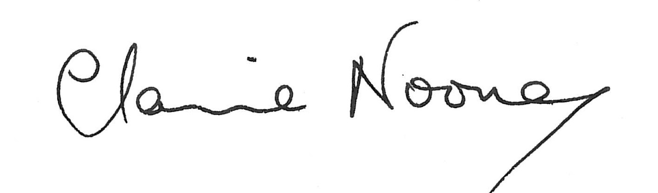
Dr Claire Noone
Constituting Member
Residential Tenancies Bond Authority
Residential Tenancies Bond Authority
Annual Report for the financial year 1 July 2013 to 30 June 2014

Contents

Charter and purpose 3
Year in review 3
Operations and service levels 3
Bond lodgments 3
Bond repayment claims 3
Transfers 3
Enquiries 3
SMS notifications 3
Receipts and periodic statements 3
RTBA Online 3
RTBA Online activity 3
Service enhancements 3
Other activities 3
Compliance 3
Education 3
Website 3
Outsourced services 3
Freedom of Information 3
Privacy 3
Application of merit and equity principles 3
Compliance with the Building Act 1993 3
Compliance with the Protected Disclosure Act 2012 (formerly, the Whistleblowers Protection Act 2001) 3
Financial report and accompanying statements 3
Statement by the Accountable Officer and Chief Finance and Accounting Officer 3
Victorian Auditor-General’s Report 3
Comprehensive Operating Statement 3
Balance Sheet 3
Statement of Changes in Equity 3
Cash Flow Statement 3
Notes to the Financial Statements 3

Charter and purpose
The Residential Tenancies Bond Authority (RTBA) is a statutory authority of the Government of Victoria, administered within the Department of Justice.
The RTBA is established by the Residential Tenancies Act 1997 (the Act) to hold all Victorian residential tenancy bonds, including those applying to long-term caravan and rooming house residents.
Section 429 of the Act establishes the RTBA as a body corporate constituted by the Director of Consumer Affairs Victoria (CAV). The RTBA has no other members and employs no staff.
The RTBA is managed and supported by staff from the Department of Justice and CAV. Processing of bond transactions and maintenance of the RTBA Register is outsourced to an external provider of registry services. These costs are met by the RTBA.
The functions of the RTBA, as set out in section 431 of the Act, are as follows:
(a) to collect and disburse bond money paid to the Authority under this Act;
(b) to establish and administer –
(i) a Residential Bonds Account; and
(ii) a Residential Bonds Investment Income Account;
- to invest money held in those Accounts in accordance with this Act;
(ca) to collect the information contained in bond lodgment forms given to the Authority and other information kept by the Authority in relation to bonds held by the Authority;
(cb) to disclose the information (other than persons' names) referred to in paragraph (ca), whether it was collected before, on or after the commencement of section 16 of the Residential Tenancies (Amendment) Act 2003, to the Director of Housing for the purpose of the use of that information by the Director of Housing in research, compiling statistics and public education;
(d) to carry out any other function conferred on it by this Act.
Under section 432 of the Act, the RTBA has power to do anything necessary or convenient in connection with carrying out its functions.
The RTBA can only repay bonds as agreed by the landlord and tenant, or as directed by the Victorian Civil and Administrative Tribunal (VCAT) or a court.

Year in review
At 30 June 2014, the RTBA held 542,209 bonds, valued at $806 million. This represents an increase of 4.7 per cent in the number of bonds since 30 June 2013, and an increase of 7.9 per cent in value.
Bond money received by the RTBA is invested in the Residential Bonds Account.
As required under Section 436 of the Act, interest earned on the bonds is paid to the Residential Bonds Investment Income Account, where it is applied to the costs of administering the RTBA and to making contributions to the Residential Tenancies Fund. Transfers to the Residential Tenancies Fund during 2013-14 totalled $12.3 million. This was $3.8 million less than the previous year, due to reduced earnings because of lower interest rates and a decision to increase the RTBA reserves.
The monthly lodgment and repayment of bonds over the past year is shown in the following chart:

Operations and service levels
The RTBA’s operations and service levels are as follows:
- 99 per cent of all bond forms received by midday are processed on the same day of receipt;
- forms that cannot be processed are returned on the following business day; and
- bond repayments are made by a direct credit issued on the evening of the day of approval, or by a cheque mailed the next business day.

Key bond processes and achievements for the year are:

Bond lodgments
The RTBA registered about 221,700 bond lodgments in 2013-14 (an average of 4,263 a week) compared with about 216,400 in 2012-13 (an average of 4,161 a week).

Bond repayment claims
The RTBA repaid about 197,500 bonds (an average of 3,798 a week) compared with 190,100 in 2012-13 (an average of 3,656 a week). 86 per cent of repayments were made by direct credit on the evening of the day of approval, and were therefore in the payee’s bank account on the following business day.
93 per cent of bond claims were made by agreement between the tenant and the landlord/agent, with only 7 per cent made by direction of VCAT or a court.
79 per cent of bond repayment claims were received through the RTBA’s Fax Facility, available to approved users. The process of claims received by fax and funds transferred by direct credit allows bond repayments to be repaid within 24 hours of the tenant and managing agent agreeing to the distribution of the bond.

Transfers
Under the Act, the RTBA must be notified of changes in tenants or landlord/agent. In the year ending 30 June 2014, there were about 60,400 transfers (an average of 1,162 a week) compared to about 61,600 in 2012-13 (an average of 1,185 a week).
57 per cent of bond transfers were received through the RTBA Fax Facility.

Enquiries
The RTBA call centre provides information and advice on bond matters. The most frequent enquiries relate to the status of a bond repayment claim.
In 2013-14, the RTBA responded to 97,309 calls and 21,540 emails, compared to 99,157 calls and 14,570 emails in 2012-13.
The call centre’s phone number (1300 137 164) is a local call service which ensures no RTBA client is disadvantaged because of their geographic location or financial circumstances. During 2013-14, the RTBA answered 88 per cent of calls received within the target time of two minutes.

SMS notifications
The RTBA continued to use SMS notifications during 2013-14, to advise of issues with the processing of forms or to remind landlords advertising properties of the need to lodge bonds.
SMS sent
SMS type | 2011-12 | 2012-13 | 2013-14
Agent/landlord transfer rejection | 39 | 46 | 41
Bond claim – rejection | 10,130 | 9,674 | 11,162
Retained repayment – creation | 18 | 7 | 0
Replacement repayment – rejection | 525 | 1,024 | 1,586
Tenant transfer – rejection | 1,609 | 1,752 | 1,669
Electronic transactions alerts | 2,048 | 6,225 | 9,902
Landlord reminders | 602 | 3,668 | 2,503
Total | 14,971 | 22,396 | 26,863

Receipts and periodic statements
When a bond is lodged with the RTBA, a receipt is sent to the tenant and to the landlord/agent. Property managers registered with the RTBA are also provided with access to a weekly statement of all bond lodgments, repayments and transfers registered against their name through RTBA Online (see below).

RTBA Online
RTBA Online provides online access to the RTBA Register. It provides:
- access at any time to bond information, including the status of a bond, and the lodgment, transfer, and claim history;
- the ability to “self serve”, allowing users to see all available information first-hand. This includes the print-out of proof that a bond is lodged with the RTBA, as is required for a bond related application to VCAT;
- speedier bond transactions, by allowing users to view and confirm the most up-to-date information held by the RTBA, avoiding return of bond forms due to avoidable errors;
- generation of forms for submitting lodgments, repayment claims, and transfers; and
- the ability to search for a lost bond repayment held by the RTBA. When a bond is closed but a repayment cannot be made due to a lack of details, the RTBA holds the money as a retained repayment, which can be redeemed by the person to which it is owed.
RTBA Online operates in two modes:
Tenants and landlords: provides for access to the details for a single bond through a log-in based on a combination of the bond number and tenant’s name.
Registered users: property managers registered with the RTBA as managing a portfolio of bonds have access to all of their bonds via a password-protected log-in, and access to a wider range of functions, including:
- undertaking bond transactions electronically;
- searching across all bonds registered to the agent in a number of different ways;
- more bond related information than in the tenant/landlord module;
- images of forms processed by the RTBA since 2004;
- images of transaction rejection notices issued by the RTBA since November 2009;
- weekly agent statements, including access to back copies;
- an agent bond list showing all bonds registered to the agent; and
- various pro forma RTBA documents in regular use by agents.
Both modes of RTBA Online comply with the Privacy Principles of the Information Privacy Act 2000 and the confidentiality requirements of the Act.
Without having to log into a bond, users can also:
- generate bond lodgment forms;
- search retained repayments for lost bond repayments; and
- access general RTBA information, including frequently asked questions.
Use of RTBA Online has continued to increase.

RTBA Online activity
Online activity | 2009-10 | 2010-11 | 2011-12 | 2012-13 | 2013-14
Number of registered users | 2,346 | 2,850 | 3,497 | 4,147 | 2,488*
Enquiries by registered users | 143,734 | 174,871 | 224,381 | 284,020 | 380,218
Enquiries by landlords | 20,412 | 19,528 | 19,393 | 20,900 | 23,486
Enquiries by tenants | 60,851 | 58,972 | 66,741 | 82,664 | 95,605
Lodgment forms created | 31,041 | 47,362 | 69,770 | 93,599 | 129,445
Claim forms created | 57,963 | 75,403 | 97,773 | 127,329 | 167,625
Tenant transfer forms created | 6,655 | 9,353 | 12,632 | 16,461 | 22,190
Agent/landlord transfer forms created | 3,039 | 5,269 | 5,630 | 9,013 | 12,729
Document images viewed | 6,375 | 4,357 | 2,871 | 3,985 | 4,736
Weekly agent statements accessed | 8,573 | 5,853 | 5,296 | 4,664 | 7,612
Agent bond lists accessed | 6,841 | 6,209 | 6,661 | 7,232 | 9,926
Visitor sessions | N/A | N/A | 359,276 | 479,545 | 578,917
Unique visitors | N/A | N/A | 95,986 | 132,323 | 150,815
Total activity | 346,059 | 407,681 | 967,007 | 1,262,385 | 1,585,792
* There was a clean up of registered users which resulted in a reduction of active registered users.
In 2013-14, online access to forms and reports generated by RTBA Online saved the RTBA 1.7 million sheets of paper (3,426 reams) in pre-printed forms and circulation of reports compared to 1.3 million sheets (2,612 reams) in 2012-13.

Service enhancements

The RTBA remains committed to improving service levels based upon a continuous improvement program.

During 2013-14, the RTBA:
- upgraded the infrastructure that hosts the RTBA Register and RTBA Online at both the primary and disaster recovery data centres. This included replacing all of the hardware with newer, higher capacity equipment and the upgrade of all base software. This upgrade has provided improvements to user response times and improved system reliability;
- introduced improvements to RTBA Online, including:
  - allowing registered users to undertake electronic transactions on all bonds; (previous arrangements only allowed electronic transactions on bonds created by electronic means);
  - a bar to prevent registered user logins being simultaneously in use on more than one login, to improve security of data access;
  - concluding the first phase of the website rebuild, which included finalising the new design;
  - a new information page to assist users to register for RTBA Online; and
  - refinements to text and screens to provide clearer instructions to users;
- implemented an automated tool to monitor system performance, including response times for the major interactions with the Register; and
- repaid $1.29 million in unclaimed money in accordance with the obligations of the Unclaimed Money Act 2008.

Other activities
Other activities of the RTBA include:

Compliance
The bond lodging requirements of the Act are enforced by identifying non-complying landlords and agents, issuing advice and warnings and, if necessary, referrals to Consumer Affairs Victoria for investigation and enforcement.

Education
The RTBA educates agents, landlords and tenants, to help ensure they understand the RTBA and its procedures, and their rights and responsibilities. During 2013-14, education activities included seminar presentations and an update to agents which included information about:
- registered users now being able to undertake electronic transactions on all bonds; and
- the introduction of the bar preventing registered users from logging in on more than one occasion simultaneously.

Website
The RTBA website (www.rtba.vic.gov.au) provides an overview of the RTBA, information on bond requirements and processes, access to a knowledge base with answers to the most frequently asked questions, and access to RTBA Online.

Outsourced services
Since it was established in 1998, the RTBA has outsourced its registry services, including the receipt, registration, transfer and repayment of bonds.

iGATE Global Solutions Limited is the present provider, under a contract running to 30 June 2018.
During the year ended 30 June 2014, iGATE maintained the RTBA’s target performance levels, including processing 99 per cent of transactions on the day of receipt.

Freedom of Information
The RTBA maintains documents and electronic records about the receipt, registration, transfer, and repayment of residential bonds. These documents are principally the forms completed by interested parties in undertaking a transaction, and any supporting attachments. The RTBA also maintains an electronic register with a summary of the transactions.
The RTBA scrutinises forms and supporting documentation to ensure sufficient evidence is provided to support requested transactions. The RTBA has no role in resolving disputes between parties to a tenancy; this role is undertaken by VCAT or a court.
The RTBA Register, transaction forms and supporting documents are confidential, pursuant to section 499 of the Act. They are not subject to Freedom of Information requests.
The Freedom of Information Act 1982 allows the public a right of access to other documents held by the RTBA. For the 12 months ending 30 June 2014, the RTBA received no such requests.
Making a request
Access to documents may be obtained through written request to the Freedom of Information Manager, as detailed in s17 of the Freedom of Information Act 1982. In summary, requests should:
- be in writing;
- identify as clearly as possible which document is being requested; and
- be accompanied by the appropriate application fee (the fee may be waived in certain circumstances).
Requests for documents held by the RTBA should be addressed to:
Freedom of Information Officer
Residential Tenancies Bond Authority
17/121 Exhibition Street
Melbourne VIC 3000
You can also lodge requests online at www.foi.vic.gov.au.
Access charges may also apply once documents have been processed and a decision on access is made; for example, photocopying and search and retrieval charges.
Further information about Freedom of Information can be found at www.foi.vic.gov.au.

Privacy
The RTBA is bound by the Information Privacy Act 2000 in relation to the collection, use and disclosure of personal information it obtains. It will only disclose the information it holds when required or allowed by law.

Application of merit and equity principles
Staff from the Department of Justice and CAV who undertake RTBA functions are covered by the Victorian Public Service Code of Conduct and by the Department’s performance management system, which encourages and supports staff development and rewards merit.

Compliance with the Building Act 1993
The RTBA does not own or control any government buildings and, as such, is exempt from notifying its compliance with the building and maintenance provisions of the Building Act 1993.

Compliance with the Protected Disclosure Act 2012 (formerly, the Whistleblowers Protection Act 2001)
The Protected Disclosure Act 2012 (formerly the Whistleblowers Protection Act 2001) encourages and assists people in making disclosures of improper conduct by public officers and public bodies. It provides protection to people who make disclosures and establishes a system for the matters disclosed to be investigated, and rectifying action to be taken.
Staff from the Department of Justice and CAV undertaking RTBA functions are covered by the Department’s policy in relation to making disclosures and the protection offered to them.

Financial report and accompanying statements

Statement by the Accountable Officer and Chief Finance and Accounting Officer
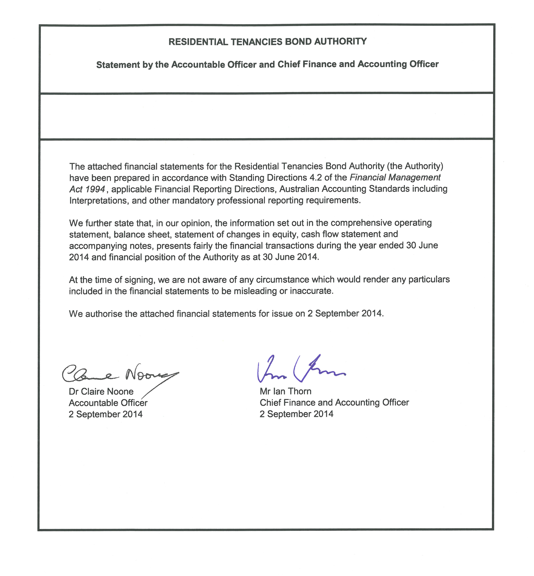

Victorian Auditor-General’s Report
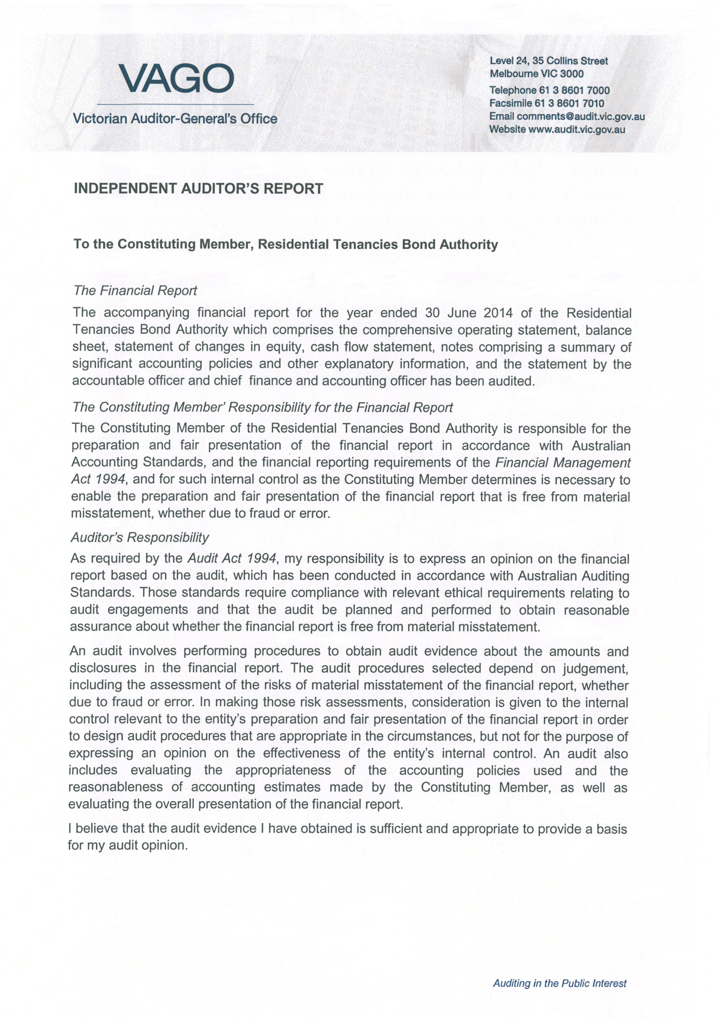
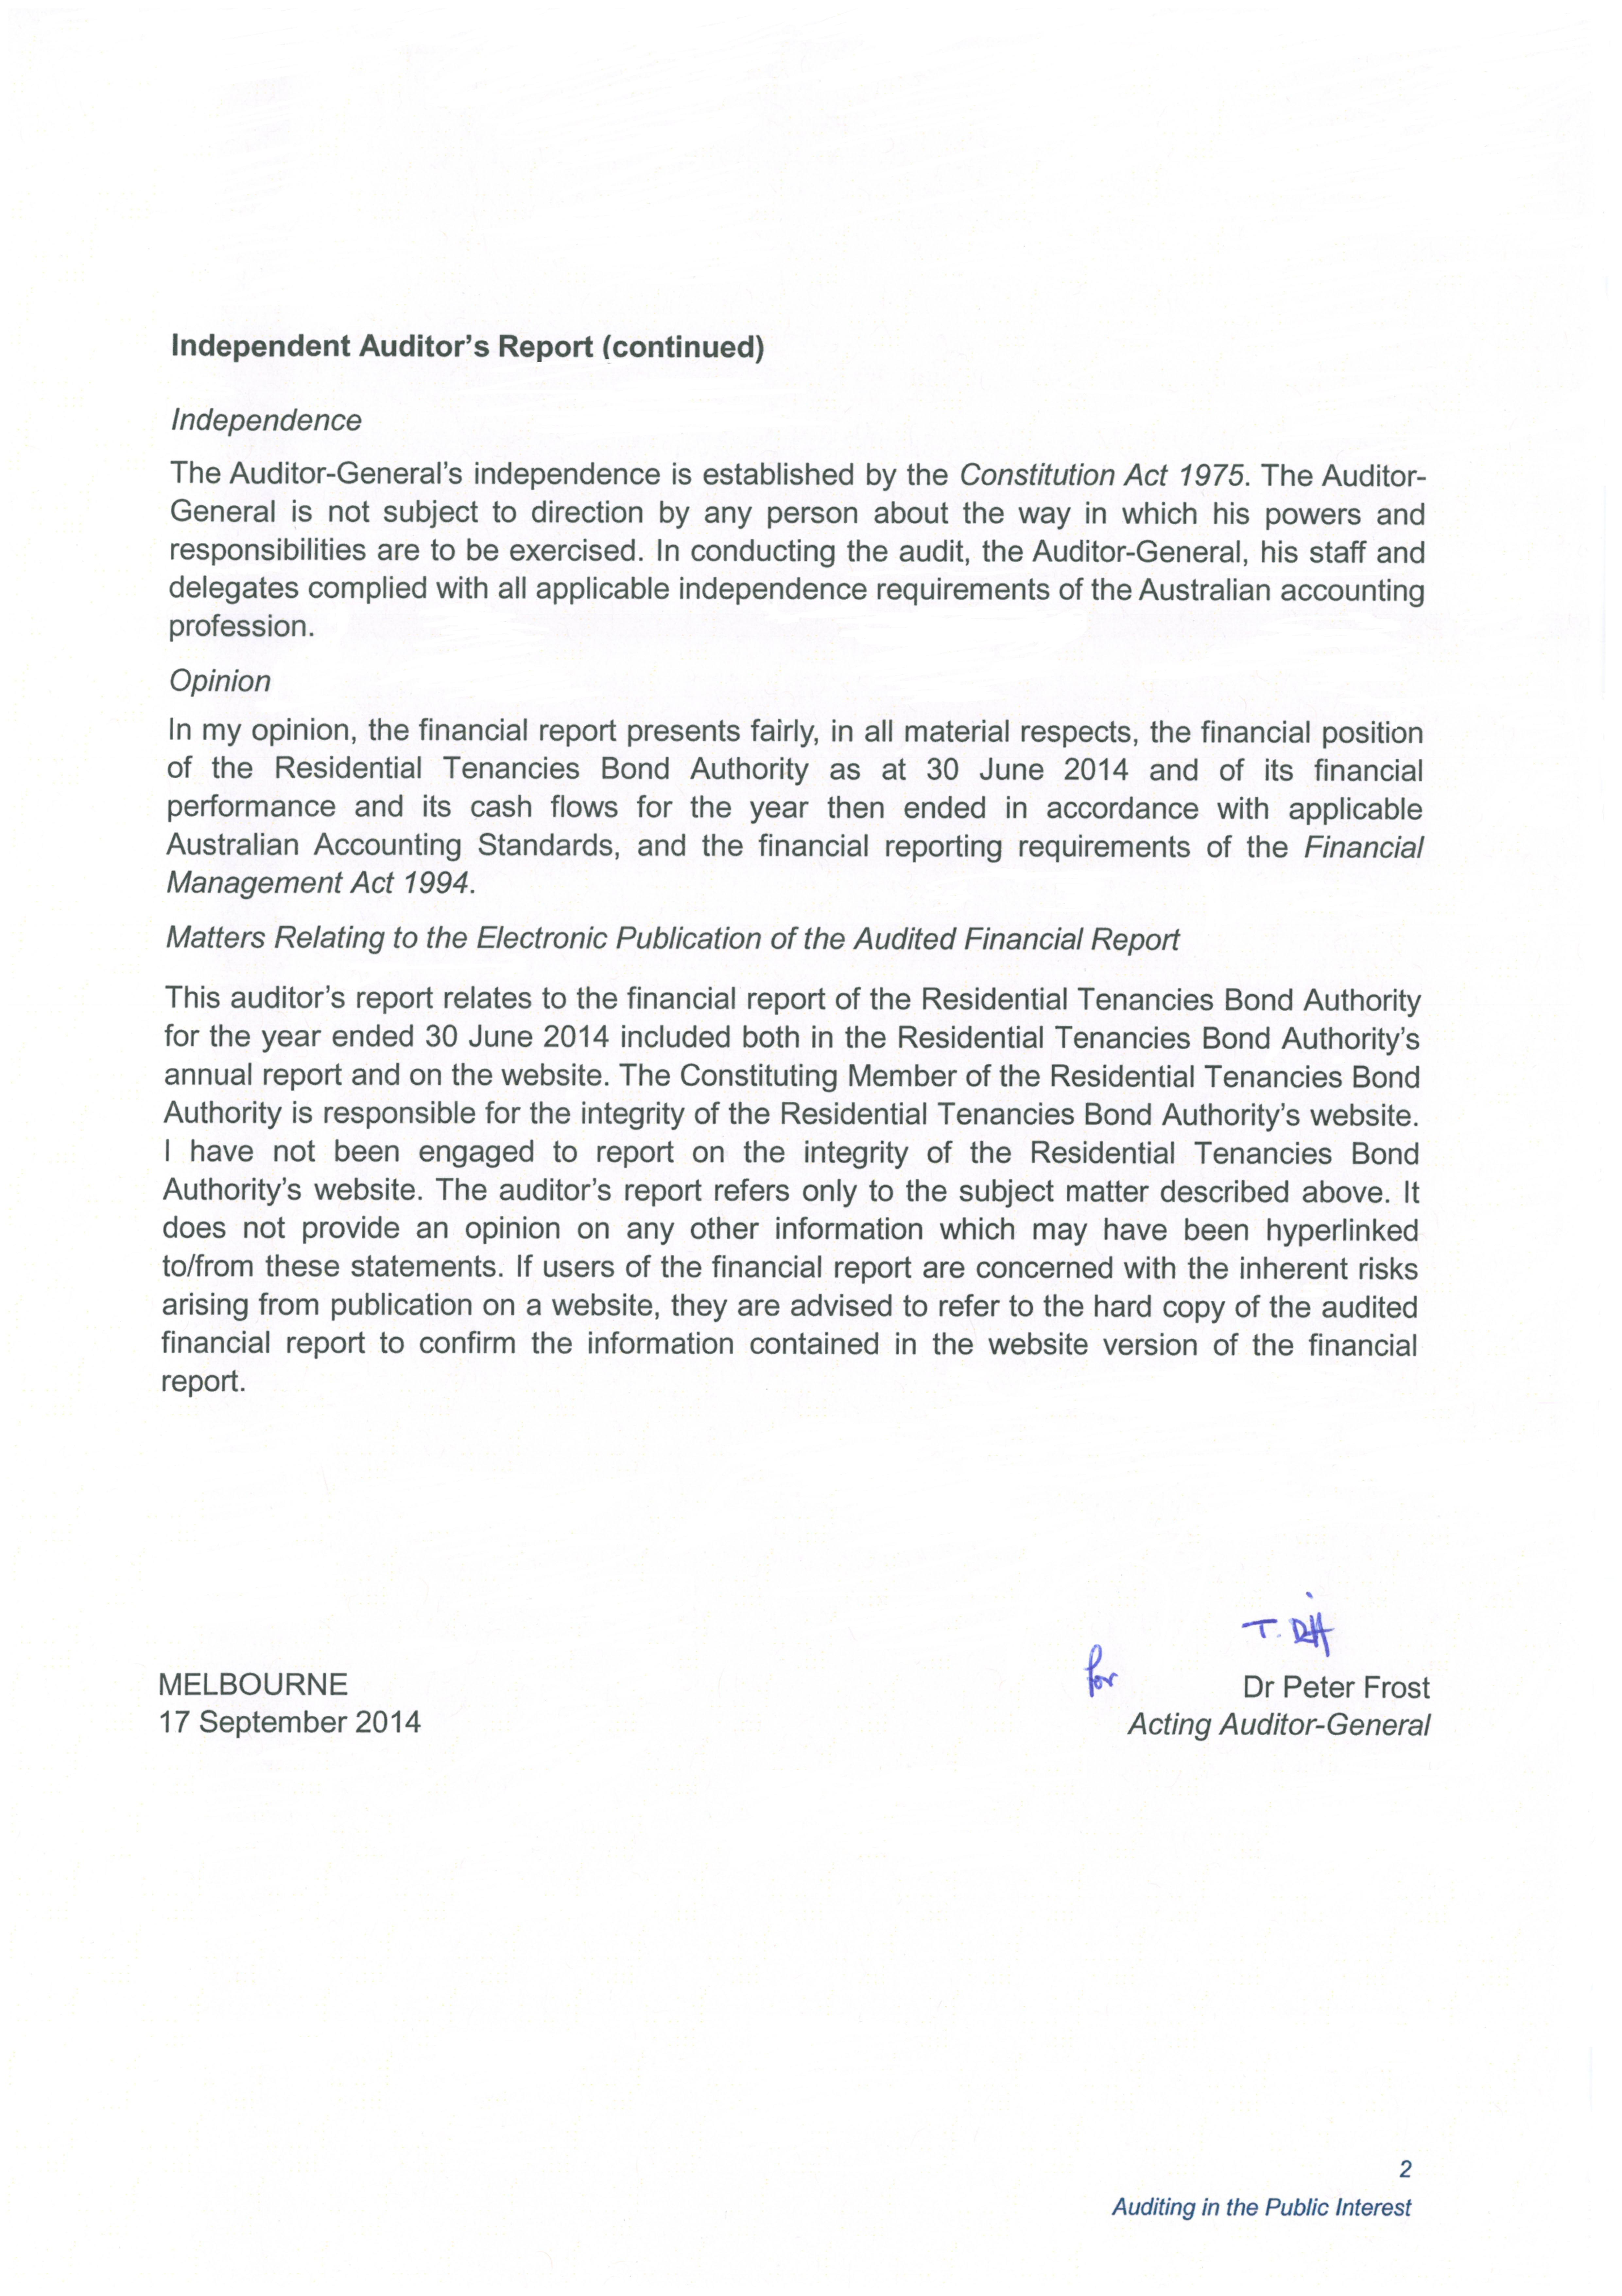

Comprehensive Operating Statement

Balance Sheet

Statement of Changes in Equity

Cash Flow Statement

Notes to the Financial Statements

