ENFORCEABLE UNDERTAKING

SECTION 218 of the AUSTRALIAN CONSUMER LAW (VICTORIA)

The commitments in this Undertaking are offered to the Director of Consumer Affairs Victoria by:
Australia Manolite Pty Ltd
(ACN 168 846 348)
and
ZHENGHONG MEI

TABLE OF CONTENTS
Contents
PARTIES 3
The Director 3
Australia Manolite Pty Ltd 3
Zhenghong Mei 3
LEGISLATION 4
Australian Consumer Law (Vic) 4
Application 4
Permanent Bans 4
Mandatory Safety Standards 4
Failure to comply with Mandatory Safety Standards gives rise to civil or criminal proceedings: 5
Civil 5
Criminal 5
Mandatory Information Standards 5
Failure to comply with Mandatory Information Standards gives rise to civil or criminal proceedings: 6
Civil 6
Criminal 6
Administrative resolution 7
Mandatory standards 7
CONSUMER AFFAIRS VICTORIA INVESTIGATION 8
Inspection and seizure 8
Determination of non-compliance 9
Contraventions of the ACL 9
Acknowledgment of the breach 10
Destruction of goods 13
UNDERTAKINGS 13
Refrain from further non-compliant conduct 13
Initiate a voluntary recall 14
Publish recall notice at points of sales 14
Publish recall notice on webpage 15
Provide refunds on recalled items 16
Compliance Program 16
Payment to the Victorian Consumer Law Fund 16
COMMENCEMENT 17
CONCLUSION/DURATION 17
PUBLIC NATURE OF UNDERTAKING 17
COMPLIANCE AND ENFORCEMENT 17
EXECUTION 18
ANNEXURES 19
Annexure A – Seized goods 19
Annexure B – Mandatory Standards and Bans 23
Annexure C – Product Safety Recall Notice 27
Annexure D – Compliance Program 28

PARTIES

The Director
- The office of the Director of Consumer Affairs Victoria (“the Director”) is provided for under section 107 of the Australian Consumer Law and Fair Trading Act 2012 (“the Act”).
- The Director is responsible for the administration of the Act, the Australian Consumer Law (“the ACL”) which is Schedule 2 to the Competition and Consumer Act 2010 (Cth), applied as a law of Victoria by Part 2.2 of the Act and known as the Australian Consumer Law (Victoria) (“the ACL (Vic)”), together with Victoria’s other consumer protection legislation.
- The Director, as a Regulator for the purposes of the ACL (Vic), and under the provisions of section 218 of the ACL (Vic), may accept a written undertaking from any person in connection with any matter involving a contravention of the ACL (Vic) in respect of which the Director has a power or function, as a means of resolving contraventions of the ACL (Vic).

Australia Manolite Pty Ltd
- Australia Manolite Pty Ltd (ACN 168 846 348) (“Australia Manolite”) is an Australian proprietary company limited by shares, which was registered on 31 March 2014. At all relevant times, Australia Manolite had and has:
  - its registered office and principal place of business at 5 Griffiths Grove, Brighton East, Victoria 3187; and
  - trades out of its warehouse premises located at 35 Nellbern Road, Moorabbin, Victoria 3189.
- Australia Manolite carries on business, in trade or commerce, operating as an importer and wholesaler in Victoria supplying miscellaneous products including toys, gifts, novelty products, tattoos, face paints and cosmetics and sticker products.

Zhenghong Mei
- Zhenghong Mei is and was, at all times relevant to this Undertaking:
  - the sole director and secretary of Australia Manolite;
  - a person who was authorised by Australia Manolite and responsible ultimately for acquiring, or arranging the acquisition of products supplied or offered for wholesale to numerous retailers; and
  - a person who was acting on behalf of Australia Manolite, in the usual and ordinary course of its business, in respect of the matter set out below.

LEGISLATION

Australian Consumer Law (Vic)

Application
- On 1 January 2011, the ACL, set out in Schedule 2 to the Competition and Consumer Act 2010 (Cth), was applied by Part 2.2 of the Act as a law of Victoria, which is known as the ACL (Vic).
- Part 3-3 of the ACL (Vic) deals with the safety of consumer goods and product-related services.
- Part 3-4 of the ACL(Vic) deals with the information standards for goods and services.

Permanent Bans
- Section 114(1) of the ACL (Vic) provides for the imposition, by the Commonwealth Minister for Competition Policy and Consumer Affairs (“the Commonwealth Minister”), of a permanent ban for consumer goods of a particular kind to prevent or reduce risk of injury to any person.

Mandatory Safety Standards
- Section 104 of the ACL (Vic) provides for the imposition, by the Commonwealth Minister, of a mandatory safety standard for consumer goods of a particular kind to prevent or reduce risk of injury to any person.

Failure to comply with Mandatory Safety Standards gives rise to civil or criminal proceedings:

Civil
- Section 106 of the ACL (Vic) imposes an obligation upon persons to refrain from:
  - in trade or commerce, supplying or offering for supply consumer goods; or
  - in or for the purpose of trade or commerce, possessing or having control of consumer goods;
if a safety standard is in force in respect of those goods and those goods, do not comply with the standard.
- A person who contravenes sections 106 of the ACL (Vic) may, in civil proceedings brought for contraventions of that section, be subject to the range of remedies available under Part 5-2 of the ACL (Vic), including the imposition of pecuniary penalties in respect of each contravention of not more than:
  - $220,000 in the case of an individual; or
  - $1,100,000 in the case of a body corporate.

Criminal
- Section 194 of the ACL (Vic) creates an offence which is committed if a person:
  - in trade or commerce, supplies or offers for supply; or
  - in or for the purposes of trade or commerce, possesses or has control of,–
consumer goods of a particular kind and a safety standard for consumer goods of that kind is in force and those goods do not comply with that standard.
- A person who breaches section 194 of the ACL (Vic) may be convicted and liable, to a fine, in respect of each offence, of not more than:
  - $220,000 in the case of an individual; or
  - $1,100,000 in the case of a body corporate

Mandatory Information Standards
- Section 134 of the ACL (Vic) provides for the imposition, by the Commonwealth Minister, of a mandatory information standard for consumer goods of a particular kind.

Failure to comply with Mandatory Information Standards gives rise to civil or criminal proceedings:

Civil
- Section 136 of the ACL (Vic) imposes an obligation upon persons to refrain from:
  - in trade or commerce, supplying or offering for supply consumer goods; or
  - in or for the purpose of trade or commerce, possessing or having control of consumer goods;
if an information standard is in force in respect of those goods and those goods, do not comply with the standard.
- A person who contravenes sections 106 of the ACL (Vic) may, in civil proceedings brought for contraventions of that section, be subject to the range of remedies available under Part 5-2 of the ACL (Vic), including the imposition of pecuniary penalties in respect of each contravention of not more than:
  - $220,000 in the case of an individual; or
  - $1,100,000 in the case of a body corporate

Criminal
- Section 203 of the ACL (Vic) creates an offence which is committed if a person:
  - in trade or commerce, supplies or offers for supply; or
  - in or for the purposes of trade or commerce, possesses or has control of,–
consumer goods of a particular kind and an information standard for consumer goods of that kind is in force and those goods do not comply with that standard.
- A person who breaches section 203 of the ACL (Vic) may be convicted and liable, to a fine, in respect of each offence, of not more than:
  - $220,000 in the case of an individual; or
  - $1,100,000 in the case of a body corporate

Administrative resolution
- Section 218 of the ACL (Vic) provides that the Director may accept a written undertaking given by a person for the purposes of addressing contraventions of the ACL (Vic) in resolution of such contraventions or breaches of the ACL (Vic) and may be downloaded from the website at www.productsafety.gov.au.

Mandatory standards
- For the purposes of Part 3-3 and 3-4 of the ACL (Vic), pursuant to section 65E of the Trade Practices Act 1974 (C’th) and for the purposes of section 65C of the Act in relation to safety standards and section 65D of that Act in relation information standards, the Commonwealth Minister made:
  - A Mandatory Safety Standard, on 30 June 2010, relating to children’s projectile toys by way of Consumer Protection Notice No. 16 of 2010 Consumer Product Safety Standard for Children’s Projectile Toys (“the Projectile Toy Standard”) which are mandatory standards by the operation of clause 4 to schedule 7 of the Trade Practices Amendment (Australian Consumer Law) Act (No.2) 2010, and which continues in effect as if imposed pursuant of section 104(1)(a) of the ACL (Vic).
  - A Mandatory Safety Standard, on 14 November 2008, relating to sunglasses and fashion spectacles by way of Consumer Product Safety Standard: Sunglasses and fashion spectacles, Consumer Protection Notice No.13 of 2003 (“Consumer Protection Notice No. 13 of 2003”) which was a mandatory standard by the operation of clause 4 to schedule 7 of the Trade Practices Amendment (Australian Consumer Law) Act (No.2) 2010, and which continued in effect as if imposed pursuant of section 104(1)(a) of the ACL (Vic). On 26 October 2017, Consumer Protection Notice No. 13 of 2003 was repealed and replaced by the Consumer Goods (Sunglasses and Fashion Spectacles) Safety Standard 2017 (“the Sunglasses Standard”). The sunglasses standard provides a transitional period which allows compliance with Consumer Protection Notice No. 13 of 2003 until 30 June 2019.
  - An Information Standard, on 29 October 1991, relating to cosmetics by way of Trade Practices (Consumer Product Information Standards) (Cosmetics) Regulations 1991 (“the Cosmetics Standard”) which are mandatory standards by the operation of clause 5 to schedule 7 of the Trade Practices Amendment (Australian Consumer Law) Act (No.2) 2010, and which continues in effect as if imposed pursuant of section 134(1) of the ACL (Vic).
- Details of the standards are available and may be downloaded from the website at www.productsafety.gov.au.

CONSUMER AFFAIRS VICTORIA INVESTIGATION

Inspection and seizure
- On 15 September 2017, Consumer Affairs Victoria Inspectors (“CAV Inspectors”) pursuant to section 155 of the Act, attended Australia Manolite’s trading premises at 35 Nellbern Road, Moorabbin, Victoria 3189 (“the trading premises”).
- CAV Inspectors ascertained that Australia Manolite occupied the trading premises and operated an import and wholesale business offering for supply miscellaneous products including toys, projectile toys, tattoos, face paint and stickers.
- CAV Inspectors identified items offered for supply and determined that:
  - 2860 pairs of sunglasses that were non-compliant with the mandatory standard in place at that time relating to sunglasses set out in Consumer Protection Notice No. 13, being aviator sunglasses identified by barcodes 6009183004212 and 6009183004199.
  - 62 projectile toys which were non-compliant with the mandatory standards relating to projectile toys being Bow & Arrows identified by and barcode 9312345541386.
  - 755 cosmetics being:
    - Halloween Make Up White Cream identified by barcode 9302731219514;
    - Halloween Face Paint identified by item code S3168 with no barcode;
    - Nail Polish identified by barcode 9312345620661; and
    - Temporary tattoos identified by barcode 9301524130046; and
    - Creepy Skin make up identified by barcode 9302731205107.
- On 15 September 2017, CAV Inspectors lawfully seized the sunglasses, projectile toys and cosmetics identified in paragraph 26. Samples of the toys identified in paragraph 26 are depicted and described in Annexure “A” attached.

Determination of non-compliance
- On 15 September 2017, Consumer Affairs Victoria Inspectors determined that the sunglasses seized and referred to in paragraph 26(a) failed to meet the requirements of Consumer Protection Notice No. 13, as the sunglasses did not have in the form of:
- an indelible marking on the sunglasses frame; or
- a removable label affixed to the lens; or
- a removable label securely attached or tied to the frame; or
- any combination of the means identified in sub-paragraphs (a) to (c) above;
information sufficient to identify the manufacturer or suppliers of the sunglasses, the lens category number and description in accordance with clause 4 of the Australian/New Zealand Standard 1067 and the number of Australian/New Zealand Standard 1067.
- On 15 September 2017, Consumer Affairs Victoria Inspectors determined that the projectile toys seized and referred to in paragraph 26(b) failed to meet the requirements of clause 4.18.3(e) of the Projectile Toy Standard, as they failed to have any warnings or labels drawing attention to the potential danger of misuse of aiming them at a person’s eyes or face; or using projectiles other than those supplied or recommended by the manufacturer.
- On 15 September 2017, Consumer Affairs Victoria Inspectors determined that the cosmetics seized and referred to in paragraph 26(c) failed the requirements of clause 5 of the Cosmetics Standard because:
  - the ingredients of the cosmetics products were not listed on the container or,
  - if the product was not packed in a container, on the product, or
  - if (a) or (b) above could not be complied with because of its size, shape or nature, a list of ingredients were not shown in another way that ensured that a consumer could be informed about the ingredients in the product.

Contraventions of the ACL
- The Director considers that Australia Manolite contravened sub-section 106(1), (2) and (3) respectively of the ACL (Vic) by supplying, offering to supply and having in its possession or control, in or for the purposes of trade or commerce not less than 2860 sunglasses that do not comply with the sunglasses standard at that time set out in Consumer Protection Notice No. 13.
- The Director considers that Australia Manolite contravened sub-section 106(1), (2) and (3) respectively of the ACL (Vic) by supplying, offering to supply and having in its possession or control, in or for the purposes of trade or commerce not less than 62 projectile toys that do not comply with the Projectile Toy Standard.
- The Director considers that Australia Manolite contravened sub-section 136(1), (2) and (3) respectively of the ACL (Vic) by supplying, offering to supply and having in its possession or control, in or for the purposes of trade or commerce not less than 755 cosmetics that do not comply with the Cosmetics Standard.
- The Director is prepared to deal with these alleged contraventions by accepting this written undertaking pursuant to section 218 of the ACL (Vic).

Acknowledgment of the breach
- Zhenghong Mei, on behalf of Australia Manolite, acknowledges that on 15 September 2017 Australia Manolite contravened subsection 106(1) of the ACL(Vic) in that, in trade or commerce, Australian Manolite did supply sunglasses and fashion spectacles:
  - for which there was a safety standard in force, namely the Consumer Protection Notice No. 13 of 2003; and
  - those goods did not comply with Consumer Protection Notice No. 13 of 2003 because the sunglasses and fashion spectacles did not provide information of the manufacturer or supplier, lens category number and description and the number of Australian Standard AS/NZS 1067 in the form of an indelible marking on the sunglasses frame, removable label affixed to the lens, or a removable label securely attached or tied to the frame in contravention of Clause 4.2.1, or at all, in contravention of Clause 4.1.1 of Australia/ New Zealand Standard AS/NZS 1067:2003 Sunglasses and Fashion Spectacles.

- Zhenghong Mei, on behalf of Australia Manolite, acknowledges that on 15 September 2017 Australia Manolite contravened subsection 106(2) of the ACL (Vic) in that Australian Manolite, in trade or commerce, offered for supply consumer goods, the supply of which is prohibited by subsection 106(1), because the sunglasses and fashion spectacles did not provide information of the manufacturer or supplier, lens category number and description and the number of Australian Standard AS/NZS 1067 in the form of an indelible marking on the sunglasses frame, removable label affixed to the lens, or a removable label securely attached or tied to the frame in contravention of Clause 4.2.1, or at all, in contravention of Clause 4.1.1of Australia/ New Zealand Standard AS/NZS 1067:2003 Sunglasses and Fashion Spectacles.
- Zhenghong Mei, on behalf of Australia Manolite, acknowledges that on 15 September 2017 Australia Manolite contravened subsection 106(3) of the ACL (Vic) in that Australian Manolite, in or for the purposes of trade or commerce, did possess or have control of consumer goods, the supply of which is prohibited by section 106(1), because the sunglasses and fashion spectacles did not provide information of the manufacturer or supplier, lens category number and description and the number of Australian Standard AS/NZS 1067 in the form of an indelible marking on the sunglasses frame, removable label affixed to the lens, or a removable label securely attached or tied to the frame in contravention of Clause 4.2.1, or at all, in contravention of Clause 4.1.1of Australia/ New Zealand Standard AS/NZS 1067:2003 Sunglasses and Fashion Spectacles.

- Zhenghong Mei, on behalf of Australia Manolite, acknowledges that on 15 September 2017 Australia Manolite contravened subsection 106(1) of the ACL(Vic) in that, in trade or commerce, Australian Manolite did supply consumer goods of a particulars kind:
- for which a safety standard was in force, namely the Projectile Toys Standard, and
- those goods did not comply with the Projectile Toys Standard, because contrary to [4.18.2] and [4.18.3] of AN/NZS ISO 8124.1:2002 the consumer goods failed to have any warnings or labels drawing attention to the potential danger of misuse in aiming them at a person’s eyes or face; or using projectiles other than those supplied or recommended by the manufacturer.
- Zhenghong Mei, on behalf of Australia Manolite, acknowledges that on 15 September 2017 Australia Manolite contravened subsection 106(2) of the ACL (Vic) in that Australian Manolite, in trade or commerce, offered for supply consumer goods, the supply of which is prohibited by subsection 106(1) because contrary to [4.18.2] and [4.18.3] of AN/NZS ISO 8124.1:2002, the consumer goods failed to have any warnings or labels drawing attention to the potential danger of misuses in aiming them at a person’s eyes or face; or using projectiles other than those supplied or recommended by the manufacturer.

- Zhenghong Mei, on behalf of Australia Manolite, acknowledges that on 15 September 2017 Australia Manolite contravened subsection 106(3) of the ACL (Vic) in that Australian Manolite, in or for the purposes of trade or commerce, did possess or have control of consumer goods, the supply of which is prohibited by section 106(1), because contrary to [4.18.2] and [4.18.3] of AN/NZS ISO 8124.1:2002, the consumer goods failed to have any warnings or labels drawing attention to the potential danger of misuses in aiming them at a person’s eyes or face; or using projectiles other than those supplied or recommended by the manufacturer.
- Zhenghong Mei, on behalf of Australia Manolite, acknowledges that on 15 September 2017 Australia Manolite contravened subsection 136(1) of the ACL(Vic) in that, in trade or commerce, Australian Manolite did supply consumer goods of a particulars kind:
- for which there was an information standard for goods of that kind in force, namely the Cosmetics Information Standard; and
- for which Australian Manolite has not complied with the Cosmetics Information Standard because:
- the ingredients of the cosmetics products were not listed on the container or,
- if the product was not packed in a container, on the product; or
- if i. or ii. above could not be complied with because of its size, shape or nature, a list of ingredients were not shown in another way that ensured that a consumer could be informed about the ingredients in the product;
as required by Clause 5(1) and 5(3).
- Zhenghong Mei, on behalf of Australia Manolite, acknowledges that on 15 September 2017 Australia Manolite contravened subsection 136(2) of the ACL(Vic) in that Australia Manolite, in trade or commerce did offer for supply goods, the supply of which is prohibited by subsection 136 (1), because:
- the ingredients of the cosmetics products were not listed on the container or;
- if the product was not packed in a container, on the product; or
- if i. or ii. above could not be complied with because of its size, shape or nature, a list of ingredients were not shown in another way that ensured that a consumer could be informed about the ingredients in the product;
as required by Clause 5(1) and 5(3).
- Zhenghong Mei, on behalf of Australia Manolite, acknowledges that on 15 September 2017 Australia Manolite contravened subsection 136(3) of the ACL(Vic) in that Australia Manolite, did in or for the purposes of trade or commerce, possess or have control of goods, the supply of which is prohibited by subsection 136 (1), because:
- the ingredients of the cosmetics products were not listed on the container; or
- if the product was not packed in a container, on the product; or
- if i. or ii. above could not be complied with because of its size, shape; or nature, a list of ingredients were not shown in another way that ensured that a consumer could be informed about the ingredients in the product;
as required by Clause 5(1) and 5(3).
- Zhenghong Mei acknowledges personally that, at all times, he was directly or indirectly knowingly concerned in, and a party to Australia Manolite’s contraventions referred to in paragraph 35- 43 of this Undertaking, save that he did not know that the goods referred to in those paragraphs contravened safety and information standards before being so informed by CAV inspectors on about 15 September 2017.
- Zhenghong Mei, individually, and on behalf of Australia Manolite, seeks to address these acknowledged contraventions of section 106 and 136 of the ACL (Vic) by offering this Undertaking to the Director.

Destruction of goods
- Zhenghong Mei, personally and on behalf of Australia Manolite:
  - confirms that Australia Manolite is the owner of or holds title to or was in control of the goods seized by CAV staff at Australia Manolite premises on 15 September 2017;
  - authorises for the Director to destroy and dispose of all the goods seized by CAV staff at Australia Manolite premises on 15 September 2017;
  - forfeits any claim or right or any future claim or right to those goods seized by CAV staff at Australia Manolite premises on 15 September 2017; and
  - will pay a total contribution of up to $500 (“the $500 contribution”) to the Director for the destruction of the goods, within 30 days of the commencement of this undertaking.
- Consumer Affairs Victoria staff will provide Zhenghong Mei on behalf of Australia Manolite a copy of the receipt for payment of destruction of the goods. If the total cost for the destruction of the goods is less than $500, Consumer Affairs Victoria staff on behalf of the Director will reimburse Zhenghong Mei any unused portion of the $500 contribution that was not applied towards the destruction of those goods.

UNDERTAKINGS

Refrain from further non-compliant conduct
- Zhenghong Mei, personally and on behalf of Australia Manolite, undertakes to the Director that he will:
  - refrain from offering to supply;
  - supplying; and
  - being in possession or having under its control -
or being in any way, directly or indirectly knowingly concerned in or party to offering to supply, supplying, manufacturing, possession or controlling any products identified in Annexure “B” attached, which fail to comply with the requirements of any:
- safety standard declared under Division 1 of Part 3-3 of the ACL (VIC)
- interim or permanent ban order imposed under Division 2 of Part 3-3 of the ACL (Vic); or
- information standard made under Part 3-4 of the ACL (Vic)

Initiate a voluntary recall
- Zhenghong Mei, personally and on behalf of Australia Manolite, undertakes to the Director that he will initiate a voluntary recall of the products, depicted and described in Annexure “C” attached, supplied by the company during the period, sufficient to satisfy the requirements of section 128 of the ACL and that Australia Manolite will give the Commonwealth Minister a written Notice in the form of Annexure “C” attached, electronically via the electronic document accessible at http://www.recalls.gov.au.

Publish recall notice at points of sales
- Zhenghong Mei, personally and on behalf of Australia Manolite, undertakes to the Director that he will within 30 days of the commencement of this Undertaking, cause to be displayed prominently for a continuous period of 90 days:
  - at or near the office area where it is visible to clients; and
  - inside the trading premises at the relevant entry/exit points
in each of its existing or new premises from which it carries on business, solely or jointly, of supplying goods to retailers or as retailers to other purchasers, a Product Safety Warning and Recall Notice in the form of Annexure “C” attached.
- Each such Notice will
  - be a minimum size of 30 cm x 42 cm (A3 size);
  - use a minimum type size of 12 point Times New Roman or equivalent; and
  - be in the full colour.
- Zhenghong Mei, personally and on behalf of Australia Manolite, undertakes to the Director that he within 14 days following the commencement of this Undertaking will notify the Director in writing that he has complied fully with the undertaking and caused the display of the notices in accordance with paragraphs 50 and 51.

Publish recall notice on webpage
- Zhenghong Mei, personally and on behalf of Australia Manolite, undertakes to the Director he will:
(a) retain and continue to operate the website accessible via uniform resource located at the website (URL) https://www.fofo.com.au/ (“the website”); and
(b) within 14 days of commencement of this Undertaking, caused to be published, the Product Safety Warning and Recall in the form Annexure “C” attached, on the website (or if any such URL is replaced or changed, the Internet home page of the corresponding website), for a period of 90 days from the date of this undertaking and use its best endeavours to ensure that:
(i) the Product Safety Warning and Recall Notice is to be viewable by clicking through a “click-through” icon located on the website or any replacement website:
(ii) the “click-through” icon referred to in the previous sub paragraph is located in a central position on the page first accessed when the user opens to the home page of the website or any replacement website;
(iii) the ‘click-through” icon must contain the words “PRODUCT SAFETY – IMPORTANT NOTICE” (in capital letters and use a minimal type of 16 point Times New Roman or equivalent), clearly and prominently in red on a contrasting background and the words “Click Here”; and
(iv) the Product Safety Warning and Recall Notice occupies the entire page of each webpage on which the Notice occurs, or on any replacement website, which is accessed via the “click-through” icon referred to above: and
(v) the website (or if any such URL is replaced or change, the Internet home page of the corresponding website) shall not have in place any mechanism which would preclude internet search engines from:
1. Indexing the page; or
2. scanning the pages for links to follow.

Provide refunds on recalled items
- Zhenghong Mei, personally, and on behalf of Australia Manolite, undertakes to the Director that he will pay a full refund to all persons returning any of the projectile toys recalled by Australia Manolite.

Compliance Program
- Zhenghong Mei, personally, and on behalf of Australia Manolite, undertakes to the Director that he will:
  - implement a compliance program in accordance with Annexure “D” attached, designed to ensure that, in or for the purposes of trade or commerce, Australia Manolite will not supply, possess or have control of products, including products of a kind or class listed in Annexure “B” attached, that contravene any;
- safety standards declared under Division 1 of Part 3-3 of the ACL (Vic);
- interim or permanent ban orders imposed under Division 2 of Part 3-3 of the ACL (Vic); or
- information standard made under Part 3-4 of the ACL (Vic)
which are, in effect, as at the commencement date of this Undertaking, and for which there continues to exist a safety standard or interim or permanent ban order under the ACL (Vic); and
  - within 65 days of the commencement of this Undertaking, will notify the Director in writing that in accordance with this Undertaking the Compliance Program has been implemented.
  - comply with the requirements set out in the Compliance Program including any specified time limits.

Payment to the Victorian Consumer Law Fund
- Zhenghong Mei, personally, and on behalf of Australia Manolite, undertakes to the Director that he will pay the sum of $4,500 to the Victorian Consumer Law Fund, created under section 134 of the ACLFTA, in nine instalments, as follows: ,
(a) a first instalment of $500 payable by 31 July 2018;
(b) a second instalment of $500 payable by 31 August 2018;
(c) a third instalment of $500 payable by 30 September 2018;
(d) a fourth instalment of $500 payable by 31 October 2018;
(e) a fifth instalment of $500 payable by 30 November 2018;
(f) a sixth instalment of $500 payable by 31 December 2018;
(g) a seventh instalment of $500 payable by 31 January 2019; and
(h) eighth instalment of $500 payable by 28 February 2019;
(i) ninth and final instalment of $500 payable by 31 March 2019.
- If Zhenghong Mei fails to pay any of the instalment amounts by the due date, the full amount of the outstanding amount (not just the instalment amount) becomes immediately due and payable and must be paid by the Company within 30 days of receiving a letter from the Director, or the Director’s staff, requesting or demanding the amount outstanding.

COMMENCEMENT
- This Undertaking commences on the eighth day after the date the Director of Consumer Affairs Victoria signs the Undertaking.

CONCLUSION/DURATION
- This Undertaking remains in effect for a period of three years from its commencement.

PUBLIC NATURE OF UNDERTAKING
- Zhenghong Mei, personally, and on behalf of Australia Manolite, acknowledges that:
  - pursuant to section 218 of the ACL (Vic), the Director will register this Undertaking in the Register of the Undertaking on the Consumer Affairs Victoria website and the Undertaking will be available for public inspection;
  - the Director and/or the Minister for Consumer Affairs Victoria may, from time to time, publicly refer to this Undertaking;
  - this Undertaking in no way derogates from the rights and remedies available to any other person arising from the alleged conduct; and
  - no compensation is payable to it, or on its behalf, arising from the destruction by the Director, or his staff, of any of the goods seized from the premises on 15 September 2017.

COMPLIANCE AND ENFORCEMENT
- Zhenghong Mei, personally, and on behalf of Australia Manolite, acknowledges that:
  - Consumer Affairs Victoria will continue to conduct compliance monitoring inspections of premises of suppliers in Victoria, investigate and prosecute breaches of the ACL (Vic) and institute and defend proceedings to achieve the purposes of the ACL (Vic); and
  - the Director of Consumer Affairs Victoria reserves the right to enforce a breach of this Undertaking in a Court to the full extent provided by law.

EXECUTION
Signed by: ………………………………………………..…………..
On
……………………..…………….2018
Zhenghong Mei, personally and as Company Director, on behalf of Australia Manolite
In the presence of……………………..…………..…….…….
Witness
(PRINT NAME) ………………………………….……....….……
Signed by: ………………………………………………..…………..
Accepted by the Director of Consumer Affairs Victoria pursuant to section 218 of the ACL.
………………………………….……………
DATED ……………………….……..…………..2018
Simon Cohen

ANNEXURES

Annexure A – Seized goods
Goods seized from Australia Manolite by Consumer Affairs Victoria Inspectors on 15 September 2017.

PHOTOGRAPH 1
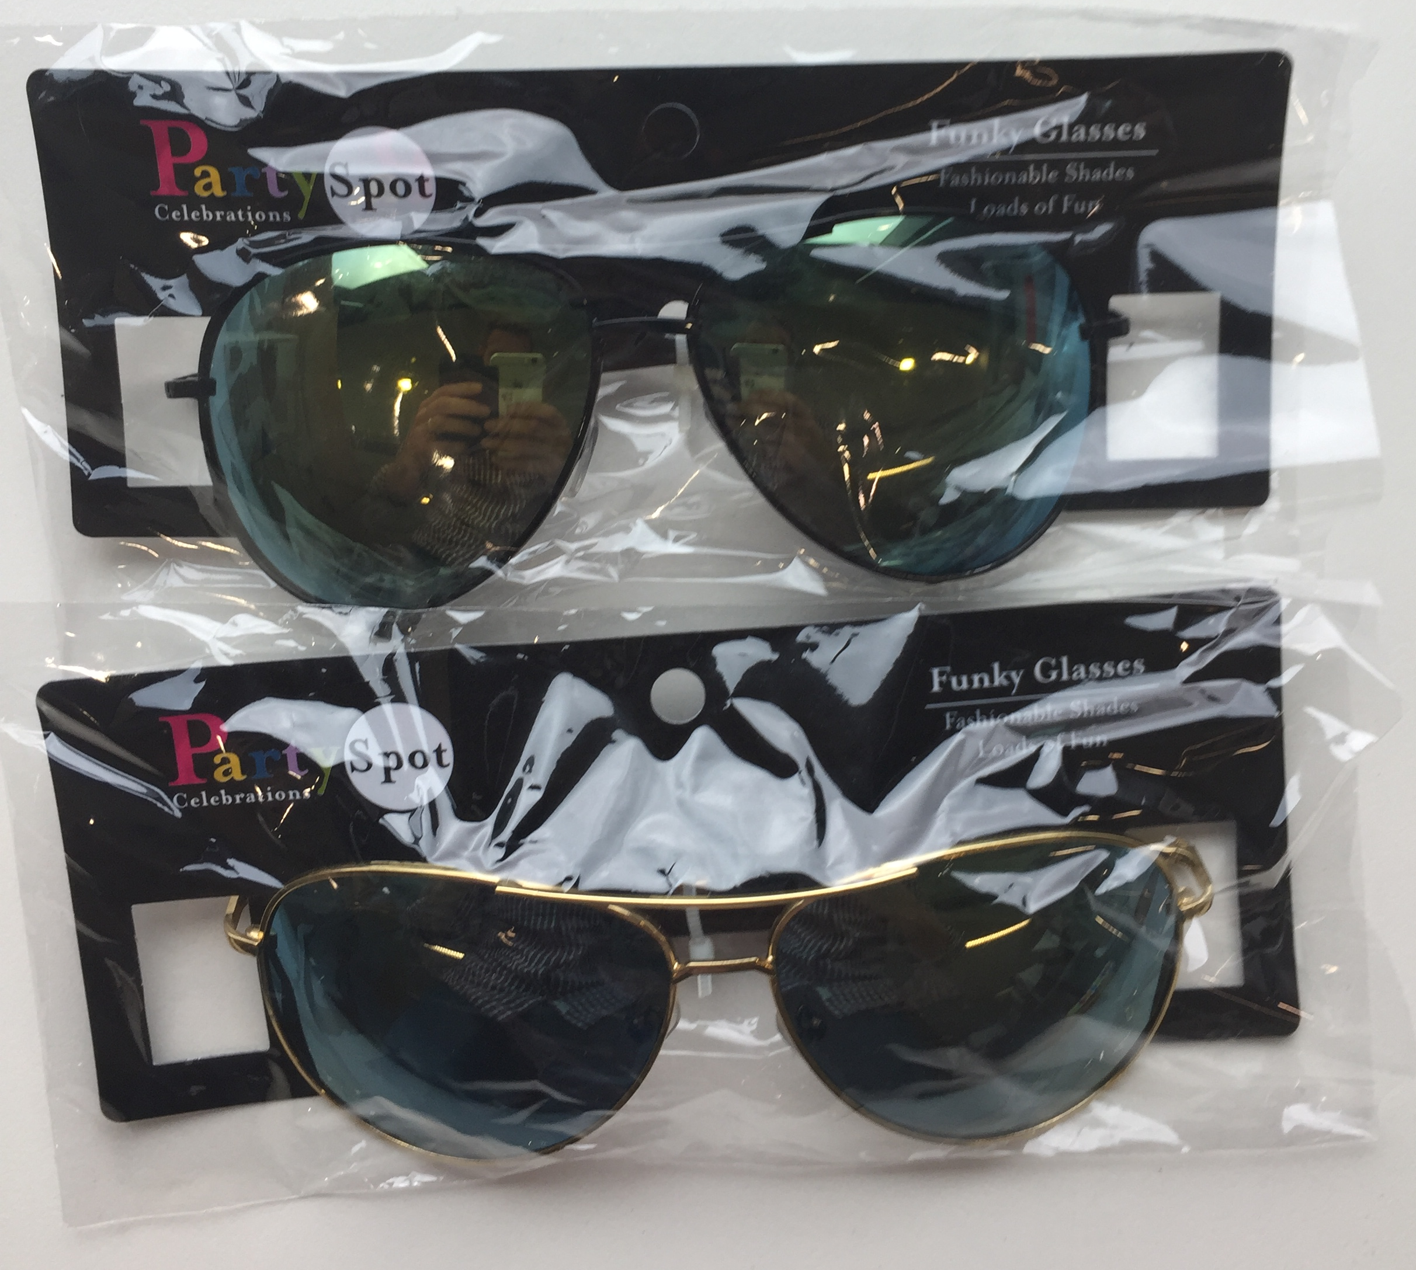

Aviator sunglasses identified by barcodes 6009183004212 and 6009183004199.

PHOTOGRAPH 2
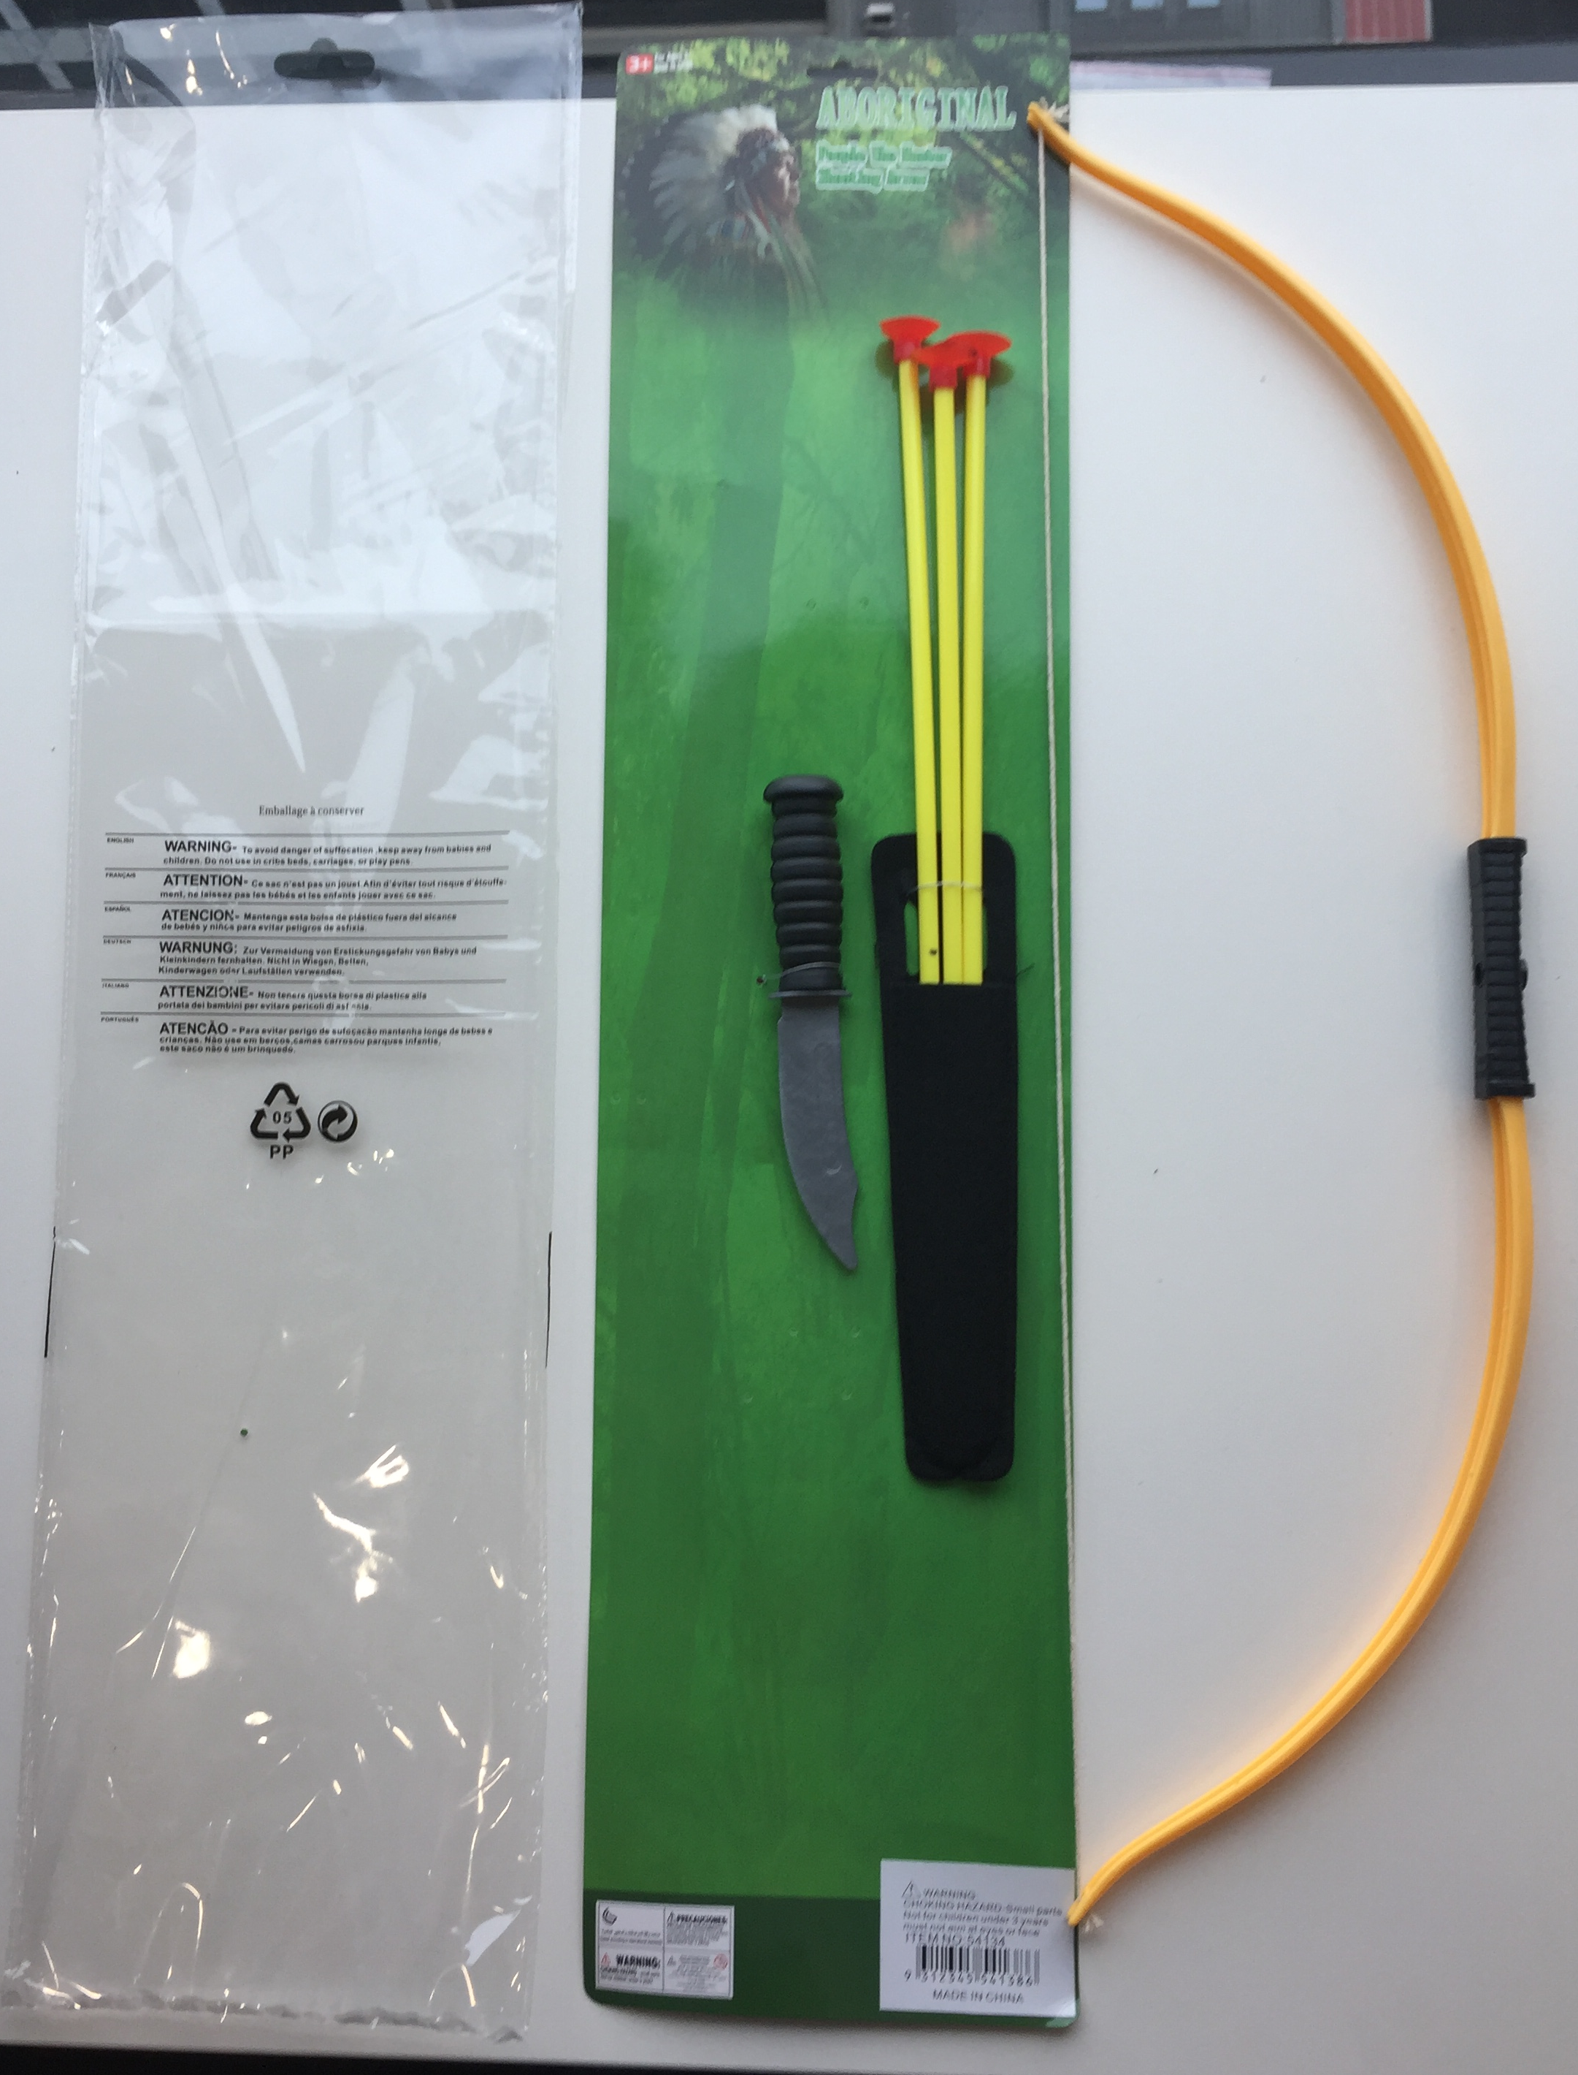

Bow & Arrows identified by and barcode 9312345541386

PHOTOGRAPH 3
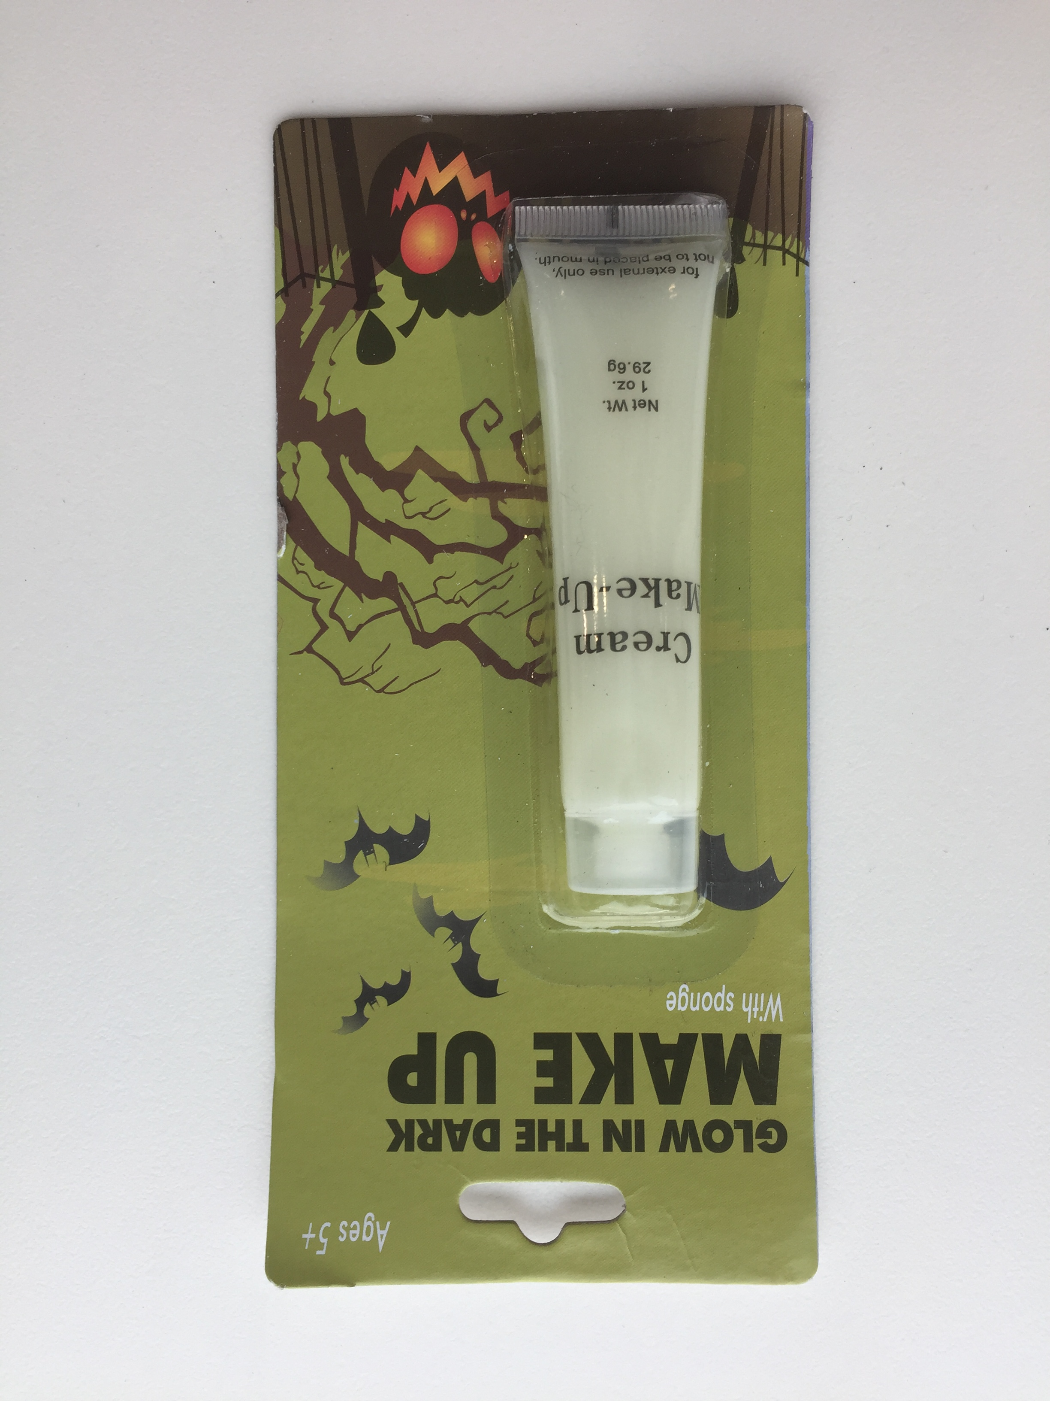
Halloween Make Up White Cream identified by barcode 9302731219514

PHOTOGRAPH 4
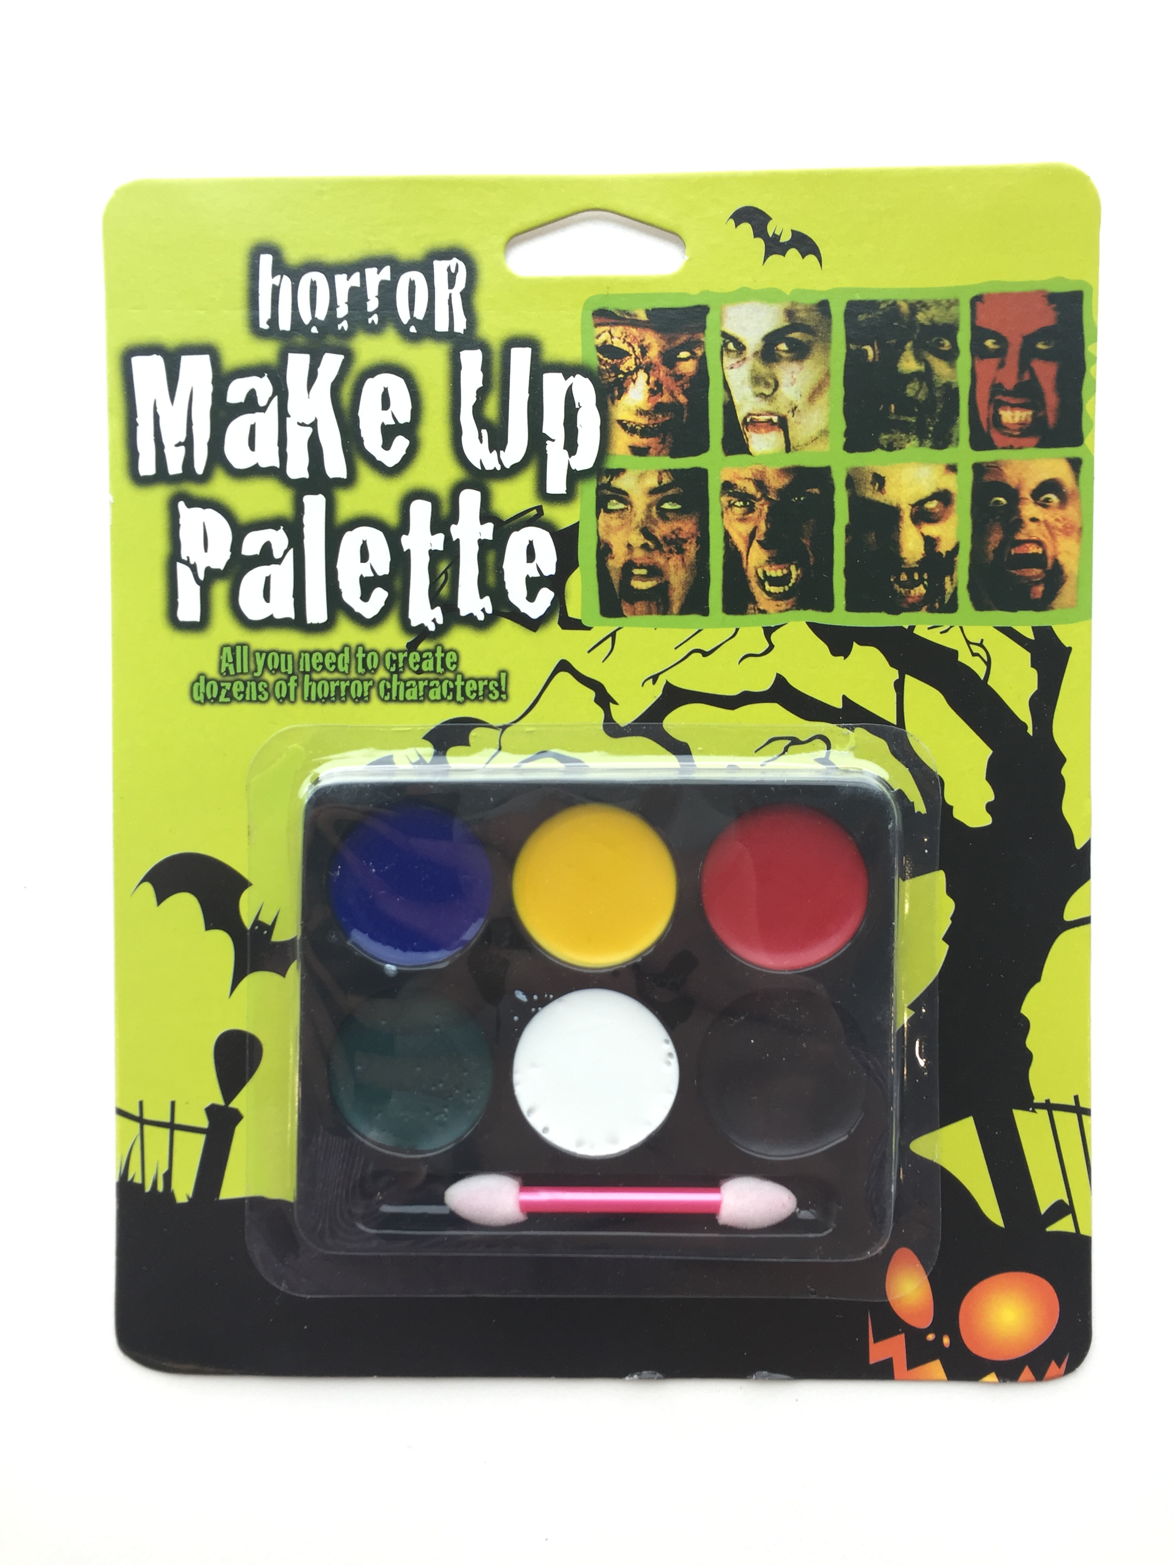
Halloween Face Paint identified by item code S3168 with no barcode;

PHOTOGRAPH 5
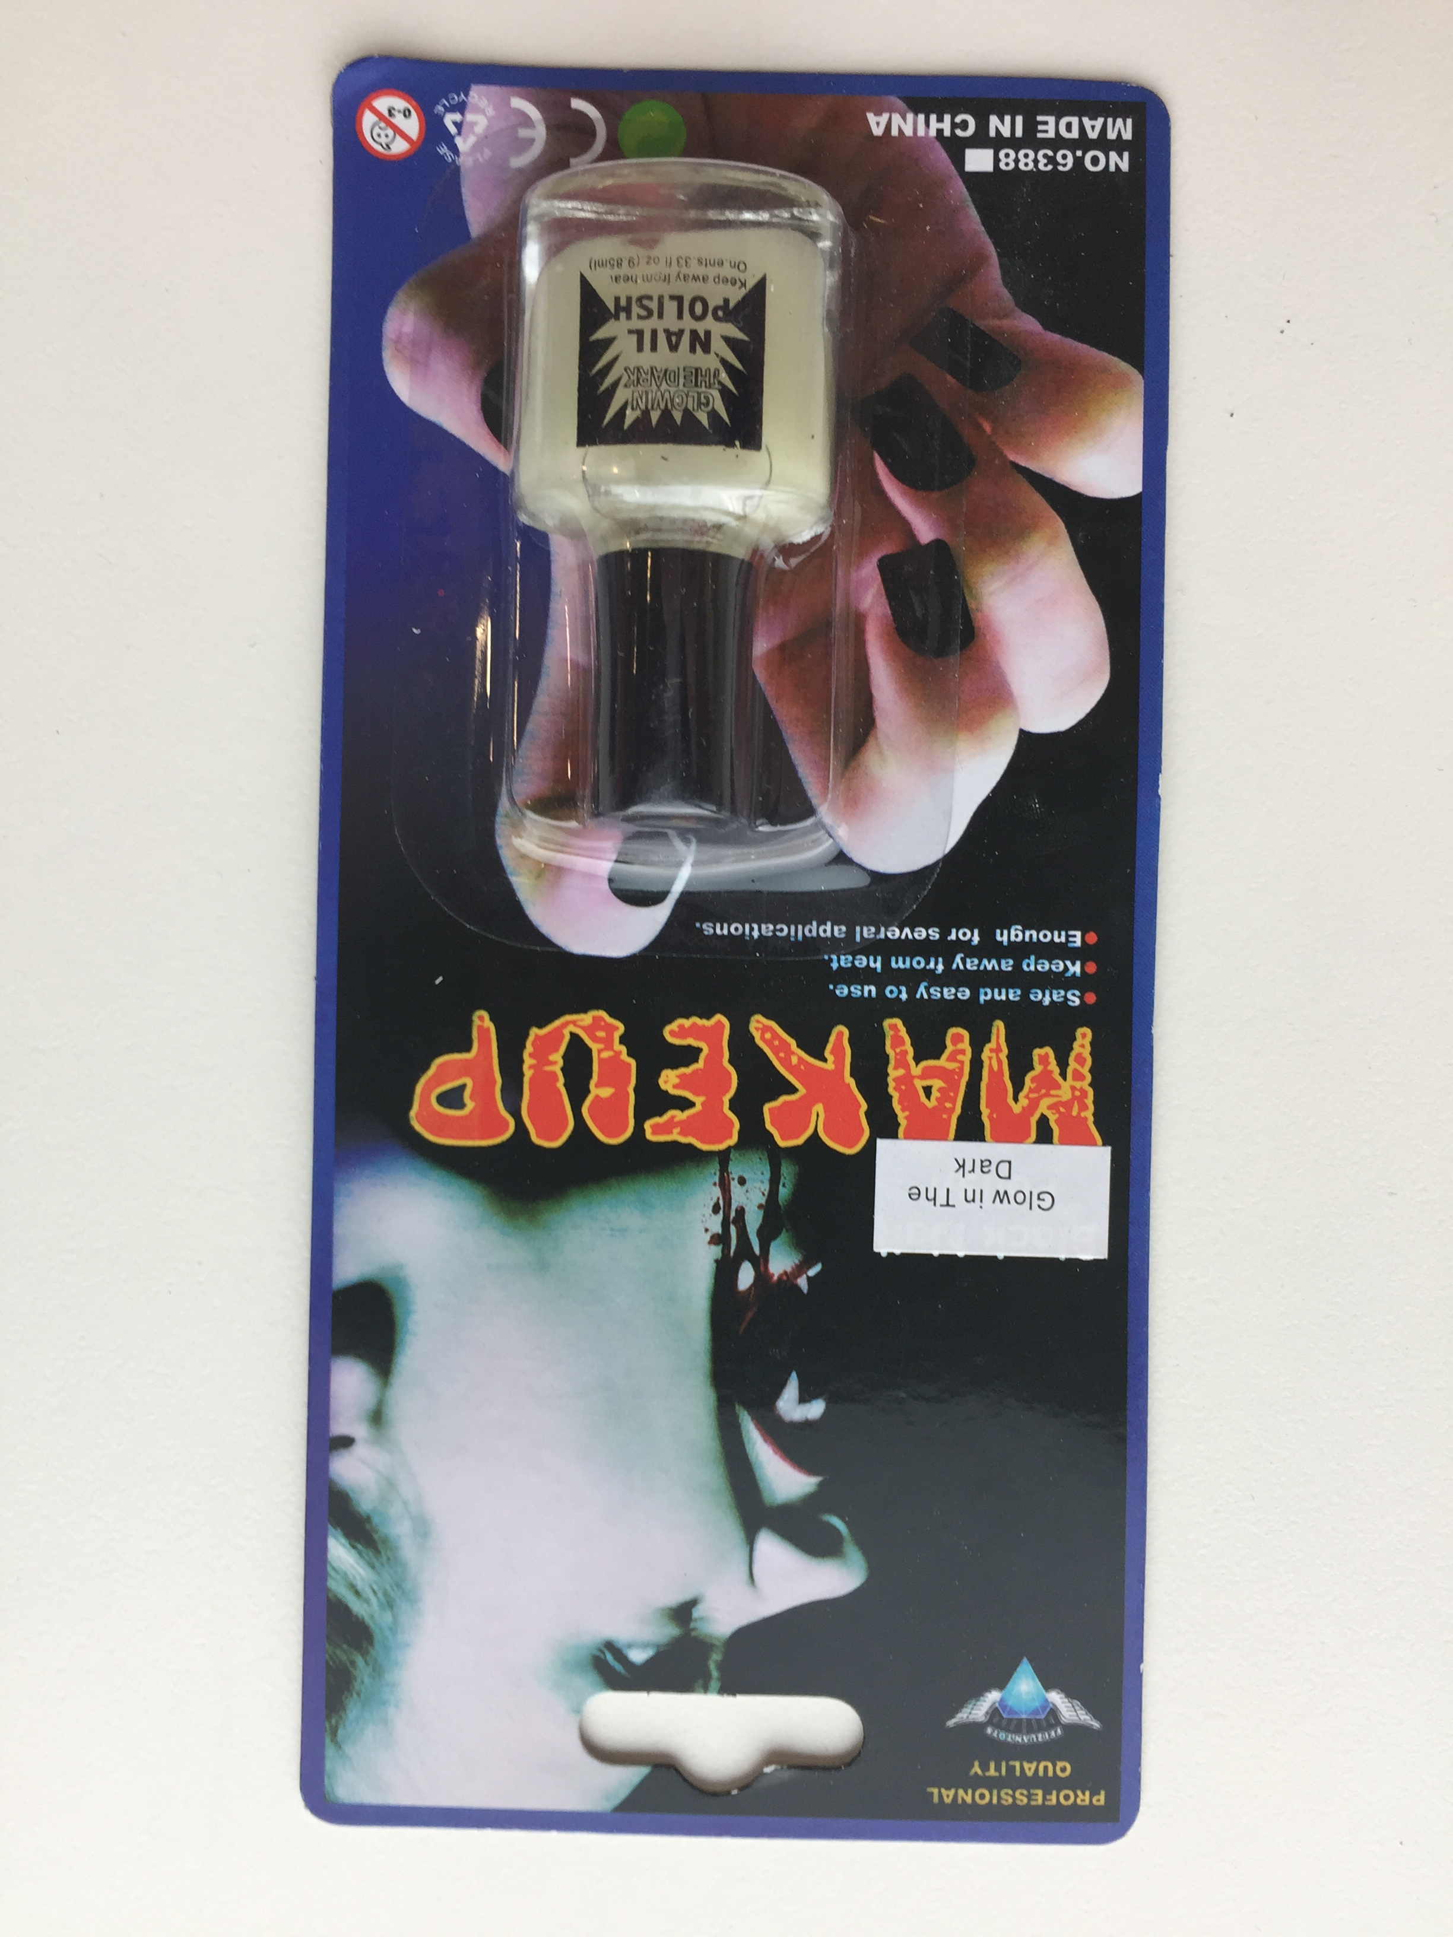
Nail Polish identified by barcode 9312345620661;

PHOTOGRAPH 6
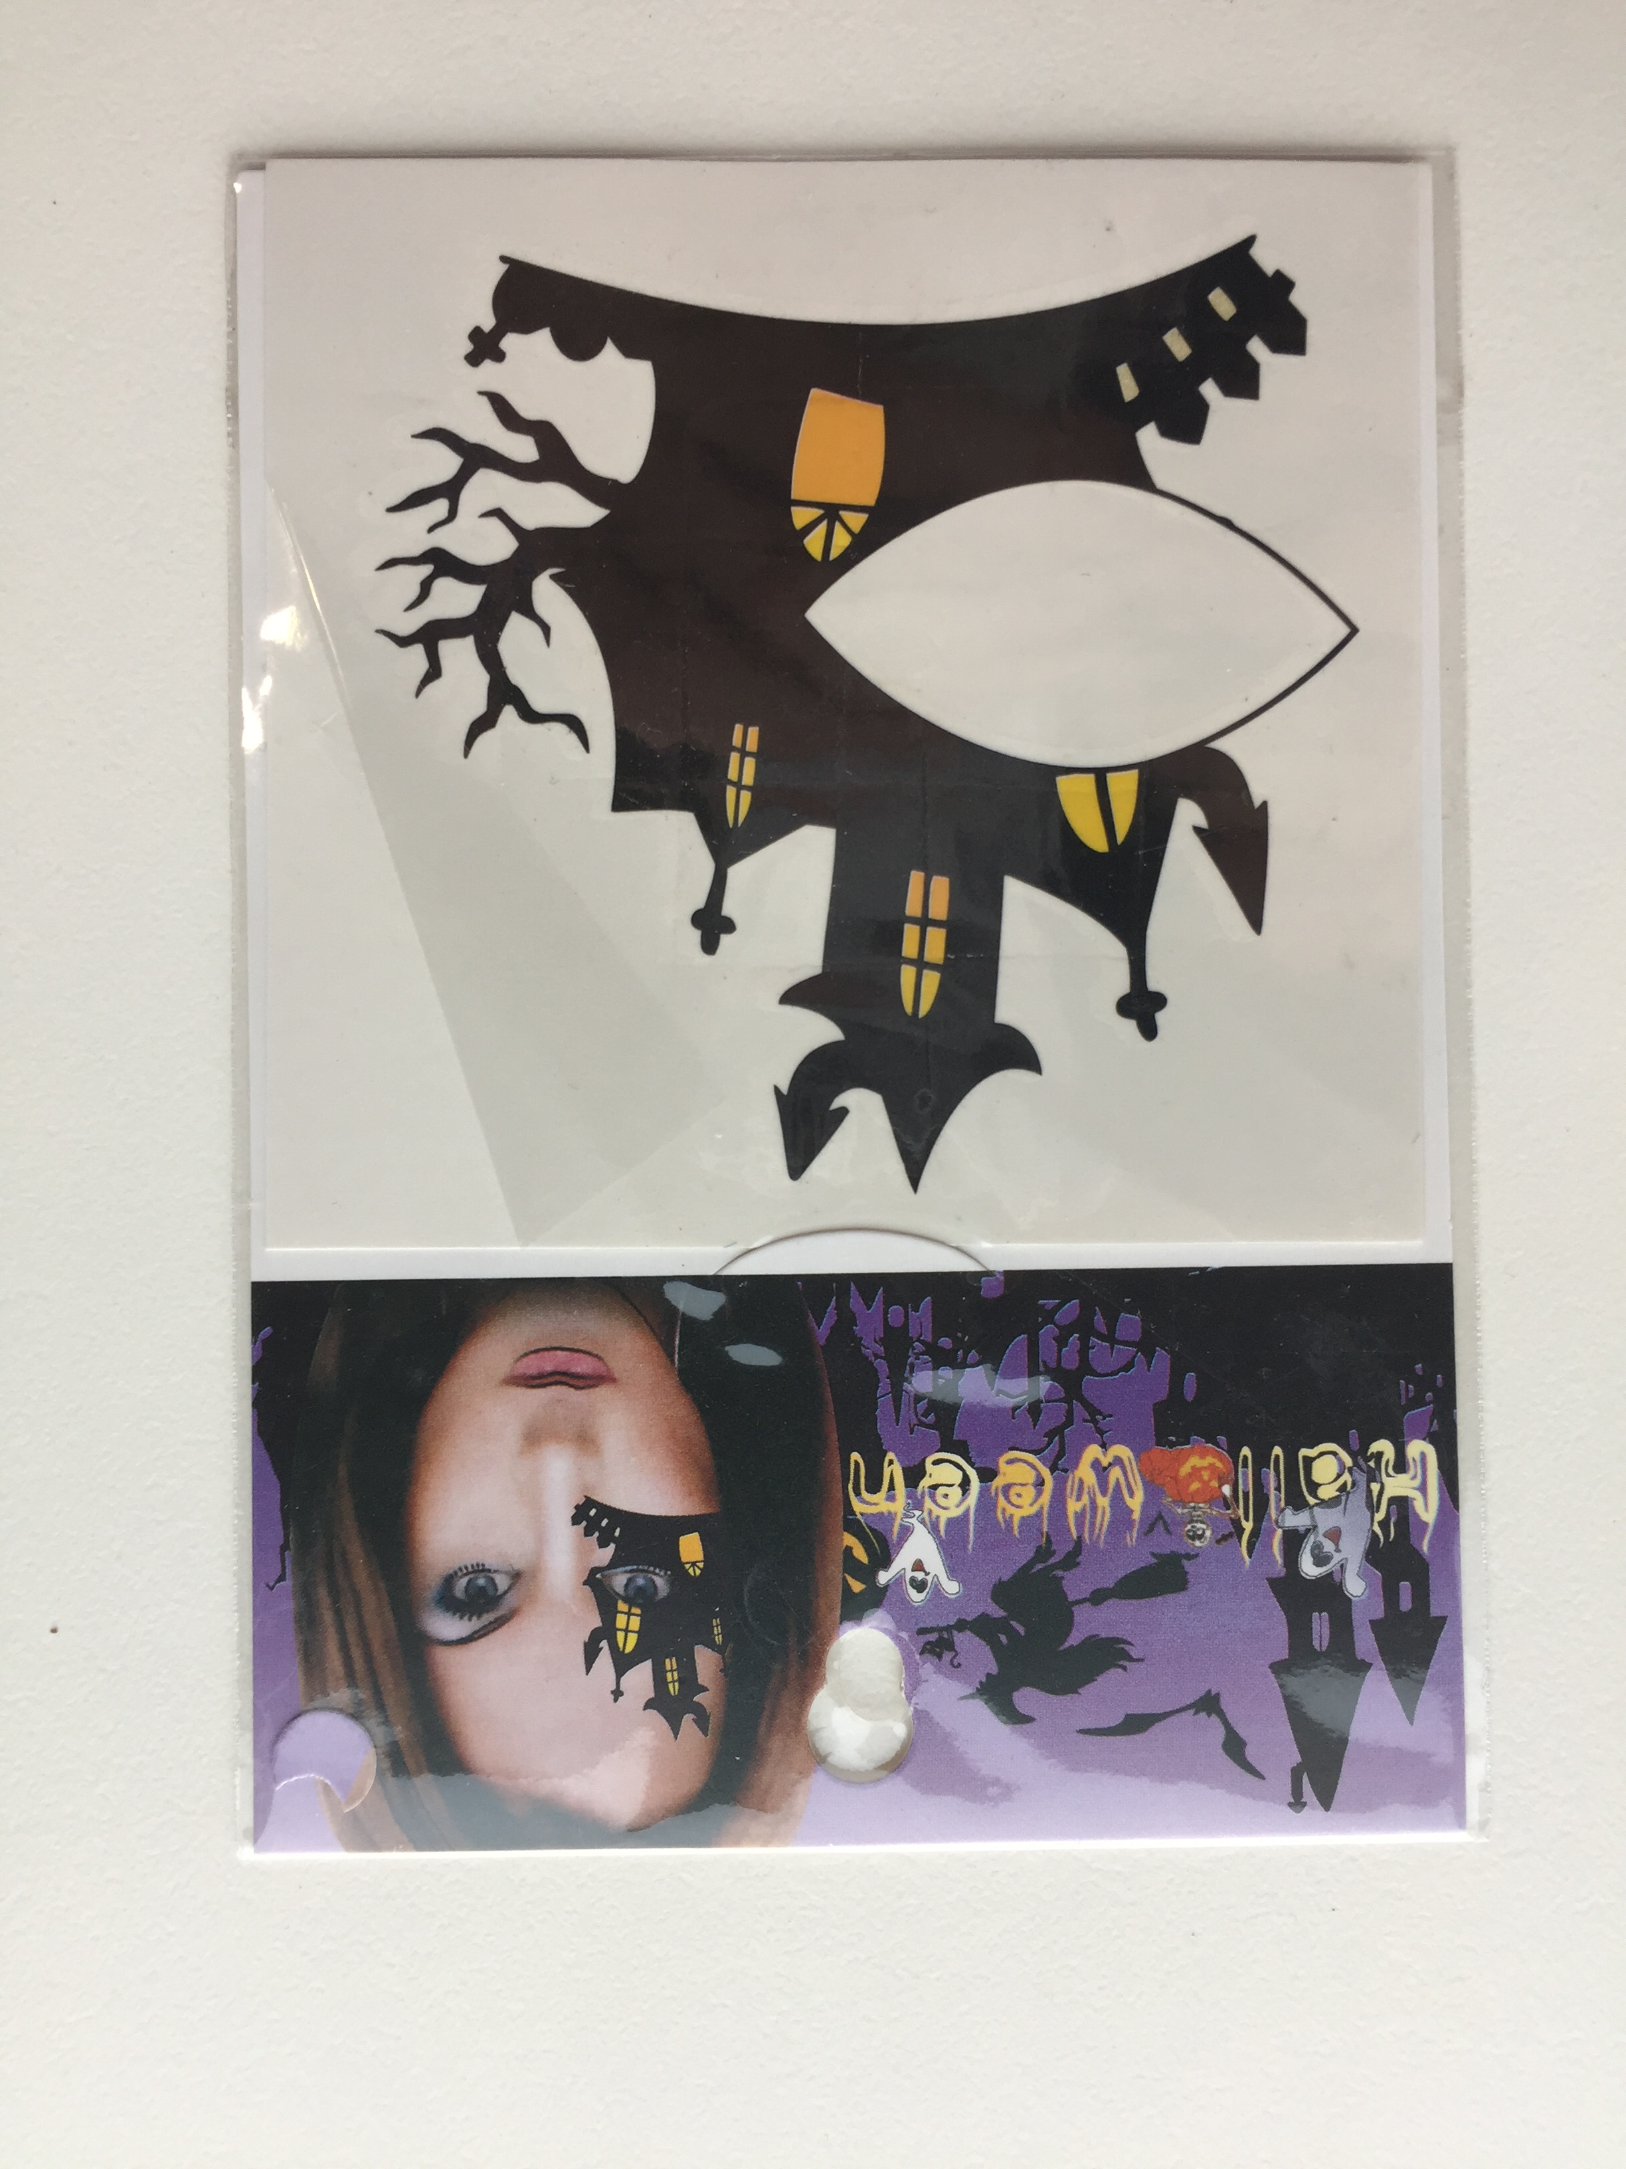
Temporary tattoos identified by barcode 9301524130046.

PHOTOGRAPH 7

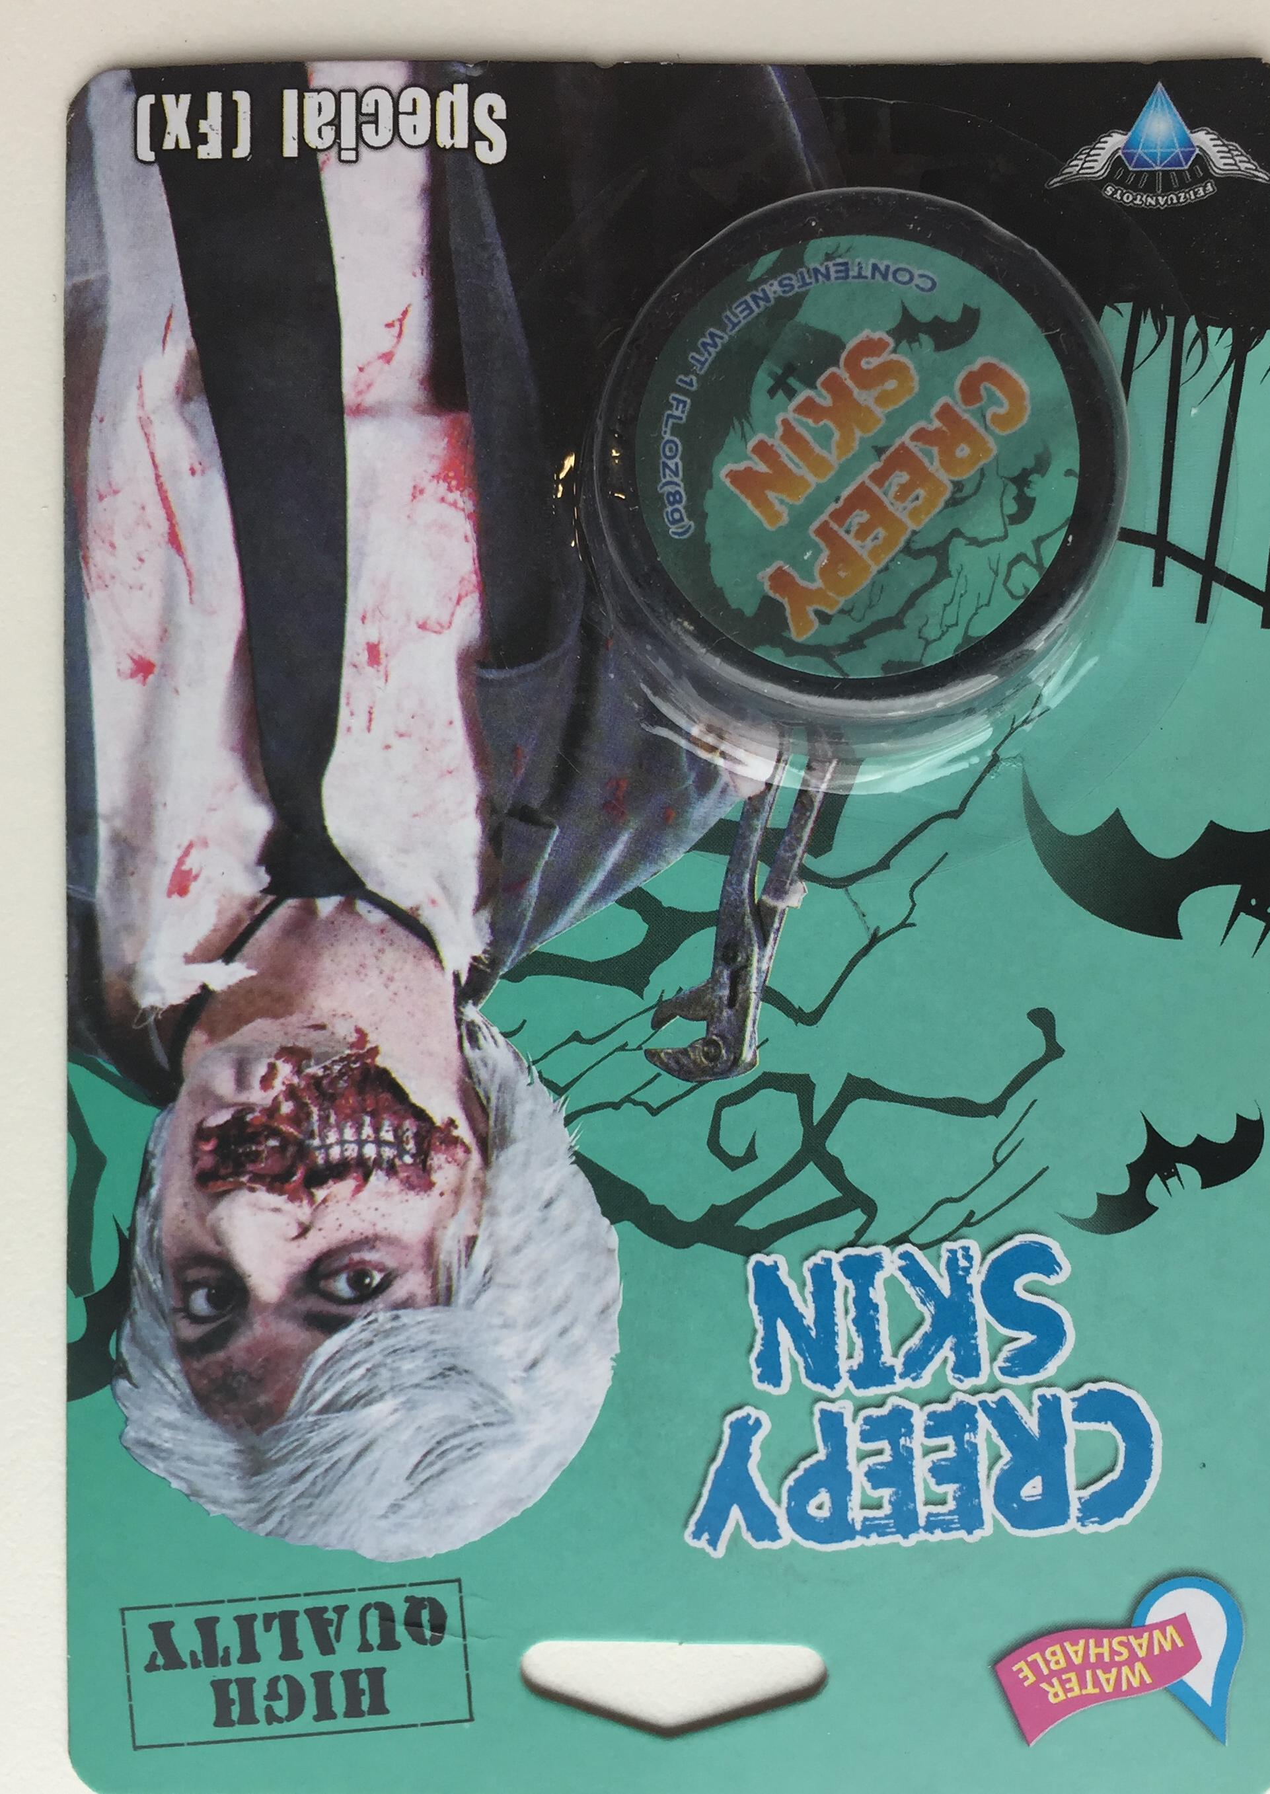

Creepy Skin make up identified by barcode 9302731205107

Annexure B – Mandatory Standards and Bans
Mandatory Standards
List of products with mandatory standards regulated by the Australian Consumer Law and enforced by Consumer Affairs Victoria and other ACL regulators including the Australian Competition and Consumer Commission.
  Aquatic toys |   Baby dummies | 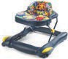  Baby walkers | 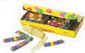  Balloon blowing kits
  Basketball rings and backboards | 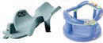  Bath aids for babies |   Bean bags |   Bicycle helmets
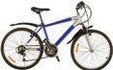  Bicycles (pedal) | 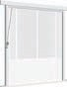  Blinds, curtains and window fittings | 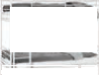  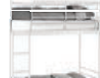  Bunk beds |   Care labelling
  Child car restraints | 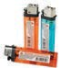  Cigarette lighters (disposable) |   Cigarettes (reduced fire risk) | 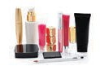  Cosmetics (ingredients labelling)
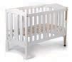  Cots (household) | 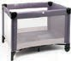  Cots (portable folding) | 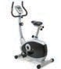  Exercise cycles | 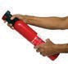  Fire extinguishers (portable aerosol)
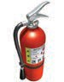  Fire extinguishers (porta non- aerosol) | 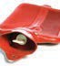  Hot water bottles | 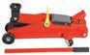  Jacks (trolley) | 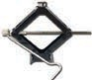  Jacks (vehicle)

Mandatory standards (continued)
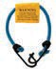  Luggage straps | 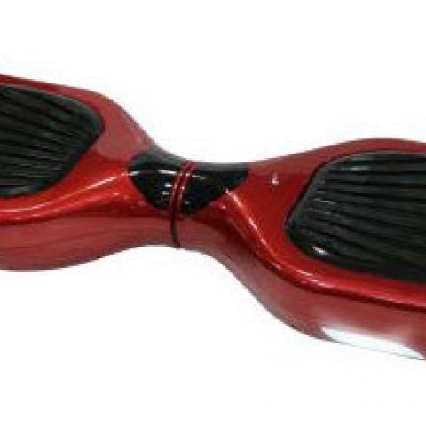  Self-balancing scooters |   Nightwear for children (including paper patters) | 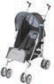  Prams and strollers
  Ramps for motor vehicles (portable) | 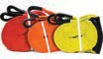  Recovery straps for motor vehicles |   Soccer goals (moveable) | 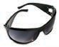  Sunglasses and fashion spectacles
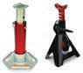  Support stands for vehicles | 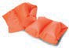  Swimming and floatation aids |   Swimming pools (portable) | 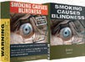  Tobacco health warnings
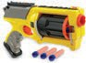  Toys (Projectile) | 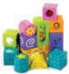  Toys and finger paints containing lead and other elements |   Toys containing magnets |   Toys for children up to and including 36 months
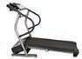

Treadmills

Existing mandatory standards may be reviewed or new mandatory standards may be introduced from time to time. Please visit www.productsafety.gov.au for updated and current information

Permanent Bans
Supplying the following products is permanently banned in Australia. Permanent bans are regulated by the Australian Consumer Law and enforced by Consumer Affairs Victoria and other ACL regulators including the Australian Competition and Consumer Commission.

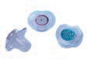  Babies dummies with unsafe decorations | 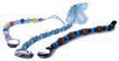  Baby dummy chains with unsafe decorations | 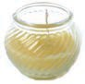  Candles with lead wicks | 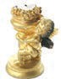  Combustible candle holders
  DEHP in children’s plastic items | 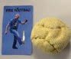  Fire foot bags | 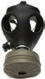  Gas masks containing asbestos |   Glucomannan in tablet form
  Magnets – small high powered |   Mini jelly cups containing konjac | 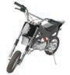  Mini motor bikes with unsafe design features | 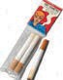  Novelty cigarettes
  Pools and spas with unsafe design features |   Sky lanterns | 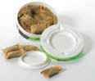  Smokeless tobacco products |   Tinted head light covers
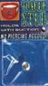  Tongue studs without holes |   Toothpaste containing Diethylene glycol  (DEG | 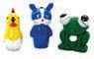  Toy like novelty cigarette lighters | 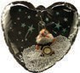  Toys containing beads  (inflatable, novelty and furniture

Permanent Bans (continued)
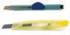  Undeclared knives or cutters in children’s  art, craft and stationery sets |   Yo balls
Existing permanent bans may be reviewed or new permanent bans may be introduced from time to time. Please visit www.productsafety.gov.au for updated and current information

Interim bans
Interim bans may be made by the state, territory or Commonwealth Minister. Their duration may be 60 – 120 days. Visit Product Safety Australia website (www.productsafety.gov.au) for details of any interim bans.
Safety Australia website (www.productsafety.gov.au) for details of any interim bans.

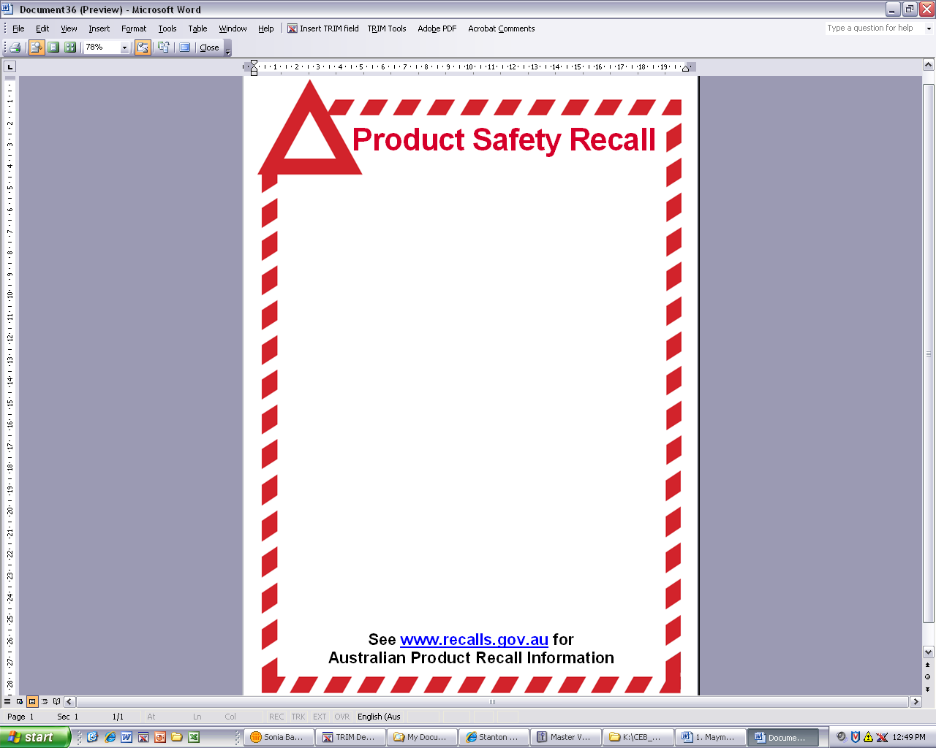
Annexure C – Product Safety Recall Notice

RECALL OF GOODS

Sold by Australia Manolite PTY LTD (ACN 168 846 348)
Defects:
(a) The sunglasses (numbered 1 below) do not a lens category label in accordance with Consumer Protection Notice No. 13 of 2003 and No. 4 of 2005.
(b) The Projectile toys (numbered 2 below) do not provide the required labelling advising of the danger of misuse, in accordance with mandatory safety standard Consumer Protection Notice No. 16 of 2010.
(c) The cosmetics (numbered 3 below) do not have a list of ingredients as required by the Trade Practices (Consumer Product Information Standards) (Cosmetics) Regulations 1991.
Hazard:
1. Paragraph (a) - poses a risk of serious and sometimes irreversible damage to eyes
2. Paragraph (b) - poses a risk of eye or facial injuries
3. Paragraph (c) - Poses a risk of allergic reactions
What to do:
Consumers should immediately stop using these products and contact Australia Manolite for either an exchange or a full refund of the purchase price.
Contact details: Contact Australia Manolite Pty Ltd on (03) <<>>. Or attend 35 Nellbern Road, Moorabbin, Victoria.
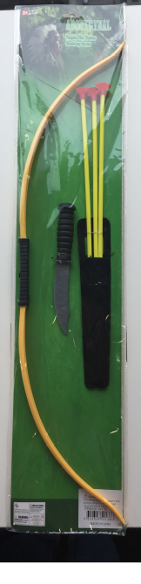

Annexure D – Compliance Program
Interpretation
- In this Annexure:
  - “the Director” means the Director of Consumer Affairs Victoria;
  - “the ACL” means the Australian Consumer Law, being Schedule 2 to the Competition and Consumer Act 2010 (C’th);
  - “commencement date” means the date of the Enforceable Undertaking in this matter;
  - “Australia Manolite” means Australia Manolite Pty Ltd (ACN 168 846 348);
  - “Compliance Officer” means the person appointed under paragraph 2 below;
  - “Company Program” means the steps taken by Australia Manolite to comply with the Enforceable Undertaking in relation to the Compliance Program;
  - “Enforceable Undertaking” means the undertaking agreed to between the Director and Australia Manolite signed, accepted and executed pursuant to section 218 of the ACL;
  - “Relevant Provisions” means the sections in Part 3.3 and 3-4 of the ACL;
  - “Risk Assessment” means the assessment required by paragraph 3 below;
  - “Risk Assessment Report” means the report required by paragraph 4 below; and
  - “Training” means the training required by paragraph 6 below.
Compliance Officer
- Australia Manolite must, within one month of the commencement date of the Enforceable Undertaking, appoint a director of the company or a person approved by all the directors of Australian Manolite, as its Compliance Officer, with responsibility for ensuring that the requirements concerning risk assessment and training, and product safety compliance procedures set out in the document are implemented and maintained.
Risk Assessment
- The Compliance Officer must, within one month of the commencement date of the Enforceable Undertaking, conduct a risk assessment or appoint a person who has experience with mandatory standards and compliance systems to conduct a risk assessment to:
  - identify the areas of Australia Manolite’s business where it is at risk of contravening the Relevant Provision;
  - assess the likelihood of any such contravention re-occurring;
  - identify where there are deficiencies in Australia Manolite’s procedures for managing such risk;
  - making findings concerning sub-paragraphs (a) to (c) above;
  - make recommendations for action having regard to sub-paragraphs (a) to (d) above; and
  - implement the recommendations within one month of the risk assessment exercise.
Risk Assessment Report
- The assessor must set out the findings of the risk assessment exercise in a written report (Risk Assessment Report) within two months of the conclusion of the risk assessment exercise and make it available should the Director or his nominee request a copy at any time the Undertaking remains in effect.
- The Compliance Officer must, at the time of the risk assessment exercise, subscribe to the Product Safety Australia Web Alerts [https://www.productsafety.gov.au/newsletter/subscribe] to ensure that any new regulations or restrictions affecting goods that the company is or may be supplying in the future are brought to his attention for requisite compliance systems to be implemented.
Training
- The Compliance Officer must, after the risk assessment exercise, receive practical training regarding the product safety provisions in Parts 3-3 and 3-4 of the ACL and that the practical training include the areas of Australia Manolite’s business where it is at risk or is likely to be at risk of contravening the Relevant Provision, as identified in the Risk Assessment Report.
- Australia Manolite will ensure that the training is administered by a person with knowledge of and/or experience with mandatory standards, bans and compliance systems.

Product Safety Compliance System
- The Compliance Officer must:
- satisfy himself or herself that his/her supplier has the capacity to meet the requirements of all relevant and applicable:
- mandatory safety or information standards; and/or
- interim or permanent ban orders –
affecting goods that the company is or may be supplying in the future (“the Standards”); and
- ensure that Australia Manolite keeps records of all orders for goods made in the future and that each such order must specify that goods to be acquired for supply by the company, in future, must conform with the requirements of the Standards and bans.
- Australia Manolite will:
- develop a checklist setting out the labelling requirements of the relevant and applicable Standards and bans and use such checklist in line with a procedure developed for batch checking when goods arrive from suppliers;
- withdraw goods of the type of class to which the Standards and bans apply from supply until such time they conform with the relevant and applicable Standards;
- maintain records of such checklist; and
- develop and implement a public complaint handling system and make such complaint handling system accessible from any website of which the company is the Registrant and upon which the company advertise or offers for supply, goods.
- Further, the Compliance Officer must:
- monitor that the checklists have been completed after the arrival of each batch of goods of the type of class to which the Standards and bans apply. Ensure the obligations and procedures provided for under paragraph 10 above are applied to such goods where non-conformance with the relevant and applicable Standards and bans is detected;
- maintain up-to-date copies of all prescribed consumer product safety standards that relate to products that the company supplies; and
- maintain files (or soft copies) of:
  - Order forms;
  - Testing results;
  - Checklist procedures;
  - Completed visual checklists; and
  - Risk assessments.
- Australia Manolite must, within the periods or on the dates provided for in the Enforceable Undertaking, provide the Director with the required documents or information.

