ENFORCEABLE UNDERTAKING

SECTION 218 of the AUSTRALIAN CONSUMER LAW (VICTORIA)

The commitments in this Undertaking are offered to the Director of Consumer Affairs Victoria by:
MRK DISTRIBUTOR Pty Ltd
(ACN 094 156 813)
and
MOUNIR KASSABIAN

TABLE OF CONTENTS
Contents
PARTIES 3
The Director 3
MRK DISTRIBUTOR Pty Ltd 3
Mounir Kassabian 4
LEGISLATION 4
Australian Consumer Law (Vic) 4
Application 4
Permanent Bans 4
Mandatory Standards 4
Failure to comply with Permanent Ban gives rise to civil or criminal proceedings: 4
Civil 4
Criminal 5
Administrative resolution 5
Permanent Ban Order 5
Failure to comply with Permanent Ban gives rise to civil or criminal proceedings: 6
Civil 6
Criminal 7
Mandatory Standards 7
CONSUMER AFFAIRS VICTORIA INVESTIGATION 7
Inspection 6
Seizure of goods 8
Contraventions of the ACL 8
Acknowledgment of the Breach 9
Destruction of Goods 11
UNDERTAKINGS 12
Refrain from further non-compliant conduct 10
Initiate a voluntary recall 10
Publish recall notice on webpage 12
Publish recall notice at points of sales 13
Provide refunds on recalled items 12
Compliance Program 12
Payment to the Victorian Consumer Law Fund 12
COMMENCEMENT 15
CONCLUSION/DURATION 13
PUBLIC NATURE OF UNDERTAKING 15
COMPLIANCE AND ENFORCEMENT 16
EXECUTION 17
ANNEXURES 18
Annexure A – Seized Goods 18
Annexure B – Mandatory Standards and Bans 20
Annexure C – Product Safety Recall Notice 19
Annexure D – Compliance Program 25

PARTIES

The Director
- The office of the Director of Consumer Affairs Victoria (“the Director”) is provided for under section 107 of the Australian Consumer Law and Fair Trading Act 2012 (“the Act”).
- The Director is responsible for the administration of the Act, the Australian Consumer Law (“the ACL”) which is Schedule 2 to the Competition and Consumer Act 2010 (Cth), applied as a law of Victoria by Part 2.2 of the Act and known as the Australian Consumer Law (Victoria) (“the ACL (Vic)”), together with Victoria’s other consumer protection legislation.
- The Director, as a Regulator for the purposes of the ACL (Vic), and under the provisions of section 218 of the ACL (Vic), may accept a written undertaking from any person in connection with any matter involving a contravention of the ACL (Vic) in respect of which the Director has a power or function, as a means of resolving contraventions of the ACL (Vic).

MRK DISTRIBUTOR Pty Ltd
- MRK DISTRIBUTOR Pty Ltd (ACN 094 156 813) (“MRK”) is an Australian proprietary company limited by shares, which was registered on 16 August 2000. At all relevant times, MRK had and has its:
- registered office at 18 Moondarra Drive, Berwick Vic 3806;
and
- principal place of business at 67 Elliott Road, Dandenong South Vic 3175.
- MRK carries on business, in trade or commerce, operating as an importer and wholesaler in Victoria supplying miscellaneous products including disposable and novelty cigarette lighters, oil lighters, smoking pipes, shisha’s, e-cigarettes, electric scales, various smoking accessories and other assorted personal items.

Mounir Kassabian
- Mounir Kassabian is and was, at all times relevant to this Undertaking:
  - the managing director and secretary of MRK;
  - a person who was authorised by MRK and responsible ultimately for acquiring, or arranging the acquisition of products supplied or offered for wholesale to numerous retailers; and
  - a person who was acting on behalf of MRK, in the usual and ordinary course of its business, in respect of the matter set out below.

LEGISLATION

Australian Consumer Law (Vic)

Application
- On 1 January 2011, the ACL, set out in Schedule 2 to the Competition and Consumer Act 2010 (Cth), was applied by Part 2.2 of the Act as a law of Victoria, which is known as the ACL (Vic).
- Part 3-3 of the ACL (Vic) deals with the safety of consumer goods and product-related services.

Permanent Bans
- Section 114(1) of the ACL (Vic) provides for the imposition, by the Commonwealth Minister for Competition Policy and Consumer Affairs (“the Commonwealth Minister”), of a permanent ban for consumer goods of a particular kind to prevent or reduce risk of injury to any person.

Mandatory Safety Standards
- Section 104 of the ACL (Vic) provides for the imposition, by the Commonwealth Minister, of a mandatory safety standard for consumer goods of a particular kind to prevent or reduce risk of injury to any person.

Failure to comply with Permanent Ban gives rise to civil or criminal proceedings:

Civil
- Section 118 of the ACL (Vic) imposes an obligation upon persons to refrain from:
  - in trade or commerce, supplying or offering for supply consumer goods; or
  - in or for the purposes of trade or commerce, possessing or have control of consumer goods–
if a Permanent Ban is in force in respect of those goods.
- A person who contravenes sections 118 of the ACL (Vic) may, in civil proceedings brought for contraventions of that section, be subject to the range of remedies available under Part 5-2 of the ACL (Vic), including the imposition of pecuniary penalties in respect of each contravention of not more than:
  - $220,000 in the case of an individual; or
  - $1,100,000 in the case of a body corporate.

Criminal
- Section 197 of the ACL (Vic) creates an offence which is committed if a person:
  - in trade or commerce, supplies or offers for supply; or
  - in or for the purposes of trade or commerce, possesses or has control of,–
consumer goods of a particular kind and a Permanent Ban on goods of that kind is in force.
- A person who breaches section 197 of the ACL (Vic) may be convicted and liable, to a fine, in respect of each offence, of not more than:
  - $220,000 in the case of an individual; or
  - $1,100,000 in the case of a body corporate.

Failure to comply with Mandatory Safety Standards gives rise to civil or criminal proceedings:

Civil
- Section 106 of the ACL (Vic) imposes an obligation upon persons to refrain from:
  - in trade or commerce, supplying or offering for supply consumer goods; or
  - in or for the purpose of trade or commerce, possessing or having control of consumer goods–
if a safety standard is in force in respect of those goods.
- A person who contravenes sections 106 of the ACL (Vic) may, in civil proceedings brought for contraventions of that section, be subject to the range of remedies available under Part 5-2 of the ACL (Vic), including the imposition of pecuniary penalties in respect of each contravention of not more than:
  - $220,000 in the case of an individual; or
  - $1,100,000 in the case of a body corporate

Criminal
- Section 194 of the ACL (Vic) creates an offence which is committed if a person:
  - in trade or commerce, supplies or offers for supply; or
  - in or for the purposes of trade or commerce possesses or has control of,–
consumer goods of a particular kind and a safety standard for consumer goods of that kind is in force and those goods do not comply with that standard.
- A person who breaches section 194 of the ACL (Vic) may be convicted and liable, to a fine, in respect of each offence, of not more than:
  - $220,000 in the case of an individual; or
  - $1,000,000 in the case of a body corporate

Administrative resolution
- Section 218 of the ACL (Vic) provides that the Director may accept a written undertaking given by a person for the purposes of addressing contraventions of the ACL (Vic) in resolution of such contraventions or breaches of the ACL (Vic).

Permanent Ban Order
- Under section 65E of the former Trade Practices Act 1974 (Cth), and for the purposes of section 65C of that Act, on 1 February 2011, the Commonwealth Minister imposed the Permanent Ban being, Consumer Protection Notice No.18 of 2011 – Permanent ban on toy-like novelty cigarette lighters (“the Permanent Ban”).
- The Ban continues in effect today, for all purposes, under the operation of clause 3 to Schedule 7 of the Trade Practices Amendment (Australian Consumer Law) Act (No. 2) 2010, as if it was imposed pursuant to subsection 114(1) of the ACL (Vic).
- Copies of the ban are available and may be downloaded from the website at www.productsafety.gov.au.

Mandatory Standards
- For the purposes of Part 3-3 of the ACL (Vic), pursuant to section 65E of the Trade Practices Act 1974 (C’th) and for the purposes of section 65C of that Act, the Commonwealth Minister made:
  - A Mandatory Safety Standard, on the 1 March 1997, relating to disposable cigarette lighters by way of the Trade Practices (Consumer Product Safety Standard) (Disposable Cigarette Lighters) Regulations 1997 (“the disposable lighters standard”); and
  - A Mandatory Safety Standard, on 14 November 2008, relating to sunglasses and fashion spectacles by the way of Consumer Protection Notice No.13 of 2003 – Consumer Product Safety: Sunglasses and Fashion Spectacles (“the sunglasses standard”)
which are mandatory standards by the operation of clause 4 to schedule 7 of the Trade Practices Amendment ( Australian Consumer Law) Act (No.2) 2010, and which continues in effect as if imposed pursuant of section 104(1)(a) of the ACL (Vic)
- Copies of the standards are available and may be downloaded from the website at www.productsafety.gov.au

CONSUMER AFFAIRS VICTORIA INVESTIGATION

Inspection
- On 22 September 2016, Consumer Affairs Victoria Inspectors (CAV Inspectors) pursuant to section 155 of the Act, attended business premises at 67 Elliott Road, Dandenong South, Vic, 3175 (“the premises”).
- CAV Inspectors ascertained that MRK occupied the premises and operated an import and wholesale business offering for supply miscellaneous products including disposable and novelty cigarette lighters, oil lighters, smoking pipes, shisha’s, e-cigarettes, electric scales, various smoking accessories and other assorted personal items.
- CAV Inspectors identified a variety of novelty cigarette lighters offered for supply and determined 628 of these units appeared to be subject to the Permanent Ban on toy like novelty cigarette lighters.
- CAV Inspectors identified further non-compliant items offered for supply and determined that the 33,767 disposable/refillable lighters and 68 sunglasses were non-compliant with the mandatory standards relating to disposable cigarette lighters and sunglasses and fashion spectacles.

Seizure of goods
- On 22 September 2016, CAV Inspectors as a result of their inspections at the premises, lawfully seized 14,950 MRK lighters (various) identified by barcode 6958371786112, 3,397 Fudi lighters identified by barcode 6003510841082, 163 Horse novelty lighter identified by barcode 8717928092193, 465 Elephant novelty lighters identified by barcode 8717928092179, 5,600 Nass quality lighters identified by barcode 6958371786112, 8,700 MRK Fashion Lighters identified by barcode 6957990209002, 1,120 BIC lighters identified by barcode 00700330607897 (“the lighters”) and 68 sunglasses with no brand or barcodes. A sample of the lighters and sunglasses are depicted and described in Annexure “A” attached.
- On 7 December 2016, CAV Inspectors seized a further 180 horse novelty lighters following MRK advising CAV of the discovery of further non-compliant novelty lighters in their stock.

Determination of non-compliance
- Between 22 September and 7 December 2016, Consumer Affairs Victoria Inspectors determined that the novelty lighters seized and referred to in paragraphs 27 and 30 were prohibited under the Permanent Ban in that they were toy-like novelty cigarette lighters that:
  - were devices which were intended to produce a flame to set alight cigarettes or other combustible materials; and
  - were likely to appeal to children under 5 years of age by appearing to be a toy taking into account the totality of the design which may depict stylised animals cartoon characters or be of colour(s) or a scale typical of toys.
- On 22 September 2016, Consumer Affairs Victoria Inspectors determined the lighters seized and referred to in paragraph 28 did not meet the requirements of the disposable lighters standard in that they did not display the following information, set out in the form below:
  - as a permanent part of the lighter, the name or other identification of the manufacturer or distributor of the lighter; or
  - ‘WARNING’- adjacent to the words that must be displayed under subparagraphs (c) to (j) below; or
  - ‘KEEP AWAY FROM CHILDREN’ or ‘KEEP OUT OF REACH OF CHILDREN’; or
  - ‘Ignite lighter away from face and clothing’; or
  - ‘Never expose to heat above 50◦C OR TO PROLONGED SUNLIGHT’; or
  - ‘Never puncture or put in fire’; or
  - for a lighter that contains flammable gas under pressure- ‘Contains flammable gas under pressure’; or
  - for a lighter that contains flammable liquid- ‘contains flammable liquid’; or
  - for a self-extinguishing lighter – ‘Be sure flame is out after use’; or
  - for a non-self-extinguishing lighter- ‘This lighter does not extinguish itself- close the cover to put out’; or
  - any combination of the required information identified in sub-paragraphs (a) to (j) above.
- On or about 22 September 2016, Consumer Affairs Victoria Inspectors determined that the sunglasses seized did not meet the requirements of the sunglasses standard in that the sunglasses did not have in the form of:
  - an indelible marking on the sunglasses frame; or
  - a removable label affixed to the lens; or
  - a removable label securely attached or tied to the frame; or
  - any combination of the means identified in sub-paragraphs (i) to (iii) above-
information sufficient to identify the manufacturer or suppliers of the sunglasses and the lens category number and description in accordance with section 4 Marking and Labelling of the Australian/New Zealand Standard 1067:2003 Sunglasses and fashion spectacles as required by the standard.

Contraventions of the ACL
- The Director considers that MRK contravened sub-section 118(1), (2) and (3) respectively of the ACL (Vic) by supplying, offering to supply and having in its possession or control, in or for the purposes of trade or commerce not less than 808 toy like lighters that were subject to the Permanent Ban being, Consumer Protection Notice No.18 of 2011 – Permanent ban on toy-like novelty cigarette lighters.
- The Director considers that MRK contravened sub-section 106(1),(2) and (3) respectively of the ACL (Vic) by supplying, offering to supply and having in its possession or control, in or for the purposes of trade or commerce not less than 33,767 disposable cigarette lighters that do not comply with the mandatory safety standard set out in the Trade Practices (Consumer Product Safety Standard) (Disposable Cigarette Lighters) Regulations 1997
- The Director considers that MRK contravened sub-section 106(1),(2) and (3) respectively of the ACL (Vic) by supplying, offering to supply and having in its possession or control, in or for the purposes of trade or commerce not less than 68 Sunglasses that do not comply with the mandatory safety standard set out in Consumer Protection Notice No.13 of 2003 – Consumer Product Safety: Sunglasses and Fashion Spectacles.
- The Director is prepared to deal with these alleged contraventions by accepting this written undertaking pursuant to section 218 of the ACL (Vic).

Acknowledgment of the Breach
- Mounir Kassabian on behalf of MRK, acknowledges that between 22 September 2016 and 7 December 2016 , MRK contravened sub-section 106(1), (2) and (3), respectively, of the ACL(Vic) by:
- offering to supply, in trade or commerce;
- supplying, in trade or commerce; and
- being in possession or having under its control in or for the purpose of trade or commerce
lighters which are subject to and do not comply with the safety standard set out in the Trade Practices (Consumer Product Safety Standard) (Disposable Cigarette Lighters) Regulations 1997.
- Mounir Kassabian on behalf of MRK, acknowledges that on 22 September 2016, MRK contravened sub-section 106(1), (2) and (3), respectively, of the ACL(Vic), by:
  - offering to supply, in trade or commerce,;
  - supplying, in trade or commerce,; and
  - being in possession or having under its control in or for the purpose of trade or commerce
sunglasses which are subject to and do not comply with safety standard set out in Consumer Protection Notice No.13 of 2003 – Consumer Product Safety: Sunglasses and Fashion Spectacles.
- Mounir Kassabian on behalf of MRK, acknowledges that between 22 September 2016 and 7 December 2016, MRK contravened sub-section 118(1),(2) and (3), respectively, of the ACL (Vic), by:
  - offering to supply, in trade or commerce,;
  - supplying, in trade or commerce,; and
  - being in possession or having under its control in or for the purpose of trade or commerce
lighters which are subject to the permanent ban order set out in Consumer Protection Notice No.18 of 2011 – Permanent ban on toy-like novelty cigarette lighters.
- Mounir Kassabian acknowledges personally that, at all times, he was directly or indirectly knowingly concerned in, and a party to MRK’s contraventions referred to in paragraphs 38-40 of this Undertaking, save that he did not know that the goods referred to in those paragraphs contravened any permanent ban or safety standards before being so informed by CAV inspectors on or about 22 September 2016.
- Mounir Kassabian individually and on behalf of MRK, seeks to address these acknowledged contraventions of section 106 and 118 of the ACL (Vic) by offering this Undertaking to the Director.

Destruction of Goods
- Mounir Kassabian, personally and on behalf of MRK:
- confirms that MRK is the owner of or holds title to or was in control of the goods seized by CAV staff at MRK’s premises on 22 September 2016 and on 7 December 2016 respectively.
- authorises for the Director to destroy and dispose of all the goods seized by CAV staff at MRK’s premises on 22 September 2016 and on 7 December 2016 respectively.
- forfeits any claim or right or any future claim or right to those goods seized by CAV staff at MRK’s premises on 22 September 2016 and on 7 December 2016 respectively and indemnifies the Director from any claim or action from their seizure or destruction.
- will pay a total contribution of $1,000.00 to the Director for the destruction of the goods, within 30 days of commencement of this undertaking.

UNDERTAKINGS

Refrain from further non-compliant conduct
- Mounir Kassabian, personally and on behalf of MRK, undertakes to the Director that he will:
  - refrain from offering to supply;
  - supplying; and
  - being in possession or having under its control-
or being in any way, directly or indirectly knowingly concerned in or party to offering to supply, supplying, manufacturing, possession or controlling any products identified in Annexure “B” attached, which fail to comply with the requirements of any:
  - safety standard declared under Division 1 of Part 3-3 of the ACL (Vic);
  - interim or permanent ban order imposed under Division 2 of Part 3-3 of the ACL (Vic); or
  - information standard made under Part 3-4 of the ACL (Vic).

Initiate a voluntary recall
- Mounir Kassabian, personally and on behalf of MRK, undertakes to the Director that he will initiate a voluntary recall of the products, depicted and described in Annexure “C” attached, supplied by the company during the period, sufficient to satisfy the requirements of section 128 of the ACL and that MRK will give the Commonwealth Minister a written Notice in the form of Annexure “C” attached, electronically via the electronic document accessible at http://www.recalls.gov.au/content/index.phtml/itemId/952488.

Publish recall notice on webpage
- Mounir Kassabian, personally and on behalf of MRK, undertakes to the Director that he will
- retain and continue to operate the website accessible via uniform resource located at the web address (URL) http://www.mrkdistributors.com.au/ / (“the website”); and
- within 14 days of commencement of this Undertaking, cause to be published, the Product Safety Warning and Recall in the form of Annexure “C” attached, on the website (or if any such URL is replaced or changed, the Internet home page of the corresponding website), for a period of 90 days from the date of this undertaking, and use its best endeavours to ensure that:
- the Product Safety Warning and Recall Notice is to be viewable by clicking through a “click-through” icon located on the website or any replacement website;
- the “click-through” icon referred to in the previous sub paragraph is located in a central position on the page first accessed when the user opens to the home page of the website or any replacement website;
- the “click-through” icon must contain the words “PRODUCT SAFETY – IMPORTANT NOTICE” (in capital letters and use a minimal type of 16 point Times New Roman or equivalent), clearly and prominently in red on a contrasting background and the words “Click Here”; and
- the Product Safety Warning and Recall Notice occupies the entire page of each webpage on which the Notice occurs, or on any replacement website, which is accessed via the “click-through” icon referred to above; and
- the website (or if any such URL is replaced or change, the Internet home page of the corresponding website) shall not have in place any mechanism which would preclude internet search engines from:
      - indexing the page; or
      - scanning the pages for links to follow.

Publish recall notice at points of sales
- Mounir Kassabian, personally and on behalf of MRK, undertakes to the Director that he will within 30 days of the commencement of this Undertaking, cause to be displayed prominently for a continuous period of 50 days:
  - at or near the office area where it is visible to clients ; and
  - inside the trading premises at the relevant entry/exit points
in each of its existing or new premises from which it carries on business, solely or jointly, of supplying goods to retailers or as retailers to other purchasers, a Product Safety Warning and Recall Notice in the form of Annexure “C” attached.
- Each such Notice will:
  - be a minimum size of 30 cm x 42 cm (A3 size);
  - use a minimum type size of 12 point Times New Roman or equivalent; and
  - be in full colour.
- Mounir Kassabian, personally and on behalf of MRK, undertakes to the Director that he within 14 days following the commencement of this Undertaking will notify the Director in writing that he has complied fully with the undertaking and caused the display of the notices in accordance with paragraphs 47 and 48.

Provide refunds on recalled items
- Mounir Kassabian, personally and on behalf of MRK, undertakes to the Director that he will pay a full refund to all persons returning any of the lighters and sunglasses recalled by MRK.

Compliance Program
- Mounir Kassabian, personally and on behalf of MRK, undertakes to the Director that he will:
- Implement a Compliance Program in accordance with Annexure “D” attached, designed to ensure that, in or for the purposes of trade or commerce, MRK will not supply, offer for supply or possess or have control of products, including products of a kind or class listed in Annexure “B” attached, that contravene any:
- safety standards declared under Division 1 of Part 3-3 of the ACL (Vic);
- interim or permanent ban orders imposed under Division 2 of Part 3-3 of the ACL (Vic); or
- information standard made under Part 3-4 of the ACL (Vic)-
which are, in effect, as at the commencement date of this Undertaking, and for which there continues to exist a safety standard or interim or permanent ban order under the ACL (Vic); and
- within 65 days of the commencement of this Undertaking, will notify the Director in writing that in accordance with this Undertaking the Compliance Program has been implemented.
- comply with the requirements set out in the Compliance Program including any specified time limits.

Payment to the Victorian Consumer Law Fund
- Mounir Kassabian, personally and on behalf of MRK, undertakes to the Director that he will:
- within 14 days of the commencement of this Undertaking pay a total of $3,000.00 to the Director, on behalf of the Victorian Consumer Law Fund (“VCLF”); and
- within 7 days following the payment he will notify the Director in writing that the payment to the VCLF as set out above in this undertaking has been made.

COMMENCEMENT
- This Undertaking commences on the eighth day after the date the Director of Consumer Affairs Victoria signs the Undertaking.

CONCLUSION/DURATION
- This Undertaking remains in effect for a period of three years from its commencement.

PUBLIC NATURE OF UNDERTAKING
- Mounir Kassabian, personally, and on behalf of MRK acknowledges that:
  - pursuant to section 218 of the ACL (Vic), the Director will register this Undertaking in the Register of the Undertaking on the Consumer Affairs Victoria website and the Undertaking will be available for public inspection;
  - the Director and/or the Minister for Consumer Affairs Victoria may, from time to time, publicly refer to this Undertaking;
  - this Undertaking in no way derogates from the rights and remedies available to any other person arising from the alleged conduct; and
  - no compensation is payable to it, or on its behalf, arising from the destruction by the Director, or his staff, of any of the goods seized from the premises on 22 September 2016.

COMPLIANCE AND ENFORCEMENT
- Mounir Kassabian personally and on behalf of MRK, acknowledges that:
  - Consumer Affairs Victoria will continue to conduct compliance monitoring inspections of premises of suppliers in Victoria, investigate and prosecute breaches of the ACL (Vic) and institute and defend proceedings to achieve the purposes of the ACL (Vic); and
  - the Director of Consumer Affairs Victoria reserves the right to enforce a breach of this Undertaking in a Court to the full extent provided by law.

EXECUTION
Signed by: ………………………………………………..…………..
on
……………………..…………….2016
Mounir Kassabian Company Director
In the presence of……………………..…………..…….…….
Witness
(PRINT NAME) ………………………………….……....….……
Signed by: ………………………………………………..…………..
Accepted by the Director of Consumer Affairs Victoria pursuant to section 218 of the ACL.
………………………………….……………
DATED ……………………….……..…………..2016
Simon Cohen

ANNEXURES

Annexure A – Seized Goods
Goods seized from MRK by Consumer Affairs Victoria Inspectors on 22 September 2016 and 7 December 2016 respectively.

PHOTOGRAPH 1

Depicts samples of the Lighters seized.
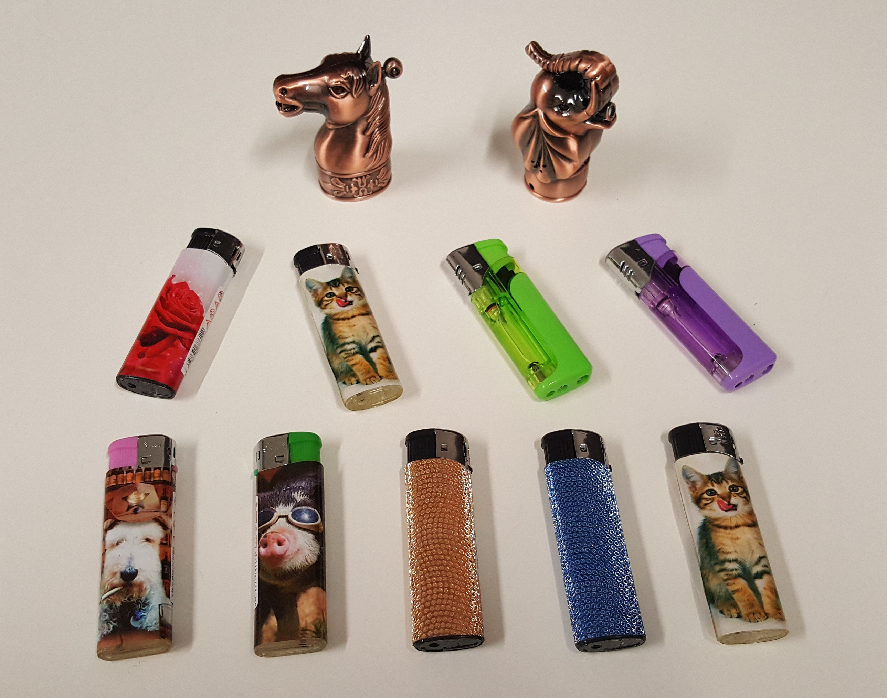

MRK Lighters (various) barcode 6958371786112
Fudi Lighters barcode 6003510841082
Horse novelty lighter barcode 8717928092193
Elephant novelty lighter barcode 8717928092179
Nass quality lighters barcode 6958371786112
MRK Fashion lighters barcode 6957990209002

PHOTOGRAPH 2
Depicts sample of the Lighter seized
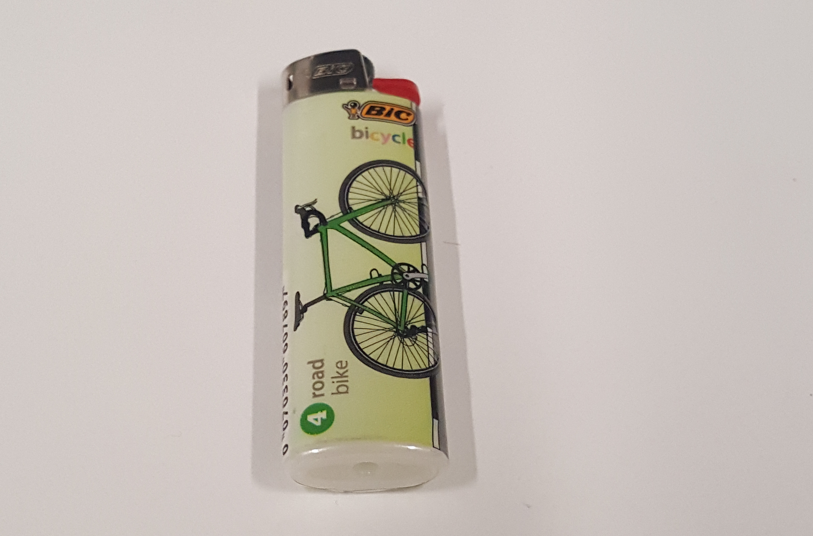
BIC lighter barcode 0070033067897
PHOTOGRAPH 3
Depicts sample of the Sunglass seized
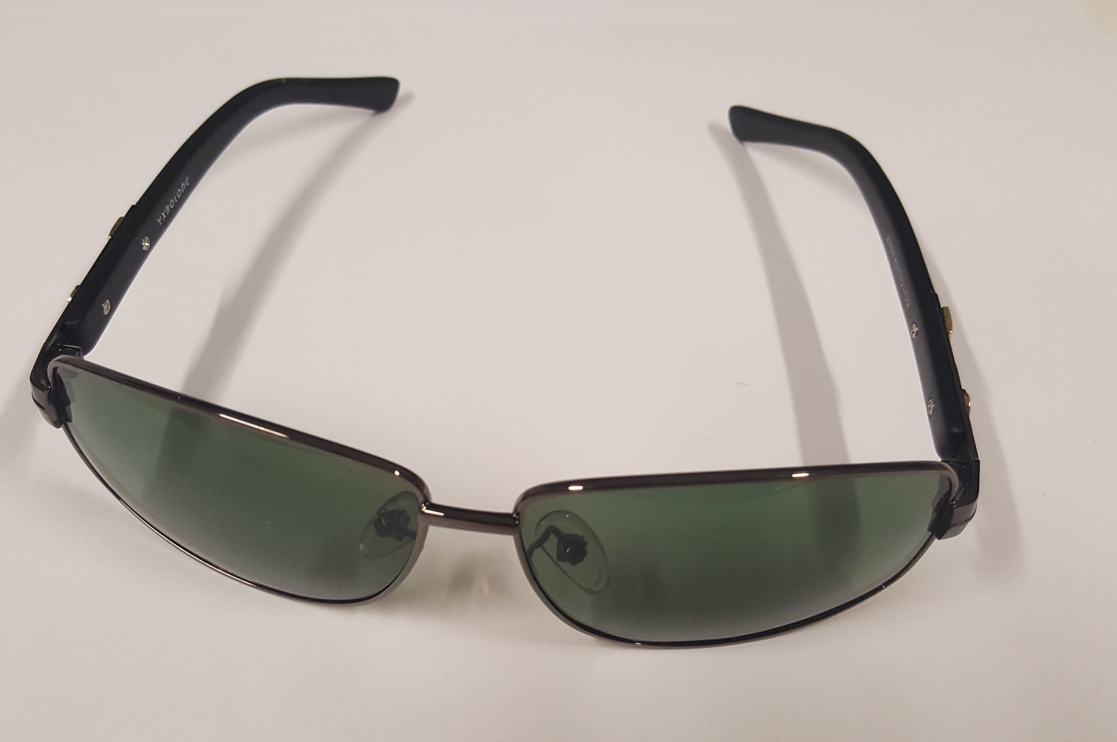
Sunglasses No barcode/no brand

Annexure B – Mandatory Standards and Bans
Mandatory Standards
List of products with mandatory standards regulated by the Australian Consumer Law and enforced by Consumer Affairs Victoria and other ACL regulators including the Australian Competition and Consumer Commission.
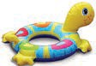  Aquatic toys | 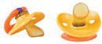  Baby dummies | 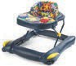  Baby walkers | 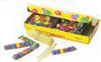  Balloon blowing kits
  Basketball rings and backboards | 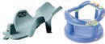  Bath aids for babies | 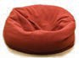  Bean bags |   Bicycle helmets
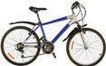  Bicycles (pedal) | 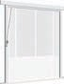  Blinds, curtains and window fittings | 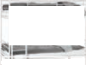  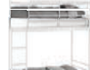  Bunk beds |   Care labelling
  Child car restraints | 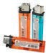  Cigarette lighters (disposable) | 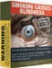  Cigarettes (reduced fire risk) | 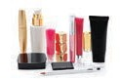  Cosmetics (ingredients labelling)
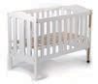  Cots (household) | 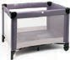  Cots (portable folding) | 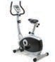  Exercise cycles | 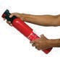  Fire extinguishers (portable aerosol)
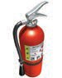  Fire extinguishers (porta non- aerosol) | 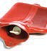  Hot water bottles | 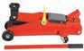  Jacks (trolley) | 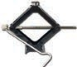  Jacks (vehicle)

Mandatory standards (continued)
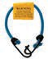  Luggage straps | 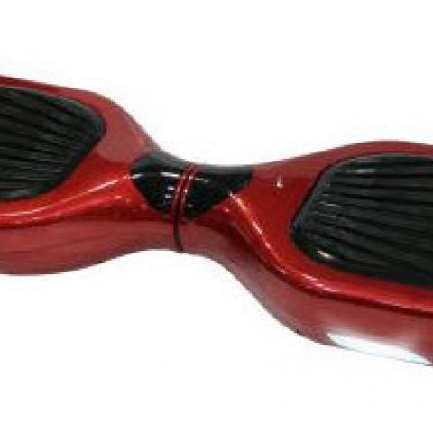  Self-balancing scooters |   Nightwear for children (including paper patters) | 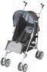  Prams and strollers
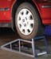  Ramps for motor vehicles (portable) | 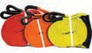  Recovery straps for motor vehicles |   Soccer goals (moveable) | 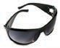  Sunglasses and fashion spectacles
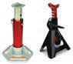  Support stands for vehicles | 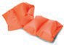  Swimming and floatation aids |   Swimming pools (portable) | 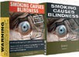  Tobacco health warnings
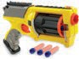  Toys (Projectile) | 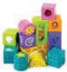  Toys and finger paints containing lead and other elements | 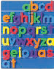  Toys containing magnets | 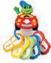  Toys for children up to and including 36 months
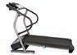

Treadmills
Existing mandatory standards may be reviewed or new mandatory standards may be introduced from time to time. Please visit www.productsafety.gov.au for updated and current information

Permanent Bans
Supplying the following products is permanently banned in Australia. Permanent bans are regulated by the Australian Consumer Law and enforced by Consumer Affairs Victoria and other ACL regulators including the Australian Competition and Consumer Commission.

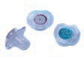  Babies dummies with unsafe decorations | 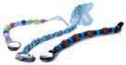  Baby dummy chains with unsafe decorations | 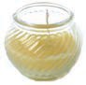  Candles with lead wicks | 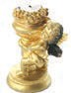  Combustible candle holders
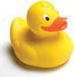  DEHP in children’s plastic items | 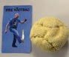  Fire foot bags | 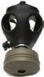  Gas masks containing asbestos |   Glucomannan in tablet form
  Magnets – small high powered | 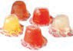  Mini jelly cups containing konjac | 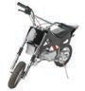  Mini motor bikes with unsafe design features | 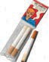  Novelty cigarettes
  Pools and spas with unsafe design features |   Sky lanterns | 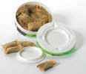  Smokeless tobacco products |   Tinted head light covers
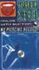  Tongue studs without holes |   Toothpaste containing Diethylene glycol  (DEG | 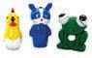  Toy like novelty cigarette lighters | 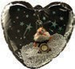  Toys containing beads  (inflatable, novelty and furniture

Permanent Bans (continued)
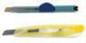  Undeclared knives or cutters in children’s  art, craft and stationery sets | 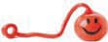  Yo yo balls
Existing permanent bans may be reviewed or new permanent bans may be introduced from time to time. Please visit www.productsafety.gov.au for updated and current information

Interim bans
Interim bans may be made by the state, territory or Commonwealth Minister. Their duration may be 60 – 120 days. Visit Product Safety Australia website (www.productsafety.gov.au) for details of any interim bans.

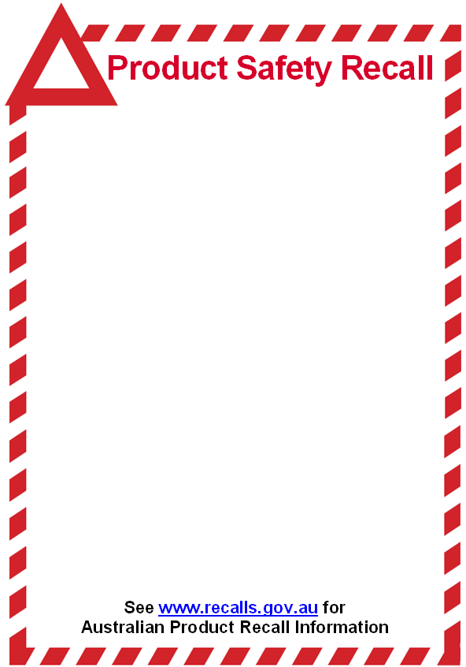
Annexure C – Product Safety Recall Notice

LIGHTERS
Barcode: Horse 8717928092193 Elephant 8717928092179
Sold by MRK DISTRIBUTORS PTY LTD (ACN 094 156 813)
Between the period June 2015 and September 2016
Defect: The Lighters are toy-like novelty cigarette lighters subject to Commonwealth of Australia Consumer Protection Notice No. 18 of 2011 and are permanently banned.
Hazard: Children under 5 years of age may mistake these lighters for toys to play with and are at risk of suffering serious burns.
What to do: Consumers who purchased the Lighters with the below pictured design should immediately stop using the Lighters and contact MRK DISTRIBUTORS PTY LTD or the retailer from where the Lighter/s were purchased for either an exchange or a full refund of the purchase price.
Contact details: Visit your respective retailer or contact MRK Distributors Pty Ltd on (03) 9794 5195 or email mrkdistributors@optusnet.com.au or go to www.mrkdistributors.com.au.

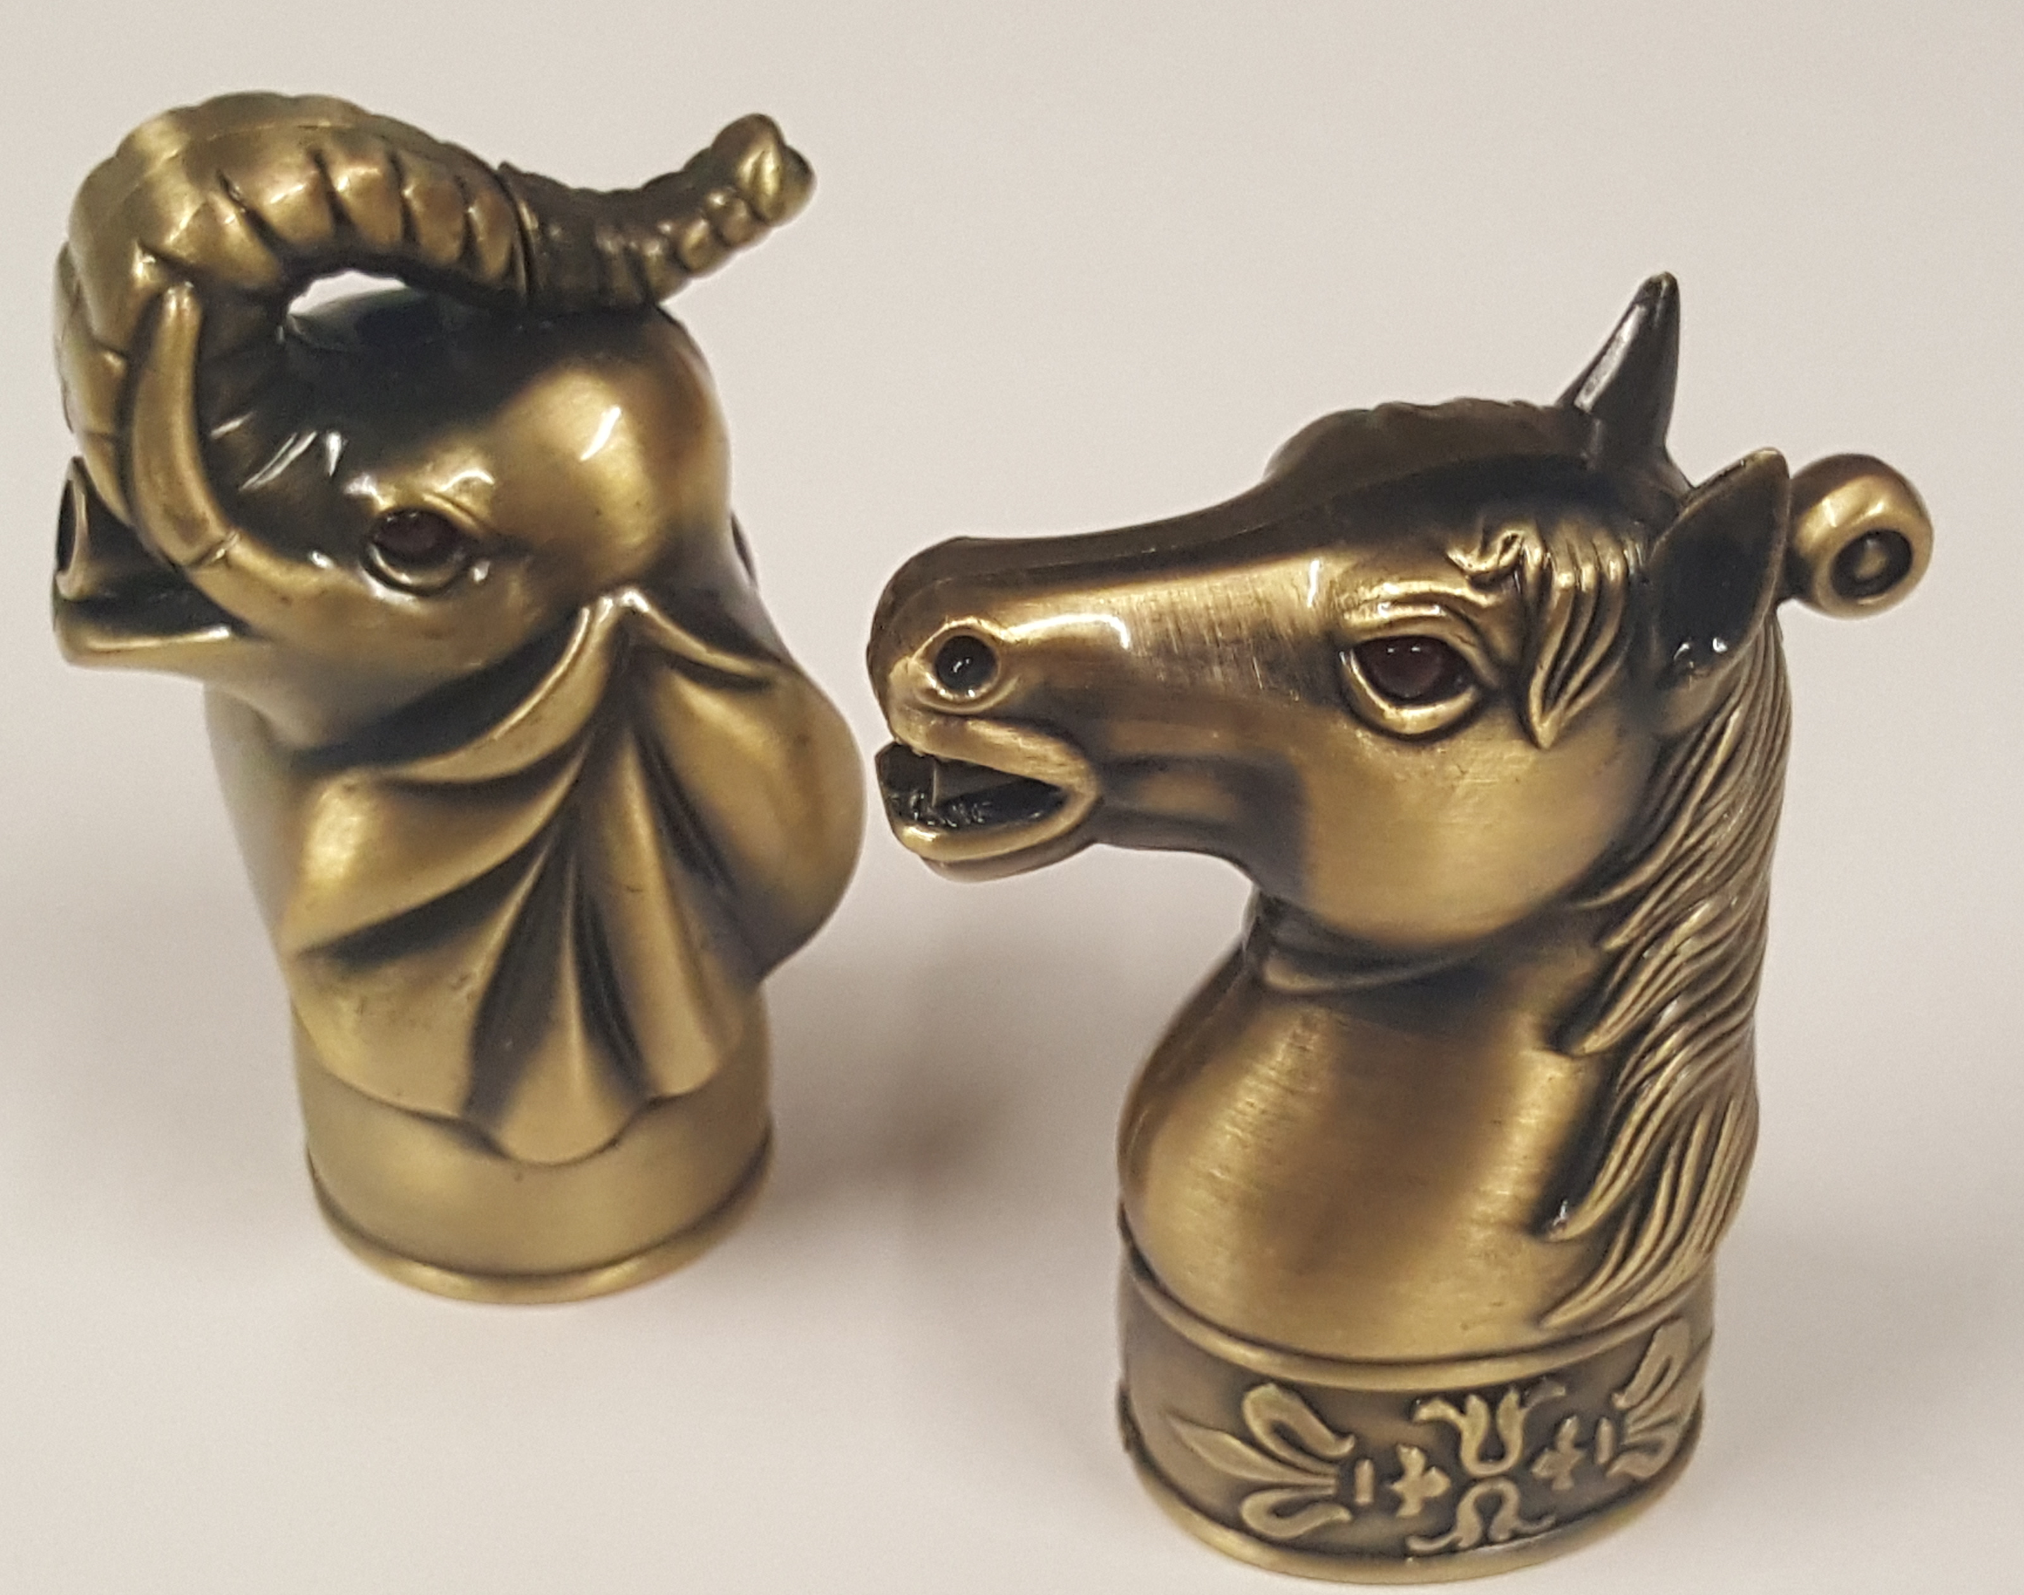

Annexure D – Compliance Program
Interpretation
- In this Annexure:
  - “the Director” means the Director of Consumer Affairs Victoria;
  - “the ACL” means the Australian Consumer Law, being Schedule 2 to the Competition and Consumer Act 2010 (C’th);
  - “commencement date” means the date of the Enforceable Undertaking in this matter;
  - “MRK” means MRK Distributors Pty Ltd (ACN 094 156 813);
  - “Compliance Officer” means the person appointed under paragraph 2 below;
  - “Company Program” means the steps taken by MRK to comply with the Enforceable Undertaking in relation to the Compliance Program;
  - “Enforceable Undertaking” means the undertaking agreed to between the Director and MRK signed, accepted and executed pursuant to section 218 of the ACL;
  - “Relevant Provisions” means the sections in Part 3-3 of the ACL;
  - “Risk Assessment” means the assessment required by paragraph 3 below;
  - “Risk Assessment Report” means the report required by paragraph 4 below; and
  - “Training” means the training required by paragraph 6 below.
Compliance Officer
- MRK must, within one month of the commencement date of the Enforceable Undertaking, appoint a director of the company, as its Compliance Officer, with responsibility for ensuring that the requirements concerning risk assessment and training, and product safety compliance procedures set out in the document are implemented and maintained.
Risk Assessment
- The Compliance Officer must, within one month of the commencement date of the Enforceable Undertaking, conduct a risk assessment or appoint a person who has experience with mandatory standards and compliance systems to conduct a risk assessment to:
  - identify the areas of MRK’s business where it is at risk of contravening the Relevant Provision;
  - assess the likelihood of any such contravention re-occurring;
  - identify where there are deficiencies in MRK’s procedures for managing such risk;
  - making findings concerning sub-paragraphs (a) to (c) above;
  - make recommendations for action having regard to sub-paragraphs (a) to (d) above; and
  - implement the recommendations within one month of the risk assessment exercise.
Risk Assessment Report
- The assessor must set out the findings of the risk assessment exercise in a written report (Risk Assessment Report) within two months of the conclusion of the risk assessment exercise and make it available should the Director or his nominee request a copy at any time the Undertaking remains in effect.
- The Compliance Officer must, at the time of the risk assessment exercise, subscribe to the Product Safety Australia Web Alerts [product-safety-alerts@accc.gov.au] to ensure that any new regulations or restrictions affecting goods that the company is or may be supplying in the future are brought to his attention for requisite compliance systems to be implemented.
Training
- The Compliance Officer must, after the risk assessment exercise, receive practical training regarding the product safety provisions in Parts 3-3 and 3-4 of the ACL and that the practical training include the areas of MRK’s business where it is at risk or is likely to be at risk of contravening the Relevant Provision, as identified in the Risk Assessment Report.
- MRK will ensure that the training is administered by a person with knowledge of and/or experience with mandatory standards, bans and compliance systems.
Product Safety Compliance System
- The Compliance Officer must:
- satisfy himself that his supplier has the capacity to meet the requirements of all relevant and applicable:
- mandatory safety or information standards; and/or
- interim or permanent ban orders –
affecting goods that the company is or may be supplying in the future (“the Standards”); and
- ensure that MRK keeps records of all orders for goods made in the future and that each such order must specify that goods to be acquired for supply by the company, in future, must conform with the requirements of the Standards and bans.
- MRK will:
- develop a checklist setting out the labelling requirements of the relevant and applicable Standards and bans and use such checklist in line with a procedure developed for batch checking when goods arrive from suppliers;
- withdraw goods of the type of class to which the Standards and bans apply from supply until such time they conform with the relevant and applicable Standards;
- maintain records of such checklist; and
- develop and implement a public complaint handling system and make such complaint handling system accessible from any website of which the company is the Registrant and upon which the company advertise or offers for supply, goods.
- Further, the Compliance Officer must:
- monitor that the checklists have been completed after the arrival of each batch of goods of the type of class to which the Standards and bans apply and that the obligations and procedures provided for under paragraph 10 above are applied to such goods where non-conformance with the relevant and applicable Standards and bans is detected;
- maintain up-to-date copies of all prescribed consumer product safety Standards that relate to products that the company supplies; and
- maintain files (or soft copies) of:
  - Order forms;
  - Testing results;
  - Checklist procedures;
  - Completed visual checklists; and
  - Risk assessments.
- MRK must, within the periods or on the dates provided for in the Enforceable Undertaking, provide the Director with the required documents or information.

