ol myCAV vXymzSd.ol.xD.w>u&Xu&d

w>pH.pdR*H>xH;

Consumer Affairs Victoria rR*hRxD.w>&J.w>usJRtoDvXttd.vXtHxJ.eJ;zDcd.vX incorporated associations (IAs) (ymzSd.ol.xD.w>u&X)t*D>vDRI

w>&J.w>usJRtHRb.w>ud;tDRvX myCAV 'D;rh>ph>uD; Victorian Government’s Digital Strategy vXurRvDRwH>0J'.y'd.tw>rRwz.'D;w>*h>w>usdRwz.'fod;vXySR0H;uxd&H,gzdwz.rRM>tDRu
ohcDzsdvXtHxJ.eJ;tylRvDRI

w>ymzSd.ol.xD.u&Xzdud;*Rvd.b.ol0JmyCAV vXuEkmvDRvXweH.wbsDw>wJzsgxD.php&Dt*h><
[h.w>tbl;tvJ'D;vXeu'k;oh.ngy0J'.vXw>vJvdmrh>td.xD.t*D>vDRI

w>rRwz.tHRrh>w>wrHRCD'D;w>vXerRtDR'D;ew>u&Xu&dcgcJtHRwcgvDR<b.q.xJ'.trh>0J'.vXtH
xJ.eJ;tzDcd.vDRI

b.Cm'D;myCAV

myCAVrh>w>tuvDvXw>uoltDRt*D>vDRIAtrRpSRvDR0JvHmvJ>tw>rR'D;'k;rRM>eoJp;w>rR
wz.nDvDR0JvDRI

eolmyCAVAoh0JvXeu
- ywHxD.vXeuuJxD.w>ymzSd.ol.xD.u&Xzd
- EkmvDRrRM>w>u&Xu&dw>*h>w>usdRcVcV'D;nDxD.
- rR*hRxD.'D;qDwvJu&Xw>*h>w>usdRwz.wbsDCDtwD>ylR
- EkmvDRvXweH.wbsDw>wJzsgxD.p&Dt*h>
- vlmydmxGJw>rReD.rRCg'D;phw>rReD.vXw>vD>wylRCDtylR

ySRtcX.p;rRpXRohvDR

vXw>uolmyCAVt*D>AeJ>&GJ>wz.ub.td.'D;myCAVp&D(account)<vDy&X<'D;vJR
EkmvDRqlthxX.eJ;vDRI

erh>vd.b.w>rRpXRb.C;'D;w>&J.w>usJRtw>rRvXthxX.eJ;tzDcd. (system online) M>eJ.&GJ>[h.pd[h.urDR0JySRtcX.p;A3A*RvXurRpXRt0Joh.t*D>ohvDRIeJ>&GJ>tHR[H;'H;rl'gvX
w>vlRydmxGJw>od.w>oD'H;vDRI

ySRtcX.p;tHRrh>0J:
- u&Xzdw*RvXeu&XylRoh0JvDR
- ySRzD.php&Drhwrh>yD>&Doh0JvDR
- tcX.p;oh0JvDR
- wHRoud;rhwrh>ySRvXe[H.zdCDzdtusgoh0JvDR

ySRtcX.p;tHRrRw>rRwz.'feJ.&GJ>oh0J<b.q.xJ'.Aw>qDwvJeJ.&GJ>vDRIxJ'.eJ.&GJ>tuJ0JcJtHRt
zXrk>w*RqDwvJeJ>&G>ohvDRI

w>*h>w>usdRtHR'k;eJ.eRvXcD.cgtcd.oh.b.C; myCAV vXeu

- 'k;td.xD.myCAVtp&D
- 'k;b.xGJep&Dqleu&X
- olmyCAV oMubsH;*H>xH;
- EkmvDRqlweH.wbsDp&Dw>rReD.
- [h.w>tyOR
- qDvJu&XtrHR
- qDwvJw>od.w>oDwz.
- qDwvJeJ.&GJ>w>*h>w>usdRwz.
- xXEkmtgxD.'D;xk;uGHmySRtcX.p;w*R
- qDwvJeD>up>*h>usdRwz.
- rRb.uhRvHmrJmzsX.clol.
- CktgxD.

[h.'D;'d;M>b.w>*h>cDzsdvDw>pl;ugvDrh.tltusdRtusJ (electronic means)

w>ol0JmyCAV tHR'k;rRoh0JeJ>&GJ>vXt[.hw>qlConsumer Affairs Victoria'D;'d;M>b.
w>cDzsdConsumer Affairs VictoriavXw>*h>wrHR*hRwrHR*hRvXw>vd.b.cDzsdAssociations
Incorporation Reform Act 2012cDzsdvDw>pl;ugvDrh.tltusdRtusJvDRI

whxD.myCAV p&DtoDoh'fvJ.
vXw>uwHxD.myCAV p&Dt*D>:  - vJRql www.consumer.vic.gov.au 'D;CkxX Sign in (EkmvDR)  vXtzDcd.pkxGJteX.xH;vXutd;xD. Sign in/Create myCAV account (qJ;vDRrHRrhwrh>'k;td.xD. myCAV  eD.*H>)tvHmubsH;t*D>  - euxH.0Jw>trJmbh.tHR  - CkxXCreate myCAV account (whuJxD. myCAV teD.*H>)  w> qD.zsX. vXw> qD. tDRI | 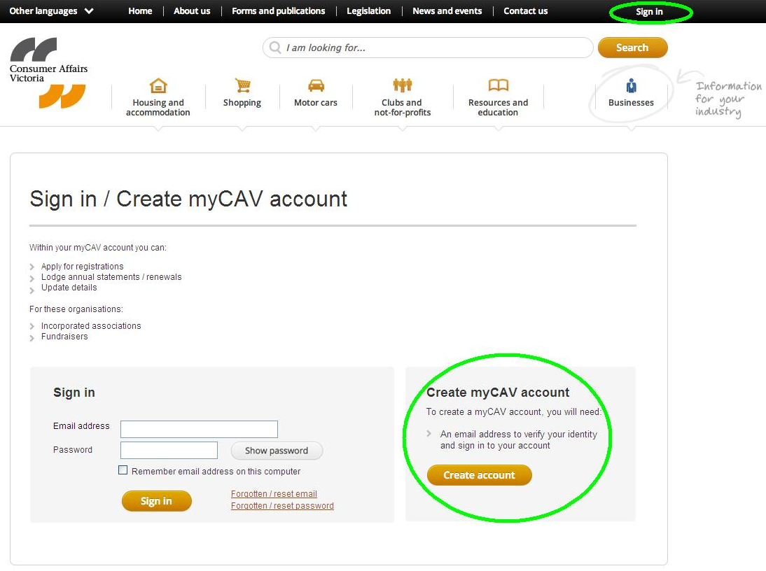
- pH;qX Yes (rh>)rhwrh>No (wrh>)A (unsure) (wvDRwH>b.)A  qlw>oHuG> Have you  received a letter from Consumer Affairs  Victoria (rh>e'd;M>b.vHmy&XvX Consumer Affairs  Victoria ttd.vHH{g) I  - erh>pH;qX No (wrh>)wcDrRySJR  w>*h>w>usdRvXvHmywHxD.  tylR0HR'D;CkxX Create  Account ('k;td.xD.eD.*H>)  w> qD.zsX.vXw> qD. tDRwuh>I  - erh>pH;qXYes (rh>), euvJRqlw>qJ;vDRrHR I | 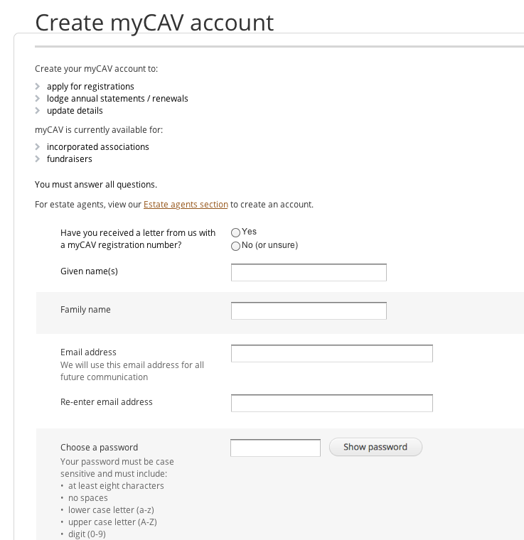
vXw>qJ;vDRrHRtubsH;ymeD>*H>tylR  - zXEkmvDR myCAV w>qJ;vDRrHRteD>*H>vXt  td.zsgvXevHmy&XtzDcd.'D;CkxX  Next (qlng) | 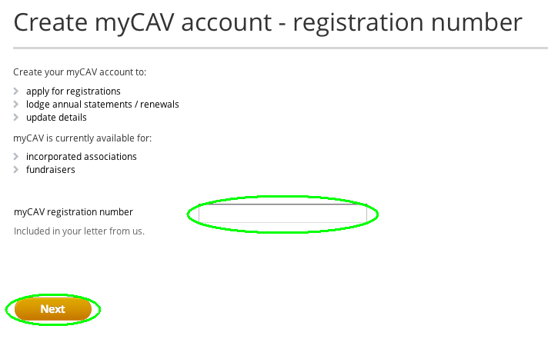
- rRvDRwH>uhRrh>erh>ySRrHRvXttd.zsg  wzsX.M>{gIArh Yes (rh>)  wcDCkxX Next (qlng) vXeuvJRqlngt*D>wuh> | 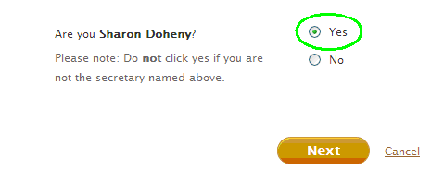
- xXEkmvDRevDy&X'D; vHmrJmzsX.clol.  - CkxX Show password (ymzsgxD.vHmrJmzsX.clol.) vXeuorHordmevHmrJmzsX.clol.  - 0HRCkxXCreate account (whxD.p&D) tw>qD.tzsX.wuh>  wd>eD.: 0Ho;plRwd>eD.evDy&X'D;vHm  rJmw>clol.'D;ymtDRylRylRzsJ;zsJ;wuh>I  vHmrJmzsX.w>clol.tb.td.pSRuwX>A  8AzsX.'D;b.y.Ckm'D;vHmrJmzsX.tqH; (lower case) wzsX.<vHmrJmzsX.t'd. (upper case)pSRuwX>wzsX.<  vHmrJmzsX.wzsX.<eD>*H>wzsX.'D;vHmrJm  zsX.vXtvDRqDwzsX.wuh>I | 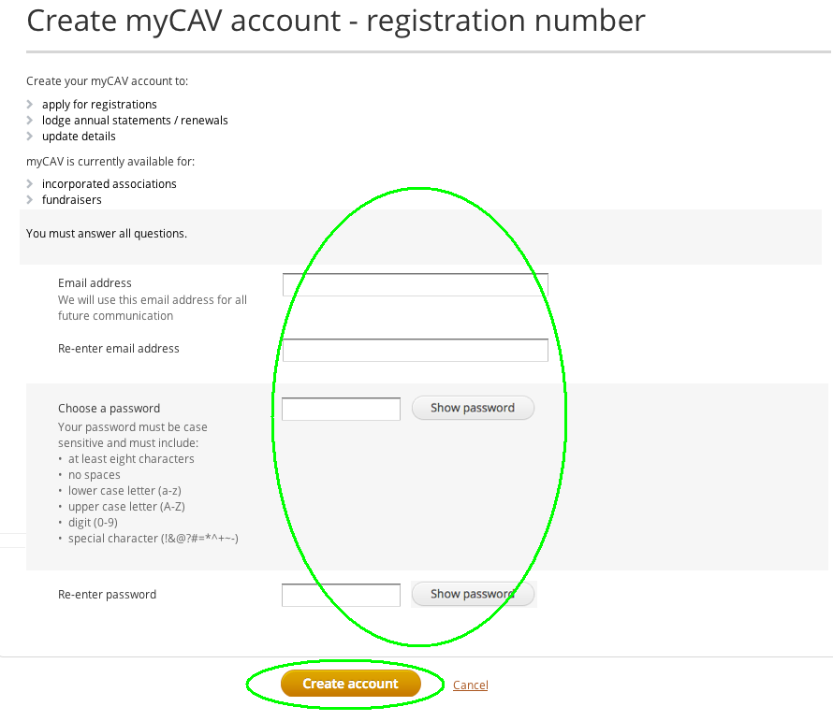
vXwpd>zdtwD>ylReu'd;M>b.w>  upD.vXu'k;oh.ngeRvXewh  xD.ep&DM>*hR*hRvH M.vDRI  qD.vDR sign in (EkmvDR)  tw>bs;pJvXew>upD.  tylR 'fod;eurR  0HRuhRw>vHmywHxD.t*D>wuh>I | 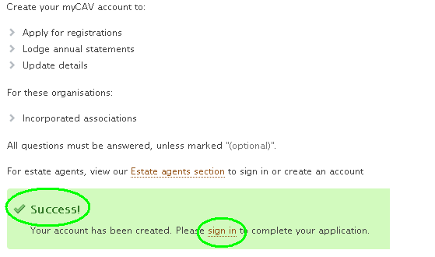
vXmyCAV Sign in (EkmvDR) w>eDRz;tylR<xXEkmvDRevDy&X'D;vHmrJm  zsX.clol.'D;CkxX Sign in (EkmvDR) vXeuvJRvXemyCAV tvHmubsH;yRoMcd.oh.wuh>I | 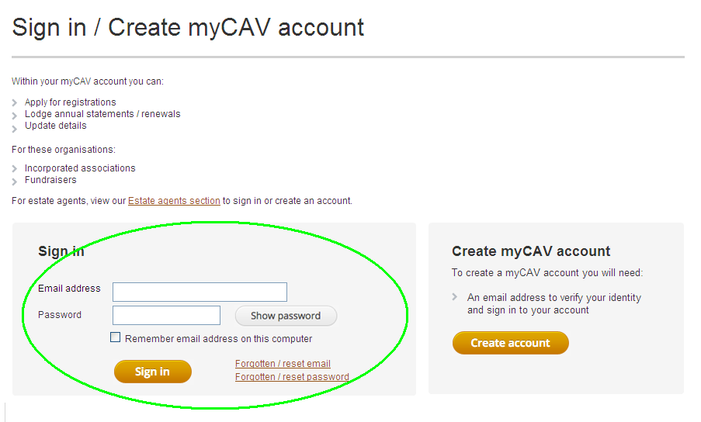
vXemyCAV ubsH;yRoMcd.oh.M.eIII  - uG>'D;qDwvJeu&Xt*h>usdRcDzsdol0J Actions list (w>[H;*h>0D)  p&Doh0JvDRI  - 'Defvd;vDRevHmtk.o;'D;w>od.w>  oDwz.oh0JvDRI  - euG>w>uGJ;eD.wz.vXttoDuwX>oh0JvDRI  - EkmvDRqleweH.wbsDp&Dw>  rReD.ohvDRI | 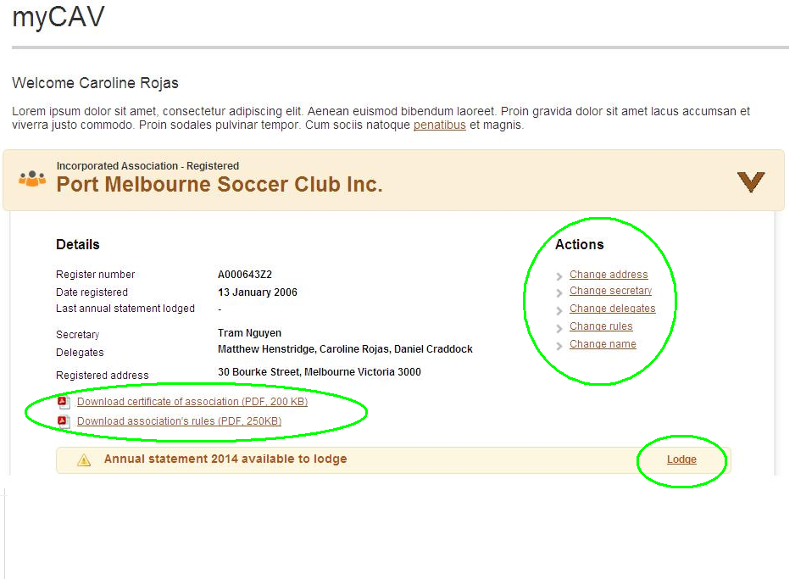
wd>eD.:  erh>wrh>rHRvXttd.zsgxD.w  zsX.M.b.M.<CkxX No (wrh>)I w>upD.(message)urXewHxD.e  myCAVp&DtoDvDRI  vXeurRw>tHRt*D>ACkxXw>bs;pJvX  ew>upD.(message)tylR0HRAxXEkmvDR  erHR<vDy&XtrHR'D;vHmrJmzsX.clol.'D;  0HRbsDCkxXAwhxD.p&Dw>qD.zsX.wuh>  ewhxD. myCAV p&D0HRwbsDe'k;  bs;pJtDR'D;eu&Xu&doh0JvDRI | 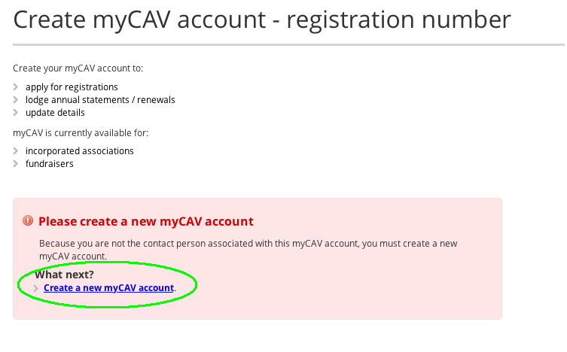

e'k;bs;pJep&D(account)qlew>u&Xu&doh'fvJ.
ewhxD.e myCAV p&DtoD0HRwbsDAe'k;  bs;pJtDRolew>u&Xu&doh0JvDRI  - CkxXerHRvXw>zDcd.pkxGJwcDvXy  (website)ySm,JRoMvXeutdm  xD.w>trHRto.p&DI  - CkxX Link to an organisation (bs;pJqlw>u&Xu&d) vXw>trHRto.p&DtylRwuh>I | 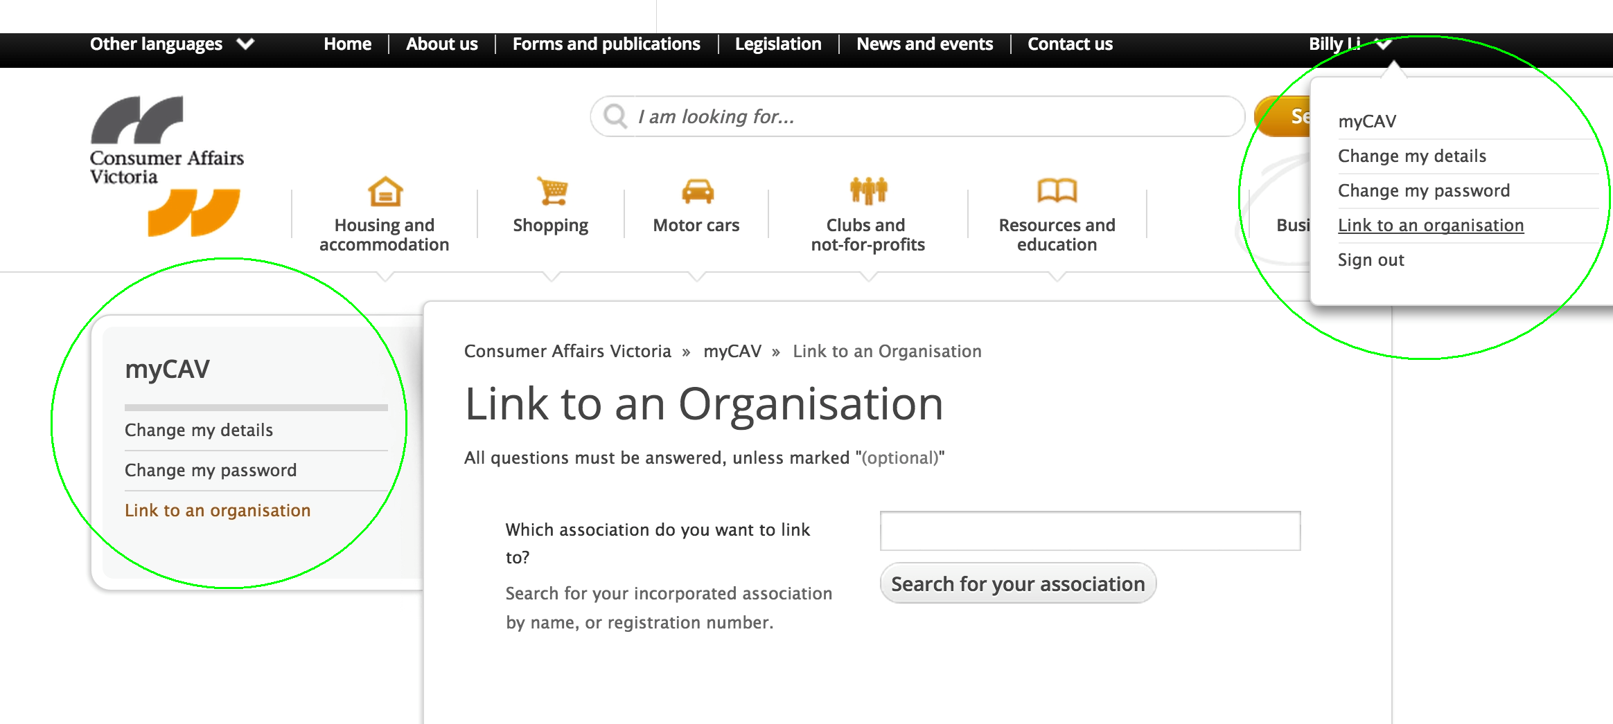
- xXEkmvDRew>u&Xu&dtrHRvXe  b.o;bs;pJtDR'D;CkxX Search  for your association  (Ckew>u&Xu&d)tw>urdm  - zJexH.ew>u&Xu&dtrHR'D;CkxXrHRwzsX.M.wuh>  - qD.vDR OK (vHmzsX.tdRchR)zJwvg td.zsgxD.Ckm'D;w>oHuG>  Are you sure you want  to link the association  as secretary? (rh>evDRwH>{gvX  eb.o;bs;pJew>u&Xu  &d'feJ.&GJ>tod;) | 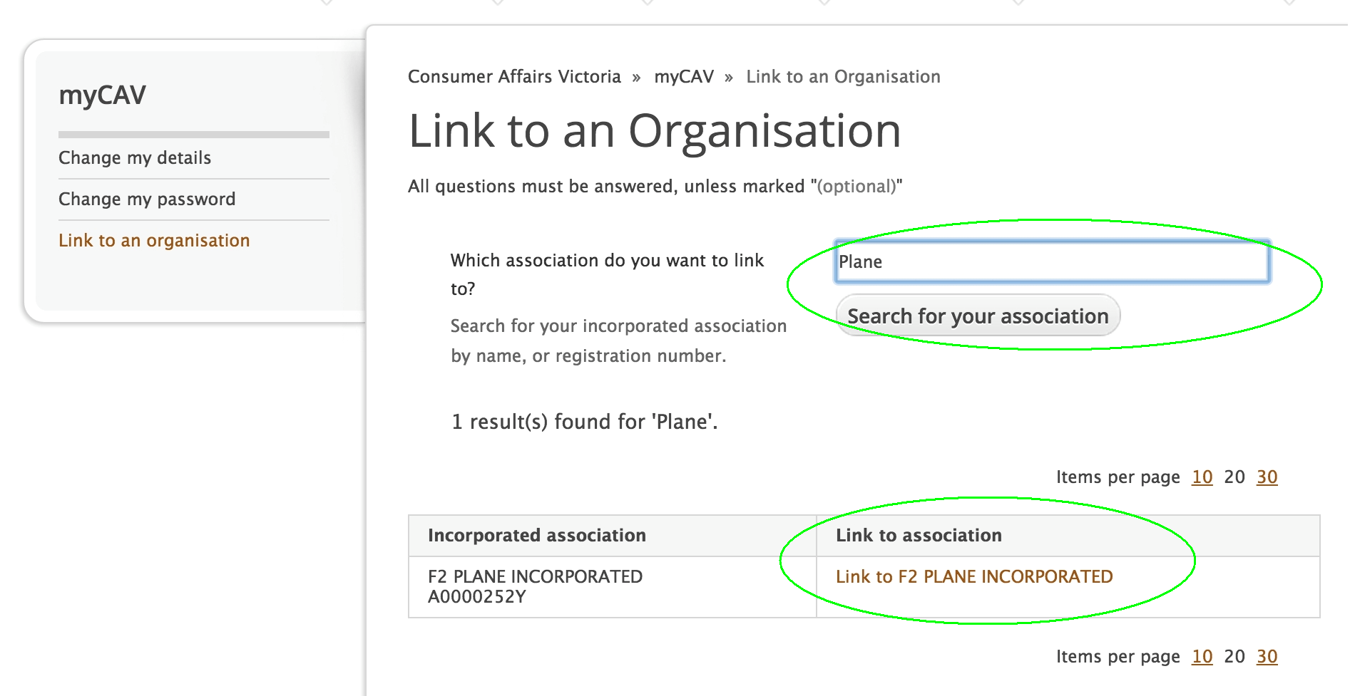
w>upD.(message) u'k;oh.ngeR  wbsDCDAzJe'k;bs;pJep&D(account)  qlew>u&Xu&drhM>*hR*hRtcgI  vXeuvJRqlmyCAV  ubsH;yRcd.oh.t*D>,  CkxXuhRReturn to myCAV (uhRu'guhRql myCAV)tw>bs;  pJvXew>upD.tylRI | 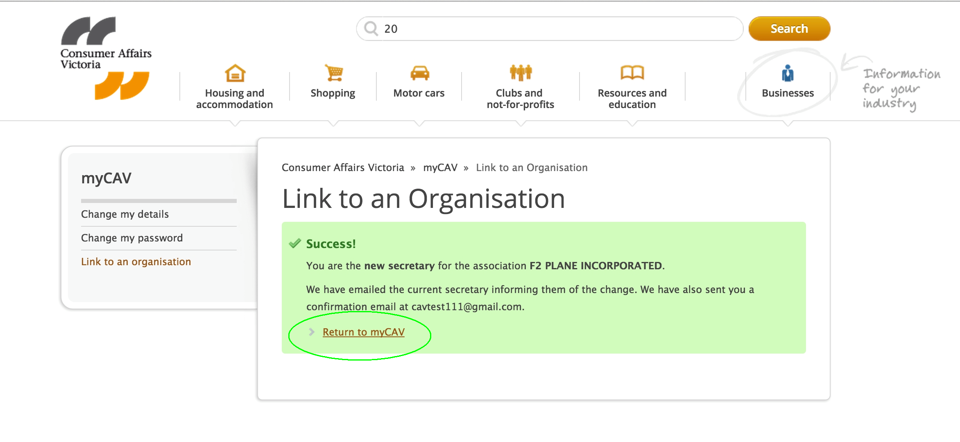
eu'd;M>b.ph>uD;vDy&XvX'k;oh.ngeR
vXeb.w>'k;bs;pJ'D;ew>u&Xu&dvHI

zJeCkxXw>bs;pJvXevDy
&X0HRM.euvJRql Sign in (EkmvDR) tvD>vX myCAV tylRvDRI
zJe'k;bs;pJe myCAVp&D  qlew>u&Xu&d0HRbsD<eEkmvDRql  myCAV ubsH;yRcd.oh.  ohud;qXuwD>'J;vDRI | 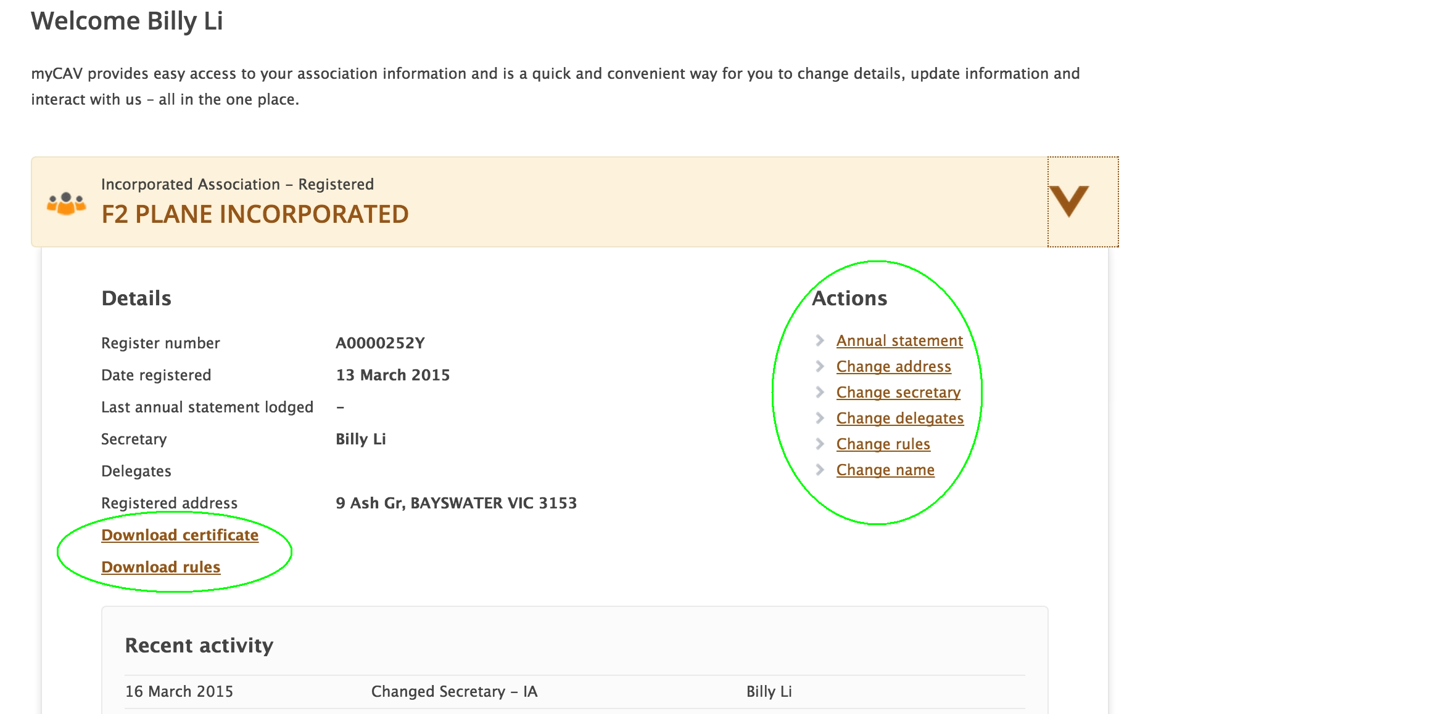

euole myCAV ubsH;ymoMcd.oh.'fvJ.
xJ'.eJ.&GJ>rhwrh>ySRcX.p;qDwvJw>u&Xu&dt*h>tusdRvX myCAV oh0JvDRI

zJw>vJvdmrh>td.xD.tcg<vDy&Xb.
w>qSXtDRqleJ.&GJ>ttd.vXu'k;
oh.ngtDRvXw>vJvdmt*h>vDRI

vXe myCAV ubsH;ymoMcd.oh.
M.ACkxXys>vXttd.vXew>
u&Xu&dtuyRvXeuIII

- uG>eu&Xu&dt*h>tusdR'D;
w>[l;w>*JRvXtcgcJtHRuwX>
- 'Defvd;vDRevHmtk.o;'D;w>od.
w>oDtwuGD.'d
- 'k;td.xD.w>vJvdmwz.vX
ew>u&Xu&dt*h>tusdRcDzsdolA
Actions List(w>[H;*h>0Dp&D)
- EkmvDRqlep&DweH.wbsDw>rR
eD.zJtuwD>wkRtcg

euywHxD.eH.wbsDp&Dw>rReD.rRCg'fvJ.
w>u&Xu&dcJvXmub.EkmvDRqlweH.w
bsDp&Dw>rReD.vXmyCAVtylRvXw
vgtwD>ylRzJttd.'D;weH.wbsDw>
td.zSd.0HRtcg (AGM)Ieu'd;M>b.vDy
&XvXu'k;oh.eD.eRvXeuEkmvDRqle
p&Dw>rReD.t*D>vDRI

tywD>A1Aw>u&Xu&dwz.A=A
vXttd.'D;weH.wbsDw>[JEkmpSRM>'f
$250,000M.Awvd.EkmvDRwD.
xD.php&DvXty.Ckm'D;weH.wbsDp
&Db.I
tywD>2A'D;A3Aw>u&Xu&du
b.'k;y.Ckm0Jphp&D'D;w>uG>uhRt'drh
wrh>w>orHord;php&Dw>ymzsgvX
trh>tHvJ;}xDeH;tvHm}wHmwz.I

CkxXlodge (ywHxD.) tw>bs;pJvXe myCAV tubsH;yRrd>yS>

- EkmvDRw>*h>w>usdRvXw>vd.b.
tDRwz.
- 'k;bs;pJw>qD.xGJtvHmtvJ>'ftHvJ;  }xDeH;tvHmtod;cDzsdqD.vDR  Select file to attach (CkxXvHmvXeu'k;bs;pJ). CkvHmvJ>wz.vXecD.zFLxX.t  ylR'D;CkxX Ok (tdch) (evHmw  z.ub.rh>0J'..doc, .docx,  .xls, .xlsx, .text, .pdf tuh>t*DR  'D;wb.tg 5MBb.)  - z; Declaration (w>bd;b.&RvDRzd;oJp;) vDRwH>vDRqJ;'D;CkxX Agree (o;vDRyvdm) wuh>CkxX Next (qlng) vXeuvJRqlw>[h.t  yORt*D>I  rReD.:  cDzsdvXo;vDRyvdm'D;w>bd;b.&RvDRoJp;vX myCAV tylRtHRArh>w>pXC;vXtzd;  oJp;vDRI | 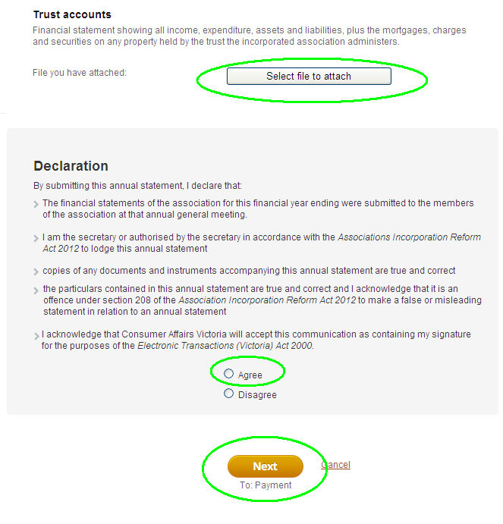
eu[h.w>yORvXwz.vX myCAVtylR'fvJ.
zJeol0J'.myCAVtcg<AeCkxXvXeu  [h.w>yORwz.vXthxX.eJ;zDcd.cDzsdtDefvJef  rhwrh>vXeeD>up>cDzsdol0J'. (cheque)p;  cdvXySR uGJ; rR vdm phvXphwX;'D;vJqlvHy  &XwX;oh0JvDRI  vXu[h.w>yORt*D>  - wdReD>e[h.w>bl;w>  vJtusJtuylR  - CkxXNext (qlng) vXeuvJR  qlw>[h.w>bl;w>vJtu&l> | 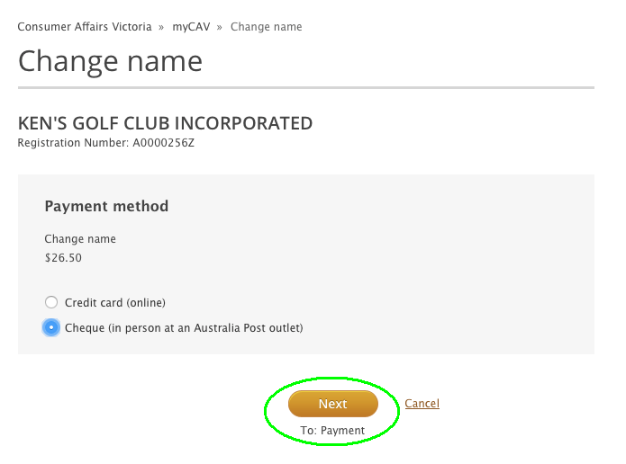
erh>[h.vXeup>wcDIII  - orHord;w>*h>w>usdRrh>t  b.{gA0HR'D;CkxX Confirm  (ym*X>ymusXR)I  rReD.:  php&Dub.w>qSXM>eRqlevDy&XtylR'D;  ew>qXuwD>td.0J 14 AoDvXeu  [h.w>tbl;tvJt*D>vDRIAeub.  ChvHmwl>vdmphzJe[h.w>bl;  w>vJtcgvDRI | 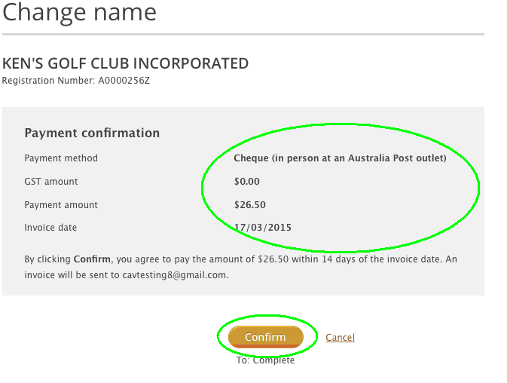
erh[h.vXthxX.eJ;  - euvd.b.0J'.'JbH;rhwrh>&J'H;c;<  Visa rhwrh> MasterCardI  - xXEkmvDRec;uhtw>*h>w>usdR'D;  CkxX Next (qlng) vXeupJ;rRqlngt*D>wuh>  - w>*h>w>usdRrhb.wcD<A  CkxX Make payment ([h.w>bl;w>vJ) wuh>I  rReD.:  w>upD.u'k;oh.ngeRwbsDCDvXe[h.  w>bl;w>vJM.vJRo;*hR*hRvH'D;vHmwl>  vdmphub.w>qSXM>eRqlevDy&XtylRvDRI | 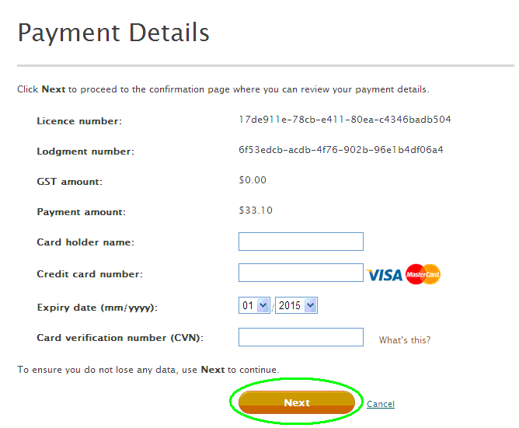

euqDvJew>u&Xu&dtrHR'fvJ.
w>pH.nD.wJmvDRvDRqDqDb.w>  vd.tDRvXeuqDvJ0Jew>u&X  u&dtrHRtcgvDRI  zJw>pH.nD.wJmvDR[Jtd.xD.0HRbsDIII  - CkxX Change name  (qDwvJrHR) vX Actions List (w>[H;*h>0D)p&DylRwuh>I | 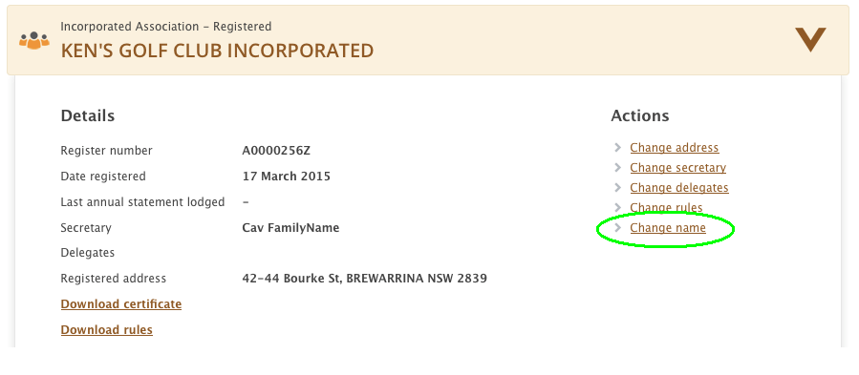
- xXEkmvDRrHRvXw>ul.xD.tDR'D;Ck  xXCheck name availability (orHrd;rHRrh>w>rRM>tDRoh{g)  w>qD.zsX.wuh>I | 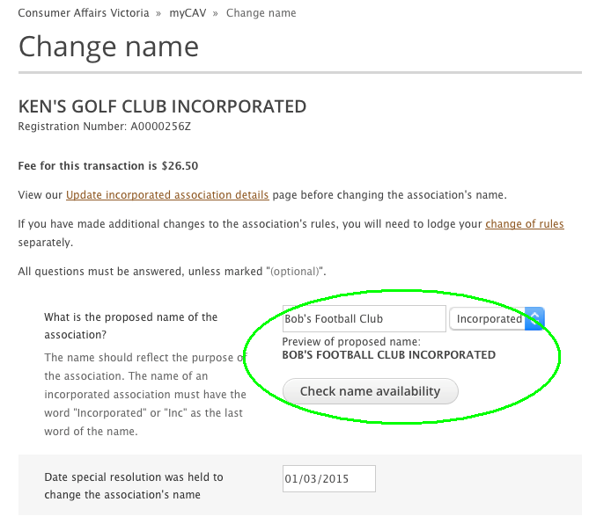
- w>upD. u'k;oh.ngeRvXrHRM.w>  oltDRohvDRI  rReD.:  rHRwzsX.M.w>oltDRrh>wM>wcD<A  eub.CkxXrHRvXt*RwzsX.vDRI  - xXEkmvDRw>pH.nD.wJmvDR  vDRqDqDrk>eHRrk>oDwuh>I | 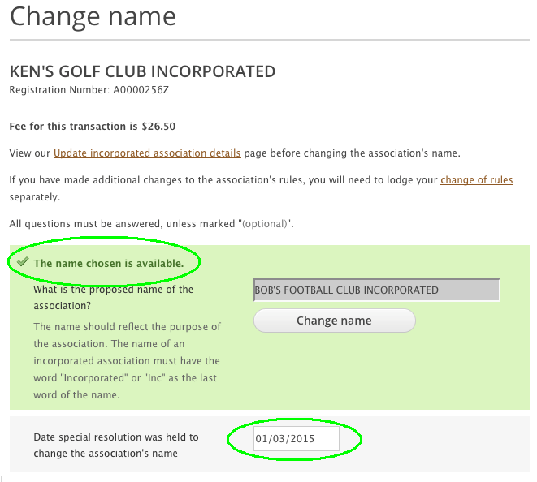
- bs;pJew>od.w>oDt'dCkm'D;  ew>u&Xu&dtrHR'ftH;vJ.  }xdeH;tvHmwuh>I  - z;oJp;'D;w>bd;b.&RvDR'D;CkxX  Agree (o;vDRyvdm)'D; Next (qlng) vXeuvJRqlw>[h.w>bl;  w>vJt*D>wuh>I | 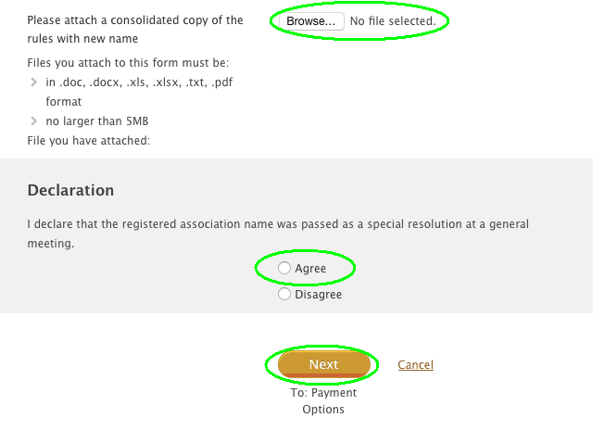
rRySJRw>vXw>[h.w>bl;w>vJtu&l>0HR  bsD<Aeu'd;M>b.w>upD.wbsDCDvX'k;  oh.ngeRvXew>u&Xu&dM>w>qDvJ  trHR0HRvHM.vDRI | 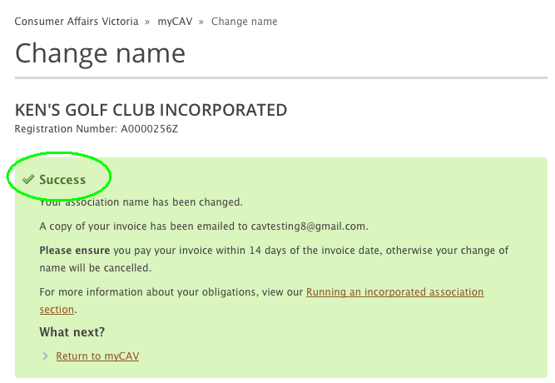
cgqlngwbsDeEkmvDRql myCAV  M.euxH.ew>u&Xu&dtrHR  vXw>qDvJtDRM.vDRI | 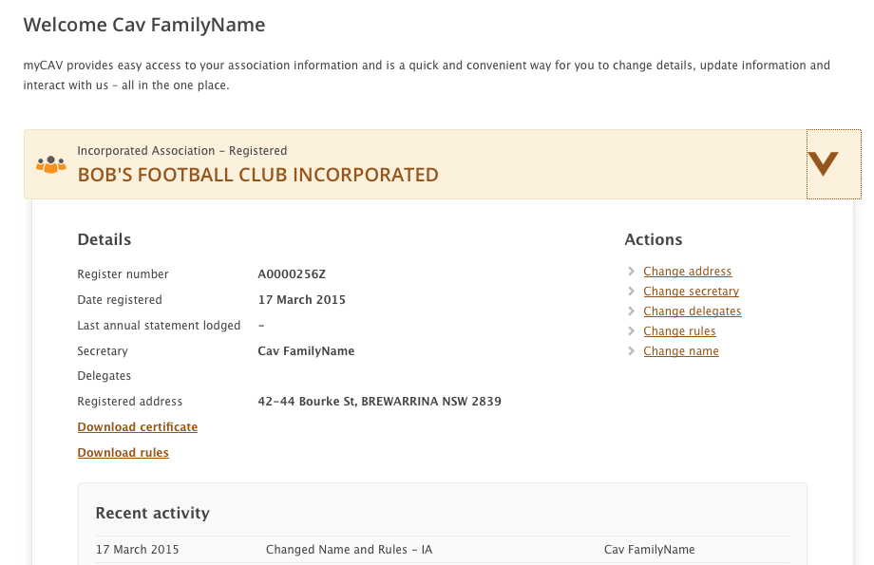

euqDvJw>od.w>oD'fvJ.
w>pH.nD.wJmvDRvDRqDqDb.w>vd.  tDRvXeuqDvJew>u&Xu&dtw>  od.w>oDt*D>vDRI  w>pH.nD.wJmtHRw>rRtDRrh>0HRwcDIII  - Change rules (CkxXqDvJw>od.w>oD)  vXA Actions List  (w>[H;*h>0Dtp&DylR)wuh>I | 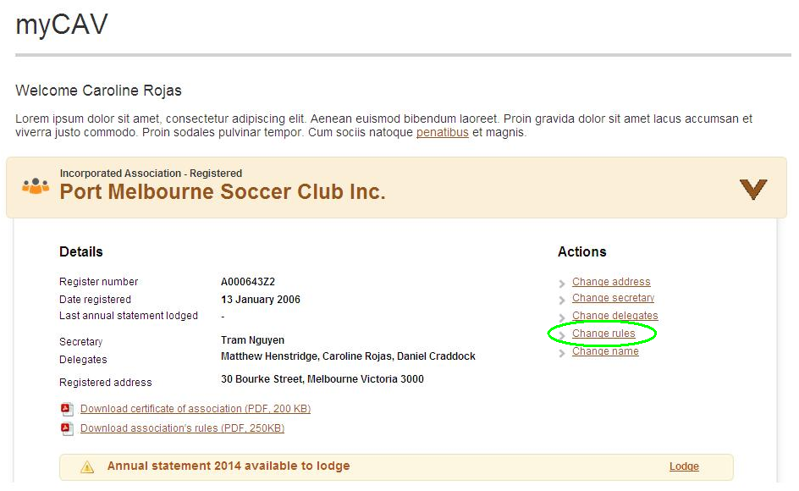
- CkxX Own rules (eD>up>w>od.w>oD)  rhwrh> model rules (w>t'dtwJmw>od.w>oD) vXp&DvXt[JvDRwcgM.tylRwuh>I  - xXEkmvDRrk>eHRrk>oDvX w>pH.nD.wJmvDRvDRqDqDtHRwuh>I | 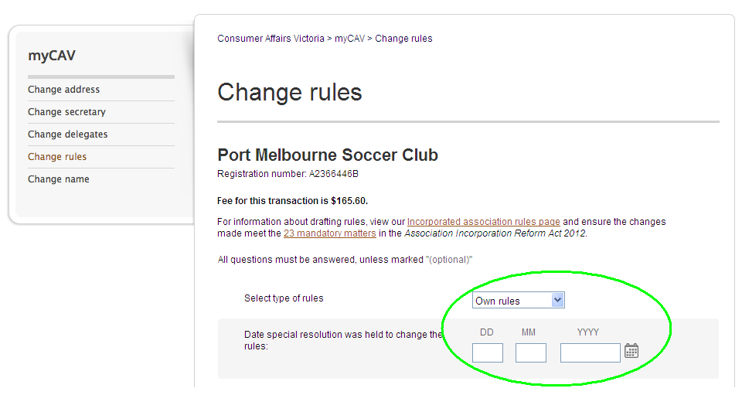
- bs;pJ w>pH.nD.wJmvDRqD'ftHvJ.  }xDeH;tvHmwuh>  - xXEkmvDRusd.pheH.uwX>trk>eHRrk>oD'D;ew>u&Xu&dtw>wdmymwuh>  - bs;pJw>od.w>oDt'dvXtHvJ.  }xDeH;  - CkxX Agree (o;vDRyvdm) qlw>bd;b.oh.ng'D; Next (qlng)vXeuvJRqlw>[h.w>bl; w>vJttd.I | 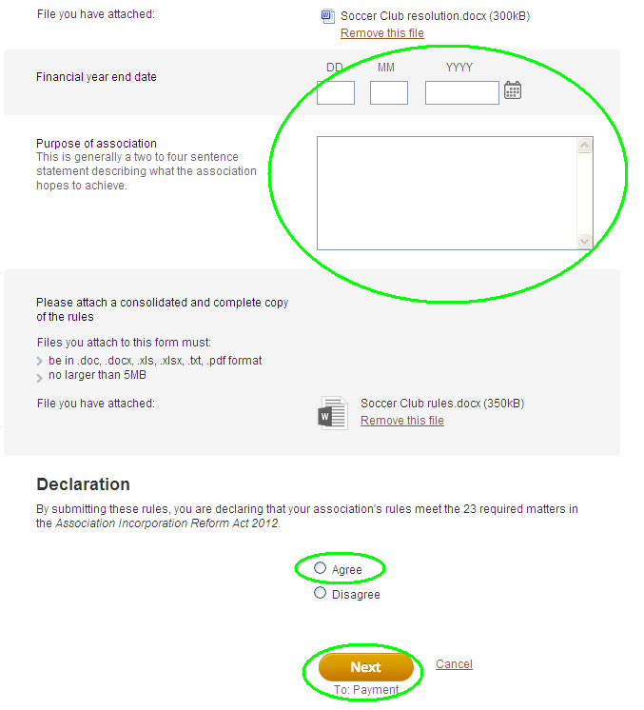

euqDwvJeJ.&GJ>'D;rRoDxD.w>*h>w>usdR'fvJ.
xJ'.eJ.&JG>chcgcJtHRw*RqDvJeJ.&GJ>  trHRohvDRI  vXeuqDvJeJ.&GJ>t*h>tusdRIII  - CkxX Change secretary (qDvJ) vX Actions (w>[l;w>*JR) tp&DvXemyCAV tubsH;ymcd.oh.  - 0HRbsD Update current secretary’s details or Change to new secretary (CkxXrR*hRxD.eJ.&GJ>cJtHRw*Rt*h>tusdR)rhwrh>(qDvJqleJ.&GJ>toD) | 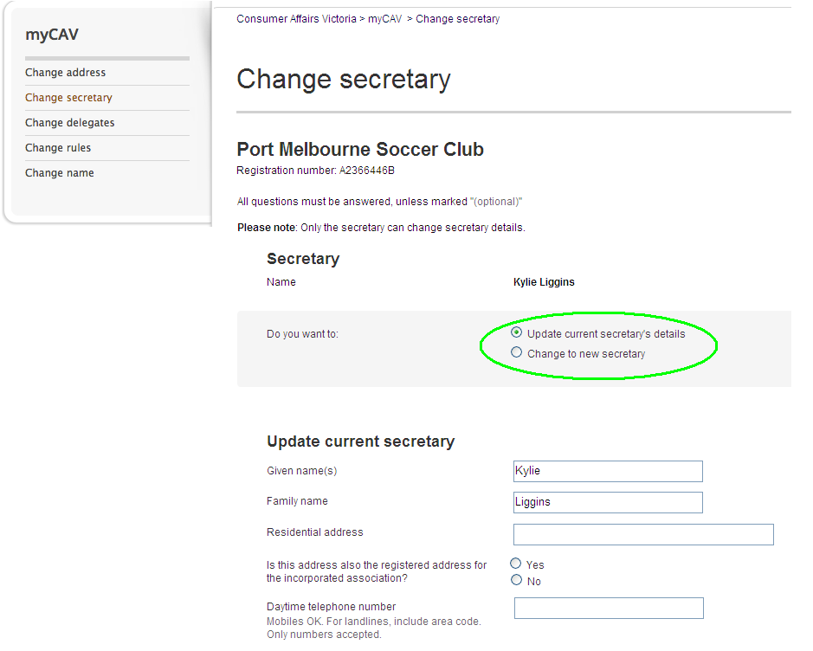
- zXEkmvDRw>*h>w>usdRtoD  - CkxX Save (ymCm)  w>rh>qDvJeJ.&GJ>M.AvDy&Xub.w>qSXqleJ.&GJ>vXt[;xD.w*Rttd.'D;w>u'k;oh.ngw>u&Xu&dtcX.p;b.Cmw>qDvJo;t*h>vDRI  eJ>&GJ>vXuEkmvDRw*Ru'd;M>b.vDy&X  vXurRvDRwH>w>oh.eHRz;oD'D;w>bs;pJ  vXurRrlxD. myCAV tp&DvDRI | 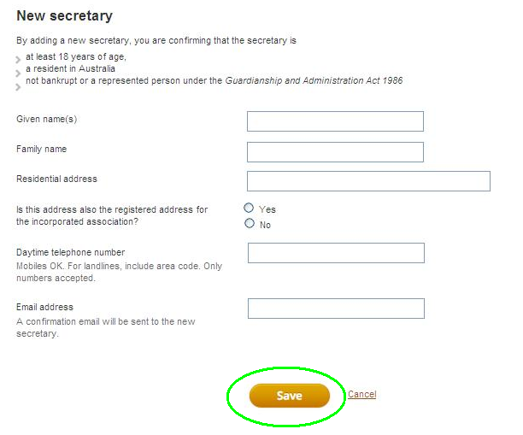

ub.xXEkmtgxD.'D;xk;uGHmySRcX.p;'fvJ.
eJ.&GJ>[h.pd[h.urDRySRtcX.p;M>wkRoX  *RvXurRpXRb.Cmw>yXw>qSXw>rR  b.Cm myCAV, zJw>rh>vd.tDRtcgvDRI  vXuzXEkmySRcX.p;  - CkxX Change delegates (qDwvJySRcX.p;wz.)vX Actions List (w>[H;*h>0Dtp&DtylR)I  - xXEkmvDRySRtcX.p;toDt  *h>tusdRwz.'D;wdReD.vXu  rRvDRwH>0JySRtcX.p;wz.  tHRb.w>[h.pd[h.urDRtDR'D;  eJ.&GJ>vHvDRI  - CkxX Add delegate (xXEkmtgxD.ySRcX.p;)I  ySRtcX.p;rh>td.oX*RvHwcD<eJ.&GJ>u  b.xk;uGHmySRtcX.p;vXttd.ympXR  wcsK;uxXEkmtgxD.ySRoDtcgvDRI  vXuxk;uGHmySRtcX.p;t*D>  - CkxX Delete (xl;oHuGHm) vXtrHRtuyRwuh>I  vDy&XuvJRqlySRcX.p;vXt[;  xD.w*Rttd.'D;eJ>&GJ>cJtHRw*R  w>u'k;oh.ngtDRvXw>vJvdmvDRI  eJ>&GJ>'D;ySRcX.p;vX[;xD.wz.EkmvDR  vXw>u&Xu&dt*h>tusdRvX  myCAVwM>vXRb. I | 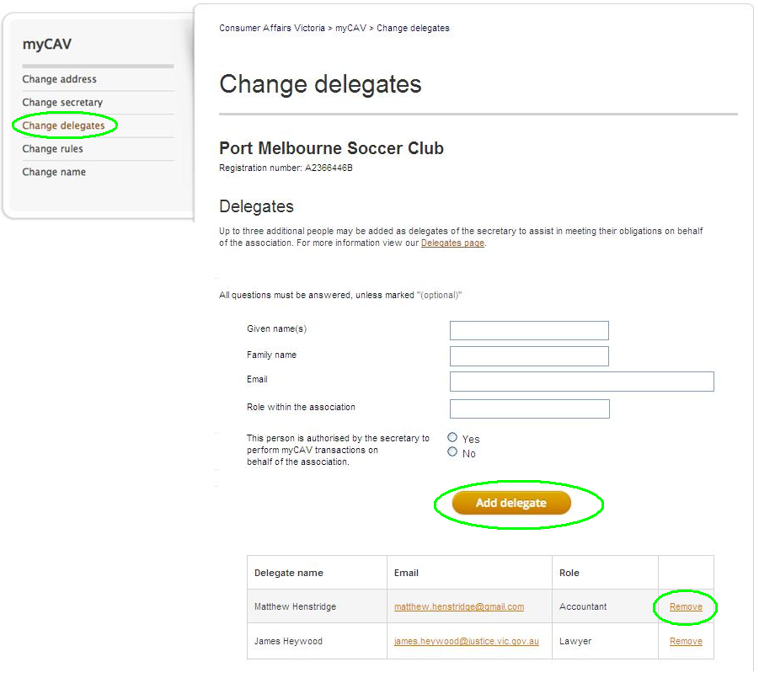
uqDwvJeD>up>w>*h >wz.'fvJ.
vXw>clol.t*D><AeD>up>w>*h>w>  usdRvXexH.vX myCAV  ylRohM.rh>xJeeD>up>tw>vDRI  vXeuqDvJeeD>up>t*h>wz.t*D>III  - vJRqlySm,JRoM'D;CkxXerHRvX  cD.zFLxX.trJ.o.tzD  cd.vXeutd;xD.p&DvXt[JvDR  wz.vDRI  - CkxXw>rRvXeb.o;rRtDRI | 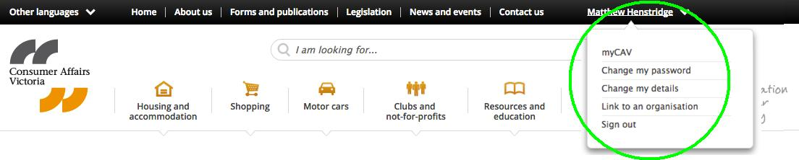
t'd<vXeuqDvJvHmrJmzsX.clol.*D>III  - CkxX Change my password (qDvJvHmrJmzsX.clol.) vXp&DylRI  - xXEkmvDRevHmrJmzsX.clol.vXtcJtHRwzsX. I  - xXEkmvDRvHmrJmzsX.clol.vXtoDwzsX.'D;CkxX Show password  (ymzsgxD.vHmrJmzsX.clol.)'fod;  eurRvDRwH>rh>w>M>tb.M.vDRI  - CkxX Save (ymCm) 'D;w>upD>  u'k;oh.ngeRvXw>vJvdmM.vDRI | 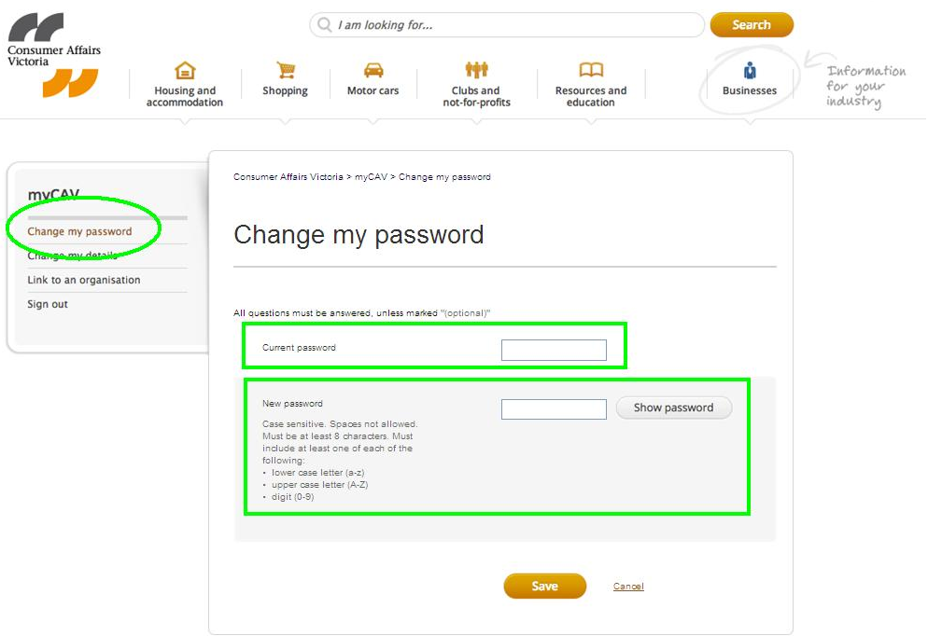

eurRb.uhRevHmrJmzsX.clol.'fvJ.
erho;yRheD.evHmrJmzsX.clol.  - vJRqlAmyCAV w> Sign in (EkmvDR) ubsH;ym'D;CkxX Forgotten/reset  (o;yRheD.rhwrh>rRb.uhR)  vHmrJmzsX.clol.wuh>I  - xXEkmvDRvDy&X'D;CkxXSend link (qSXw>bs;pJ)I  vDy&Xub.w>qSXM>eRvXeuqDvJ  evHmrJmzsX.clol.t*D>vDRI  ew>qXuwD>td.0JA24Ae>&H>vXeu  CkxXw>bs;pJ(link)'DydmxGJw>eJ.  vDRvXeu'k;td.xD.evHmrJmzsX.t  oDt*D>vDRI  w>bs;pJtqXuwD> rh>vXmuGHmwcsK;  vXeqDvJevHmrJmzsX.clol.'D;A  rRu'd;toDwbsDwuh>I | 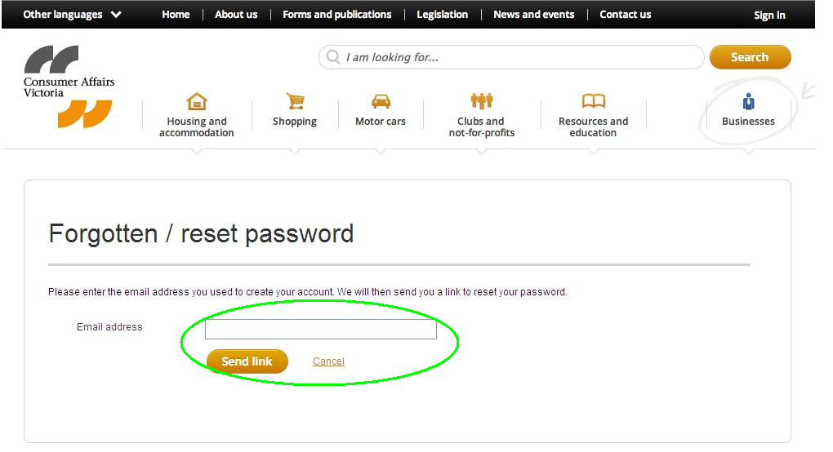

u[;xD.(sign out)uGHmql myCAV 'fvJ.
vXw>bH.w>bXt*D><AxDbdM.[;  xD.uGHmAzJolmyCAV 0HRtcgwuh>I  - CkxX Sign out ([;xD.) vXcD.zFLxX.trJmo.tzD  cd.vXtxGJwuh>I | 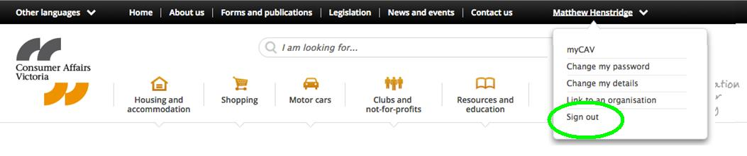

w>[l;w>*JRwz.vXwtd.vX myCAVtylRwz.

w>[l;w>*JRwz.vXw>rRtDRvX myCAV ylRwohb.wz.rh>0JIII

- w>ymzSd.Ckmw>u&Xu&dwz.
- ChxD.vXw>u[h.tgxD.w>qXuwD>vXuzD.*X>Cm(AGM)'D;
wD.xD.weH.wbsDp&D
- rR*hRxD.wrh>rR[;*DRuGHmw>u&Xu&dI

vHmywHxD.vXw>rRoh.wz.t*D>M>erRM>tDRohvXySm,JRoM(website)ohvDRI
www.consumer.vic.gov.au/associations

rRoDxD.uhR e tHxXeJ;tw>xH.CkuG>

vXtqXuxD.vXt*hRuwX>t*D>M><y [h.ul.eRvXeuol Google Chrome
vXe internet browserI Chrome M>tcV'D;rRw>*hR'D;erRM>tDRuvDvDRI

w>wJusd;xHw>tw>rRwz.

w>*h>w>usdRb.Cm myCAV tHRw>rRM>tDRohvXusdmtguvkmvXyySm,JRoMvDI www.consumer.vic.gov.au/languages

eudmyw>wJusd;xHw>Aw>rRoh0JuvDRAzJ 131 450I wJzsgxD.eusdmvXudmvR0gusdm'D;
rXyySRwJusd;xHw>ud;yvDusdRw>rRpXRvX 1300 55 81 81 vXw>rRe.&H>tqXuwD>vDRI

w>rRpXRtHRtd.ph>uD;vX Koori tvDw>rRpXRusdR1300 661 511I

w>*h>w>usdRt*R

euG>0Jyw>od.vdw>*DRrlvXmyCAV 'D;w>*h>t*Rwz.'D;w>csK;cHeDRo;vX(myCAV)tylRt*D>A
vJRb.qlIII consumer.vic.gov.au/associations

vXuqJ;vDRrHR'D;rRM>w>upD.vXwtd.'D;tup>bsK;'.0JvXty.Ckm'D;w>*h>w>usdRb.C;w>u&Xu&dA
vJRb.ql consumer.vic.gov.au/newsletters

myCAVub.w>rRcsK;cHeDRo;tDRb.qXb.uwD>vDRIAzJmyCAVtw>td.zsguqDvJo;
vXw>qXuwD>tylR<Atw>rRwqDb.wqDvXtnDtHRupJRrRpXReRvXeurR0HRew>rRvXtcV'D;
usXRol.usXRo;vXew>u&Xu&dt*D>vDRI

