Notice of entry to resident/s of SDA enrolled dwellings
Residential Tenancies Act 1997 (the Act), Part 12A
Specialist Disability Accommodation
Sections 498U, 498V and 498X
Use this form if you are a specialist disability accommodation (SDA) provider and you have an SDA residency agreement with an SDA resident (the resident) for a dwelling or room.

How to use this form

Identify your reason for entry
Read the information on page 3 about when you can exercise a right of entry for an SDA enrolled dwelling.
You should also consult Part 12A of the Act to make sure that you are entitled to enter the resident’s dwelling or room. Make sure you identify the correct reason for your circumstances.
Depending on the reason for entry, you may be required to give the resident/s written notice. If you must give written notice of entry (section C, page 3), you will need to complete the attached notice.

Work out if a minimum notice period applies
Identify if you are required to give notice to the resident/s before you can enter.
The minimum notice period begins on the day after the notice is given.
Note: Australia Post has three different speeds for mail delivery – express, priority and regular. If you send this notice by post, you must take into account the days it takes for the notice to be delivered. For more information about postal delivery options and times, visit the Australia Post website (auspost.com.au/sending/send-within-australia).

Complete the attached notice of entry
- Complete boxes 1 to 7
- Sign at 8 and write your name at 9
- Insert the date and time you wish to enter the dwelling or room at 10
- In box 11, write the section number and reason for entry using the exact words from the 'Purpose of entry – reasons to use in question 11' column in the table on page 3.
Note: You must complete all boxes. The notice may be invalid if you remove or change any questions or other text.

When the notice of entry is complete
Give a copy of the notice to the resident. If there is more than one resident living in the SDA enrolled dwelling, you must give a copy to each resident.
If it would assist the resident/s, you must also give a copy to the resident’s guardian, family member, carer, advocate or other chosen person.
For more information, see ‘How to give this notice’ on page 4.
Keep a copy of the notice for your records.

Assistance

Consumer Affairs Victoria
If you need help with this notice, visit the Specialist disability accommodation section – Consumer Affairs Victoria website (consumer.vic.gov.au/sda) or call Consumer Affairs Victoria
on 1300 40 43 19.

Telephone Interpreter Service
If you have difficulty understanding English, contact the Translating and Interpreting Service (TIS) on 131 450 (for the cost of a local call) and ask to be put through to an Information Officer at Consumer Affairs Victoria on
1300 55 81 81.
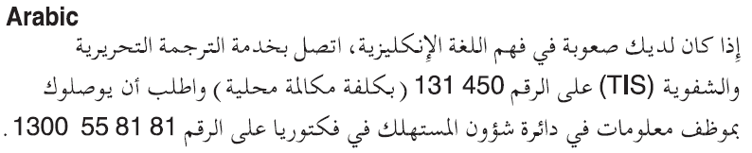
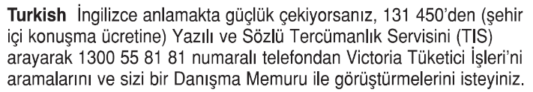
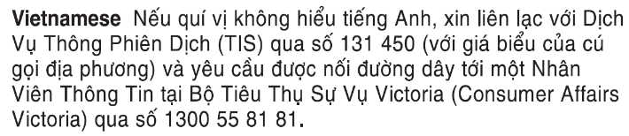
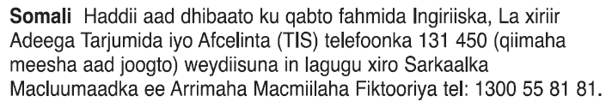
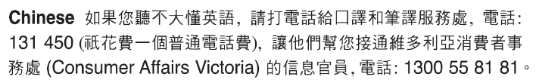
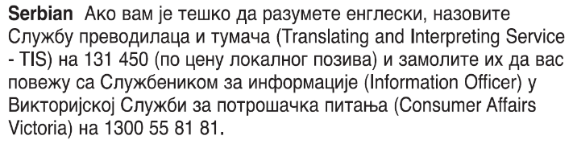
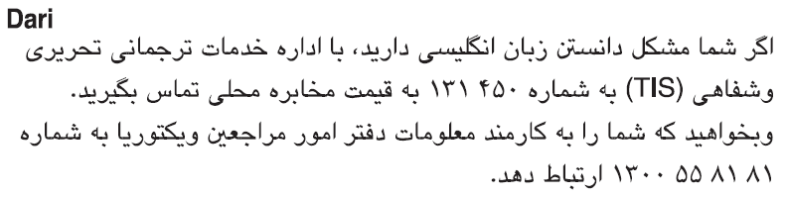
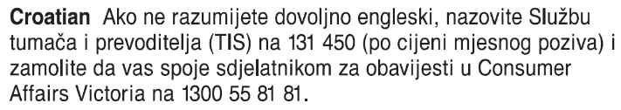
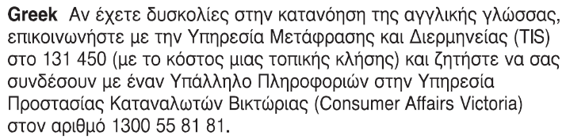
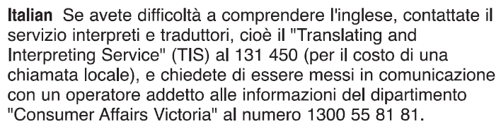 Information about renting is available in other languages at consumer.vic.gov.au/languages.

Notice of entry to resident/s of SDA enrolled dwellings

Entry where notice is not required
Section 498V(2) provides that you (the SDA provider) can enter the resident’s room or dwelling without giving prior notice if:
- all resident/s agree to the entry at the time entry is sought
- there is an emergency
- you believe on reasonable grounds that it is necessary to protect the health or safety of the resident or any other person at the SDA enrolled dwelling
- you believe on reasonable grounds that the resident has abandoned the SDA enrolled dwelling. Note: if multiple residents live in the dwelling, you must not enter areas of the dwelling exclusively occupied by them
- entry is necessary to undertake urgent repairs.

Entry where notice is required
Section 489U(a) provides that you and the resident can also agree to entry at any time, provided the resident consented no more than seven days before the entry. If there are multiple residents living at the SDA enrolled dwelling, all the residents must have consented to the entry no more than seven days before the entry.

Entry where written notice is required
You can enter the resident’s dwelling or room for another purpose provided for under the Act by providing written notice. This right of entry may be exercised on any day between 8am and 6pm, except on a public holiday.
The following table sets out the circumstances in which this right of entry may be exercised under the Act, and the required notice that must be given to resident/s before the right may be exercised.
Section of the Act | Purpose for entry – reasons to use in question 11 | Minimum notice required | Additional conditions
498V(1)(f) | To undertake maintenance or repairs, or for the purpose of maintenance or repairs. | 24 hours
498V(1)(c) | To carry out my legal duty as an SDA provider to (insert duty under section 498M of this Act or any other Act). | 24 hours
498V(1)(a) | To show the SDA enrolled dwelling to a prospective resident or tenant. I have already given you a notice to vacate or you have given me a notice of intention to vacate. | 48 hours | You can hold up to two one-hour inspections a week, unless otherwise agreed with the resident/s.  Inspections can only be held within 21 days of the termination date specified in the notice to vacate or notice of intention to vacate.
498V(1)(b) | To show the SDA enrolled dwelling to a prospective buyer or lender. | 48 hours | You must have given the resident/s notice of intention to sell (in the approved form) at least 14 days in advance, and made reasonable efforts to negotiate inspection times with the resident/s.  You can hold inspections up to twice a week for a period of no longer than one hour, unless otherwise agreed with the resident/s.  You must pay each resident prescribed compensation of half a day’s rent for each inspection.
498V(1)(d) | Because I am having the SDA enrolled dwelling valued. | Seven days
498V(1)(e) | To inspect the SDA enrolled dwelling, and entry for that purpose has not been made within the last six months. | Seven days | You can only conduct an inspection after the resident has lived in the SDA enrolled dwelling for at least three months.

How to give this notice
The notice must be given by post, or by delivering it personally to the resident between 8am and 6pm, or by email (with consent).
You can only give this notice by email if you already have the resident’s written consent to receive notices and other documents this way. You and the resident/s may have consented to electronic service of notices and other documents in the SDA residency agreement.
If there is more than one resident living in the SDA enrolled dwelling, you must give a copy to each resident.
You must also explain the notice of entry in a language, mode of communication and terms the resident is likely to understand. If it will help the resident, you must explain it orally and in writing.
If it will help the resident, you must also give a copy of the notice to the resident’s guardian, family member, carer, advocate or other chosen person. If the resident has not chosen a support person, you can choose a person who is not your employee or representative to assist the resident.
If you need help with this notice, visit the Specialist disability section – Consumer Affairs Victoria website (consumer.vic.gov.au/sda) or call Consumer Affairs Victoria on 1300 40 43 19.

Community visitors
Community visitors are volunteers empowered under law to visit SDA enrolled dwellings provided under SDA residency agreements. Community visitors visit dwellings, make enquiries and inspect documents to ensure residents are being cared for and supported with dignity and respect, and to identify any issues of concern.
Community visitors have specific safeguarding functions under the Disability Act 2006 in respect of SDA enrolled dwellings. Community visitors can visit SDA enrolled dwellings at any time, without notice and can exercise powers of inspection. This is additional to the rights of entry that may be exercised by SDA providers and their agents under the Act.

Notice of entry to resident/s of SDA enrolled dwellings Resident’s copy

SDA resident details
- This notice is given to:
(resident/s names)
- Regarding the SDA enrolled dwelling at:
(write address)
- A copy of this notice is also given to:
(if applicable, insert name and address of resident’s family member, carer, advocate, guardian, administrator or chosen person)

SDA provider details
- SDA provider’s name:
(cannot be an agent’s)
- Address for serving documents:
(can be an agent’s)
- Contact telephone numbers:
(of SDA provider or agent)
Business hours:
After hours:

Service details
- This notice is given:
(mark one method only and if posted note the delivery speed)
By delivering it personally between hours of 8am and 6pm:
By registered post:
By ordinary post:
By email:
Insert email address:
(if applicable)
On this date:  (dd/mm/yyyy) | / /
- Signature of SDA provider or agent:
- Name of SDA provider or agent signing this notice:
(include name of real estate agency where applicable)

Date and time of entry
- I wish to enter the dwelling/room on:
/ / at am/pm
(dd/mm/yyyy) (time, strike out am or pm)

Reason for entry
- Write the section number and reason:
(use the exact words from the ‘Purpose of entry – reasons to use in question 11’ column in the table on page 3)

SDA resident please note:
If you need help with this notice, call Consumer Affairs Victoria on 1300 40 43 19 or visit consumer.vic.gov.au/sda.

Notice of entry to resident/s of SDA enrolled dwellings

SDA residents support person’s copy

SDA resident details
- This notice is given to:
(resident/s names)
- Regarding the SDA enrolled dwelling at:
(write address)
- A copy of this notice is also given to:
(if applicable, insert name and address of resident’s family member, carer, advocate, guardian, administrator or chosen person)

SDA provider details
- SDA provider’s name:
(cannot be an agent’s)
- Address for serving documents:
(can be an agent’s)
- Contact telephone numbers:
(of SDA provider or agent)
Business hours:
After hours:

Service details
- This notice is given:
(mark one method only and if posted note the delivery speed)
By delivering it personally between hours of 8am and 6pm:
By registered post:
By ordinary post:
By email:
Insert email address:
(if applicable)
On this date:  (dd/mm/yyyy) | / /
- Signature of SDA provider or agent:
- Name of SDA provider or agent signing this notice:
(include name of real estate agency where applicable)

Date and time of entry
- I wish to enter the dwelling/room on:
/ / at am/pm
(dd/mm/yyyy) (time, strike out am or pm)

Reason for entry
- Write the section number and reason:
(use the exact words from the ‘Purpose of entry – reasons to use in question 11’ column in the table on page 3)

SDA resident please note:
If you need help with this notice, call Consumer Affairs Victoria on 1300 40 43 19 or visit consumer.vic.gov.au/sda.

Notice of entry to resident/s of SDA enrolled dwellings SDA provider’s copy

SDA resident details
- This notice is given to:
(resident/s names)
- Regarding the SDA enrolled dwelling at:
(write address)
- A copy of this notice is also given to:
(if applicable, insert name and address of resident’s family member, carer, advocate, guardian, administrator or chosen person)

SDA provider details
- SDA provider’s name:
(cannot be an agent’s)
- Address for serving documents:
(can be an agent’s)
- Contact telephone numbers:
(of SDA provider or agent)
Business hours:
After hours:

Service details
- This notice is given:
(mark one method only and if posted note the delivery speed)
By delivering it personally between hours of 8am and 6pm:
By registered post:
By ordinary post:
By email:
Insert email address:
(if applicable)
On this date:  (dd/mm/yyyy) | / /
- Signature of SDA provider or agent:
- Name of SDA provider or agent signing this notice:
(include name of real estate agency where applicable)

Date and time of entry
- I wish to enter the dwelling/room on:
/ / at am/pm
(dd/mm/yyyy) (time, strike out am or pm)

Reason for entry
- Write the section number and reason:
(use the exact words from the ‘Purpose of entry – reasons to use in question 11’ column in the table on page 3)

SDA resident please note:
If you need help with this notice, call Consumer Affairs Victoria on 1300 40 43 19 or visit consumer.vic.gov.au/sda.

