Notice of goods left behind (SDA)
Residential Tenancies Act 1997, Part 12A
Specialist Disability Accommodation
Sections 498ZZZD, 498ZZZF, 498ZZZG, 498ZZZI

Note:
- Use this form if you are a specialist disability accommodation (SDA) provider and the SDA resident (the resident) has left behind goods after vacating the SDA enrolled dwelling.
- Enter text in spaces provided only.
- This document is available for download at consumer.vic.gov.au/forms.

How to serve this notice
You must give the notice to both the resident and their guardian or administrator, if any.
The notice must be given by post, or by delivering it personally to the resident between 8am and 6pm, or by email (with consent).
You must also explain the notice in a language, mode of communication and terms the resident is likely to understand. If it will help the resident, you must explain it verbally and in writing.
If it will help the resident, you must also give a copy of the notice to the resident’s family member, carer, advocate or other chosen person.
If the resident has not chosen a support person, you can choose a person who is not your employee or representative to assist the resident.
You can only give this notice by email if you already have the resident’s written consent to receive notices and other documents this way.
You and the resident may have consented to electronic service of notices and other documents in the SDA residency agreement.

Telephone Interpreter Service
If you have difficulty understanding English, contact the Translating and Interpreting Service (TIS) on 131 450 (for the cost of a local call) and ask to be put through to an Information Officer at Consumer Affairs Victoria on
1300 55 81 81.
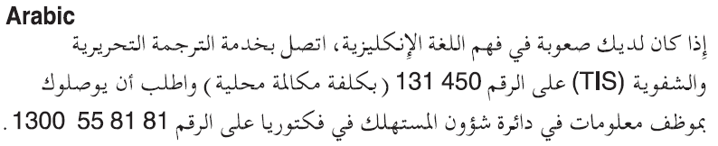
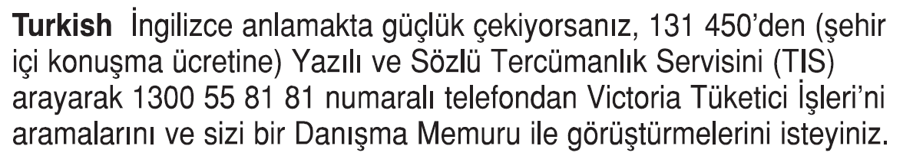
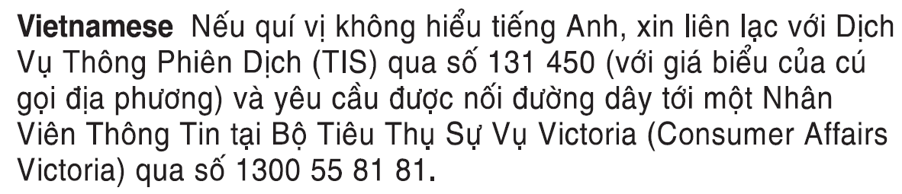
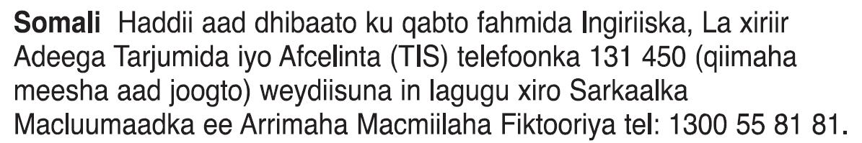
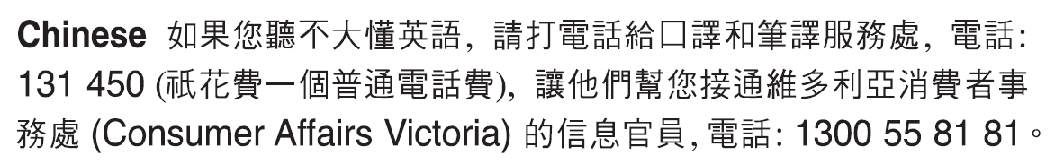
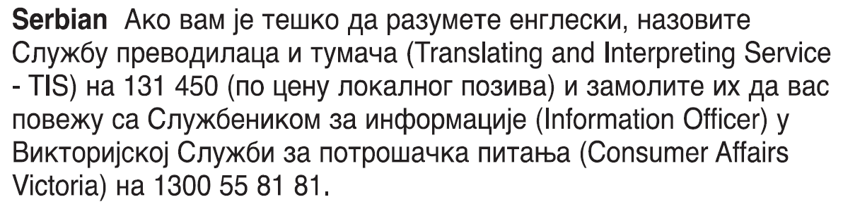
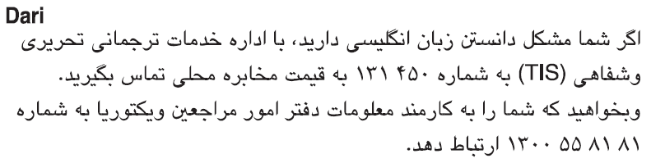
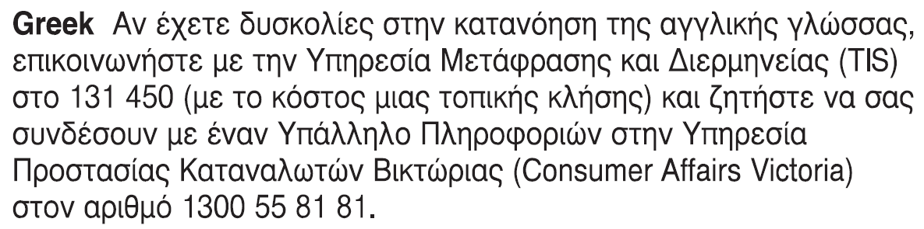
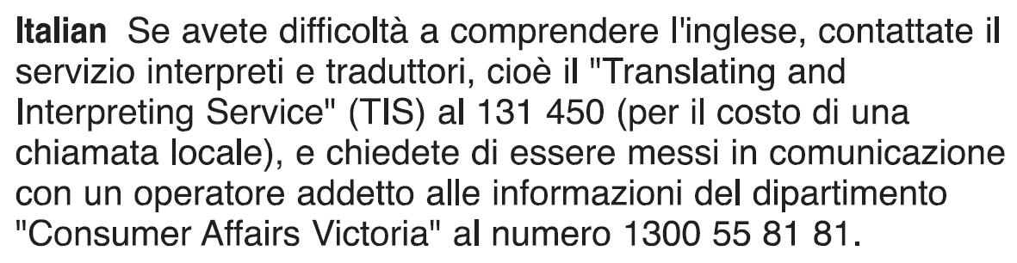 Information about renting is available in other languages at consumer.vic.gov.au/languages.

Notice of goods left behind (SDA) SDA resident’s copy
Residential Tenancies Act 1997 ss498ZZZD, 498ZZZF, 498ZZZG, 498ZZZI

Former SDA resident details
- This notice is given to:
(former resident/s name)
- A copy of this notice is also given to:
(if applicable, insert name and address of resident’s family member, carer, advocate, guardian, administrator or other chosen person)
- Regarding the SDA dwelling at:
(write address)
- Resident’s address:

SDA provider details
- SDA provider name:
(cannot be agent’s name)
- SDA provider address for serving documents:
(can be an agent’s address)
- Contact telephone numbers for SDA provider:
(can be agent’s telephone number)
Business hours:
After hours:

Goods left behind
- You vacated the dwelling on:
(dd/mm/yyyy)
/ /
and have left the following goods behind:
(describe goods)

Storage of goods
- I will store these goods for 14 days from the date of this notice.

Sale of goods
- If you do not collect these goods by:
(insert a date which is at least 14 days from the date of this notice)
/ /
(dd/mm/yyyy)
I will sell or dispose of them.
- If I sell the goods you have a right to the proceeds of the sale, less my costs. You can request payment of this amount within six months of the sale
- If your goods are damaged, sold or disposed of in a way that goes against the law, you may apply to VCAT for compensation. Also, if the SDA provider wrongfully keeps your goods, you may apply to VCAT to order that the goods be returned or to request compensation.
- Signature of SDA provider, their authorised officer or agent:
- Name of SDA provider, their authorised officer or agent signing this notice:

Notice of good left behind (SDA) SDA resident support person’s copy
Residential Tenancies Act 1997 ss498ZZZD, 498ZZZF, 498ZZZG, 498ZZZI

Former SDA resident details
- This notice is given to:
(former resident/s name)
- A copy of this notice is also given to:
(if applicable, insert name and address of resident’s family member, carer, advocate, guardian, administrator or other chosen person)
- Regarding the SDA dwelling at:
(write address)
- Resident’s address:

SDA provider details
- SDA provider name:
(cannot be agent’s name)
- SDA provider address for serving documents:
(can be an agent’s address)
- Contact telephone numbers for SDA provider:
(can be agent’s telephone number)
Business hours:
After hours:

Goods left behind
- You vacated the dwelling on:
(dd/mm/yyyy)
/ /
and have left the following goods behind:
(describe goods)

Storage of goods
- I will store these goods for 14 days from the date of this notice.

Sale of goods
- If you do not collect these goods by:
(insert a date which is at least 14 days from the date of this notice)
/ /
(dd/mm/yyyy)
I will sell or dispose of them.
- If I sell the goods you have a right to the proceeds of the sale, less my costs. You can request payment of this amount within six months of the sale
- If your goods are damaged, sold or disposed of in a way that goes against the law, you may apply to VCAT for compensation. Also, if the SDA provider wrongfully keeps your goods, you may apply to VCAT to order that the goods be returned or to request compensation.
- Signature of SDA provider, their authorised officer or agent:
- Name of SDA provider, their authorised officer or agent signing this notice:

Notice of goods left behind (SDA) SDA provider’s copy
Residential Tenancies Act 1997 ss498ZZZD, 498ZZZF, 498ZZZG, 498ZZZI

Former SDA resident details
- This notice is given to:
(former resident/s name)
- A copy of this notice is also given to:
(if applicable, insert name and address of resident’s family member, carer, advocate, guardian, administrator or other chosen person)
- Regarding the SDA dwelling at:
(write address)
- Resident’s address:

SDA provider details
- SDA provider name:
(cannot be agent’s name)
- SDA provider address for serving documents:
(can be an agent’s address)
- Contact telephone numbers for SDA provider:
(can be agent’s telephone number)
Business hours:
After hours:

Goods left behind
- You vacated the dwelling on:
(dd/mm/yyyy)
/ /
and have left the following goods behind:
(describe goods)

Storage of goods
- I will store these goods for 14 days from the date of this notice.

Sale of goods
- If you do not collect these goods by:
(insert a date which is at least 14 days from the date of this notice)
/ /
(dd/mm/yyyy)
I will sell or dispose of them.
- If I sell the goods you have a right to the proceeds of the sale, less my costs. You can request payment of this amount within six months of the sale
- If your goods are damaged, sold or disposed of in a way that goes against the law, you may apply to VCAT for compensation. Also, if the SDA provider wrongfully keeps your goods, you may apply to VCAT to order that the goods be returned or to request compensation.
- Signature of SDA provider, their authorised officer or agent:
- Name of SDA provider, their authorised officer or agent signing this notice:

