11 March 2016

Consumer Property Acts Review
Policy and Legislation Branch
Consumer Affairs Victoria
GPO Box 123
Melbourne VIC 3001
Email: consumerpropertylawreview@justice.vic.gov.au
Dear Sir/Madam
Please find following my response to your review paper in relation to Part B- Conduct of Owners Corporation Managers
Question 64.

Answer: Absolutely

Question 65.

Answer: The responsibilities of an Owners Corporation are significantly much more onerous than that of a Real Estate Property Manager to the extent that an Owners Corporation Manager is required to:

- Conducting meetings and preparing comprehensive minutes
- Understand, prepare and report on financial status of their Clients (Owners Corporations) which in many instances have a turnover well in excess of $1M.
- Understand and be competent providing advice in relation to many Acts of Parliament which can affect the management of owners corporation and the private Lots within
- Attend to matters which breach the Owners Corporation Act 2006, Regulations 2007 and Rules of the relevant Owners Corporation
- Attending VCAT and acting on behalf of their Client
- Provide advice in relation to the longer term maintenance requirements of the Owners Corporation
- Assist and provide advice to Committees of Management
- Ensure the Owners Corporation’s building is ensured and be expected to provide general advice.

The above is just a snapshot of the expectations of Owners Corporation Managers.

Accordingly Owners Corporation Managers should be licensed and separately so to that of Estate Agents

Question 66.

Answer: No conditional on an appropriate licensing regime in place

Question 67

Answer: The cost is simply the premium charged by the PI insurer. The benefit provides assurances to the Client that the Manager has appropriate backup of a financial and legal nature in the event that a claim is made against the Manager.

Related Issues:

There are Owners Corporation Management companies which are not advocating the introduction of licensing to ensure that the entrance level to operating in this industry remains low.

This relates essentially to franchisors who do not wish to limit their ability to sell franchises without restriction.

Given that there could well be over 400 owners corporation managers in Victoria we are certainly not in short supply.

Licensing will provide for a higher level of professionalism within the industry but will ultimately depend upon the level of entry demanded by the conditions required of the licence.

Question 68

Answer: The receipt of commissions especially in relation to insurance is problematic. The SCAV agreement (Clause 1.3) provides for the Manager to claim an amount up to 15% of the cost of the annual insurance even in the event that the Client buys the insurance directly and as a consequence by passing the Manager.

If insurance commission comes out of the profits of the Broker why therefore is the premium inflated to accommodate the commission paid to the Manager.

Commission on insurance is the only commission specifically referred to in the SCAV pro forma contract of appointment.

As such no other commissions should be received unless a specific agreement is entered into with the Client.

Whilst there is a disclosure within the contract of appointment it is my opinion that any reference to the actual commission amount (other than that which is specifically identified in the insurance premium renewal documentation) is variable.

Question 69.

Answer: Yes. The test is to request a net policy. In other words when commission is not paid the price of the insurance premium will reduce by an amount equal to the commission which would otherwise have been paid.

Question 70.

Answer: None however it should be recognised that the receipt of commission on insurance contributes significantly to the income of the Manager. In some instances it may equate to the net profit of the Management company.

If commission is in fact regulated as not being able to be received there must be a mechanism (explanation by the Regulators) to accommodate the ability to increase the management fee by the quantum of the commission lost.

In other words for example if the management fee was $10,000 and the insurance premium $5500 (which includes commission of $500) then the total amount paid out by the Client would be $15500 .

Given the Regulators legislate that the commission is illegal then to ensure that the Manager is not adversely affected the Management Fee charged would increase by $500 and the insurance premium reduced by the same amount (no commission paid).

The end result is that the Client and Manager are no worse off financially.

Questions 71 & 72

Answer: Management agreements should either be able to be terminated by the Committee or at a General Meeting depending on what is agreed with between the Client and the Manager.

Contracts should not be able to be rolled over for an additional 12 month term but only until the contract is either renewed or terminated; for example:

“If no notice is given by the Owners Corporation, prior to the expiry date, the appointment will continue until this contract of appointment is renegotiated or otherwise”.

If you are referring to the SCAV pro forma contract the fact that it requires the Client to indemnify the Manager for negligence is misleading in the extreme.

Question 73

Answer: In my opinion the only distinction which should be made is where a Developer appoints a Manager which is fully or partially owned by the Developer.

In this instance the contract term should be for 12 months only or until the second Annual General Meeting (noting that the first AGM is the inaugural general meeting prior to settlements) where all members (it would be anticipated that the ownership of the majority of the Lots would by then have passed from the Developer to the new owner) would have the opportunity to ratify the contract.

Question 74

Answer: In order to maintain delegated powers as contained in the SCAV contract of appointment the contract should only roll over as noted in the answer to question 72 otherwise the answer is No.

Renewals also should not be at the prerogative of the Manager only.

Question 75:

If the contract is negotiated at arms length (no apparent conflicts) then the maximum term of the contract should not be regulated.

As noted above contracts with related parties to Developers should be for a maximum of 12 months as it is far from being at arms length.
Furthermore Developers have been known to have entered into extravagantly priced contracts with Managers for 5 – 10 years allowing a kick back to the Developers of in excess of $100,000.

I recently provided professional advice in respect to the value of an owners corporation/facility management contract which was $250,000p.a in excess of what the market would have charged given that the contract was negotiated at arms length.

Secret commissions should be criminalised with gaol terms and significant $$ penalties.

Developers are also entering into contracts with Managers who have the deepest pockets and not necessarily with Managers who provide a professional service.

Question 76.

Answer: Managers should not be able to be a proxy for a member of the Owners Corporation unless the member providing the proxy has expressly stated how the Manager should vote in respect to the motions proposed in the meeting Agenda otherwise the proxy should be deemed invalid

Question 77.

Answer: Yes.

Question 78.

Answer: In transitioning from pooled accounts to individual accounts last August involved the following:
- IT time - change of biller codes, banking details
- Staff time - change of banking details in system
- Paper, postage, email cost re advice as to change of details
- Attending to Client enquiries
- Attending to missing payments due to Clients using old banking details
- Project time - 37.5 hours

Total time - 75 hours approximately

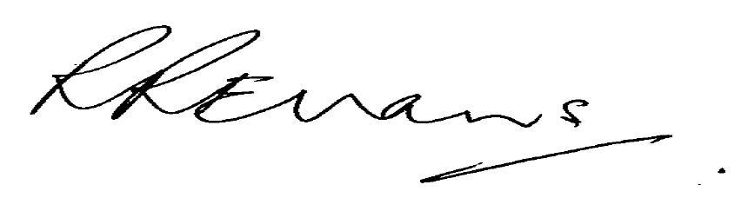

Robert Evans CPA AGIA HIA Member
0408 545 374

